***1. Write a program that keeps taking input (integers) until the user enters -1. (Use while or do-while loop)***

#include <iostream>  
using namespace std;  
int main() {  
int x;  
 while (cin>>x && x!=-1) {  
 cout << " input or input -1 to stop\n";  
 }  
 return 0;  
}

***2, Write a program that keeps taking input (character) until the user enters a dot.***

#include <iostream>  
using namespace std;  
int main() {  
char x;  
 while (cin>>x && x!='.') {  
 cout << " input or input . to stop\n";  
 }  
 return 0;  
}

3. Write a program that displays the following number sequence.

Make sure there is no extra comma, 0.1,2,3, …….., 99

#include <iostream>  
using namespace std;  
int main() {  
int x;  
 for (int x = 0; x <= 99; ++x) {  
 cout << x;  
 if (x<99) {  
 cout << ", ";  
 }  
 }  
 return 0;  
}

**4. Write a program that displays the following number sequence. Make sure there is no extra comma. 2,2.25.2.50,2.75…...,4**

#include <iostream>  
using namespace std;  
int main() {  
  
 for (float x = 2; x <= 4; x+=.25) {  
 cout << x;  
 if (x<4) {  
 cout << ", ";  
 }  
 }  
 return 0;  
}

**5. Write a program that displays the following character sequence,**

**a, b, c, ...., z**

#include <iostream>  
using namespace std;  
int main() {  
  
 for (char x = 'a'; x <='z'; x++) {  
 cout << x;  
 if (x<'z') {  
 cout << ", ";  
 }  
 }  
 return 0;  
}

**6. Write a program that displays the following number sequence. 1,3,5, 7,...,73.**

#include <iostream>  
using namespace std;  
int main() {  
  
 for (int x = 1; x <=73; x++) {  
 cout << x;  
 if (x<73) {  
 cout << ", ";  
 }  
 }  
 return 0;  
}

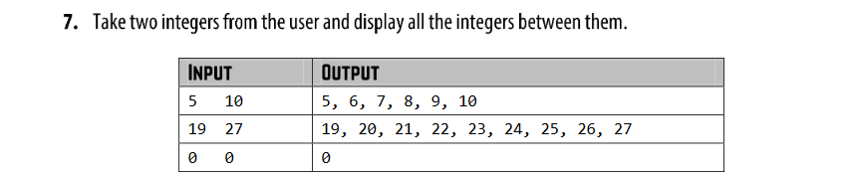

#include <iostream>  
using namespace std;  
int main() {  
 int x,y;  
 cout << " input two number \n";  
 cin >> x >> y;  
  
 while (x<=y)  
 {  
 cout << x << endl;  
 x++;  
 }  
 return 0;  
}

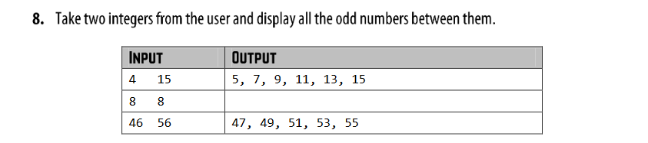

#include <iostream>  
using namespace std;  
int main() {  
 int x,y;  
 cout << " input two number \n";  
 cin >> x >> y;  
 while (x<=y){  
 if(x%2!=0){  
 cout << x;  
 x++;  
 if (x<y)  
 cout << ", ";  
 }  
 else {  
 x++;  
 }  
 }  
 return 0;  
}

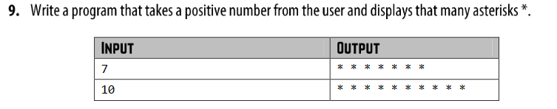

#include <iostream>  
using namespace std;  
int main () {  
 int x;  
 cin>>x;  
 for (int i=0; i<x; i++)

{  
 cout<<"*";  
 }  
 return 0;  
}

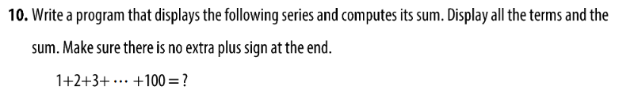

#include <iostream>  
using namespace std;  
int main() {  
 int sum =0;  
 for (int i =1; i <=100 ; i++)  
 {  
 cout <<i;  
 sum = sum +i;  
 if (i<100){  
 cout<<"+";  
 }  
 }  
 cout << "="<<sum;  
 return 0;  
}

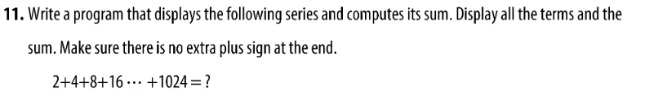

#include <iostream>  
using namespace std;  
int main() {  
 int sum =0;  
 for (int i =2; i <=1024 ; i= i*2)  
 {  
 cout <<i;  
 sum = sum +i;  
 if (i<1024){  
 cout<<"+";  
 }  
 }  
 cout << "="<<sum;  
 return 0;  
}

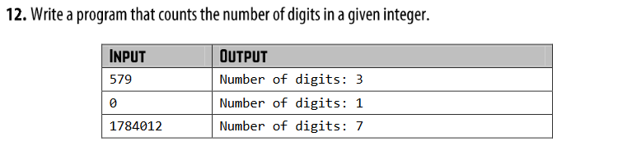

#include <iostream>  
using namespace std;  
int main() {  
 int x;  
 cout<<"Enter the number"<<endl;  
 cin>>x;  
 int c=0;  
 while(x>0){  
 x=x/10;  
 c++;  
 }  
 cout<<c<<endl;  
 return 0;  
}

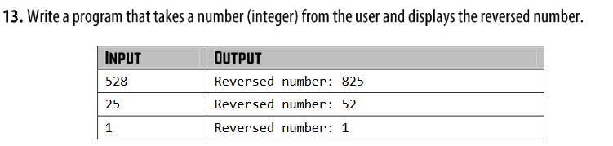

#include <iostream>  
using namespace std;  
int main()  
{  
 int x, reverse=0, rem;  
 cout<<"Enter a number: ";  
 cin>>x;  
 while(x!=0)  
 {  
 rem=x%10;  
 x=x/10;  
 reverse=reverse*10+rem;  
 }  
 cout<<"Reversed Number: "<<reverse<<endl;  
 return 0;

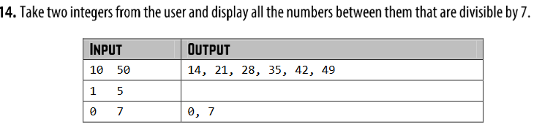

#include <iostream>  
using namespace std;  
int main() {  
 int x,y;  
 cin >>x>>y;  
 for ( int i=x; i <=y ; i++)  
 {  
 if(i%7==0){  
 cout <<i;  
 if (i<y){  
 cout <<", ";  
 }  
 }  
 }  
 return 0;  
}

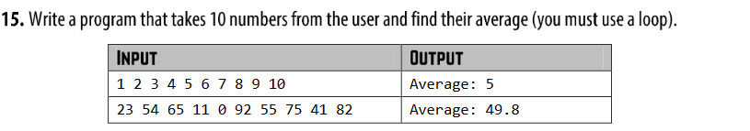

#include <iostream>  
using namespace std;  
int main() {  
 float total =0;  
 int x;  
 for (int i=x; i <10 ; i++)   
 {  
 cin >>x;  
 total = total +x;  
 }  
 cout <<total/10;  
 return 0;  
}