# Problem 1
a = int(input("Enter first number: "))
b = int(input("Enter second number: "))

print("\nBefore Swapping:")
print("a =", a)
print("b =", b)

a, b = b, a

print("\nAfter Swapping:")
print("a =", a)
print("b =", b)
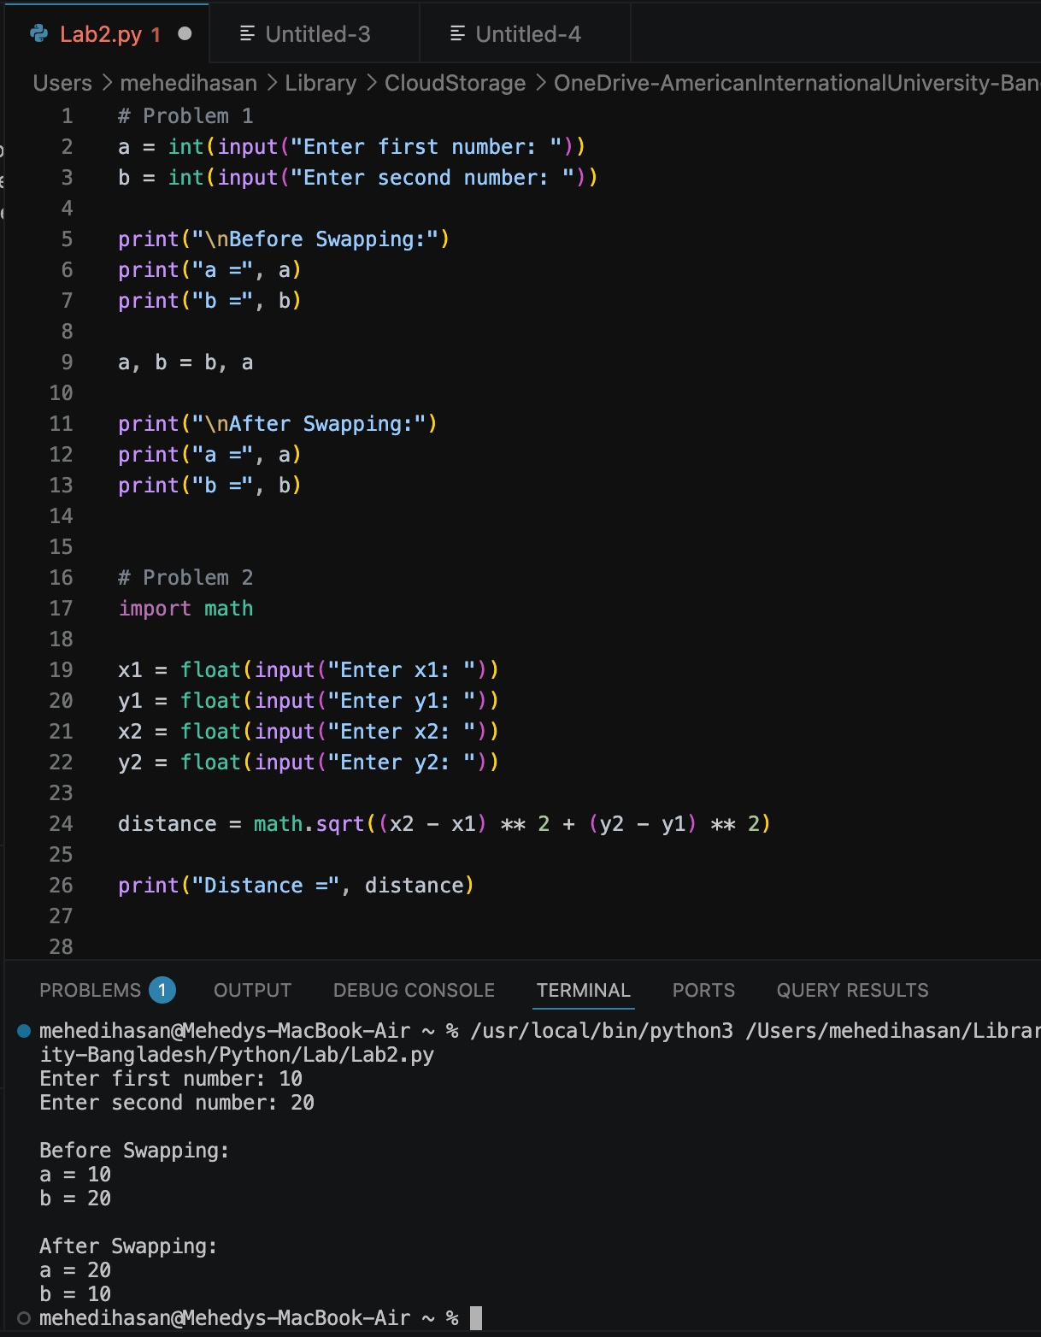
# Problem 2
import math

x1 = float(input("Enter x1: "))
y1 = float(input("Enter y1: "))
x2 = float(input("Enter x2: "))
y2 = float(input("Enter y2: "))

distance = math.sqrt((x2 - x1) ** 2 + (y2 - y1) ** 2)

print("Distance =", distance)
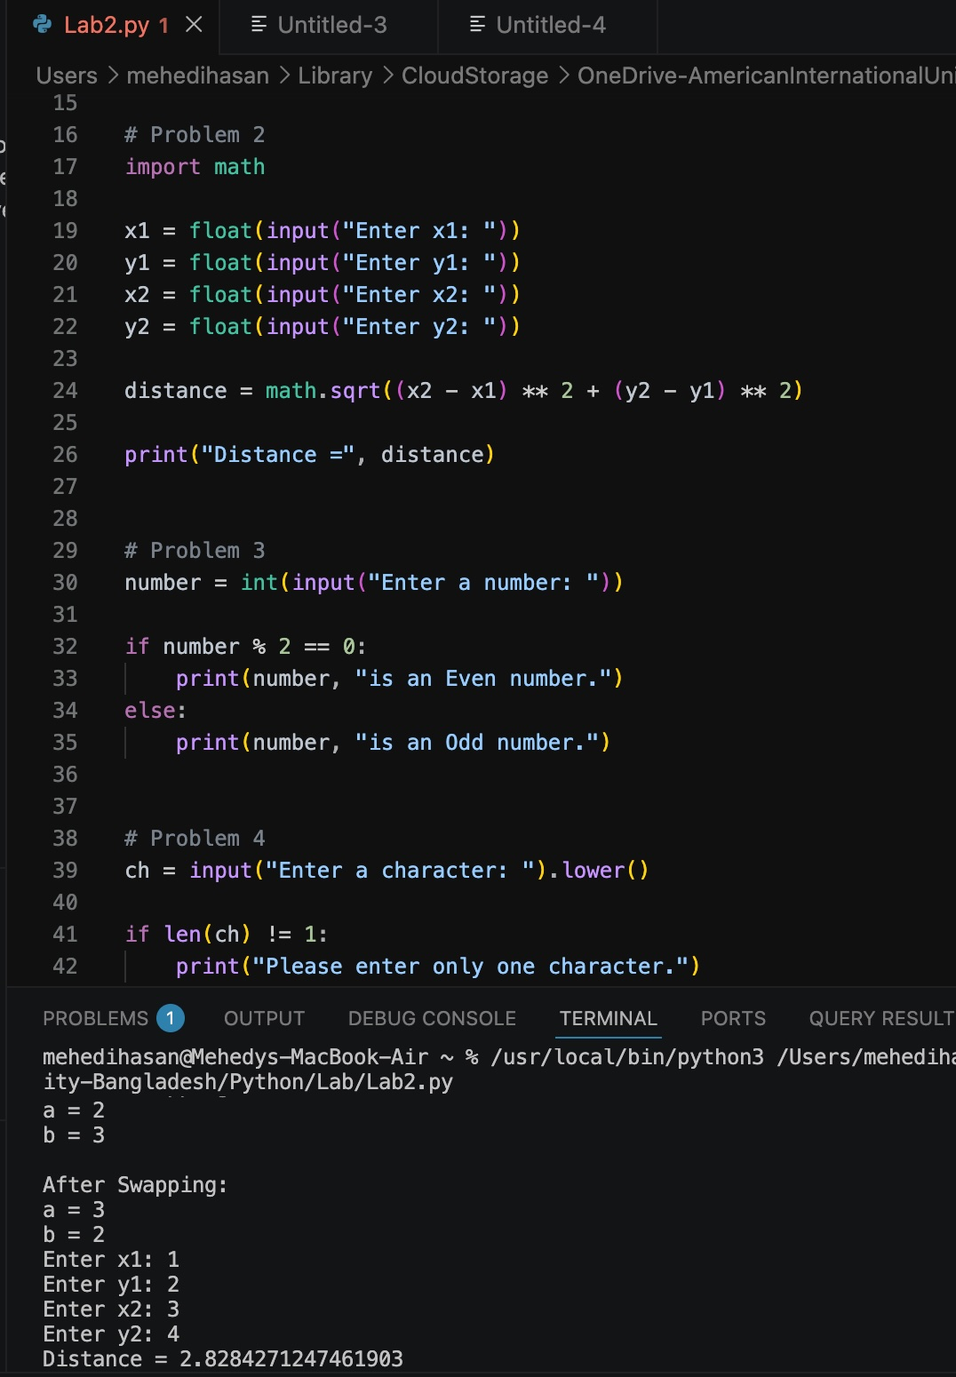
# Problem 3
number = int(input("Enter a number: "))

if number % 2 == 0:
print(number, "is an Even number.")
else:
print(number, "is an Odd number.")
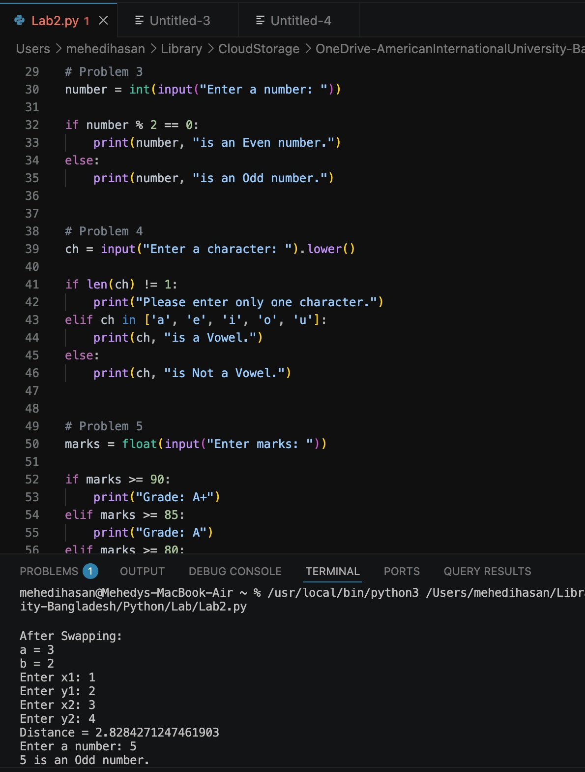
# Problem 4
ch = input("Enter a character: ").lower()

if len(ch) != 1:
print("Please enter only one character.")
elif ch in ['a', 'e', 'i', 'o', 'u']:
print(ch, "is a Vowel.")
else:
print(ch, "is Not a Vowel.")
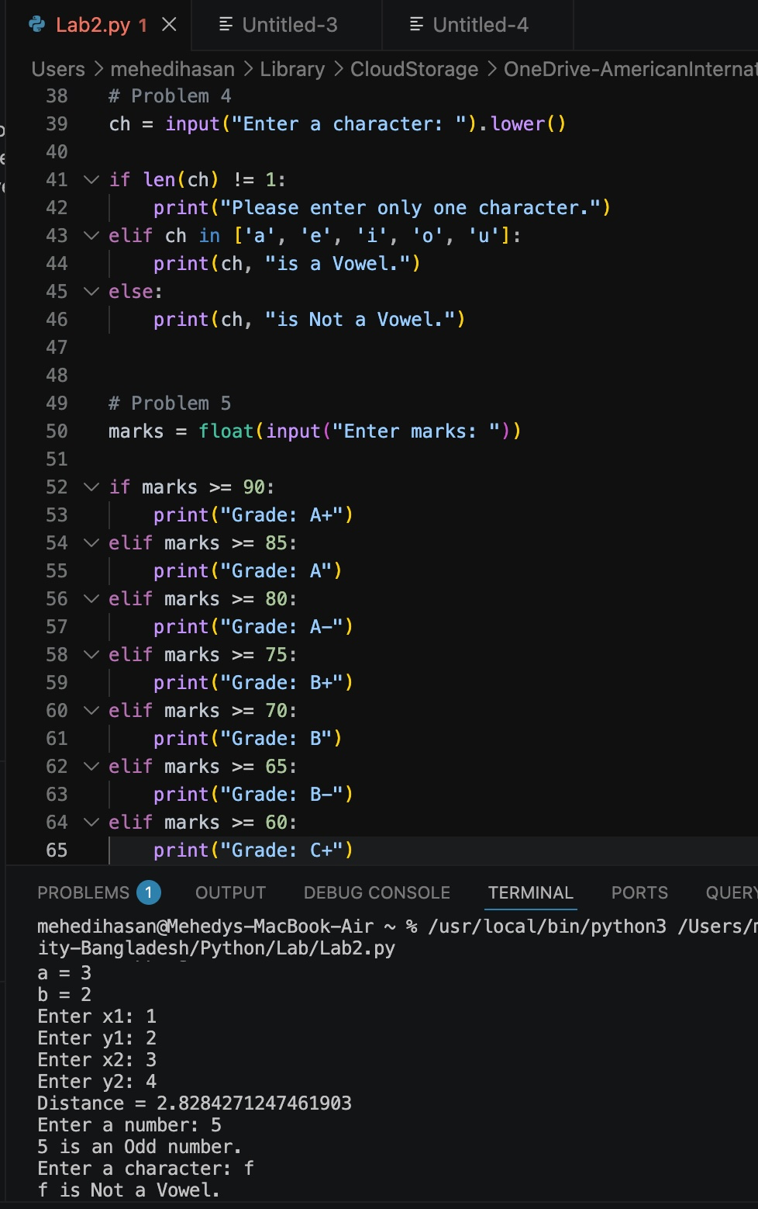
# Problem 5
marks = float(input("Enter marks: "))

if marks >= 90:
print("Grade: A+")
elif marks >= 85:
print("Grade: A")
elif marks >= 80:
print("Grade: A-")
elif marks >= 75:
print("Grade: B+")
elif marks >= 70:
print("Grade: B")
elif marks >= 65:
print("Grade: B-")
elif marks >= 60:
print("Grade: C+")
elif marks >= 50:
print("Grade: C")
else:
print("Grade: F")
