**Subject:** Database Management System

**Week:** 01

i. What is Database?

Ans: A Database is an organized collection of structured information or data which are stored in a Computer system. A Database is usually controlled by a Database Management System. Database is used for storing, updating and maintaining and accessing any sort of data.

Database Management System(DBMS) is a software which is used to manage data in a Database. For example: *MySQL*, *Oracle* etc. DBMS provides an interface to perform various operations like database creation, storing data in it, updating data, creating a table in the database and a lot more. It provides protection and security to the database. In the case of multiple users, it also maintains data consistency.

ii. What is 3 Schema Architecture or What is 3 level Abstraction?

Ans: The Three Schema Architecture is called Three Level Architecture. It is used to separate the user application and physical database. The Three Schema architecture contains three levels. It breaks the database down into three different categories. These are External Schema, Conceptual Schema and Internal Schema.

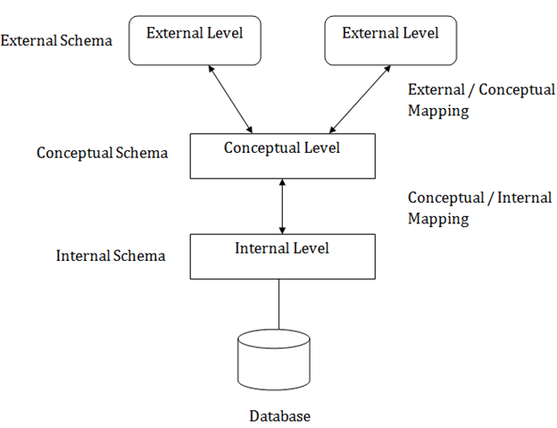

iii. Write about ER Data Model.

Ans: ER Data Model stands for an Entity-Relationship Data Model. It is a high-level data model. This model is used to define the data elements and relationship for a specified system. In ER modeling, the database structure is portrayed as a diagram called an entity-relationship diagram.

For example, suppose we design a school database. In , database, the student will be an entity with attributes like address, name, id, age, etc. The address can be another entity with attributes like city, street name, pin code, etc and there will be a relationship between them.

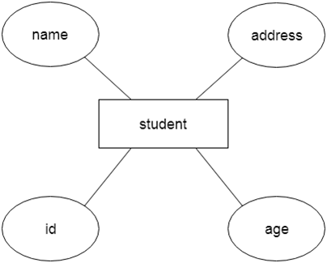

Components of ER Diagram:

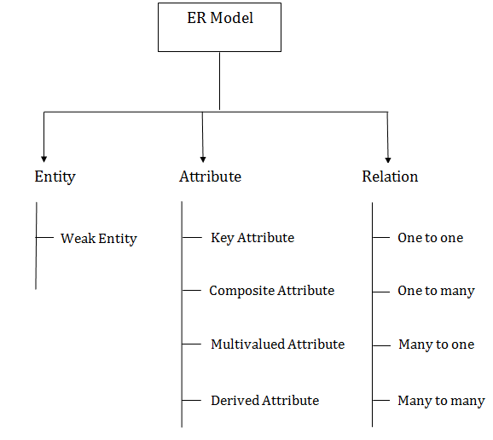

iv. Write about various types of keys in DBMS.

Ans: Keys play an important role in Database Management System. There are various types of keys in Database Management System. Such as -

Primary Key: The Primary Key refers to a column or a set of columns of a table that helps us identify all the records uniquely present in that table. A table can consist of just one primary key. Also, this primary key cannot consist of the same values reappearing/repeating for any of its rows. All the values of a primary key have to be different, and there should be no repetitions.

Candidate Keys: The candidate keys in a table are defined as the set of keys that is minimal and can uniquely identify any data row in the table. In a table, we select the primary key from a candidate key. Thus, a candidate key has similar properties as that of the primary keys. In a table there can be multiple Candidate Keys.

Super Key: A super key refers to the set of all those keys that help us uniquely identify all the rows present in a table. A super key is a candidate key’s superset. We need to pick the primary key of any table from the super key’s set so as to make it the table’s identity attribute.

Foreign Key: A foreign key is an attribute value in a table that acts as the primary key in another table. Hence, the foreign key is useful in linking together two tables. Data should be entered in the foreign key column with great care, as wrongly entered data can invalidate the relationship between the two tables.