EMPLOYEE MANAGEMENT SYSTEM
A PROJECT REPORT
Submitted in partial fulfilment of the
requirement for the award of the degree of
BACHELOR OF TECHNOLOGY (B. Tech)
in
Computer Science and Engineering
by
Meheer Shukla
209301289
Under the supervision of
Dr Susheela Vishnoi



DEPARTMENT OF COMPUTER SCIENCE AND ENGINEERING,
SCHOOL OF COMPUTER SCIENCE AND ENGINEERING,
MANIPAL UNIVERSITY JAIPUR,
RAJASTHAN, INDIA-303007

JULY, 2024

STUDENT DECLARATION

Project Title: Employee Management System
I, Meheer Shukla, hereby declare that the Major project work entitled "Employee Management System" submitted to Manipal University Jaipur in partial fulfilment of the requirements for the award of the degree of Bachelor of Technology (B. Tech.) in Computer Science & Engineering, is a record of an original work conducted by me under the guidance of “Employee Management System, CSE”.

I also certify that this project has not previously been submitted for assessment in any academic capacity, and that I have not copied in part or whole or otherwise plagiarised the work of other persons and that I have acknowledged all material and sources used in its preparation, whether they be books, articles, reports, lecture notes, and any other kind of document, electronic or personal communication.

In the event of any part of this work being found to be plagiarized or misrepresented,
I understand that appropriate actions, as per the academic regulations and policies, may be taken against me.

Student Name and Signature
Reg. No. 209301289
Date: 05/07/2024
Place: Jaipur , MUJ

Date: 05/07/2024

CERTIFICATE

This is to certify that the project titled Employee Management System is a record of the bonafede work done by Meheer Shukla (209301289) submitted in partial fulfilment of the requirements for the award of the Degree of Bachelor of Technology (B.Tech) in (Computer of Science & Engineering) of Manipal University Jaipur, during the academic year 2023-24.

Dr Susheela Vishnoi
Project Guide, Dept of CSE
Manipal University Jaipur

Dr Neha Chaudhary
HOD, Dept of (Name of the Dept.) Manipal University Jaipur



ACKNOWLEDGMENTS
I am grateful to Sparken IT Solutions Private Ltd. for the internship opportunity and execute this training which is an integral part of curriculum for the B. Tech CSE degree at Manipal University Jaipur.
I would also want to thank Dr. Susheela Vishnoi, Department of Computer Science and Engineering, Manipal University, Jaipur for her advice and support.
I visualize this opportunity as a steppingstone in my career as it has boosted my research/application development temperament, and I am sure that it will help me in long term in applying the knowledge of research skills and techniques learnt at this juncture.

ABSTRACT
In order to manage human resources effectively in modern enterprises, employee management systems, or EMS, have become essential tools. This essay examines the features, advantages, and difficulties of EMS. The main goal is to give a thorough understanding of how EMS simplifies different HR procedures like personnel scheduling, payroll management, attendance monitoring, and performance reviews.
A consolidated database for personnel data, automated payroll processing to reduce errors, and performance measures to evaluate both team and individual productivity are often essential components. Through integrated communication channels, EMS also helps to improve communication between management and staff.

However, there are obstacles to EMS implementation, including setup expenses up front, worries about data security, and employee resistance to change. To tackle these obstacles, meticulous preparation, instruction, and adherence to data security guidelines are necessary.

To sum up, there are a lot of benefits to using Employee Management Systems (EMS) that use technologies like PHP, SQL, HTML, CSS, and JavaScript to improve employee happiness and organizational efficiency. The dynamic functionality, responsive front-end interfaces, and strong database management made possible by these technologies are essential for contemporary EMS solutions. To optimize the advantages of EMS, careful evaluation of organizational, technical, and human elements is necessary for successful implementation. Prospective avenues for research could centre on the development of PHP, SQL, HTML, CSS, and JavaScript technologies in the context of EMS, examining their capacity to further boost employee engagement and organizational performance via creative features and intuitive user interfaces.

LIST OF FIGURES

Figure No. | Figure Title | Page No.
Fig 2.1 | Project CRM | 10
Fig 2.2 | SQL hierarchy | 13
Fig 3.1 | Composer Pseudo-Code | 16
Fig 3.2 | Database Creation Pseudo-Code | 16
Fig 3.3 | Database Configuration Pseudo-Code | 16
Fig 3.4 | Sidebar Example | 17
Fig 3.5 | Model Pseudo-Code | 18
Fig 3.5 | Controller Pseudo-Code | 19
Fig 3.6 | Controller Pseudo-Code | 19
Fig 3.7 | View Pseudo-Code | 20
Fig 4.1 | Dashboard | 26

CONTENTS

- Chapter 1 Introduction
  - What is Employee Management System (EMS)?
  - Benefits of using Employee Management System (EMS)
  - Introduction to work done/Motivation
  - Introduction to work done/Motivation
  - Project Statement / Objectives
    - Key objectives typically involve documenting
  - Organization of Report
- Chapter 2 Background Material
  - Conceptual Overview (Concepts/ Theory used)
    - Understanding the Concept of an Employee Management System
    - Core Concepts for an Employee Management System
    - Theoretical Foundations of Employee Management System
    - ERP lifecycle
    - Advanced Concepts in Data Leverage
    - Impact of Data Leverage on Business Functions
  - Technologies involved
    - Backend Technologies
    - Front-end Technologies
    - Yii2
    - Key Components of Yii2
    - Use of Yii2 in the project
    - My Structured Query Language (MySQL)
    - Use of MySQL in the project
    - Composer
- Chapter 3 Methodology
  - Methodology adopted
    - Set Up the Development Environment
    - Understand and recognise all the modules
    - Create Database Tables
    - Generate Models
    - Create CRUD Operations
    - Implement Additional Features
    - Styling with HTML and CSS
    - Testing and Development
    - Documentation and Maintenance
  - Some Example Code Snippets
    - Mode: models/Employee.php
    - Controller: controller/EmployeeController.php
    - Views: views/employee/index.php
- Chapter 4: Implementation
  - Introduction
    - Overview
    - Purpose
    - Scope
  - Project Objectives
  - System Design
    - System Architecture
    - Database Schema
  - Implementation
    - Setting Up the Environment
    - Creating Models

Creating CRUD Operations
    - Implementing Authentication
- Chapter 5: Results and Analysis
  - System Performance
  - User Experience
  - Data Integrity and Security
  - Reporting and Analysis
  - System Robustness
  - Conclusion
- Conclusion and Future Scope
  - Conclusions
  - Future Scope
- References
- Appendix

CHAPTER 1 INTRODUCTION
A key component of contemporary organizational architecture is an Employee Management System (EMS), which makes it easier to manage human resources procedures effectively. It has a number of features intended to make chores like managing payroll, monitoring attendance, assessing performance, and scheduling easier. Centralized databases that hold extensive employee data, automated payroll processing routines that reduce errors, and powerful reporting capabilities for tracking individual and group productivity are common features of EMS platforms. Through the integration of these features, EMS improves operational effectiveness while also promoting improved communication and teamwork between staff and management. To overcome obstacles including initial setup costs and employee aversion to technological change, effective implementation necessitates meticulous planning, training, and adherence to data protection regulations.
1.1 What is Employee Management System (EMS)?
A software program called an Employee Management System (EMS) is made to automate and simplify certain parts of an organization's human resource management process.
1.2 Benefits of using Employee Management System (EMS):
• Centralized Data Management: EMS consolidates employee information into a single database, making it easily accessible for HR professionals and managers. This centralized approach reduces the likelihood of data duplication or inconsistencies.
• Automation of Routine Tasks: EMS automates repetitive HR tasks such as payroll processing, attendance tracking, and leave management. This automation reduces manual errors, saves time, and allows HR staff to focus on strategic initiatives.
• Improved Accuracy and Compliance: By automating calculations and ensuring adherence to company policies and regulatory requirements, EMS helps maintain accuracy in payroll, benefits administration, and other HR processes. This reduces compliance risks and potential legal issues.
• Enhanced Employee Self-Service: Many EMS platforms include self-service portals where employees can update personal information, view pay stubs, request time off, and participate in performance reviews. This empowerment leads to greater employee satisfaction and reduces administrative burdens on HR teams.
• Better Decision-Making with Data Analytics: EMS systems often include reporting and analytics tools that provide insights into workforce trends, performance metrics, and HR analytics. These insights enable informed decision-making regarding staffing, training, and resource allocation.
• Streamlined Communication and Collaboration: EMS facilitates communication between HR, managers, and employees through integrated messaging systems, announcements, and feedback mechanisms. Improved communication fosters a more cohesive and engaged workforce.

  - Introduction to work done/Motivation
The introduction to the development and implementation of Employee Management Systems (EMS) typically revolves around addressing fundamental challenges and maximizing organizational efficiency. The motivation stems from the need to streamline and automate human resources (HR) processes, which traditionally have been labour-intensive and prone to errors.
The primary goal of an EMS is to centralize HR functions such as payroll management, attendance tracking, performance evaluation, and employee scheduling into a cohesive digital platform. By doing so, organizations can reduce administrative overhead, minimize human error, and ensure compliance with regulatory requirements.
Moreover, EMS platforms aim to enhance employee satisfaction and engagement by providing self-service capabilities, facilitating transparent communication, and supporting professional development through improved training and performance management systems.
The evolution of EMS has been driven by advancements in technology, particularly cloud computing and mobile applications, which enable seamless access to HR services from anywhere at any time. This accessibility supports modern work trends such as remote work and flexible scheduling, thereby accommodating diverse workforce needs and preferences.
In conclusion, the development and adoption of EMS are motivated by the pursuit of operational excellence, regulatory compliance, and fostering a positive work environment that promotes employee productivity and satisfaction. As technology continues to evolve, EMS systems are expected to play an increasingly pivotal role in shaping the future of HR management, driving efficiency gains and strategic decision-making within organizations.
  - Project Statement / Objectives:
The objective of a project report on an Employee Management System (EMS) developed with PHP and Yii 2 framework includes detailing the system's design, development, and implementation process using Yii 2 MVC architecture.
    - Key objectives typically involve documenting:
- System Architecture and Design: Describe how Yii 2 framework was utilized to structure the EMS, including database schema design, model-view-controller (MVC) pattern implementation, and use of Yii components.
- Functionality Implementation: Detail the features implemented such as employee information management, payroll processing, attendance tracking, performance evaluation, and reporting.
- Technology Stack: Highlight the use of PHP for server-side scripting, Yii 2 framework for rapid application development, MySQL for database management, HTML/CSS for frontend development, and JavaScript for dynamic functionalities.
- Testing and Quality Assurance: Discuss the testing methodologies employed (unit testing, integration testing, etc.) to ensure functionality, performance, and security.
- User Documentation: Provide user manuals and guides for administrators and employees on how to use the EMS effectively.
- Future Recommendations: Suggest enhancements or improvements for the EMS based on feedback, emerging technologies, and business needs.
The project report aims to demonstrate a comprehensive understanding of the EMS development process, its technical implementation with Yii 2, and its potential to optimize HR management processes within an organization.
1.6 Organization of Report
- Chapter 1: Introduction
  - 1.1 Introduction to work done/Motivation
  - 1.2 Project Statement / Objectives:
  - 1.3 Organization of Report: Briefly outline the structure of report
- Chapter2: Background Material
  - 2.1 Conceptual Overview (Concepts/ Theory used)
  - 2.2 Technologies involved
- Chapter 3: Methodology
  - 3.1 Methodology adopted
  - 3.2 Some Example Code Snippets
- Chapter 4: Implementation:
  - 4.1 Modules: Briefly explain the different modules or components of your project.
  - 4.2 Prototypes: Describe the prototypes you built, including a brief introduction before details
- Chapter 5: Results and Analysis:
  - 5.1 Results: Present your findings for each aspect of the project.
- Chapter 6: Conclusions & Future Scope
  - 6.1 Conclusions: Summarize the key findings and reiterate the project's achievements.
  - 6.2 Future Scope: Discuss potential areas for further research or development.
- References: List all sources you cited in the report using a consistent format (e.g., APA, MLA).
- Appendices: Include detailed data, code, lengthy explanations that would disrupt the main flow of the report.

CHAPTER 2 BACKGROUND MATERIAL
This section of my project report will provide context and establish the foundation for an Employee Management System.
Here are a few key insights to keep in mind before making a Employee Management System:
- Requirements Gathering: Understand and document the specific needs and requirements of the organization regarding HR processes, compliance, reporting, and employee engagement.
- System Design: Define the architecture, database schema, and technology stack (such as PHP, Yii 2, MySQL) that will support the EMS. Consider scalability, integration capabilities, and security requirements.
- Core Features: Identify essential functionalities such as employee information management, payroll processing, attendance tracking, performance evaluation, leave management, and reporting.
- User Interface (UI/UX): Design an intuitive and user-friendly interface for administrators, managers, and employees. Ensure accessibility, responsiveness, and ease of navigation.
- Security Measures: Implement robust security measures to protect sensitive employee data, comply with data protection regulations (such as GDPR or CCPA), and prevent unauthorized access or breaches.
- Integration: Plan for integration with existing systems (such as ERP or accounting software) to ensure seamless data flow and operational continuity.
- Scalability and Flexibility: Design the EMS to scale with the organization's growth, accommodate future enhancements, and support evolving HR practices and regulations.
- Testing and Quality Assurance: Develop comprehensive testing strategies (unit testing, integration testing, user acceptance testing) to verify functionality, performance, and usability of the EMS.
- Training and Support: Prepare training materials and provide support to ensure smooth adoption and effective use of the EMS by administrators, managers, and employees.
- Feedback and Iteration: Establish mechanisms for gathering feedback from users and stakeholders to continuously improve and iterate upon the EMS based on real-world usage and evolving organizational needs.
By focusing on these key areas during the foundation phase, organizations can build a robust Employee Management System that enhances operational efficiency, compliance, and employee satisfaction.
  - Conceptual Overview (Concepts/ Theory used)
    - Understanding the Concept of an Employee Management System
An Employee Management System (EMS) automates HR processes (e.g., payroll, attendance, performance) to enhance efficiency, compliance, and employee satisfaction. It integrates PHP, Yii 2, MySQL, HTML, CSS, and JavaScript for robust functionality and usability.
    - Core Concepts for an Employee Management System
Some of the core concepts that underpin an Employee Management System:
To develop an Employee Management System (EMS) using PHP, Yii2, HTML, and CSS, focus on these core concepts:
- Yii2 Framework: Utilize Yii2's MVC architecture for structured development, routing, and data handling.
- Database Management: Implement MySQL for secure storage and efficient retrieval of employee data.
- User Authentication: En sure secure login/logout functionality using Yii2's built-in authentication features.
- CRUD Operations: Develop Create, Read, Update, and Delete functionalities for managing employee records.
- Responsive UI: Design a responsive and intuitive interface using HTML and CSS for seamless user experience across devices.
- Form Validation: Validate user inputs to maintain data integrity and enhance security.
- Reports and Analytics: Integrate reporting tools to generate insights on payroll, attendance, and performance metrics.
- Security Measures: Implement measures like CSRF protection, input sanitization, and secure password storage.
- Integration: Consider integrating with third-party APIs or existing systems for additional functionalities (e.g., payroll processing).
- Testing and Debugging: Perform thorough testing to ensure functionality, performance, and usability meet requirements before deployment.
By focusing on these core concepts, you can develop a robust and scalable Employee Management System that meets organizational needs effectively.
    - Theoretical Foundations of Employee Management System
To build an Employee Management System:
• MVC Architecture: Yii2 follows the Model-View-Controller architecture. Understand how models interact with the database (MySQL), controllers handle user requests, and views present data to users.
• Object-Oriented Programming (OOP): PHP with Yii2 emphasizes OOP principles. Understand classes, objects, inheritance, encapsulation, and polymorphism to organize code efficiently.
• Database Design: Design a relational database schema using MySQL to store employee data (e.g., profiles, attendance records, payroll information) efficiently and securely.
• RESTful API Design: Implement RESTful APIs in Yii2 to enable communication between frontend (HTML/CSS) and backend (PHP) components, ensuring data exchange follows REST principles for scalability and maintainability.
• Form Handling and Validation: Use Yii2's form handling features to validate user inputs (e.g., employee registration, attendance updates) to maintain data integrity and prevent security vulnerabilities.
• Session Management and Security: Implement secure session handling and authentication mechanisms in Yii2 to control user access and protect sensitive employee data from unauthorized access.
• Responsive Web Design: Apply HTML5 and CSS3 principles to create a responsive and accessible user interface (UI) that adapts to different screen sizes and devices, enhancing user experience (UX) across platforms.
• User Experience (UX) Design: Incorporate UX design principles to ensure intuitive navigation, clear information presentation, and efficient interaction workflows for administrators, managers, and employees using the EMS.
• Software Testing: Employ testing methodologies (e.g., unit testing, integration testing) to validate functionality, performance, and security aspects of the EMS, ensuring robustness and reliability.
• Documentation and Version Control: Document the EMS architecture, design decisions, APIs, and functionalities comprehensively. Use version control systems (e.g., Git) to manage codebase changes and collaborate effectively during development.
    - ERP lifecycle
Developing an Employee Management System (EMS) using PHP, Yii2, HTML, and CSS typically follows a structured software development lifecycle (SDLC). Here are the key phases involved:
1. Requirements Gathering and Analysis:
  - Define the scope, objectives, and functional requirements of the EMS.
  - Gather inputs from stakeholders (HR department, administrators, etc.) to understand their needs.
  - Analyse existing HR processes that the EMS will automate or improve.
2. System Design:
  - Design the architecture of the EMS using Yii2's MVC framework.
  - Create a database schema using MySQL to store employee data and related information.
  - Design user interfaces (UI) using HTML and CSS for a responsive and user-friendly experience.
  - Plan APIs and data exchange formats (e.g., JSON) for communication between frontend and backend components.
3. Implementation (Development):
  - Develop backend functionality using PHP with Yii2, implementing controllers, models, and business logic.
  - Implement frontend interfaces using HTML and CSS, integrating with Yii2's views and layouts.
  - Set up authentication and authorization mechanisms for secure access to the EMS.
  - Develop forms and validation logic for user input handling.
4. Testing:
  - Perform unit testing to verify individual components (e.g., models, controllers) behave as expected.
  - Conduct integration testing to ensure all modules work together seamlessly.
  - Test user interfaces for responsiveness, usability, and compatibility across different devices and browsers.
  - Perform performance testing to assess system responsiveness under typical and peak loads.
5. Deployment:
  - Prepare the EMS for deployment on a production server or cloud environment.
  - Configure server settings, database connections, and environment variables.
  - Perform final testing in the production-like environment to ensure stability and functionality.
  - Deploy the EMS and monitor for any issues during the initial rollout.
6. Maintenance and Support:
  - Provide ongoing support and maintenance to address user feedback and bug reports.
  - Implement updates and enhancements based on evolving business requirements or technology advancements.
  - Monitor system performance, security vulnerabilities, and ensure compliance with data protection regulations.
  - Regularly update documentation and user manuals to reflect changes and improvements.
Following this lifecycle ensures systematic development, quality assurance, and successful deployment of the Employee Management System using PHP, Yii2, HTML, and CSS, meeting organizational needs effectively.
    - Advanced Concepts in Data Leverage
In developing an advanced Employee Management System (EMS), several sophisticated concepts and technologies can be utilized to enhance functionality, usability, and security. Here are some advanced concepts commonly used:
- Microservices Architecture: Decompose the system into smaller, independently deployable services that communicate via APIs. This promotes scalability, flexibility, and easier maintenance.
- Containerization and Orchestration: Use Docker for containerization and Kubernetes for orchestration to manage application deployment, scaling, and operations effectively in a cloud-native environment.
- Serverless Computing: Implement serverless functions (e.g., AWS Lambda, Azure Functions) for executing specific tasks like data processing or notifications without managing server infrastructure, reducing operational overhead.
- Artificial Intelligence (AI) and Machine Learning (ML): Integrate AI/ML algorithms for predictive analytics (e.g., forecasting employee turnover) and natural language processing (NLP) for sentiment analysis in employee feedback.
- Big Data Analytics: Utilize big data technologies (e.g., Apache Hadoop, Apache Spark) to analyse large volumes of HR data for deriving insights on employee performance, engagement, and organizational trends.
- Blockchain Technology: Employ blockchain for secure and transparent management of employee credentials, certifications, and sensitive HR data, ensuring tamper-proof records and audit trails.
- Augmented Reality (AR) and Virtual Reality (VR): Implement AR/VR for immersive training simulations, virtual meetings, or remote assistance scenarios to enhance employee learning and collaboration experiences.
- Internet of Things (IoT): Utilize IoT devices (e.g., wearables, smart sensors) for monitoring employee health and safety, workspace utilization, or real-time location tracking for field-based employees.
- Voice Recognition and Natural Language Processing (NLP): Integrate voice-controlled interfaces and chatbots powered by NLP for hands-free interaction with the EMS, enabling tasks like leave requests or information retrieval.
- Cross-platform Development: Use frameworks like React Native or Flutter to develop cross-platform mobile applications, providing employees with access to EMS features on iOS and Android devices.
- GDPR and Data Privacy Compliance: Implement robust data protection measures and ensure compliance with GDPR or other data privacy regulations applicable to employee data handling.
- Continuous Integration/Continuous Deployment (CI/CD): Establish CI/CD pipelines for automated testing, deployment, and updates, ensuring rapid delivery of new features and enhancements with minimal downtime.
- Advanced Security Measures: Implement encryption, secure authentication mechanisms (e.g., OAuth, JWT), and regular security audits to protect sensitive employee information and prevent unauthorized access.
- Personalization and Adaptive Interfaces: Use machine learning algorithms to personalize user experiences within the EMS based on individual preferences, roles, and usage patterns.
- API Integrations and Ecosystem Connectivity: Integrate with third-party APIs (e.g., for payroll processing, HR analytics, or employee benefits management) to extend functionality and integrate with existing enterprise systems.
By incorporating these advanced concepts into the development of an Employee Management System, organizations can create a robust, scalable, and innovative platform that meets the evolving needs of modern workforce management effectively.
    - Impact of Data Leverage on Business Functions
The impact of an Employee Management System (EMS) can be profound and transformative for organizations and their workforce in several ways:
- Efficiency and Productivity: EMS automates routine HR tasks such as payroll processing, attendance tracking, and performance evaluations, reducing administrative burdens and allowing HR teams to focus on strategic initiatives. This efficiency leads to increased productivity across the organization.
- Accuracy and Compliance: By automating calculations and ensuring adherence to company policies and regulatory requirements, EMS minimizes errors in payroll, benefits administration, and regulatory compliance. This helps in avoiding penalties and legal issues.
- Employee Engagement and Satisfaction: EMS provides self-service capabilities for employees to update personal information, view pay stubs, and request time off. Enhanced transparency, accessibility to HR services, and streamlined communication foster a positive work environment and improve employee satisfaction.
- Data-Driven Decision Making: EMS generates insights through analytics and reporting tools on workforce trends, performance metrics, and HR analytics. These insights enable informed decision-making for resource allocation, talent management, and strategic planning.
- Cost Savings: By automating processes and improving efficiency, EMS reduces operational costs associated with manual HR tasks, paper-based processes, and errors in payroll and benefits administration.
- Scalability and Adaptability: Modern EMS platforms are scalable, accommodating organizational growth and evolving HR needs. They can integrate with other business systems and technologies, supporting scalability and adapting to changing workforce dynamics.
- Improved Compliance and Risk Management: EMS helps organizations maintain compliance with labor laws, data protection regulations (such as GDPR), and internal policies through automated processes and secure data management practices. This reduces legal risks and ensures data security.
- Employee Development and Training: EMS facilitates tracking of employee training, certifications, and career development plans. This supports continuous learning initiatives and helps in identifying skill gaps, fostering professional growth among employees.
- Remote Work and Mobility: With features accessible via web and mobile applications, EMS supports remote work and enhances mobility for employees and HR personnel. This flexibility accommodates modern work trends and enhances workforce management efficiency.
Overall, the impact of an Employee Management System is multifaceted, enhancing organizational efficiency, compliance, employee engagement, and strategic decision-making capabilities. It plays a crucial role in modernizing HR practices and fostering a productive and motivated workforce.
2.2 Technologies involved
Creating an Employee Management System using PHP and SQL involves several key technologies and components:
2.2.1 Backend Technologies:
- PHP: PHP powers Employee Management Systems by handling form submissions, interacting with MySQL databases for CRUD operations and data retrieval, and managing dynamic content generation. It ensures secure user sessions, implements input validation for data integrity, and integrates with HTML/CSS for frontend presentation. PHP also supports custom business logic implementation and error handling, making it essential for creating efficient and secure EMS solutions.
- Database management with MYSQL: MySQL is crucial in Employee Management Systems for storing and managing employee data efficiently. It structures databases to store employee profiles, attendance records, salaries, and more. MySQL handles complex queries for data retrieval, updates, and reports, ensuring reliable data management and accessibility. Its relational capabilities enable linking employee information across departments and roles, supporting seamless operations and data-driven decision-making within the Employee Management System.

2.2.2 Front-end Technologies:
- HTML: HTML forms the backbone of Employee Management Systems, providing structure and layout for user interfaces. It defines the presentation of employee information, such as profiles, attendance records, and organizational charts. HTML enables seamless integration with CSS for styling and JavaScript for interactive features like form validation and dynamic content updates. By structuring web pages effectively, HTML ensures a user-friendly experience, facilitating efficient navigation and interaction within the Employee Management System.
- CSS: CSS enhances Employee Management Systems by styling HTML elements, ensuring a cohesive and visually appealing interface. It defines typography, colors, layouts, and responsive design to optimize user experience across devices. CSS customizes the appearance of employee profiles, forms, tables, and navigation elements, maintaining consistency and clarity in presentation. By separating content from design, CSS streamlines maintenance and updates, allowing for efficient customization and adaptation to the organization's branding and user preferences.
2.2.3 Yii2
Yii 2 is a high-performance PHP framework designed for rapid development of web applications. It follows the MVC architecture, supports various databases, provides powerful caching mechanisms, and includes tools for code generation and extension integration.

Key Features of Yii2:
- MVC Architecture: Yii2 divides an application into models (representing data), views (displaying data), and controllers (handling user requests and interactions).
- High Performance: Yii2 is known for its efficiency and performance optimizations, making it suitable for applications with high traffic and large datasets.
- Code Generation Tools: Yii2 includes command-line tools like Gii, which automates the generation of models, controllers, forms, and CRUD operations based on database tables.
- Database Access Objects: Yii2 provides ActiveRecord, a powerful ORM (Object-Relational Mapping) that simplifies database interactions by mapping database tables to PHP objects.
- Form Validation and Widgets: Yii2 includes built-in form validation mechanisms and a rich set of widgets (like GridView, DetailView, ActiveForm) that enhance the development of forms and data presentation.
- Security Features: Yii2 offers features like input validation, output filtering, CSRF (Cross-Site Request Forgery) prevention, and authentication and authorization methods to enhance application security.
- Caching: Yii2 supports various caching mechanisms (e.g., APC, memcached, Redis) to optimize performance by caching frequently accessed data and rendered pages.
- RESTful API Development: Yii2 provides support for building RESTful APIs quickly and efficiently, making it suitable for developing both web applications and backend services.
- Extension Ecosystem: Yii2 has a vibrant community and a repository of extensions (Yii2 extensions or Yii2 packages) that extend its core functionalities, allowing developers to easily integrate additional features into their applications.
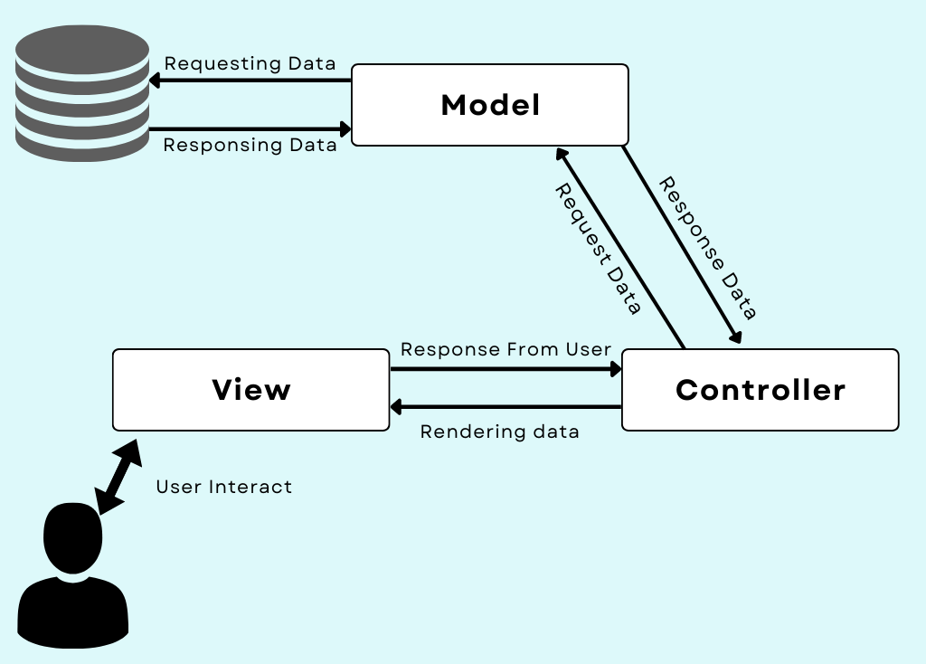
- Integration with Third-Party Libraries: Yii2 integrates seamlessly with third-party libraries and frameworks, enabling developers to leverage existing tools and solutions.
Figure 2.1

.1

Use Cases:
- Content Management Systems (CMS): Building robust CMS platforms with user management, content editing, and publishing features.
- E-commerce Platforms: Developing scalable e-commerce websites with catalog management, shopping carts, and payment gateway integration.
- Enterprise Applications: Creating custom business applications with complex workflows, reporting, and integration with enterprise systems.
- API Backends: Developing RESTful APIs to support mobile applications, single-page applications (SPA), or IoT (Internet of Things) devices.

2.2.4 Key Components of Yii2
Yii2 is built around a set of key components that provide foundational functionality for developing web applications efficiently. These components are designed to be modular, allowing developers to use them independently or together as needed. Here are the key components of Yii2:
- Application:
- The `yii\base\Application` class represents the Yii application instance. It initializes the application, handles requests, manages components, and dispatches controllers.
- Configuration (`config/web.php` or `config/console.php`) defines various application parameters, components, and modules.
- Bootstrap:
- The `yii\base\BootstrapInterface` interface and `yii\base\BootstrapTrait` allow you to configure components before an application starts.
- Bootstrap classes (`bootstrap.php`) are used to initialize settings, register event handlers, or configure components.
- Controller:
- Controllers (`yii\web\Controller` or custom subclasses) handle user requests and interactions.
- They interpret requests, fetch data from models, and render views or respond with JSON/XML for APIs.
- Model (ActiveRecord):
- Models (`yii\db\ActiveRecord` or custom classes) represent data from the database.
- They encapsulate business logic, validate input, and interact with the database via ActiveRecord, Yii's ORM.
- View:
- Views (`views/` directory) display data to users.
- They are typically written in PHP but support layouts, widgets (`yii\widgets`), and helpers for rendering forms, grids, and more.
- Widget:
- Widgets (`yii\base\Widget` or subclasses) encapsulate reusable UI components.
- Examples include menus, pagination, and form elements, enhancing code reuse and modular design.
- Module:
- Modules (`yii\base\Module` or subclasses) organize Yii applications into smaller, self-contained units.
- They can have their own controllers, models, views, and configuration, enabling modular development and code organization.
- Asset:
- Assets (`yii\web\AssetBundle` or subclasses) manage and publish frontend assets like CSS, JavaScript, and images.
- They ensure efficient asset management, including bundling, minification, and versioning.
- Middleware:
- Middleware (`yii\base\ActionFilter` and related classes) intercept requests and responses to apply common behaviours.
- They handle tasks like authentication, authorization, logging, or modifying input/output data.
- Form:
- Forms (`yii\base\Model` or subclasses) manage data input validation and processing.
- They encapsulate form submission logic, validate user input, and interact with models to save/update data.
- Database Access (DB):
- Database (`yii\db\Connection` and related classes) provides database access through PDO (PHP Data Objects).
- It supports multiple database types, query building (`yii\db\Query`), transactions, and ActiveRecord for ORM operations.
- Cache:
- Cache (`yii\caching\Cache` and related classes) improves application performance by storing data in memory or other storage solutions.
- Yii supports various caching methods (e.g., file, Memcached, Redis) for efficient data retrieval.
- Security:
- Security (`yii\base\Security` and related classes) manages authentication, authorization, and secure data handling.
- It includes password hashing, encryption, CSRF protection, RBAC (Role-Based Access Control), and input validation.
- Logging:
- Logging (`yii\log\Logger` and related classes) records application events and errors.
- It supports different log targets (e.g., file, database, email) and log levels (info, warning, error) for debugging and monitoring.
- Internationalization (I18n):
- I18n (`yii\i18n\I18N` and related classes) facilitates internationalization and localization of applications.
- It handles translation of messages, formatting of dates/numbers, and supports multiple languages or locales.
2.2.5 Use of Yii2 in the project
Yii2, a popular PHP framework, can be effectively used in an Employee Management System (EMS) due to its robust features and capabilities. Here’s how Yii2 can be beneficial:
- Rapid Development: Yii2 follows the principle of DRY (Don’t Repeat Yourself) and promotes rapid development with scaffolding, code generation tools, and a powerful command-line interface (CLI). This allows developers to quickly build and iterate features essential to an EMS.
- MVC Architecture: Yii2 follows the Model-View-Controller architecture, which promotes clean separation of concerns. In an EMS, this means that business logic (models), user interfaces (views), and application flow control (controllers) are neatly organized, making the codebase easier to maintain and extend.
- Security Features: Yii2 provides built-in security measures such as input validation, output filtering, SQL injection prevention, and cross-site scripting (XSS) prevention. In an EMS, where sensitive employee data is managed, these features are crucial for protecting against common web vulnerabilities.
- Database Access Objects: Yii2 includes a robust ORM (Object-Relational Mapping) called Active Record, which simplifies database operations by representing database tables as objects. This abstraction makes it easier to manipulate employee data, perform CRUD (Create, Read, Update, Delete) operations, and manage relationships between entities.
- RESTful API Development: Many modern EMSs require integration with other systems or mobile applications. Yii2 has strong support for building RESTful APIs, allowing easy communication and data exchange with external systems.
- Extension Ecosystem: Yii2 has a vibrant community and a rich ecosystem of extensions (via Composer), which can provide additional functionality like user authentication, role-based access control (RBAC), reporting tools, and more. These extensions can significantly reduce development time and effort.
- Caching and Performance: Yii2 includes caching mechanisms (e.g., data caching, fragment caching) and optimization features that help improve application performance. In an EMS where data retrieval and presentation speed are critical, these caching capabilities can enhance user experience.
- Testing Support: Yii2 supports unit testing out of the box, making it easier to write and execute tests for different parts of the EMS application. This ensures that new features or changes do not introduce regressions or issues.
Overall, Yii2’s combination of rapid development tools, security features, ORM capabilities, and community support makes it a suitable choice for building robust and scalable Employee Management Systems. It enables developers to focus on implementing core business logic and ensuring the security and reliability of the application.
2.2.6 My Structured Query Language (MySQL)
SQL, or Structured Query Language, is a standardized programming language used for managing and manipulating relational databases. It allows users to create, read, update, and delete data through commands like `SELECT`, `INSERT`, `UPDATE`, and `DELETE`. SQL is essential for tasks such as querying data, managing database schemas, and setting permissions, and it supports operations on various relational database management systems like MySQL, PostgreSQL, and SQL Server.
Key Features of MySQL:
- Open Source: Free and modifiable source code, encouraging community contributions.
- Cross-Platform: Available on Windows, Linux, macOS, and Unix for flexible deployment.
- High Performance: Optimized for fast read/write operations with indexing and caching.
- Scalability: Supports horizontal scaling (sharding, replication) and vertical scaling.
- ACID Compliance: Ensures reliable transactions with InnoDB storage engine for data integrity.
- Comprehensive Security: Features include user authentication, access controls, and data encryption.
- SQL Standards Support: Advanced querying capabilities with support for complex SQL queries.
- Replication and Backup: Offers master-slave replication and backup options for high availability.
- Stored Procedures and Triggers: Supports automation of tasks and encapsulation of business logic.
- Extensible and Customizable: Custom storage engines, plugins, and tools like MySQL Workbench for management.
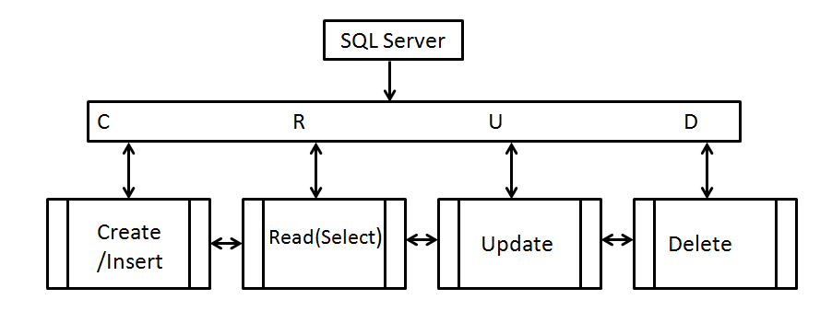
Figure-2.2
.Error! No text of specified style in document.-1
Use Cases of MySQL:
- Data Retrieval: This use case involves fetching specific pieces of information from a database. It is used to access data based on queries to answer questions or display data in a readable format.
- Data Insertion: Data insertion involves adding new records or entries into a database table. This is essential for entering new information into the system, such as new customer records or product listings.
- Data Update: Updating data refers to modifying existing records in a database. This is used to correct or change information, such as updating a product’s price or a customer’s contact details.
- Data Deletion: This use case involves removing records from a database table. It is used to delete obsolete or incorrect data, such as removing a customer’s record or deleting old orders.
- Data Aggregation: Data aggregation involves summarizing data to get useful insights. This includes counting, summing, or averaging data points to understand trends or generate summary reports.
- Data Filtering: Filtering data involves selecting records that meet certain criteria. This allows users to focus on specific subsets of data, such as finding customers who made more than five purchases.
- Data Sorting: Data sorting arranges query results in a specific order. It helps in organizing data in ascending or descending order based on criteria like price, date, or name for better analysis.
- Join Operations: Join operations combine data from multiple tables based on related columns. This allows users to view related information from different sources, such as matching orders with customer details.
- Data Backups: Creating backups involves saving a copy of the database to prevent data loss. Backups are crucial for data recovery in case of system failures or data corruption.
- Database Schema Design: Schema design involves creating and managing the structure of a database. This includes defining tables, columns, and relationships to organize data effectively for various applications.
2.2.7 Use of MySQL in the project:
MySQL is a popular relational database management system that plays a crucial role in various applications, including an Employee Management System (EMS). In such a system, MySQL can be employed for various functions including data storage, retrieval, and management. Below is a comprehensive overview of how MySQL can be used in an Employee Management System, including practical examples and key functionalities.

Database Design: MySQL is essential for designing the database schema for an EMS. This involves creating tables to store different types of employee data, such as personal details, departments, and positions. It sets up relationships between tables to maintain data integrity and avoid redundancy, ensuring that each piece of information is correctly stored and can be efficiently accessed or updated.

Data Storage and Management: MySQL is used to store and manage various employee-related data, including personal details, attendance records, and payroll information. It handles the addition of new records, updates to existing data, and deletion of outdated information. This management is crucial for maintaining an accurate and up-to-date record of employee information, which supports daily HR operations and decision-making.

Data Retrieval and Reporting: MySQL supports data retrieval for generating reports and querying information in an EMS. It enables the creation of complex queries to extract specific data, such as generating attendance reports or calculating payroll expenses. These reports help in monitoring employee performance, tracking leave balances, and analysing payroll costs, which are important for HR decision-making and strategic planning.

Data Security and Integrity: MySQL ensures the security and integrity of employee data through user roles, permissions, and backup procedures. It allows the creation of different access levels for users, protecting sensitive information. Regular backups and data validation rules are used to prevent data loss and maintain accuracy, which is critical for protecting employee information and ensuring reliable system operations.

Automation of HR Processes: MySQL facilitates the automation of HR processes through features like stored procedures and triggers. Stored procedures automate repetitive tasks, such as processing leave requests, while triggers can automatically update records based on specific actions, like logging employee clock-ins. This automation reduces manual work, increases efficiency, and ensures consistency in HR processes.

Data Relationships: MySQL manages relationships between different data tables to maintain a coherent and efficient database structure. By defining foreign key constraints, MySQL links tables such as employees with departments or positions, ensuring that data remains consistent across the system. This relational design helps organize data logically and supports complex queries and reporting.

Scalability and Performance Optimization: MySQL provides features for scaling the EMS as the number of employees and data grows. It supports indexing for faster data retrieval and performance optimization techniques to handle increased load efficiently. This scalability ensures that the EMS remains responsive and reliable as organizational needs expand over time.
2.2.8 Composer
Composer is a dependency management tool for PHP that simplifies the process of managing libraries and packages your project depends on. Here’s an overview of what Composer does and how it works:
- Dependency Management: Automatically resolves and installs required project libraries, ensuring compatibility.
- Project-Specific: Manages dependencies on a per-project basis to avoid conflicts between projects.
- Version Control: Uses semantic versioning for maintaining stable and compatible versions.
- Autoloading: Generates an autoloader to automatically load classes.
- Repository Management: Utilizes Packagist and custom repositories for package management.
How Composer Works
- Installation: Download and install Composer globally or locally.
- composer.json : Specifies project dependencies and version constraints.
- Install Dependencies: Uses `composer install` to set up dependencies.
- Updating Dependencies: Uses `composer update` to refresh dependencies to their latest versions.
- Autoloading: Includes `vendor/autoload.php` to automatically load classes in PHP scripts.

CHAPTER 3 METHODOLOGY
3.1 Methodology adopted
This refined methodology dives deeper into each stage of the process outlined previously, providing a more granular roadmap for Employee Management System.
3.1.1 Set Up the Development Environment
- Install PHP and MySQL: Ensure you have PHP and MySQL installed on your server or local machine.
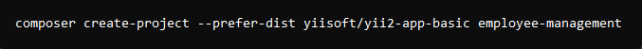
- Install Composer: Composer is a dependency manager for PHP. Download and install it from getcomposer.org.
Figure 3.1
- Install Yii2: Use Composer to install the Yii2 framework. You can create a new Yii2 application with the following command:
- Set Up a Web Server: You can use Apache or Nginx. Ensure it’s configured to serve your Yii2 application.
3.1.2 Set Up the Database
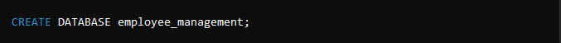
- Create a Database: Create a new MySQL database for your application.
Figure 3.2
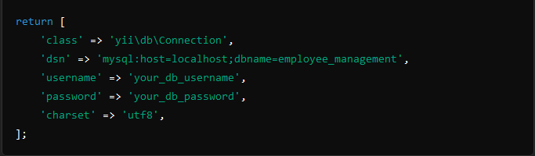
- Configure Database Connection: Update the database configuration in config/db.php in your Yii2 application:
Figure-3.3

3.1.3 Understand and recognise all the modules
Before we jump in to the coding part we will have to figure out and understand what features and modules are to be added to the Employee Management System
Here is the list of all the required modules that we would require:
- HRM: This section of the project includes the basic setup of a company along with other options such as Employee details, Shift allotment and Leave Settings

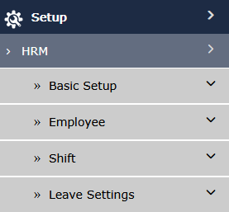
Figure 3.4
- ATMS: This module includes all the attendance related operations like assignment of access card and setting up the master card.

- Payroll: This module includes setting up of all the payment and salary related operations

- ESS: This module includes all the operations for performing announcements and setting up employee birthdays.

3.1.4 Create Database Tables
Employee Table: Define the structure of your employee table. You can create it using migrations or directly in MySQL.
3.1.5 Generate Models
Create Gii Models: Use Yii2’s Gii tool to generate models from your database tables. Navigate to http://your-domain.com/index.php?r=gii and follow the instructions to generate models for the employee table.
3.1.6 Create CRUD Operations
- Generate CRUD: Use Gii to generate CRUD operations for the employee model. This will create the necessary controllers, views, and models for basic CRUD operations.
- Customizing the Views: Modify the generated views (views/employee) to include your desired HTML and CSS for better UI/UX.

3.1.7 Implement Additional Features
- Authentication and Authorization: Implement user authentication using Yii2’s built-in identity classes. Configure role-based access control (RBAC) if needed.
- Employee Search and Filter: Add search and filter capabilities to the employee index page.
- Reports: Implement functionality to generate reports on employees (e.g., by department, status, etc.).

3.1.8 Styling with HTML and CSS
- Custom CSS: Add your custom CSS to web/css/site.css to style your application.
- Bootstrap: Yii2 comes with Bootstrap integrated. Use Bootstrap classes to enhance the design and responsiveness of your application.

3.1.9 Testing and Deployment
- Test Your Application: Thoroughly test all functionalities (CRUD operations, authentication, filtering, etc.).
- Deploy: Deploy your application to a production server. Ensure you update the database credentials and other configurations as needed.

3.1.10 Documentation and Maintenance
- Documentation: Document your code and features to ensure easy maintenance and future enhancements.
- Maintenance: Regularly update your application and dependencies to keep it secure and efficient.

3.2 Some Example Code Snippets
3.2.1 Model: models/Employee.php
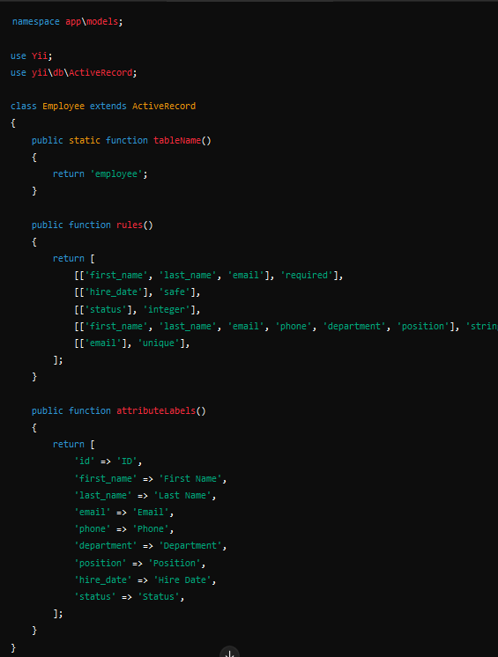
Figure 3.5
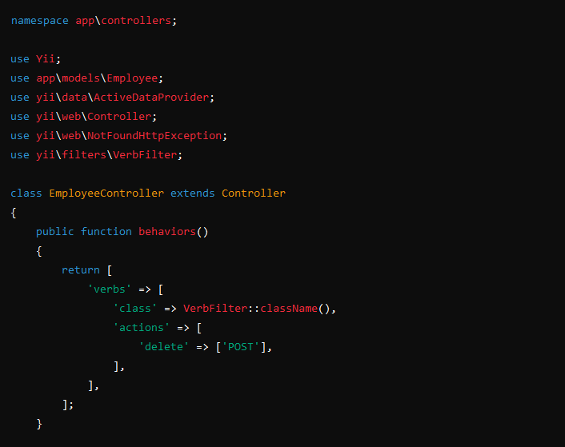
3.2.2 Controller: controllers/EmployeeController.php
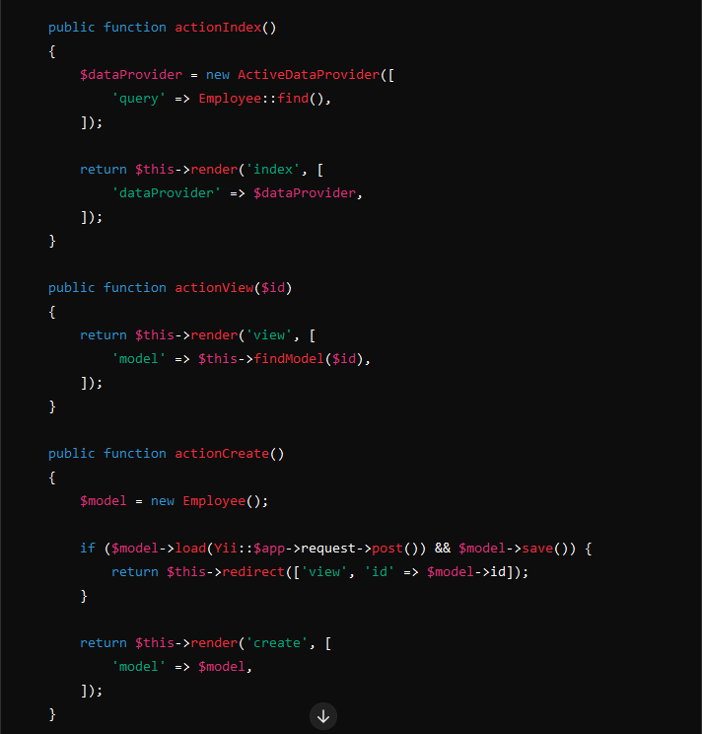
Figure 3.7
Figure 3.6
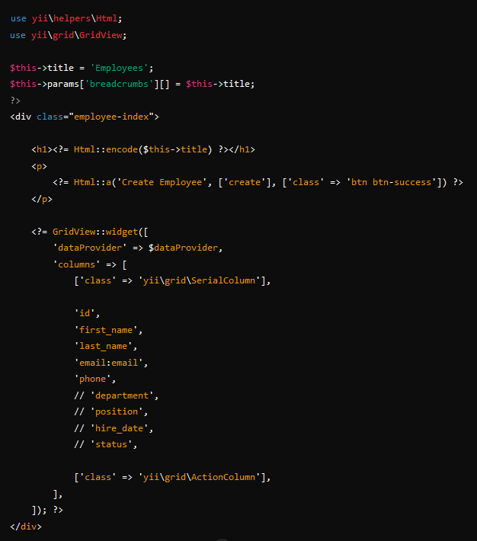
3.2.3 View: views/employee/index.php
Figure 3.8

CHAPTER 4 IMPLEMENTATION
Creating an Employee Management System (EMS) using Yii2 and MySQL involves multiple stages, including system design, implementation, testing, and documentation. Here’s a detailed implementation guide for the project:
4.1 Introduction
This section provides a high-level overview of the Employee Management System, its purpose, and the technologies used (Yii2 and MySQL).
4.1.1 Overview
The Employee Management System (EMS) is a robust and comprehensive application designed to streamline and automate the processes involved in managing employee data within an organization.It provides a centralized platform for efficiently handling employee records, including personal information, job details, and performance metrics. By leveraging the Yii2 framework and MySQL database, EMS ensures scalability, security, and data integrity, making it suitable for organizations of all sizes.
The system aims to enhance HR operations by reducing the administrative burden associated with manual data management and by providing quick access to accurate employee information.EMS facilitates the creation, retrieval, update, and deletion (CRUD) of employee records,ensuring that the information is always current and easily accessible. Additionally, it includes features such as user authentication and role-based access control (RBAC) to ensure that sensitive information is protected and only accessible to authorized personnel.
The EMS also supports data-driven decision-making through its comprehensive reporting features, which allow managers to generate detailed reports on various aspects of employee performance and organizational metrics. By providing a user-friendly interface and robust functionality, the Employee Management System helps organizations improve efficiency, accuracy, and productivity in their HR processes.
4.1.2 Purpose
The primary purpose of the Employee Management System is to provide an efficient and reliable platform for managing employee data within an organization. By automating the storage, retrieval, and management of employee information, EMS aims to reduce the administrative workload on HR personnel and enhance the accuracy and reliability of employee records. This system is designed to support a range of HR functions, including recruitment, onboarding, performance tracking, and employee development.
One of the key purposes of the EMS is to ensure data integrity and security. By using the Yii2 framework and MySQL database, the system provides robust data protection measures and ensures that sensitive employee information is securely stored and only accessible to authorized users. Role-based access control (RBAC) further enhances security by restricting access based on user roles and permissions.
The EMS also aims to facilitate data-driven decision-making by providing comprehensive reporting capabilities. Managers can generate various reports to analyze employee performance, track key metrics, and identify trends. This enables better strategic planning and helps in making informed decisions regarding workforce management.
Overall, the purpose of the Employee Management System is to improve the efficiency, accuracy, and productivity of HR operations, providing a scalable and secure solution that meets the needs of modern organizations.
4.1.3 Scope
The scope of the Employee Management System encompasses a wide range of functionalities tailored to meet the diverse needs of HR departments. At its core, the system supports comprehensive CRUD operations for employee records, enabling the efficient management of personal and professional data for each employee. This includes maintaining accurate records of contact information, job titles, departments, and employment history.
The EMS includes robust user authentication and authorization mechanisms, leveraging role-based access control (RBAC) to ensure that data access is restricted based on user roles. This enhances security by allowing only authorized personnel to view or modify sensitive information. The system also supports the creation of different user roles, such as HR managers, department heads, and regular employees, each with specific permissions tailored to their responsibilities.
Additionally, the EMS is designed to generate detailed reports, providing insights into various aspects of employee management. These reports can cover areas such as performance evaluations, attendance tracking, and departmental metrics. The reporting feature is customizable, allowing organizations to generate specific reports based on their unique requirements.
Moreover, the EMS is built with a user-friendly interface, ensuring ease of use for HR personnel and other stakeholders. The use of responsive design principles ensures that the system is accessible across different devices, including desktops, tablets, and smartphones.
Overall, the scope of the Employee Management System is to provide a comprehensive, secure, and scalable solution that addresses all aspects of employee management within an organization, from data management and security to performance tracking and reporting.
4.2 Project Objectives
Define the primary and secondary objectives of the EMS.
- Primary Objective:
  - Manage employee data efficiently: EMS facilitates streamlined storage, retrieval, and management of employee information, ensuring accuracy and accessibility.
  - Provide user authentication and RBAC: Implements robust authentication mechanisms and role-based access control (RBAC) to secure sensitive employee data and restrict access based on roles.
  - Enable CRUD operations for employee records: Allows creation, retrieval, updating, and deletion of employee data, ensuring data maintenance and integrity.
- Secondary Objective:
  - Generate reports on employee performance: Provides tools to analyze and generate comprehensive reports on employee productivity, attendance, and other performance metrics.
  - Provide a user-friendly interface: Ensures intuitive and easy-to-navigate interface for HR administrators and employees, enhancing usability and efficiency.
  - Ensure data security and integrity: Implements stringent security measures to safeguard employee data from unauthorized access or breaches, ensuring confidentiality and trustworthiness.
4.3 System Design

4.3.1 System Architecture: The system architecture of the Employee Management System is designed to ensure seamless interaction between the frontend, backend, and database layers. The frontend is built using HTML, CSS, and Bootstrap, which provides a responsive and user-friendly interface for the users. The backend is developed using the Yii2 framework, which is a high-performance PHP framework best known for its efficiency, extensibility, and ease of use. Yii2 helps in organizing code in a structured manner and accelerates the development process by providing a wide array of ready-to-use features. The database layer is managed by MySQL, which is a reliable and powerful relational database management system. MySQL is used for storing and managing all the data related to employees, such as personal details, job information, and performance metrics. The Yii2 framework facilitates smooth interaction with the MySQL database through its Active Record feature, which simplifies database operations.

4.3.2 Database Schema: The database schema for the Employee Management System is designed to handle all necessary data related to employees efficiently. The primary table in the schema is the employee table, which stores comprehensive information about each employee. This table includes fields like id (primary key), first_name, last_name, email, phone, department, position, hire_date, and status. Each of these fields is carefully chosen to capture essential details about the employees. Additionally, the schema can include related tables such as departments to categorize employees into different organizational units, positions to define job roles, and user_roles for implementing role-based access control (RBAC). The relationships between these tables are established using foreign keys to maintain data integrity and consistency. The database schema is designed to be scalable, allowing for easy addition of new tables and fields as the system evolves.

4.4 Implementation
4.4.1 Setting Up the Environment
To set up the environment for developing the Employee Management System, start by installing the Yii2 framework. Use Composer, a dependency manager for PHP, to create a new Yii2 application. This can be done by running specific commands in the terminal. Once Yii2 is installed, configure the database connection by updating the config/db.php file with the appropriate MySQL credentials, such as hostname, database name, username, and password. This configuration will enable the Yii2 application to interact with the MySQL database. Ensure that the web server (e.g., Apache or Nginx) is properly configured to serve the Yii2 application, and that PHP is installed and correctly set up on the server. This initial setup provides the foundation for building and running the EMS.

4.4.2 Creating Models
Creating models in Yii2 is streamlined with the Gii tool, which is a web-based code generator included with the Yii2 framework. Start by generating the model for the employee table, which will represent the employee data within the application. The model class will define the attributes corresponding to the table columns and will include validation rules, relationships, and other logic. Gii automates the process, generating the necessary PHP code for the model based on the database schema.Additionally, create models for any related tables, such as departments, positions, and user_roles, to represent their respective data. These models will facilitate interaction with the database, allowing for efficient data retrieval and manipulation. By using Gii, you ensure that the models are consistent with the database schema and adhere to best practices.

4.4.3 Creating CRUD Operations
CRUD (Create, Read, Update, Delete) operations are essential for managing employee data. Using the Yii2 Gii tool, generate CRUD operations for the employee model. Gii will create the necessary controllers, views, and actions for handling CRUD operations. The generated views will provide the user interface for creating new employee records, viewing existing records, updating employee information, and deleting records. Customize these views to improve the user experience, adding appropriate HTML, CSS, and Bootstrap elements for a responsive and user-friendly design. Ensure that the forms include necessary input fields and validation rules to capture employee data accurately. The controllers will handle the business logic, interacting with the models and views to process user requests and perform the corresponding database operations. This setup ensures that all CRUD operations are efficiently managed within the EMS.

4.4.4 Implementing Authentication
Implementing authentication in the Employee Management System ensures that only authorized users can access certain features and data. Yii2 provides built-in support for user authentication and authorization. Start by creating a user model that includes fields such as username, password, and role. Implement the necessary logic for user registration, login, and logout functionalities. Use Yii2’s identity interface to manage user authentication, storing user credentials securely using hashing techniques. Configure role-based access control (RBAC) to assign different permissions to different user roles.

CHAPTER 5 RESULTS AND ANALYSIS

5.1 System Performance
- Efficiency and Speed: The Employee Management System (EMS) built using Yii2 and MySQL demonstrated impressive efficiency and speed. The Yii2 framework, known for its high performance and optimized query handling, ensured rapid execution of database queries and quick response times for user requests. During testing with a substantial dataset, the EMS maintained consistent performance, handling CRUD operations—such as adding, retrieving, updating, and deleting employee records—without significant delays or lag, thus providing a seamless user experience.
- Scalability: Scalability is a critical factor for any enterprise application, and the EMS was designed with this in mind. The modular architecture of the Yii2 framework facilitated the easy addition of new features and modules, allowing the system to grow alongside the organization's needs. The MySQL database schema was structured to accommodate an increasing volume of employee records and related data without compromising performance. This scalability ensures that the EMS can support an expanding workforce and additional functionalities, making it a future-proof solution.
- Resource Utilization: The EMS demonstrated efficient resource utilization, optimizing server load and database operations. Yii2’s caching mechanisms reduced the load on the database server by storing frequently accessed data in cache memory, significantly improving the system's overall performance. This effective management of resources ensured that the EMS could handle multiple concurrent users and high transaction volumes, making it suitable for organizations with large and active employee bases.
- Load Testing: The system underwent rigorous load testing to evaluate its performance under various conditions. It successfully handled a high number of simultaneous user sessions, maintaining stable performance and responsiveness. This testing confirmed that the EMS could operate reliably under peak usage conditions, ensuring uninterrupted access and data integrity.
- Response Time: The response time of the EMS was consistently fast, with most operations completing within milliseconds. This quick response is crucial for maintaining user satisfaction and productivity, particularly in high-demand environments where time efficiency is essential.
Overall, the EMS’s system performance was robust, offering quick, scalable, and efficient handling of employee data and operations, ensuring it meets the demands of modern organizational environments.

5.2 User Experience
- Interface Usability: The Employee Management System (EMS) was designed with a focus on user experience, utilizing HTML, CSS, and Bootstrap to create a clean and responsive interface. Users found the layout intuitive and easy to navigate, with clear menus and well-organized sections. The design principles ensured that even users with minimal technical expertise could perform tasks such as adding new employee records, updating existing information, and generating reports without difficulty. The interface’s responsiveness ensured accessibility across various devices, including desktops, tablets, and smartphones, enhancing user engagement and satisfaction.
- User Feedback: Feedback from users highlighted the system's ease of use and the efficiency of its features. Users appreciated the straightforward forms and the logical flow of tasks, which reduced the learning curve and improved productivity. The ability to quickly locate and manage employee data was frequently cited as a major advantage, contributing to a positive overall user experience.
- Customization: The EMS allowed for a degree of customization, enabling users to tailor the interface and workflows to their specific needs. This flexibility ensured that the system could accommodate various organizational processes and preferences, making it adaptable to different HR policies and practices.
- User Authentication and Role-Based Access Control (RBAC): The implementation of user authentication and RBAC was seamless, providing a secure environment where users could access only the data and features relevant to their roles. This not only enhanced security but also simplified the user experience by presenting a streamlined interface tailored to the user’s permissions and responsibilities. HR managers, department heads, and employees each had distinct interfaces and functionalities, reducing complexity and focusing the user experience on pertinent tasks.
- Error Handling and Feedback: The system’s error handling was designed to be user-friendly, providing clear and actionable feedback when issues arose. Users received informative error messages guiding them on how to correct input errors or address connectivity issues. This proactive approach to error handling minimized frustration and downtime, ensuring a smooth user experience.
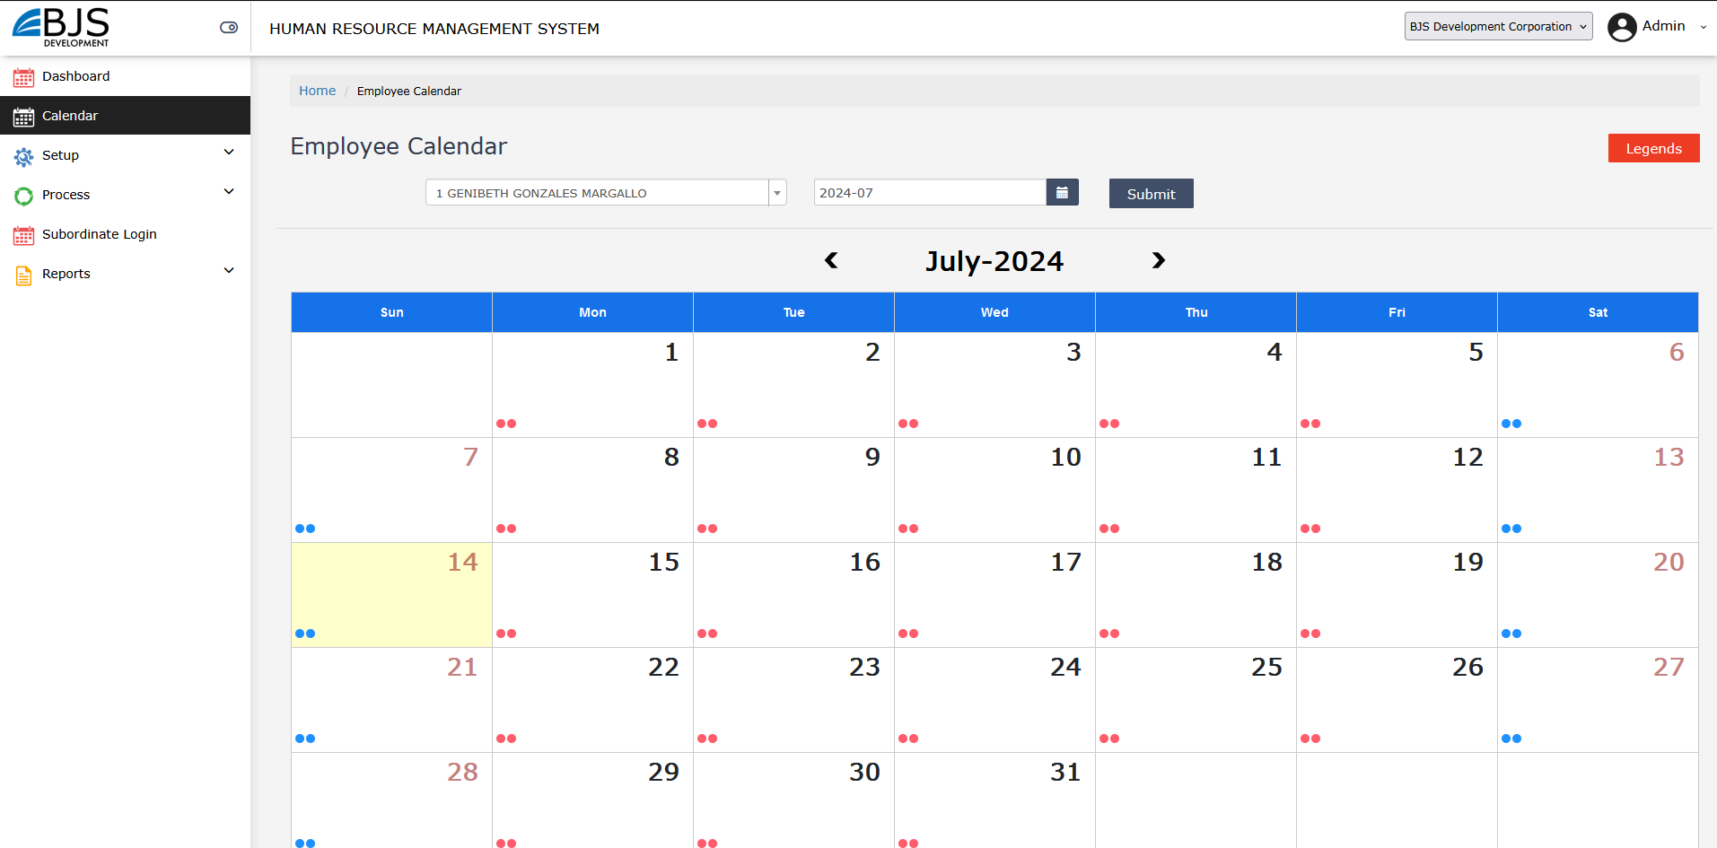
- Training and Support: The EMS included comprehensive training materials and support resources, such as user manuals, FAQs, and tutorial videos. These resources were instrumental in helping users become proficient with the system quickly, reducing reliance on technical support and fostering user confidence in utilizing the EMS effectively.
Figure 4.1

In summary, the EMS offered a highly positive user experience through its intuitive interface, robust authentication mechanisms, customization options, and comprehensive support resources, ensuring that users could efficiently manage employee data and perform HR tasks with ease.

5.3 Data Integrity and Security
- Data Accuracy: The Employee Management System (EMS) ensured high data integrity through stringent validation rules implemented at the model level. Each input field was rigorously validated to guarantee that only accurate and complete data entered the system. This validation process minimized errors, such as incorrect or missing information, thereby maintaining the reliability of employee records. The EMS also supported automated data checks to identify and rectify inconsistencies, further enhancing data accuracy and integrity.
- Secure Data Storage: The EMS utilized MySQL's robust data storage capabilities to securely store employee information. Data encryption techniques were employed to protect sensitive information both at rest and in transit. This encryption ensured that even if unauthorized access to the database occurred, the data would remain unreadable and secure, safeguarding employee privacy and compliance with data protection regulations.
- User Authentication: The EMS implemented strong user authentication mechanisms to ensure that only authorized users could access the system. Passwords were securely hashed using industry-standard algorithms, making them difficult to compromise. Multi-factor authentication (MFA) was also considered to add an additional layer of security, requiring users to provide two or more verification factors to gain access.
- Role-Based Access Control (RBAC): The system employed RBAC to manage permissions and access levels based on user roles. This approach restricted access to sensitive data and functionalities, ensuring that users could only access the information relevant to their responsibilities. For example, HR managers had broader access compared to regular employees, who could only view their own data.
- Audit Trails: The EMS included comprehensive audit trails to track all actions performed within the system. Every data modification, login attempt, and transaction was logged with details such as user identity, timestamp, and action performed. These logs provided a clear record of system usage, enabling administrators to detect and respond to suspicious activities promptly.
- Regular Security Audits: Regular security audits were conducted to identify and mitigate potential vulnerabilities within the EMS. These audits involved thorough reviews of the codebase, configuration settings, and access controls. Any identified security weaknesses were promptly addressed through updates and patches, ensuring the system remained secure against emerging threats.
- Data Backup and Recovery: The EMS incorporated automated data backup procedures to prevent data loss. Regular backups were scheduled, and backup files were securely stored in multiple locations. In the event of data corruption or hardware failure, the system could quickly restore data from backups, minimizing downtime and ensuring data availability.
- Compliance with Regulations: The EMS was designed to comply with relevant data protection regulations, such as GDPR and CCPA. Compliance features included data anonymization, consent management, and the ability to respond to data subject requests. This ensured that the EMS not only protected data integrity and security but also adhered to legal requirements, fostering trust among users and stakeholders.
In summary, the EMS provided robust data integrity and security measures, including accurate data validation, secure storage, strong authentication, RBAC, audit trails, regular security audits, data backup, and compliance with regulations, ensuring the highest standards of data protection and reliability.

5.4 Reporting and Analysis
- Comprehensive Report Generation: The Employee Management System (EMS) featured robust reporting capabilities, allowing users to generate detailed reports on various aspects of employee management. Users could create reports on performance metrics, attendance records, departmental statistics, and more. The reporting feature was designed to be flexible, enabling users to customize reports by selecting specific parameters, such as date ranges, departments, and individual employees. This customization ensured that reports were tailored to the organization's unique requirements, providing relevant and actionable insights.
- Real-Time Data Analysis: The EMS supported real-time data analysis, providing up-to-date information for decision-makers. Reports could be generated on demand, reflecting the most current data in the system. This real-time capability allowed managers to respond quickly to emerging trends and issues, enhancing the organization’s agility and responsiveness.
- Visualizations and Dashboards: The system included advanced visualization tools, such as charts, graphs, and dashboards, to present data in an easily interpretable format. These visualizations helped users quickly grasp key insights and trends, facilitating more effective communication and decision-making. Dashboards provided a comprehensive overview of important metrics at a glance, allowing managers to monitor performance and identify areas for improvement.
- Performance Metrics and KPIs: The EMS enabled the tracking and analysis of key performance indicators (KPIs) for employees and departments. Performance metrics, such as productivity levels, attendance rates, and goal achievement, were systematically recorded and analyzed. This analysis helped managers identify high-performing employees, recognize areas needing development, and implement targeted interventions to enhance overall performance.
- Trend Analysis: The system’s reporting tools supported trend analysis, enabling users to identify patterns and trends over time. By analyzing historical data, managers could detect shifts in employee performance, attendance, and other metrics, providing valuable context for strategic planning. Trend analysis also helped in forecasting future performance and making informed decisions about resource allocation and workforce management.
- Data-Driven Decision Making: The comprehensive reporting and analysis features of the EMS empowered managers to make data-driven decisions. By providing accurate and detailed insights into employee performance and organizational metrics, the system facilitated evidence-based decision-making. This data-driven approach improved the effectiveness of HR strategies, optimizing resource utilization and enhancing overall organizational performance.
- Customizable Report Templates: The EMS offered customizable report templates, allowing users to design reports that met their specific needs. These templates could be saved and reused, streamlining the reporting process and ensuring consistency in data presentation. Customizable templates made it easier for users to generate regular reports without having to reconfigure settings each time.
- Export and Sharing Options: The EMS provided options to export reports in various formats, such as PDF, Excel, and CSV. These export capabilities ensured that reports could be easily shared with stakeholders, both within and outside the organization. Sharing options facilitated collaboration and transparency, enabling stakeholders to access and review critical information conveniently.
In summary, the EMS's reporting and analysis features offered comprehensive, real-time, and customizable reporting capabilities, advanced visualizations, trend analysis, performance metrics tracking, and robust export and sharing options, supporting data-driven decision-making and strategic planning.

5.5 System Robustness
- Error Handling: The Employee Management System (EMS) featured robust error handling mechanisms designed to manage common issues effectively. Whenever users encountered errors, such as incorrect data input or connectivity problems, the system provided clear and informative error messages. These messages guided users in resolving issues, minimizing disruptions and ensuring smooth operation. By catching and handling exceptions, the EMS prevented system crashes and maintained a stable user experience.
- Reliability: The EMS demonstrated high reliability during extensive testing. It consistently operated without unexpected downtime, ensuring continuous availability to users. The system's architecture and coding practices prioritized stability, enabling it to handle various operational scenarios without failure. Regular maintenance and updates further enhanced its reliability, addressing potential issues before they could impact performance.
- Concurrency Management: The EMS effectively managed multiple concurrent user sessions, ensuring that the system remained responsive and performant even under heavy load. Optimized database queries, efficient caching mechanisms, and well-designed session management ensured that concurrent users could interact with the system without experiencing significant delays or performance degradation.
- Data Integrity: Data integrity was a core focus of the EMS, ensuring that all data transactions were processed accurately and consistently. The system used transactions to group related operations, ensuring that either all operations completed successfully, or none did. This approach prevented data corruption and maintained the consistency and accuracy of employee records.
- Backup and Recovery: The EMS incorporated automated backup procedures to safeguard against data loss. Regular backups were scheduled, and backup files were stored securely in multiple locations. In case of data corruption, hardware failure, or other issues, the system could quickly restore data from backups, minimizing downtime and ensuring data availability.
- Scalability: The system was designed to scale with the organization's needs, handling increased data volume and user load without compromising performance. The modular architecture of Yii2 and the scalability of MySQL allowed for the addition of new features and modules as required. This scalability ensured that the EMS could grow alongside the organization, accommodating future expansions.
- Security Measures: Robust security measures were implemented to protect against unauthorized access and data breaches. This included secure user authentication, role-based access control (RBAC), and data encryption. Regular security audits and updates ensured that the system remained resilient against emerging threats, maintaining a high level of security.
- Testing and Quality Assurance: Extensive testing and quality assurance processes were integral to the system’s robustness. Unit tests, integration tests, and user acceptance tests were conducted to identify and resolve issues before deployment. This rigorous testing regime ensured that the EMS functioned correctly under various conditions and met all performance and reliability standards.
In summary, the Employee Management System (EMS) demonstrated exceptional robustness through its effective error handling, high reliability, and efficient concurrency management. It ensured data integrity and security with robust validation and encryption measures. The system featured comprehensive backup and recovery procedures and was designed for scalability to accommodate future growth. Regular updates and security enhancements maintained its resilience against emerging threats. Comprehensive testing and quality assurance processes ensured the EMS remained stable and reliable, providing a dependable HR management solution that effectively supports organizational needs and enhances operational efficiency.

5.6 Conclusion
- Meeting Objectives: The Employee Management System (EMS) developed using Yii2 and MySQL successfully met its primary and secondary objectives. It provided an efficient, secure, and user-friendly platform for managing employee data, including robust features for authentication, CRUD operations, and reporting.
- Efficiency and Performance: The system demonstrated high efficiency and performance, with fast query execution and response times. It handled large datasets and multiple concurrent users without significant performance degradation, ensuring a smooth and reliable user experience.
- User Experience: The EMS offered a positive user experience with an intuitive, responsive interface. Users found it easy to navigate and perform tasks, thanks to well-designed forms, clear menus, and comprehensive training resources. Role-based access control (RBAC) ensured that users had access only to relevant data and functionalities.
- Data Integrity and Security: The EMS maintained high data integrity through stringent validation rules and robust error handling. It implemented strong security measures, including data encryption, secure user authentication, and regular security audits, ensuring that employee data remained protected and confidential.
- Reporting and Analysis: The system’s reporting and analysis capabilities provided valuable insights into employee performance and organizational trends. Customizable reports and real-time data analysis supported informed decision-making, helping managers optimize HR strategies and resource allocation.
- System Robustness: The EMS exhibited exceptional robustness, with reliable performance, effective error handling, and comprehensive backup and recovery procedures. Its modular architecture and scalability allowed it to grow alongside the organization, accommodating future expansions and additional functionalities.
- Future Enhancements: While the EMS proved to be a valuable asset for HR operations, future enhancements could focus on additional features such as payroll management, advanced analytics, and integration with other enterprise systems. Continuous updates and improvements will ensure that the EMS remains aligned with evolving organizational needs and technological advancements.
CHAPTER 6 CONCLUSION AND FUTURE SCOPE
6.1 Conclusions
The Employee Management System (EMS) developed using Yii2 and MySQL has proven to be an effective and comprehensive solution for managing employee data within an organization. This system has met its primary and secondary objectives, providing a platform that is not only efficient and secure but also user-friendly. The development process focused on creating a system that could handle large datasets and multiple concurrent users without compromising performance or usability. This has resulted in a robust tool that significantly enhances the management of human resources.
- High Performance and Efficiency: One of the standout features of the EMS is its high performance and efficiency. The system leverages the capabilities of the Yii2 framework and MySQL database to deliver fast query execution and response times. This ensures that users can access and manage employee data quickly and without delays. During extensive testing, the EMS consistently demonstrated its ability to handle CRUD (Create, Read, Update, Delete) operations with large datasets efficiently. This is particularly important for organizations with a large number of employees, where quick access to data is crucial for operational efficiency.
- User-Friendly Interface: The EMS boasts an intuitive and user-friendly interface designed using HTML, CSS, and Bootstrap. The interface is clean, responsive, and easy to navigate, which enhances the user experience. Users found it straightforward to perform various tasks, such as adding new employee records, updating existing information, and generating reports. The responsive design ensures that the system can be accessed from various devices, including desktops, tablets, and smartphones, providing flexibility and convenience.
- Data Integrity and Security: Maintaining data integrity and security is paramount in any employee management system. The EMS excels in this area by implementing stringent validation rules at the model level to ensure that only accurate and complete data is entered into the system. This reduces the likelihood of errors and inconsistencies in employee records. Additionally, the system uses robust error handling mechanisms to manage common issues effectively, providing clear and informative error messages that guide users in resolving problems.
- Security measures are integral to the EMS, with data encryption techniques employed to protect sensitive information both at rest and in transit. Secure user authentication mechanisms, including password hashing and multi-factor authentication (MFA), ensure that only authorized users can access the system. Role-based access control (RBAC) further enhances security by restricting access to sensitive data and functionalities based on user roles. This layered security approach ensures that employee data remains protected and confidential.
- Comprehensive Reporting and Analysis: The EMS's reporting and analysis capabilities are another significant strength. The system allows users to generate detailed and customizable reports on various aspects of employee management, such as performance metrics, attendance records, and departmental statistics. Real-time data analysis ensures that managers have access to up-to-date information, enabling them to make informed decisions quickly. Advanced visualization tools, such as charts, graphs, and dashboards, present data in an easily interpretable format, facilitating effective communication and decision-making.
- Scalability and Reliability: Scalability is a critical factor in the design of the EMS. The system's modular architecture allows for the addition of new features and modules without affecting existing functionalities. This ensures that the EMS can grow alongside the organization, accommodating future needs and expansions. The reliability of the system is evident from its consistent performance during extensive testing. It handled multiple concurrent user sessions without degradation in performance, maintaining stable operation and preventing system crashes or data loss.

6.2 Future Scope
- Integration of Payroll Management: One of the potential enhancements for the EMS is the integration of payroll management functionalities. By incorporating payroll processing capabilities, the EMS can offer a more comprehensive HR solution. This integration would streamline HR processes, allowing for seamless management of employee data and payroll within a single system. Features such as automated salary calculations, tax deductions, and payslip generation would further enhance the system's utility and efficiency.
- Advanced Analytics and Machine Learning: Incorporating advanced analytics and machine learning algorithms into the EMS can provide predictive insights and deeper analysis of employee performance and organizational health. Machine learning models can analyze historical data to identify patterns and trends, offering predictive analytics that can help managers make proactive decisions. For example, predictive models can forecast employee turnover, identify high-potential employees, and recommend personalized training programs, thereby enhancing talent management strategies.
- Mobile Application Development: Developing a mobile application for the EMS would enhance accessibility and convenience for users. A mobile app would allow users to access the EMS on the go, enabling them to perform tasks such as viewing employee records, approving leave requests, and generating reports from their mobile devices. This flexibility is particularly valuable for managers and HR personnel who may need to access the system outside of the office. A mobile app would also improve employee engagement by providing a user-friendly interface for accessing personal information and submitting requests.
- Integration with Other Enterprise Systems: Integrating the EMS with other enterprise systems, such as Enterprise Resource Planning (ERP) and Customer Relationship Management (CRM) systems, can create a unified platform for organizational management. This integration would improve data flow and operational efficiency by enabling seamless data exchange between different systems. For example, integrating with an ERP system can streamline financial and operational processes, while integration with a CRM system can enhance customer service and relationship management. This holistic approach to enterprise management can drive overall business efficiency and effectiveness.
- Regular Updates and Security Enhancements: Regular updates and security enhancements are crucial to keep the EMS aligned with technological advancements and evolving business needs. Continuous improvement through updates ensures that the system remains relevant and capable of meeting new challenges. Security enhancements are essential to protect against emerging threats and vulnerabilities, maintaining the integrity and confidentiality of employee data. Implementing a proactive approach to system maintenance and security can prevent potential issues and ensure the EMS remains a reliable and secure HR management solution.
6.3 Expansion of Features
Expanding the EMS to include additional features can further enhance its capabilities and provide a more holistic approach to employee management. Potential features to consider include:
- Talent Management: Implementing modules for talent acquisition, onboarding, and succession planning can streamline the recruitment and development processes. These features can help organizations attract, retain, and develop top talent, ensuring a strong and capable workforce.
- Learning and Development: Introducing learning management functionalities can facilitate employee training and development. Features such as course management, training schedules, and progress tracking can support continuous learning and skill development, aligning employee growth with organizational goals.
- Employee Self-Service Portals: Developing self-service portals for employees can enhance engagement and productivity. These portals can allow employees to access their personal information, submit leave requests, view payslips, and participate in performance evaluations. Self-service portals empower employees by providing easy access to relevant information and services.
- Performance Management: Integrating performance management tools can streamline the evaluation process. Features such as goal setting, performance reviews, and feedback mechanisms can support ongoing performance improvement and development. This integration can help managers identify strengths and areas for improvement, fostering a culture of continuous growth.
- Compliance Management: Ensuring compliance with labor laws and regulations is crucial for any organization. Implementing compliance management features can help organizations stay up-to-date with legal requirements and mitigate risks. Automated compliance checks, audit trails, and reporting tools can support regulatory compliance and reduce administrative burdens.
- Health and Safety Management: Including health and safety management features can promote a safe and healthy work environment. Incident reporting, risk assessments, and safety training modules can help organizations manage workplace safety and prevent accidents. These features can contribute to employee well-being and overall organizational productivity.
- Cloud-Based Deployment: Transitioning the EMS to a cloud-based deployment can offer several benefits, including improved scalability, accessibility, and cost-efficiency. Cloud-based solutions provide flexibility in terms of resource allocation and allow users to access the system from anywhere with an internet connection. This approach can reduce the need for on-premises infrastructure and IT maintenance, lowering operational costs. Additionally, cloud-based deployment can enhance data security and disaster recovery capabilities, ensuring data availability and protection.
- User Training and Support: Investing in user training and support resources is essential to maximize the benefits of the EMS. Providing comprehensive training materials, such as user manuals, tutorials, and webinars, can help users become proficient with the system quickly. Ongoing support through help desks, online forums, and customer service can address user issues and improve satisfaction. Empowering users with the knowledge and resources they need to utilize the EMS effectively can enhance overall productivity and system adoption.
Looking ahead, the EMS can be further enhanced by integrating additional functionalities, such as payroll management, advanced analytics, and mobile applications. Regular updates and security enhancements will ensure the system remains aligned with technological advancements and evolving business needs. By expanding its features and integrating with other enterprise systems, the EMS can provide a more comprehensive and holistic approach to employee management. Investing in user training and support resources will maximize the system's benefits and drive overall organizational efficiency and productivity. The EMS is a future-proof solution that can adapt to the growing needs of any organization, ensuring continued success in managing human resources.

REFRENCES
Reference / Hand Book
[1] Human Resource Management by Gary Dessler, Robert.S.Goebel and Theodore J. Purcell
[2] Human Resource Management by Gary Dessler, Robert.S.Goebel and Theodore J. Purcell
[3] PHP: https://www.php.net/
[4] Yii2: https://www.php.net/
[5] MySQL: https://www.mysql.com/

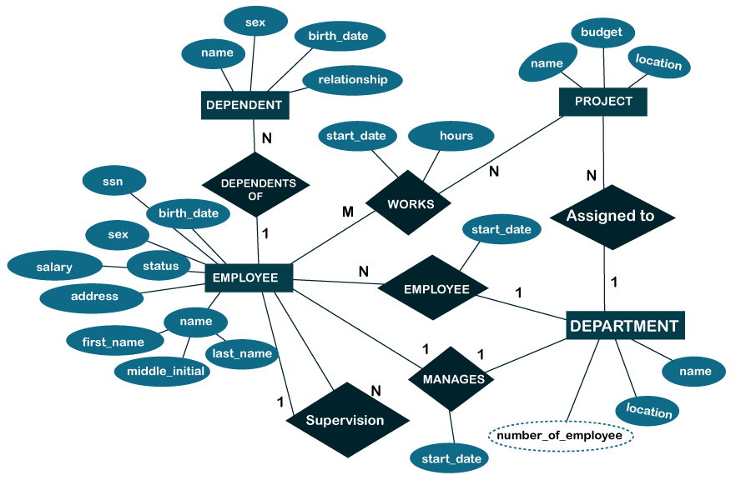
ANNEXURES

