MINI PROJECT REPORT

COMPUTER GRAPHICS

TEAM MEMBER:-

Mehek Male : 8474

Pranay Lobo : 8472

Sakshi Mishra : 8469

INTRODUCTION :

The game called "Brick Breaker" typically involve the player

controlling a bumper, there is no official version of the game, so

gameplay varies. We have made a game Brick Breaker in which total three levels exist with three lifes in each level. User will loose a life as soon as it miss the ball and the y2 co-ordinate of the ball touches the y2 co-ordinate of window as user looses three lifes he/she will be returned to total number of bricks in that level. Number of bricks is 18 in first level and will increase by 12 in each level. This bricks is an array of object of class brick. As user breaks all bricks their level will be increased with increased number of bricks and decreased delay (i.e the speed of ball will increase in each level) default delay is 30 which will decrease by 5 in each level for ball. Ball is a class with object ‘ b’ which is used as ball for the game. Bumper which is controlled by user is also an object of class bumper. Bumper moves left and right depending on kbhit()=m or n. For m bumper will move right by increasing x2 co-ordinate of bumper by 10 and for left x1 will be decreased by 10. Also background colour will change in every level so user will not get bored. To exit the game press 'e'.

MOTIVATION :

We made this game to improve our logical thinking and creativity. We understood Computer Graphics more clearly and also manipulated it and enjoyed making project with User Interface. Also it gave a boost to our C++ programming skills.

REQUIRMENT SPECIFICATION :

1. Need turboC.
2. Need Windows.

DESIGN :

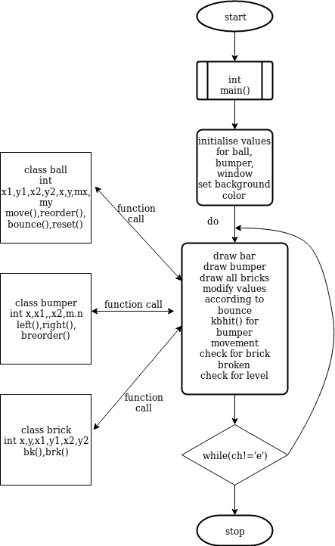

IMPLEMENTATION :

//add code with page layout double column and remove space

SREENSHOTS :

