**Name: Mehek Thaker**

**Student ID: 1001869277**

**Login ID: mxt9277**

**Write-up of Lab #3**

**Language Used:** Python

**Technology used for GUI:** Tkinter

**Software/IDE used for development:** Visual Studio Code

**Instructions for running program:**

1. Extract the project zip to the project folder name.
2. Go to File and Open the project folder in Visual Studio Code.

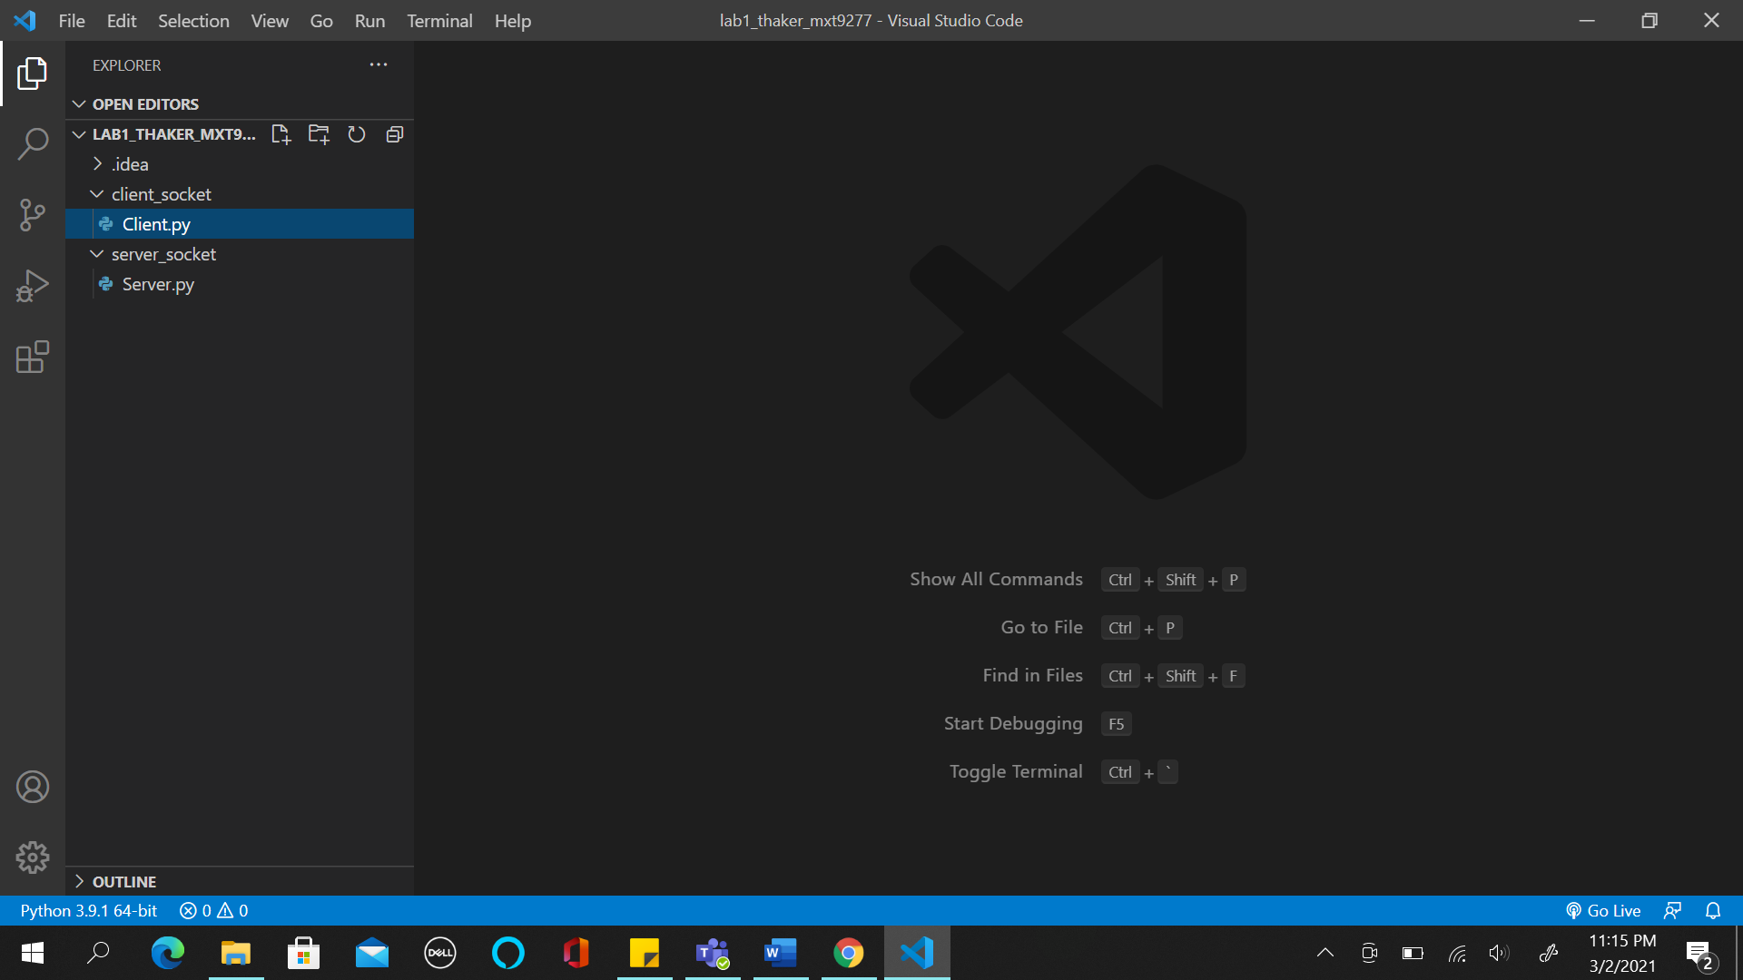

1. Before running the code, press Ctrl + Shift + X or click on the “Extensions” tab available on the left panel as indicated in the screenshot above.

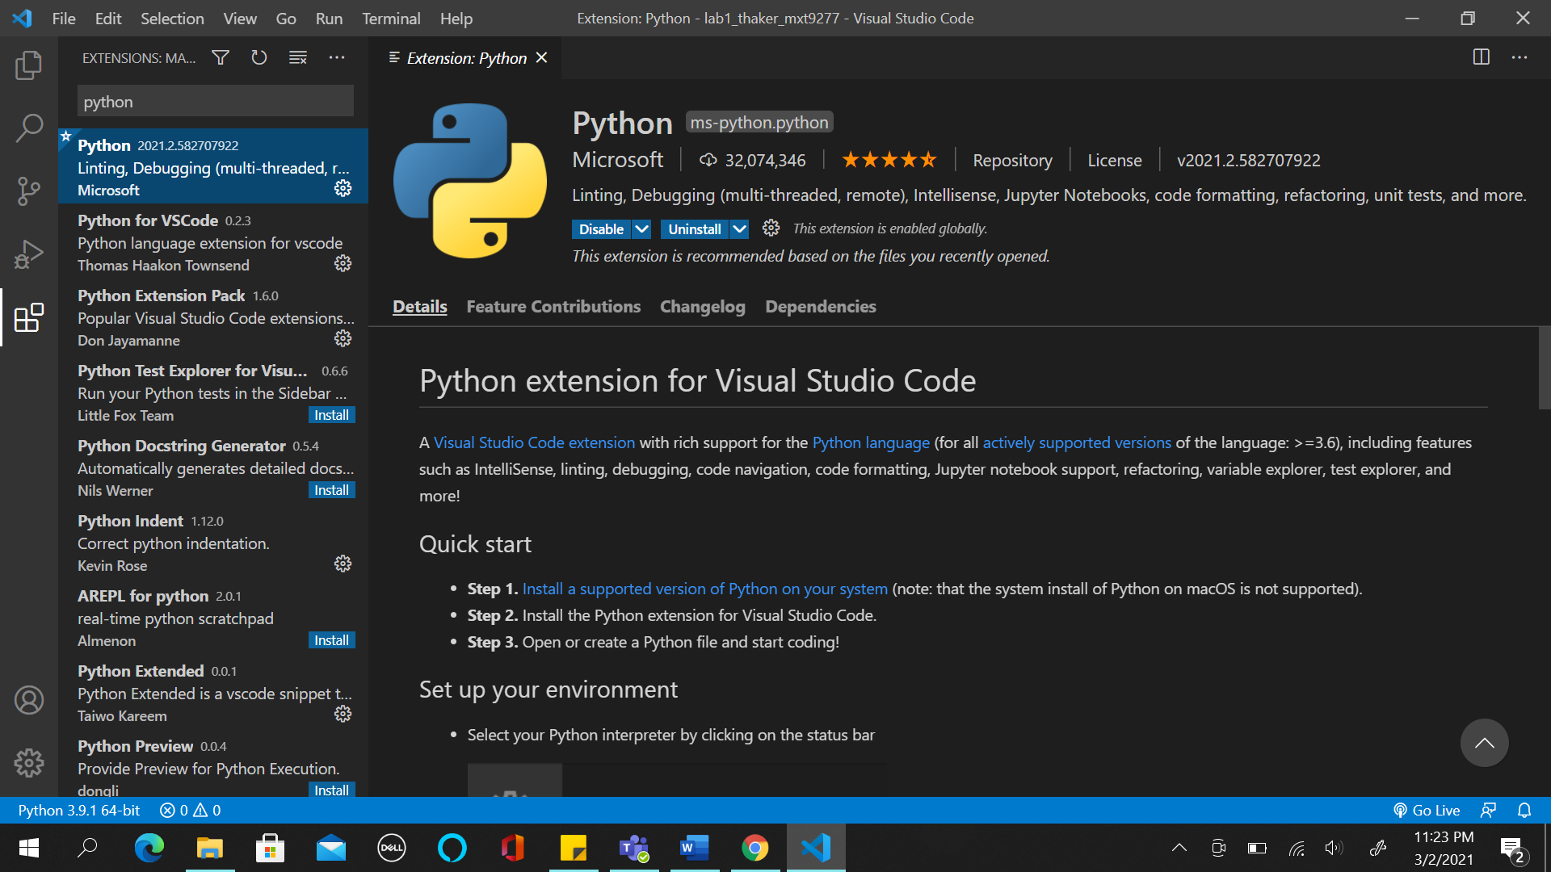

1. Then search for “python” in the search bar and install the following extensions:

* Python
* Python for VSCode
* Python Extension Pack
* Python Indent
* Python Extended

Then type “Intellicode” in the search bar and install “Visual Studio Intellicode” extension as well.

1. Check for the VS code path in the user variable’s path variable.

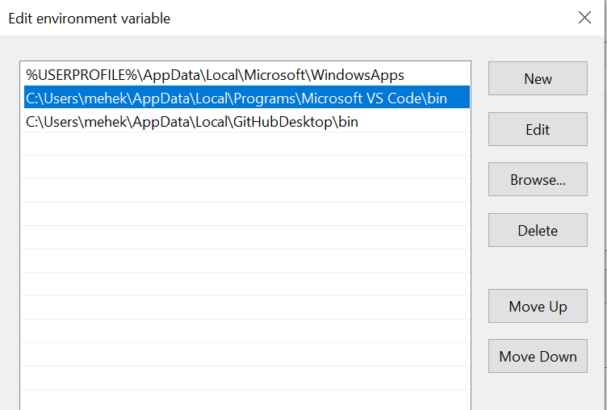

1. Set the System Variable’s path variable with below two highlighted path values for python, if not set already.

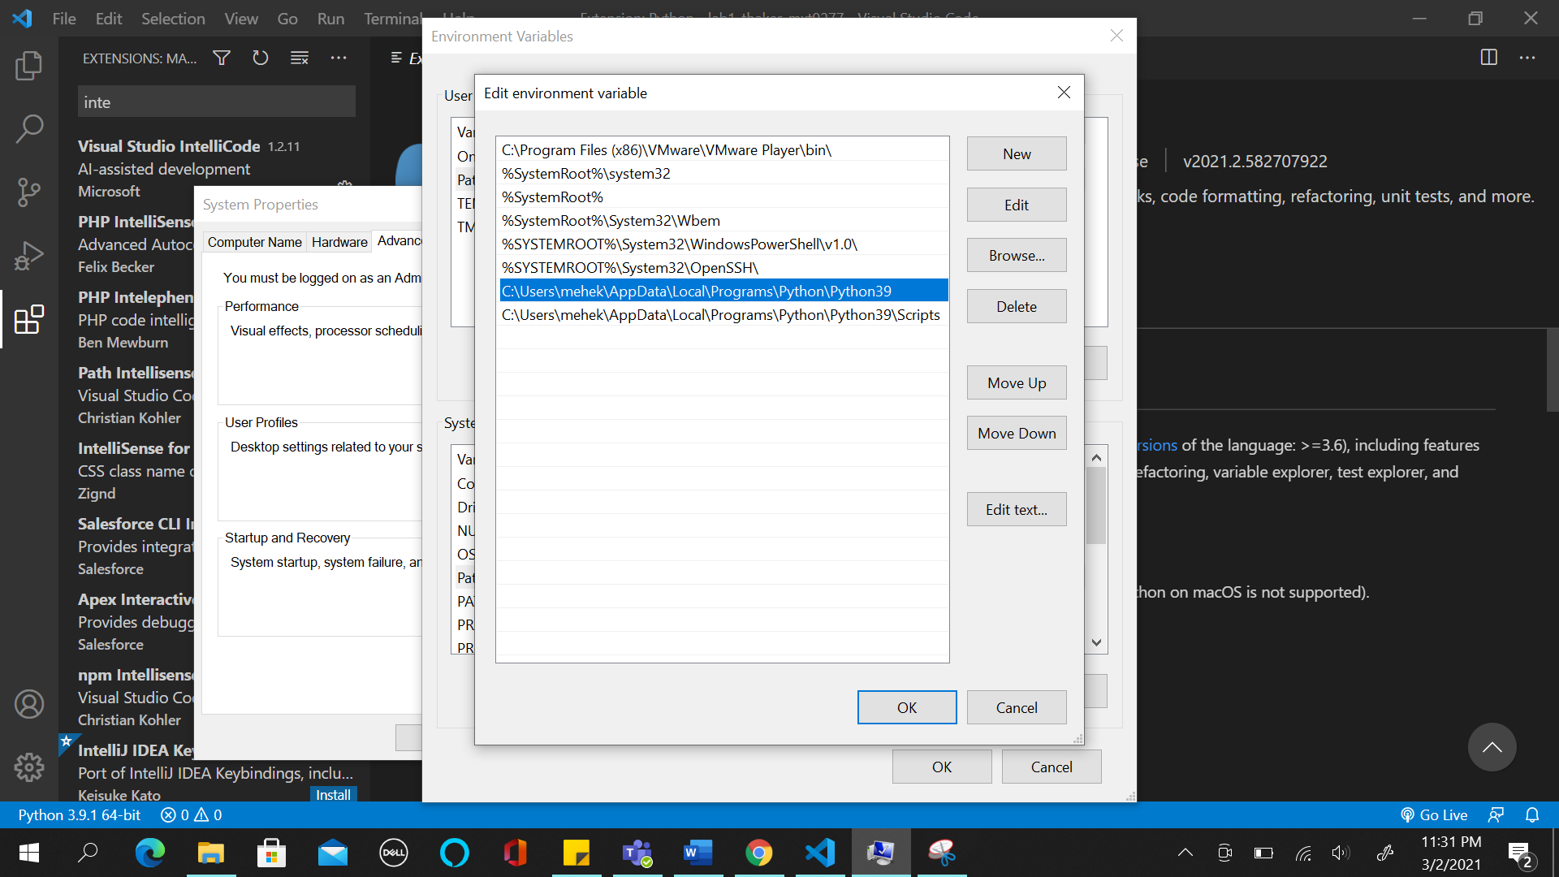

1. Once all the above steps are done and are in place. Click on the Server.py file to open it and then click on the “Run” button, which is located on top right corner, as highlighted in the screenshot below.

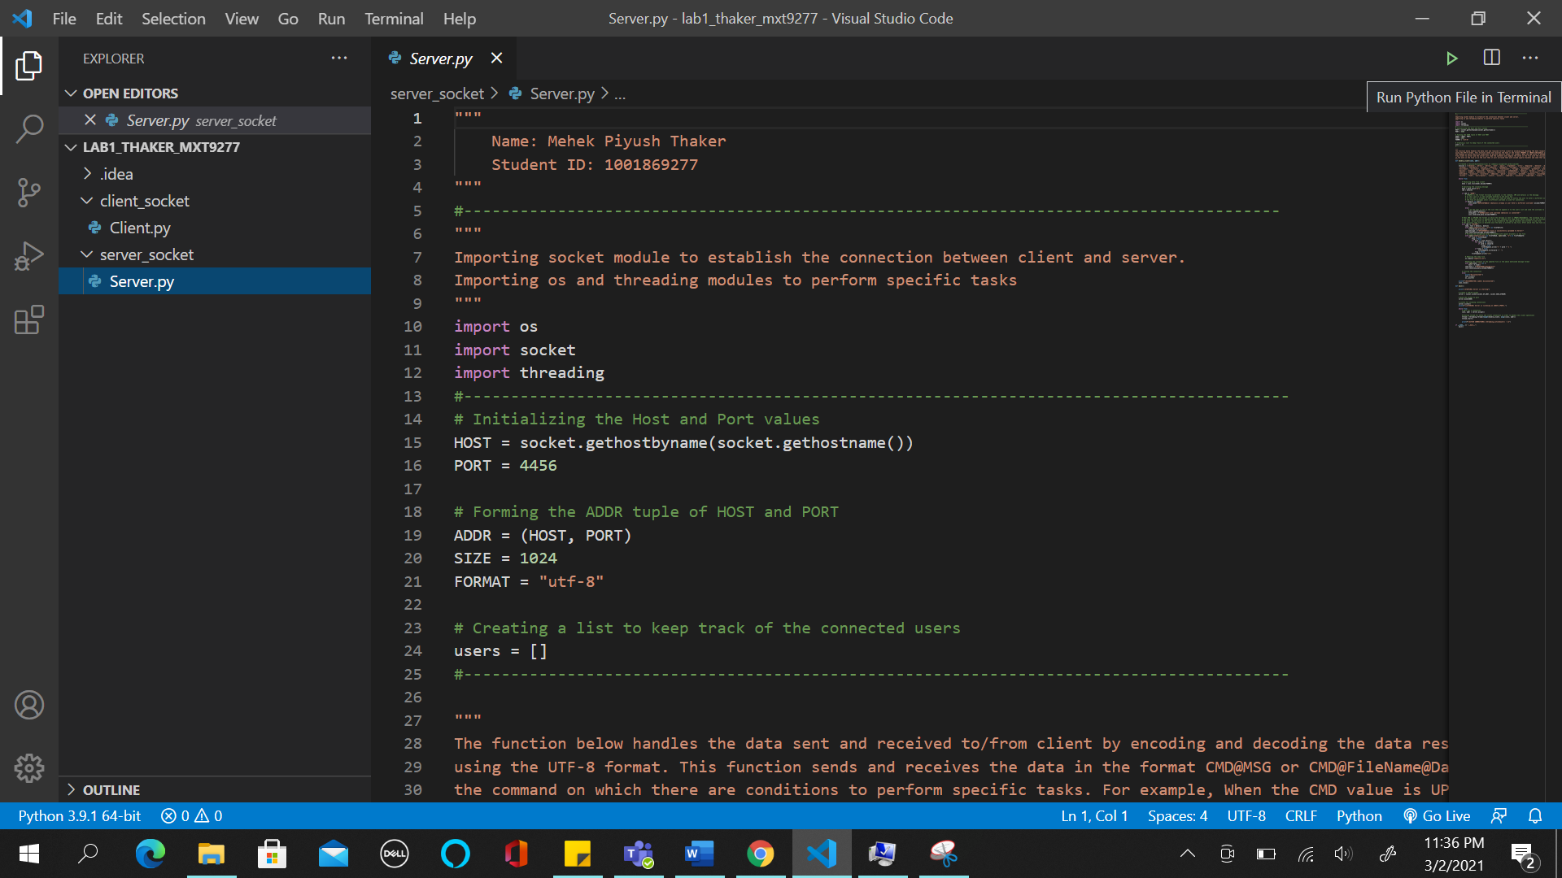

1. Clicking on the Run button it will show the execution in the window below and Server will start running. Screenshot below shows the terminal window.

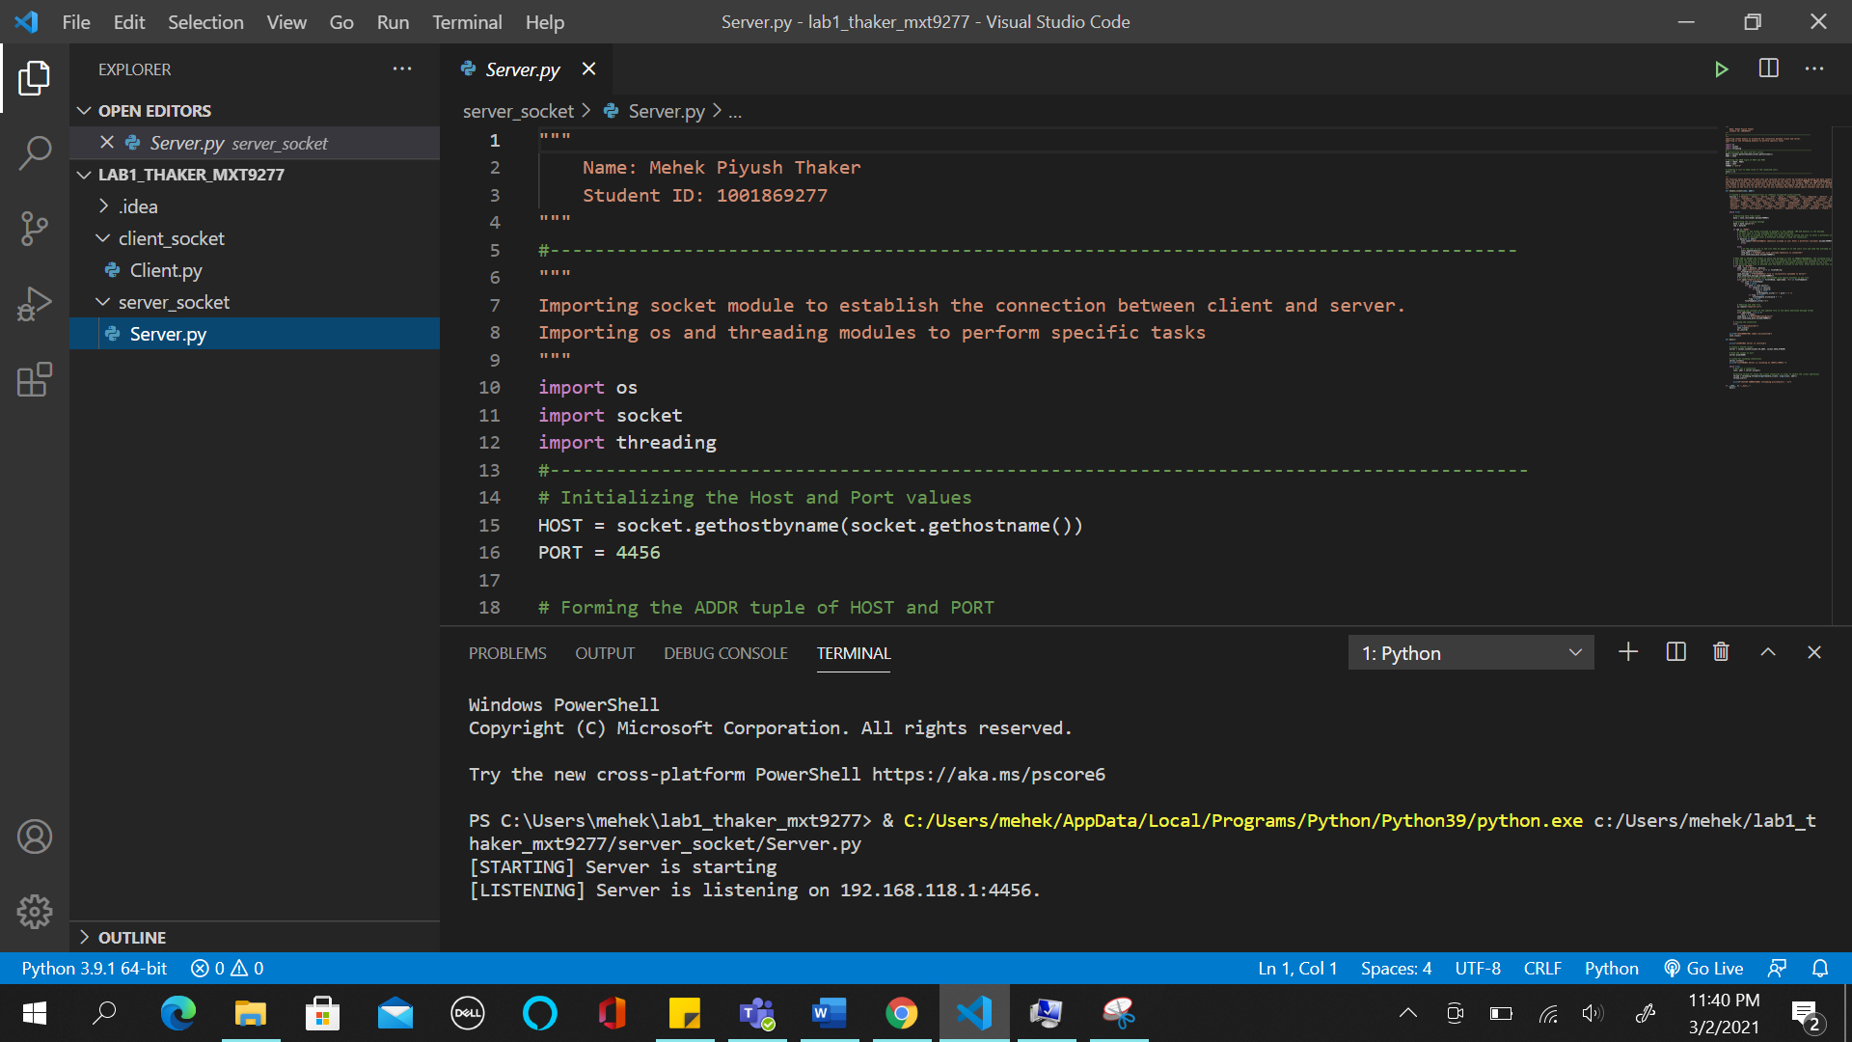

1. Then to run the Client program click on the “Split Terminal” icon or “Ctrl + Shift + 5” on the terminal window (highlighted in the screenshot below). Then give the path to the folder in which the file is located. “cd client_socket” then type python Client.py command to run the client. Now the application is running. A window appears where one can type the username and get connected to server for file transfer. Also, the user can do lexicon additions.

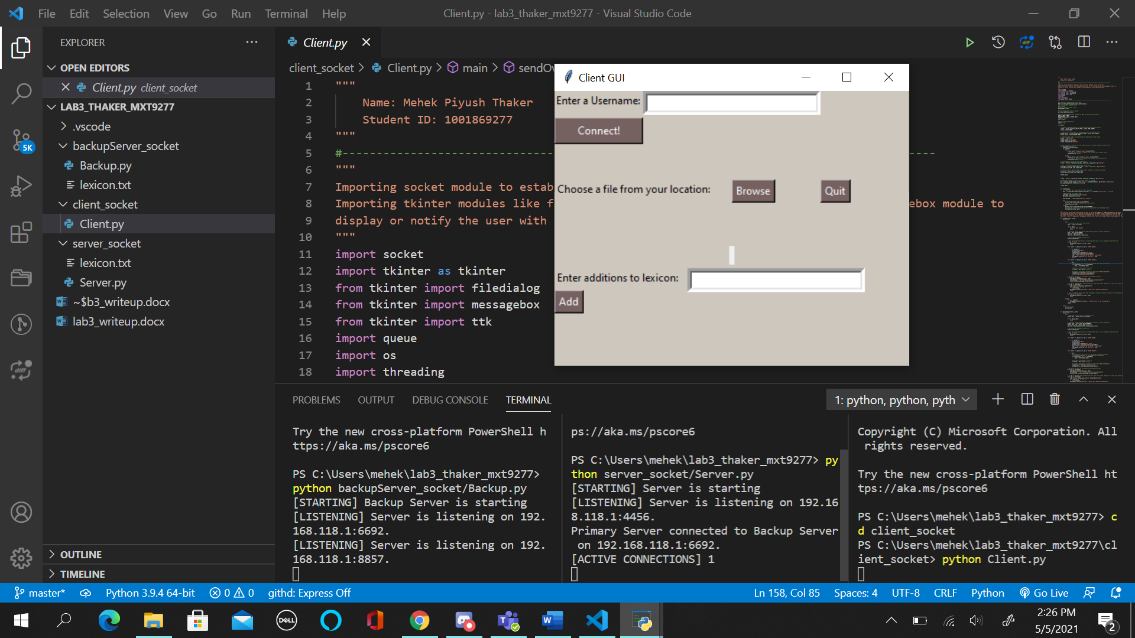

**References:**

1. <https://github.com/nikhilroxtomar/Multithreaded-File-Transfer-using-TCP-Socket-in-Python/blob/main/client.py>
2. <https://www.youtube.com/watch?v=MEcL0-3k-2c>
3. <https://stackoverflow.com/questions/38976790/display-path-of-a-file-in-tkinter-using-browse-button-python>
4. <https://www.geeksforgeeks.org/python-askopenfile-function-in-tkinter/>
5. <https://www.tutorialspoint.com/python3/tk_messagebox.htm>
6. <https://www.geeksforgeeks.org/how-to-close-a-tkinter-window-with-a-button/>
7. <https://stackoverflow.com/questions/46331408/limiting-python-filedialog-to-a-specific-filetype>
8. <https://www.geeksforgeeks.org/gui-chat-application-using-tkinter-in-python/>
9. <https://realpython.com/python-gui-tkinter/>
10. <https://www.tutorialspoint.com/python/tk_button.htm>
11. <https://www.datacamp.com/community/tutorials/gui-tkinter-python>
12. <https://www.youtube.com/watch?v=ytPw-_EE4KE>
13. <https://www.edureka.co/blog/tkinter-tutorial/>
14. <https://yagisanatode.com/2018/02/26/how-to-display-and-entry-in-a-label-tkinter-python-3/>
15. <https://linuxhint.com/python_socket_file_transfer_send/>
16. <https://www.pythontutorial.net/tkinter/tkinter-separator/>
17. <https://medium.com/@jisosceles/using-the-polling-module-in-python-87052d7da4d9>
18. <https://www.troyfawkes.com/learn-python-multithreading-queues-basics/>
19. <https://docs.python.org/3/library/queue.html>
20. <https://stackoverflow.com/questions/41713234/better-way-to-write-a-polling-function-in-python>
21. <https://www.youtube.com/watch?v=jnrCpA1xJPQ>
22. <https://pythonexamples.org/python-tkinter-button-background-color/#:~:text=Python%20Tkinter%20Button%20Background%20Color,bg%20property%20as%20shown%20below.&text=The%20default%20color%20of%20Tkinter%20Button%20is%20grey>.
23. <https://stackoverflow.com/questions/16639125/how-do-i-change-the-background-of-a-frame-in-tkinter>
24. <https://pythonexamples.org/python-tkinter-window-background-color/#:~:text=There%20are%20two%20ways%20through,property%20bg%20of%20tkinter.Tk>.
25. <https://www.tutorialspoint.com/python/tk_listbox.htm>
26. <https://stackoverflow.com/questions/48854656/how-to-clear-listbox-entries-when-pressing-a-button>
27. <https://pythonbasics.org/tkinter-listbox/>

**Zip Contents:**

1. lab3_writeup.docx
2. Client.py
3. Server.py
4. Backup.py
5. lexicon.txt

**Bugs/Limitations:**

1. Does not contain any known bug or issue in the overall functioning of the application.
2. There is only one server for all the three clients (from the backend point of view) but due to some issue at front-end (tkinter), new server GUI window opens for each client.