1. SELECT ENAME, MGR, TO_CHAR(HIREDATE, 'DDSPTH MONTH YYYY') AS DATE_HIRED FROM EMP WHERE JOB= 'CLERK' OR DEPTNO= 20

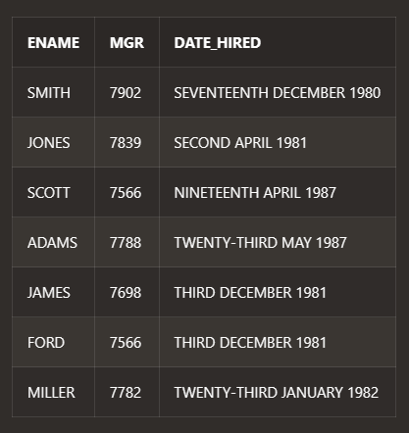



1. SELECT ENAME, SAL AS OLD_SAL, ROUND(1.25*SAL) AS NEW_SAL FROM EMP

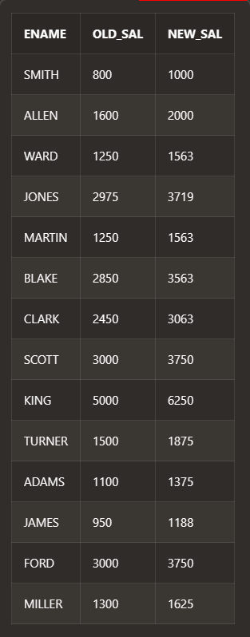

1. SELECT LPAD(ENAME, 30), RPAD(SAL,30) FROM EMP

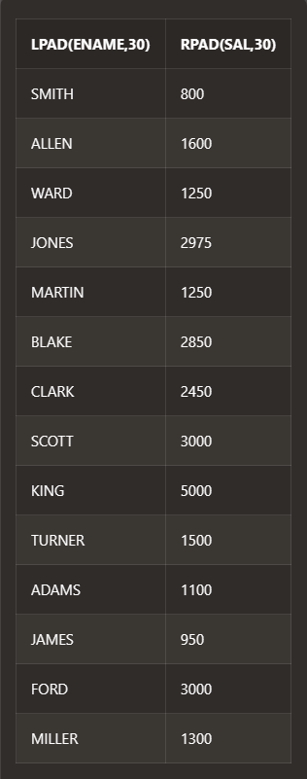

1. SELECT CONCAT(CONCAT(INITCAP(ENAME), '<'), CONCAT(INITCAP(JOB), '>')) AS "ROLE OF THE EMPLOYEE" FROM EMP





1. SELECT ENAME, HIREDATE AS HIRE_DATE, ADD_MONTHS(HIREDATE, 12) AS SALARY_REVIEW_DATE FROM EMP ORDER BY SALARY_REVIEW_DATE ASC

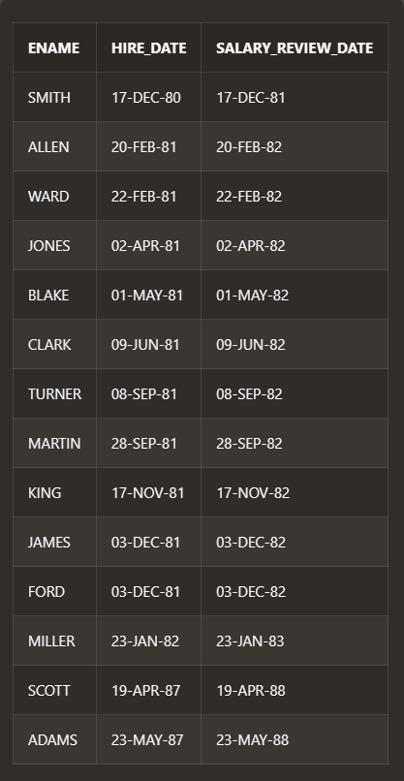

1. SELECT ENAME, JOB,SAL FROM EMP WHERE SAL IN (SELECT MAX (SAL) FROM EMP GROUP BY JOB) ORDER BY SAL DESC

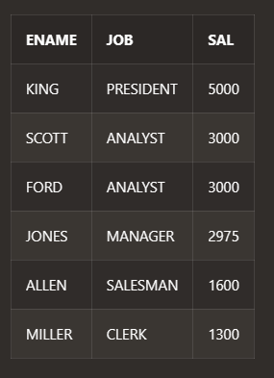

1. SELECT ENAME, HIREDATE, DEPTNO FROM EMP WHERE HIREDATE IN (SELECT MAX(HIREDATE) FROM EMP GROUP BY DEPTNO) ORDER BY HIREDATE DESC

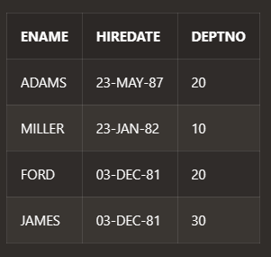

1. SELECT DNAME,COUNT(*) AS "NO OF EMPLOYEES" FROM DEPT,EMP WHERE EMP.DEPTNO=DEPT.DEPTNO GROUP BY DNAME ORDER BY COUNT(*)

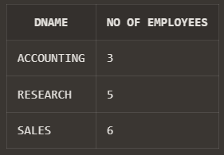

1. SELECT E.EMPNO, E.ENAME, E.SAL, S.GRADE FROM EMP E, SALGRADE S WHERE E.SAL IN(SELECT MAX(SAL) FROM EMP GROUP BY DEPTNO) AND E.SAL BETWEEN S.LOSAL AND S.HISAL ORDER BY E.DEPTNO

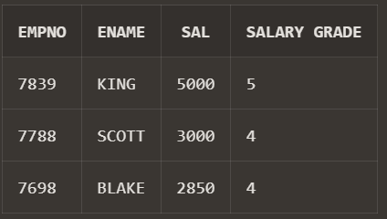

1. SELECT YR AS "MOST HIRED YEAR", COUNT AS "NO OF EMPLOYEE" FROM (SELECT TO_CHAR(HIREDATE, 'yyyy') AS YR, COUNT (*) AS "COUNT", ROW_NUMBER() OVER(ORDER BY COUNT(*) DESC) AS RNK FROM EMP GROUP BY TO_CHAR(HIREDATE, 'yyyy')) WHERE RNK = 1

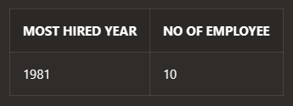

1. SELECT * FROM (SELECT EMP.* ,ROW_NUMBER() OVER(ORDER BY EMPNO) AS RNK FROM EMP) WHERE MOD(RNK,2)=0

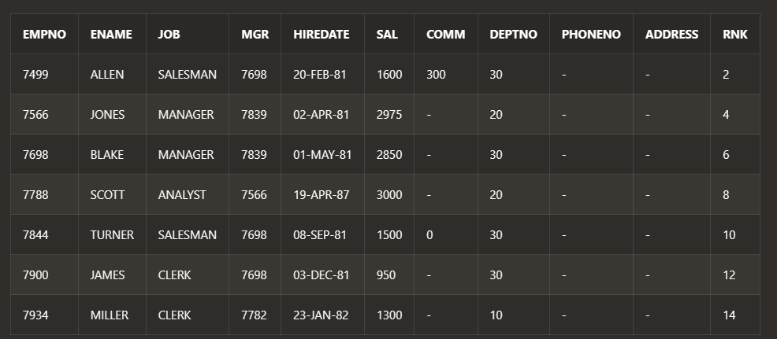

1. SELECT SUM(SAL + NVL(COMM,0)) AS "TOTAL SALARY" FROM EMP

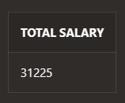

1. SELECT DNAME, COUNT(DISTINCT JOB) FROM EMP, DEPT WHERE EMP.DEPTNO = DEPT.DEPTNO GROUP BY DNAME ORDER BY COUNT(JOB) DESC;

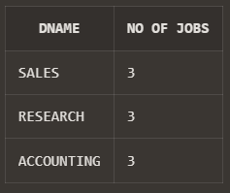

1. SELECT DNAME,ENAME FROM EMP NATURAL JOIN DEPT ORDER BY DNAME;

