1.

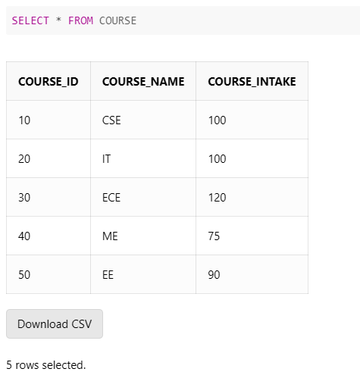Create Table COURSE (

COURSE_ID number (2), COURSE_NAME varchar2(10), COURSE_INTAKE number (3),

PRIMARY KEY(COURSE_ID))

Insert into COURSE values (10, 'CSE', 100)

Insert into COURSE values (20, 'IT', 100)

Insert into COURSE values (30, 'ECE', 120)

Insert into COURSE values (40, 'ME', 75)

Insert into COURSE values (50, 'EE', 90)

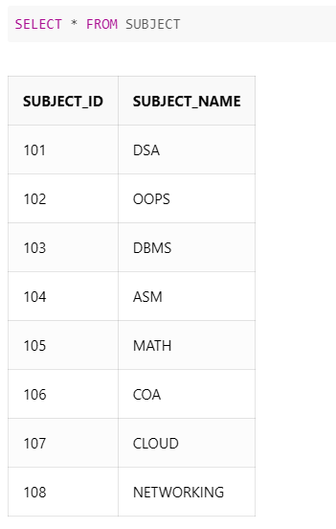CREATE TABLE SUBJECT (

SUBJECT_ID NUMBER (3), SUBJECT_NAME VARCHAR2(15),

PRIMARY KEY(SUBJECT_ID))

INSERT INTO SUBJECT VALUES (101, 'DSA')

INSERT INTO SUBJECT VALUES (102, 'OOPS')

INSERT INTO SUBJECT VALUES (103, 'DBMS')

INSERT INTO SUBJECT VALUES (104, 'ASM')

INSERT INTO SUBJECT VALUES (105, 'MATH')

INSERT INTO SUBJECT VALUES (106, 'COA')

INSERT INTO SUBJECT VALUES (107, 'CLOUD')

INSERT INTO SUBJECT VALUES (108, 'NETWORKING')

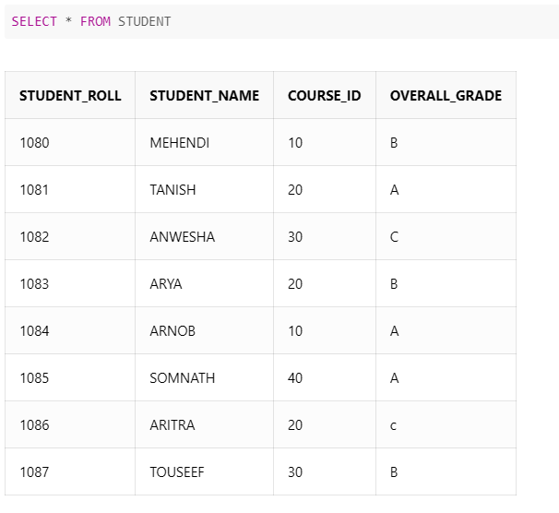CREATE TABLE STUDENT (

STUDENT_ROLL NUMBER (5), STUDENT_NAME VARCHAR2(25),

COURSE_ID NUMBER (2), OVERALL_GRADE VARCHAR2(1)

PRIMARY KEY(STUDENT_ROLL),

FOREIGN KEY(COURSE_ID) REFERENCES COURSE(COURSE_ID)

ON DELETE CASCADE)

INSERT INTO STUDENT VALUES (1080, 'MEHENDI', 10, 'B')

INSERT INTO STUDENT VALUES (1081, 'TANISH', 20, 'A')

INSERT INTO STUDENT VALUES (1082, 'ANWESHA', 30, 'C')

INSERT INTO STUDENT VALUES (1083, 'ARYA', 20, 'B')

INSERT INTO STUDENT VALUES (1084, 'ARNOB', 10, 'A')

INSERT INTO STUDENT VALUES (1085, 'SOMNATH', 40, 'A')

INSERT INTO STUDENT VALUES (1086, 'ARITRA', 20, 'C')

INSERT INTO STUDENT VALUES (1087, 'TOUSEEF', 30, 'B')

CREATE TABLE ENROLLED (

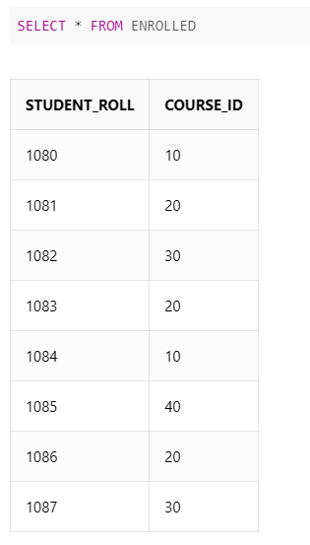STUDENT_ROLL NUMBER (5), COURSE_ID NUMBER (2),

FOREIGN KEY(STUDENT_ROLL) REFERENCES STUDENT(STUDENT_ROLL)

ON DELETE CASCADE,

FOREIGN KEY(COURSE_ID) REFERENCES COURSE(COURSE_ID)

ON DELETE CASCADE)

INSERT INTO ENROLLED VALUES (1080, 10)

INSERT INTO ENROLLED VALUES (1081, 20)

INSERT INTO ENROLLED VALUES (1082, 30)

INSERT INTO ENROLLED VALUES (1083, 20)

INSERT INTO ENROLLED VALUES (1084, 10)

INSERT INTO ENROLLED VALUES (1085, 40)

INSERT INTO ENROLLED VALUES (1086, 20)

INSERT INTO ENROLLED VALUES (1087, 30)

CREATE TABLE COURSE_SUBJECT(COURSE_ID NUMBER (2), SUBJECT_ID NUMBER (3), SUBJECT_NAME VARCHAR (15),

FOREIGN KEY(COURSE_ID) REFERENCES COURSE(COURSE_ID) ON DELETE CASCADE, FOREIGN KEY(SUBJECT_ID)

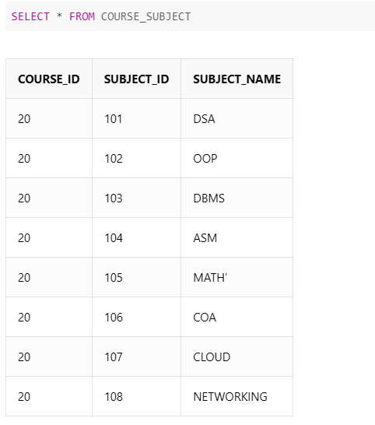REFERENCES SUBJECT(SUBJECT_ID) ON DELETE CASCADE)

INSERT INTO COURSE_SUBJECT VALUES (20, 101, 'DSA')

INSERT INTO COURSE_SUBJECT VALUES (20, 102, 'OOP')

INSERT INTO COURSE_SUBJECT VALUES (20, 103, 'DBMS')

INSERT INTO COURSE_SUBJECT VALUES (20, 104, 'ASM')

INSERT INTO COURSE_SUBJECT VALUES (20, 105, 'MATH’')

INSERT INTO COURSE_SUBJECT VALUES (20, 106, 'COA')

INSERT INTO COURSE_SUBJECT VALUES (20, 107, 'CLOUD')

INSERT INTO COURSE_SUBJECT VALUES (20, 108, 'NETWORKING')

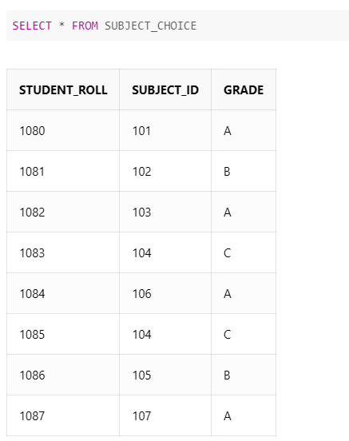CREATE TABLE SUBJECT_CHOICE (STUDENT_ROLL NUMBER (5),

SUBJECT_ID NUMBER (3), GRADE VARCHAR2(1) ,

FOREIGN KEY(STUDENT_ROLL) REFERENCES

STUDENT(STUDENT_ROLL) ON DELETE CASCADE)

INSERT INTO SUBJECT_CHOICE VALUES (1080, 101, 'A')

INSERT INTO SUBJECT_CHOICE VALUES (1081, 102, 'B')

INSERT INTO SUBJECT_CHOICE VALUES (1082, 103, 'A')

INSERT INTO SUBJECT_CHOICE VALUES (1083, 104, 'C')

INSERT INTO SUBJECT_CHOICE VALUES (1084, 106, 'A')

INSERT INTO SUBJECT_CHOICE VALUES (1085, 104, 'C')

INSERT INTO SUBJECT_CHOICE VALUES (1086, 105, 'B')

INSERT INTO SUBJECT_CHOICE VALUES (1087, 107, 'A')

2.

ALTER TABLE ENROLLED

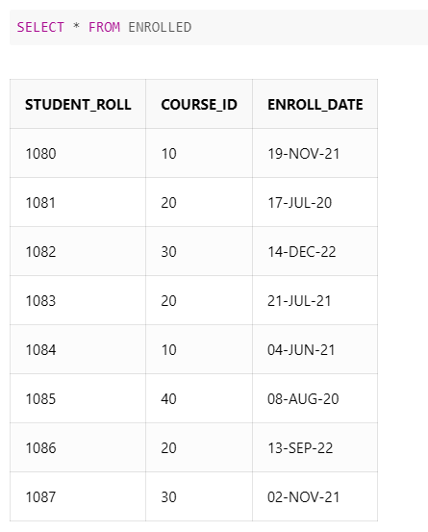ADD (ENROLL_DATE DATE)

UPDATE ENROLLED SET ENROLL_DATE='19-NOV-21' WHERE STUDENT_ROLL=1080

UPDATE ENROLLED SET ENROLL_DATE='17-JUL-20' WHERE STUDENT_ROLL=1081

UPDATE ENROLLED SET ENROLL_DATE='14-DEC-22' WHERE STUDENT_ROLL=1082

UPDATE ENROLLED SET ENROLL_DATE='21-JUL-21' WHERE STUDENT_ROLL=1083

UPDATE ENROLLED SET ENROLL_DATE='04-JUN-21' WHERE STUDENT_ROLL=1084

UPDATE ENROLLED SET ENROLL_DATE='08-AUG-20' WHERE STUDENT_ROLL=1085

UPDATE ENROLLED SET ENROLL_DATE='13-SEP-22' WHERE STUDENT_ROLL=1086

UPDATE ENROLLED SET ENROLL_DATE='02-NOV-21' WHERE STUDENT_ROLL=1087

3.

ALTER TABLE COURSE

MODIFY COURSE_NAME VARCHAR (10) NOT NULL;

4.

SELECT * FROM

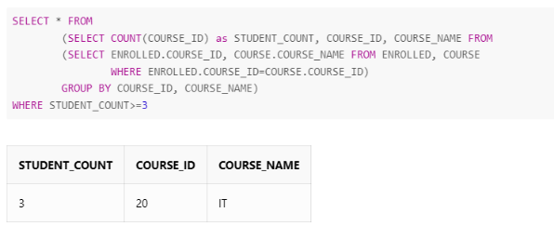(SELECT COUNT(COURSE_ID) as STUDENT_COUNT, COURSE_ID, COURSE_NAME FROM

(SELECT ENROLLED.COURSE_ID, COURSE.COURSE_NAME FROM ENROLLED, COURSE

WHERE ENROLLED.COURSE_ID=COURSE.COURSE_ID)

GROUP BY COURSE_ID, COURSE_NAME)

WHERE STUDENT_COUNT>=3;

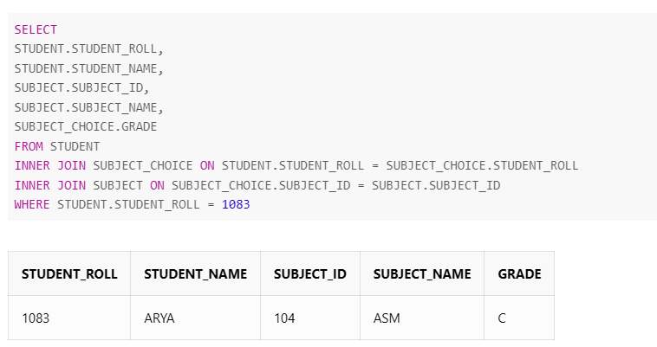5.

SELECT

STUDENT.STUDENT_ROLL,

STUDENT.STUDENT_NAME,

SUBJECT.SUBJECT_ID,

SUBJECT.SUBJECT_NAME,

SUBJECT_CHOICE.GRADE

FROM STUDENT

INNER JOIN SUBJECT_CHOICE ON STUDENT.STUDENT_ROLL = SUBJECT_CHOICE.STUDENT_ROLL

INNER JOIN SUBJECT ON SUBJECT_CHOICE.SUBJECT_ID = SUBJECT.SUBJECT_ID

WHERE STUDENT.STUDENT_ROLL = 1083

6.

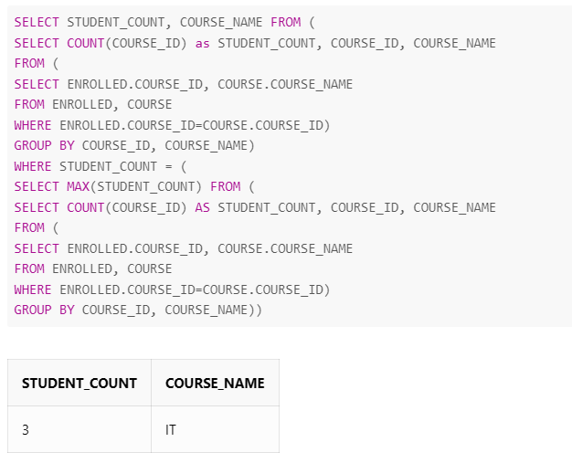SELECT STUDENT_COUNT, COURSE_NAME FROM (

SELECT COUNT(COURSE_ID) as STUDENT_COUNT, COURSE_ID, COURSE_NAME

FROM (

SELECT ENROLLED.COURSE_ID, COURSE.COURSE_NAME

FROM ENROLLED, COURSE

WHERE ENROLLED.COURSE_ID=COURSE.COURSE_ID)

GROUP BY COURSE_ID, COURSE_NAME)

WHERE STUDENT_COUNT = (

SELECT MAX(STUDENT_COUNT) FROM (

SELECT COUNT(COURSE_ID) AS STUDENT_COUNT, COURSE_ID, COURSE_NAME

FROM (SELECT ENROLLED.COURSE_ID, COURSE.COURSE_NAME

FROM ENROLLED, COURSE

WHERE ENROLLED.COURSE_ID=COURSE.COURSE_ID)

GROUP BY COURSE_ID, COURSE_NAME))

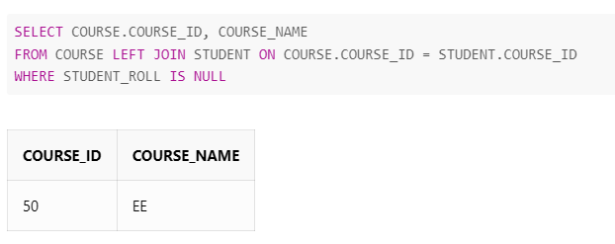7.

SELECT COURSE.COURSE_ID, COURSE_NAME

FROM COURSE LEFT JOIN STUDENT ON COURSE.COURSE_ID = STUDENT.COURSE_ID

WHERE STUDENT_ROLL IS NULL;

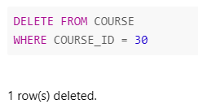8.

DELETE FROM COURSE

WHERE COURSE_ID = 30;

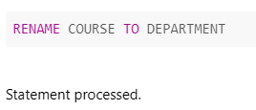9.

RENAME COURSE TO DEPARTMENT;

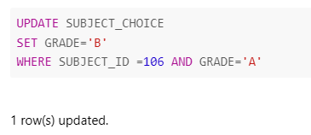10.

UPDATE SUBJECT_CHOICE

SET GRADE='B'

WHERE SUBJECT_ID =106 AND GRADE='A';

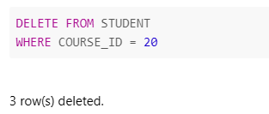

11.

DELETE FROM STUDENT

WHERE COURSE_ID = 20;

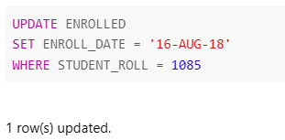

12.

UPDATE ENROLLED

SET ENROLL_DATE = '16-AUG-18' WHERE STUDENT_ROLL = 1085;