**ASSIGNMENT – 4**

**(MEHENDI SIL – 002311001094)**

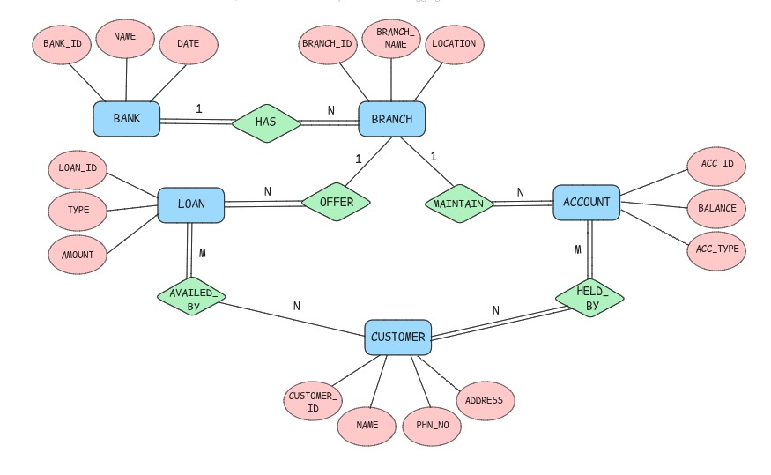ER DIAGRAM

DATABASE SCHEMA

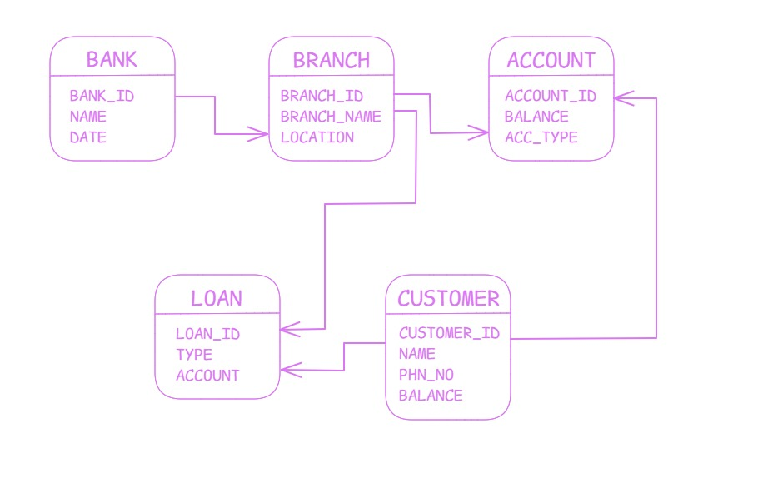  
  
  
**1. INSERT AT LEAST FIVE TUPLES IN EACH TABLE**

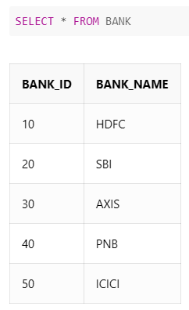

CREATE TABLE BANK (

BANK_ID NUMBER (2) PRIMARY KEY,

BANK_NAME VARCHAR (100) NOT NULL);

INSERT INTO BANK VALUES (10,'HDFC');

INSERT INTO BANK VALUES (20, 'SBI');

INSERT INTO BANK VALUES (30, 'AXIS');

INSERT INTO BANK VALUES (40, 'PNB');

INSERT INTO BANK VALUES (50, 'ICICI');

CREATE TABLE BRANCH (

BRANCH_ID NUMBER (3) PRIMARY KEY,

BRANCH_NAME VARCHAR (100) NOT NULL,

BANK_ID NUMBER (2),

FOREIGN KEY (BANK_ID) REFERENCES BANK (BANK_ID) ON DELETE CASCADE);

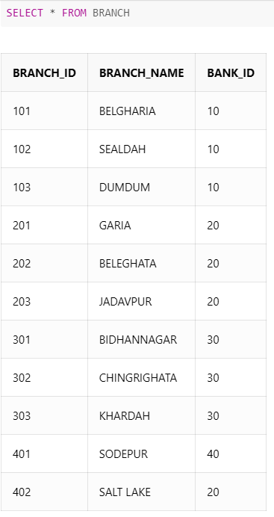

INSERT INTO BRANCH VALUES (101, 'BELGHARIA', 10);

INSERT INTO BRANCH VALUES (102, 'SEALDAH', 10);

INSERT INTO BRANCH VALUES (103, 'DUMDUM', 10);

INSERT INTO BRANCH VALUES (201, 'GARIA', 20);

INSERT INTO BRANCH VALUES (202, 'BELEGHATA', 20);

INSERT INTO BRANCH VALUES (203, 'JADAVPUR', 20);

INSERT INTO BRANCH VALUES (301, 'BIDHANNAGAR', 30);

INSERT INTO BRANCH VALUES (302, 'CHINGRIGHATA', 30);

INSERT INTO BRANCH VALUES (303, 'KHARDAH', 30);

INSERT INTO BRANCH VALUES (401, 'SODEPUR', 40);

CREATE TABLE CUSTOMER (

CUSTOMER_ID NUMBER (5) PRIMARY KEY,

CUSTOMER_NAME VARCHAR (100) NOT NULL);

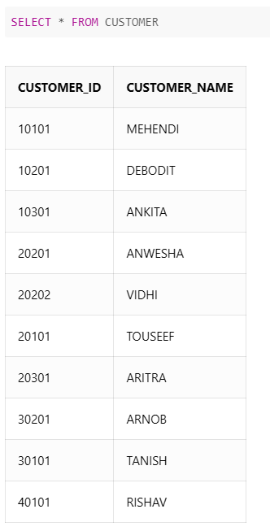INSERT INTO CUSTOMER VALUES (10101, 'MEHENDI');

INSERT INTO CUSTOMER VALUES (10201, 'DEBODIT');

INSERT INTO CUSTOMER VALUES (10301, 'ANKITA');

INSERT INTO CUSTOMER VALUES (20201, 'ANWESHA');

INSERT INTO CUSTOMER VALUES (20202, 'VIDHI');

INSERT INTO CUSTOMER VALUES (20101, 'TOUSEEF');

INSERT INTO CUSTOMER VALUES (20301, 'ARITRA');

INSERT INTO CUSTOMER VALUES (30201, 'ARNOB');

INSERT INTO CUSTOMER VALUES (30101, 'TANISH');

INSERT INTO CUSTOMER VALUES (40101, 'RISHAV');

CREATE TABLE ACCOUNT (

ACCOUNT_NO NUMBER (11) PRIMARY KEY,

BALANCE DECIMAL (10, 2),

CUSTOMER_ID NUMBER (5),

BRANCH_ID NUMBER (3),

FOREIGN KEY (CUSTOMER_ID) REFERENCES CUSTOMER (CUSTOMER_ID) ON DELETE CASCADE,

FOREIGN KEY (BRANCH_ID) REFERENCES BRANCH (BRANCH_ID) ON DELETE CASCADE);

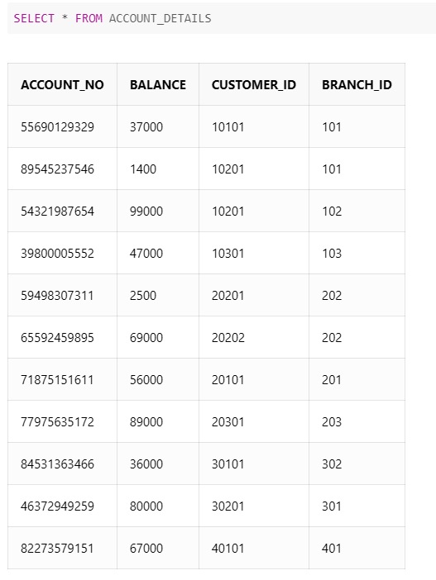INSERT INTO ACCOUNT VALUES (55690129329, 37000, 10101, 101);

INSERT INTO ACCOUNT VALUES (89545237546, 1400, 10201, 101);

INSERT INTO ACCOUNT VALUES (54321987654, 99000, 10201, 102);

INSERT INTO ACCOUNT VALUES (39800005552, 47000, 10301, 103);

INSERT INTO ACCOUNT VALUES (59498307311, 2500, 20201, 202);

INSERT INTO ACCOUNT VALUES (65592459895, 69000, 20202, 202);

INSERT INTO ACCOUNT VALUES (71875151611, 56000, 20101, 201);

INSERT INTO ACCOUNT VALUES (77975635172, 89000, 20301, 203);

INSERT INTO ACCOUNT VALUES (84531363466, 36000, 30101, 302);

INSERT INTO ACCOUNT VALUES (46372949259, 80000, 30201, 301);

INSERT INTO ACCOUNT VALUES (82273579151, 67000, 40101, 401);

CREATE TABLE LOAN (

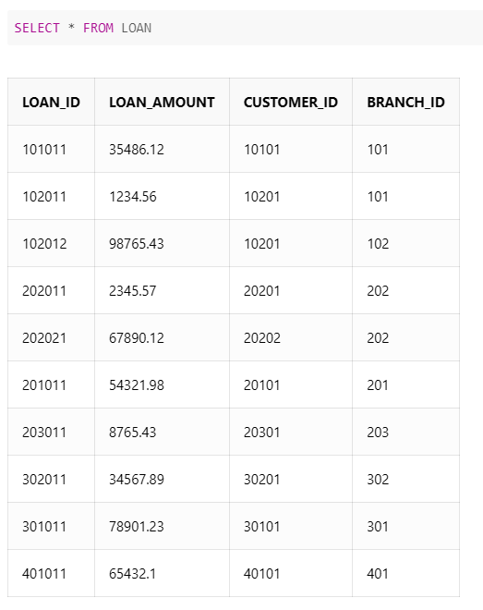LOAN_ID NUMBER (6) PRIMARY KEY,

LOAN_AMOUNT DECIMAL (12, 2),

CUSTOMER_ID NUMBER (5),

BRANCH_ID NUMBER (3),

FOREIGN KEY (CUSTOMER_ID) REFERENCES CUSTOMER (CUSTOMER_ID) ON DELETE CASCADE,

FOREIGN KEY (BRANCH_ID) REFERENCES BRANCH (BRANCH_ID) ON DELETE CASCADE);

INSERT INTO LOAN VALUES (101011, 35486.12, 10101, 101);

INSERT INTO LOAN VALUES (102011, 1234.56, 10201, 101);

INSERT INTO LOAN VALUES (102012, 98765.43, 10201, 102);

INSERT INTO LOAN VALUES (202011, 2345.57, 20201, 202);

INSERT INTO LOAN VALUES (202021, 67890.12, 20202, 202);

INSERT INTO LOAN VALUES (201011, 54321.98, 20101, 201);

INSERT INTO LOAN VALUES (203011, 8765.43, 20301, 203);

INSERT INTO LOAN VALUES (302011, 34567.89, 30201, 302);

INSERT INTO LOAN VALUES (301011, 78901.23, 30101, 301);

INSERT INTO LOAN VALUES (401011, 65432.10, 40101, 401);

1. **EVERY CUSTOMER MUST HAVE AT LEAST ONE ACCOUNT BUT IS RESTRICTED TO AT MOST TWO LOANS AT A TIME.**

ALTER TABLE CUSTOMER

ADD ACCOUNT_NO NUMBER (11) NOT NULL

ADD CONSTRAINT FK FOREIGN KEY (ACCOUNT_NO) REFERENCES ACCOUNT (ACCOUNT_NO);

CREATE TRIGGER MAXLOANSPERCUSTOMER

BEFORE INSERT ON LOAN

FOR EACH ROW

BEGIN

DECLARE LOAN_COUNT INT;

SELECT COUNT (*) INTO LOAN_COUNT

FROM LOAN

WHERE CUSTOMER_ID = NEW.CUSTOMER_ID;

IF LOAN_COUNT >= 2 THEN

SIGNAL SQLSTATE '45000'

SET MESSAGE_TEXT = 'A CUSTOMER CAN HAVE A MAXIMUM OF 2 LOANS.';

END IF;

END;

1. **GIVE ALL THE ACCOUNT DETAILS OF A PERSON WHO HAS ACCOUNTS IN SBI.**

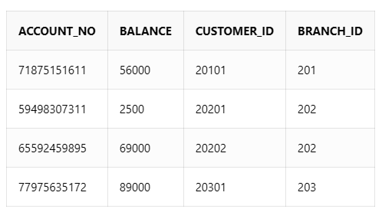 SELECT A.*

FROM ACCOUNT A

JOIN BRANCH B ON A.BRANCH_ID = B.BRANCH_ID

JOIN BANK K ON B.BANK_ID = K.BANK_ID

WHERE K.BANK_NAME = 'SBI';

1. **FIND THE ACCOUNT HOLDER NAME WHO HAS MORE THAN 2 ACCOUNTS.**

SELECT CUSTOMER_NAME

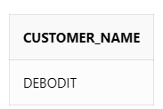FROM CUSTOMER

WHERE CUSTOMER_ID IN (

SELECT A. CUSTOMER_ID

FROM ACCOUNT A

GROUP BY A. CUSTOMER_ID

HAVING COUNT(A.ACCOUNT_NO) > 2);

1. **RENAME THE ACCOUNTS TABLE AS ACCOUNT DETAILS.**

ALTER TABLE ACCOUNT RENAME TO ACCOUNT_DETAILS;

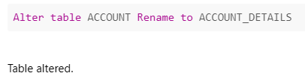

1. **FIND THE LOAN AMOUNT AND LOAN TAKEN FROM WHICH BANK FOR EACH ACCOUNT HOLDER.**

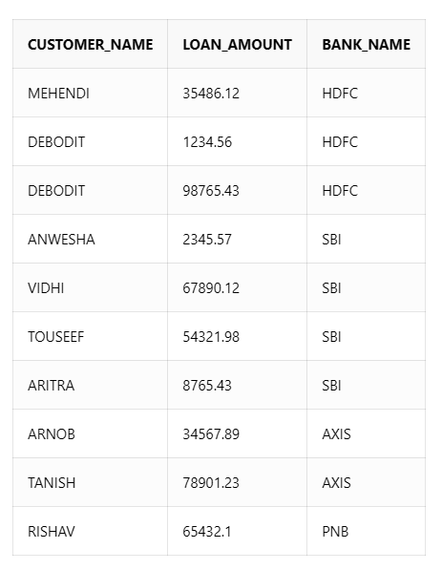

SELECT C.CUSTOMER_NAME, L.LOAN_AMOUNT, B.BANK_NAME

FROM LOAN L

JOIN CUSTOMER C ON L.CUSTOMER_ID = C.CUSTOMER_ID

JOIN BRANCH BR ON L.BRANCH_ID = BR.BRANCH_ID

JOIN BANK B ON BR.BANK_ID = B.BANK_ID;

1. **FIND THE ACCOUNT NO. AND ACCOUNT HOLDER NAME WHO HAS NOT TAKEN ANY LOAN.**

SELECT A.ACCOUNT_NO, C.CUSTOMER_NAME

FROM ACCOUNT_DETAILS A

JOIN CUSTOMER C ON A.CUSTOMER_ID = C.CUSTOMER_ID

LEFT JOIN LOAN L ON A.CUSTOMER_ID = L.CUSTOMER_ID

WHERE L.LOAN_ID IS NULL;

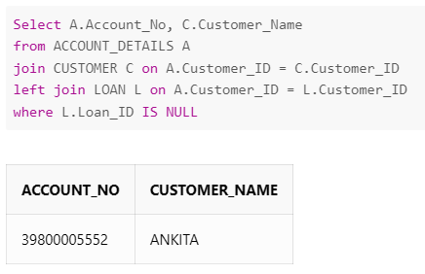

1. **DELETE THE ACCOUNT OF ALL THE PERSONS WHO HAD ACCOUNTS IN PNB, SEALDAH BRANCH.**

DELETE FROM ACCOUNT_DETAILS

WHERE BRANCH_ID =

(SELECT BRANCH_ID FROM BRANCH WHERE BRANCH_NAME = 'SEALDAH'

AND BANK_ID = (SELECT BANK_ID FROM BANK WHERE BANK_NAME = 'PNB'));

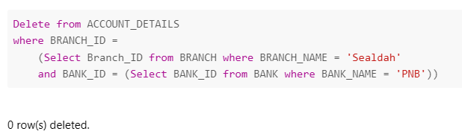

1. **UPDATE THE BRANCH TO SBI, SALT LAKE BRANCH FOR ALL THE PERSONS WHO HAD A SBI ACCOUNT IN SEALDAH BRANCH.**

UPDATE BRANCH

SET BRANCH_NAME ='SALT LAKE'

WHERE BANK_ID = (SELECT BANK_ID FROM BANK WHERE BANK_NAME = 'SBI')

AND BRANCH_NAME = 'SEALDAH';

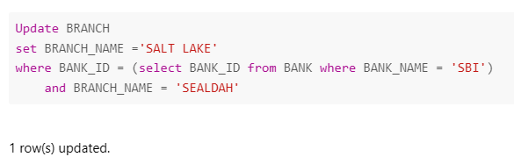

1. **FIND THE MAXIMUM ACCOUNT BALANCE OF A PERSON WITH ACCOUNT NO 54321987654 AMONG ALL OF HIS ACCOUNTS.**

SELECT MAX(BALANCE)

FROM ACCOUNT_DETAILS

WHERE CUSTOMER_ID =

(SELECT CUSTOMER_ID FROM ACCOUNT_DETAILS WHERE ACCOUNT_NO = 54321987654);

