Course: COSC475.101 – Database Management Systems
Instructor: Leon Bernard
Room: YR- 401
Assignment #2
Due Date: September 26, 2016 11:59pm

Please create the database in the textbook page 72 (which has 6 tables) and write SQL script (Please use MySQL. Workbench is optional). You can use create and insert scripts from Lab session.
Please hand in table creation script, question itself with the question number, SQL statement, and the query result for each question. Please use only standard SQL.

Note: you can copy and paste the queries and answer tables and then past those in Word document

(a) Retrieve the names of employee in department 5 who work more than 10 hours per week on the ‘ProductX’ project.
Query

SELECT Fname,Lname
FROM EMPLOYEE e
INNER JOIN WORKS_ON wo on e.Ssn = wo.Essn
INNER JOIN PROJECT p on p.Pnumber = wo.Pno
WHERE p.pname ='ProductX'
and Hours > 10
and dno =5 ;

Results
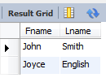
(b) List the names of employees who have a dependent with the same first name as themselves.
Query

SELECT Fname, Lname
FROM EMPLOYEE e
INNER JOIN DEPENDENT d on e.Ssn = d.Essn
WHERE e.Fname = d.Dependent_name;

Results


(c) Find the names of employees that are directly supervised by ‘Franklin Wong’.
Query

SELECT e.Fname,e.Lname
FROM EMPLOYEE e
INNER JOIN EMPLOYEE es on e.Super_ssn = es.ssn
WHERE es.Fname ='Franklin'
and es.Lname = 'Wong';

Results
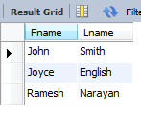

(d) For each project, list the project name and the total hours per week (by all employees) spent on that project.
Query

SELECT Pname, Sum(Hours) as Total_Hours_per_week
FROM PROJECT p
INNER JOIN WORKS_ON w on p.Pnumber = w.Pno
GROUP BY Pname

Results
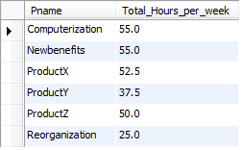

(f) Retrieve the names of employees who do not work on any project.
Query

SELECT e.Fname,e.Lname
FROM EMPLOYEE e
WHERE e.ssn
not in (
SELECT Essn
FROM WORKS_ON
);

Results


(g) For each department, retrieve the department name, and the average salary of employees working in that department.
Query

SELECT Dname, AVG(Salary) as Average_Salary
FROM EMPLOYEE e
INNER JOIN DEPARTMENT d on e.Dno = d.Dnumber
GROUP BY Dname

Results
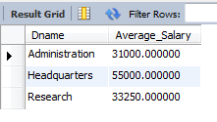

(h) Retrieve the average salary of all female employees.
Query

SELECT AVG(Salary) as Average_Salary
FROM EMPLOYEE e
WHERE e.Sex ='F'

Results
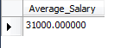

(i) Find the names and addresses of employees who work on at least one project located in Houston but whose department has no location in Houston.
Query

SELECT e.Fname,e.Lname,Address
FROM EMPLOYEE e
INNER JOIN WORKS_ON w on e.ssn = w.essn
INNER JOIN PROJECT p on p.Pnumber = w.Pno
WHERE Plocation ='Houston' and e.Dno not in (SELECT Dnumber from DEPT_LOCATIONS WHERE Dlocation ='Houston');

Results
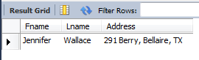

(j) List the last names of department managers who have no dependents.
Query

SELECT e.Lname
FROM EMPLOYEE e
INNER JOIN DEPARTMENT d on e.ssn = d.Mgr_ssn
WHERE e.ssn not in (select essn from DEPENDENT);

Results
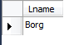

(k) Find the names of employees and the names of the projects that the employees are working on.
Query

SELECT e.Fname,e.Lname,Pname
FROM EMPLOYEE e
INNER JOIN WORKS_ON w on e.ssn = w.essn
INNER JOIN PROJECT p on p.Pnumber = w.Pno;

Results
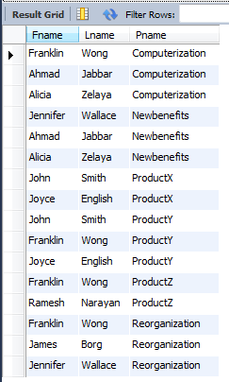

(l) Find the names of employees who are not working on the project that is not controlled by the employee’s own department. (Employees who work on only the employee’s own department’s projects).
Query

SELECT e.Fname,e.Lname
FROM EMPLOYEE e
INNER JOIN WORKS_ON w on e.ssn = w.essn
INNER JOIN PROJECT p on p.Pnumber = w.Pno
INNER JOIN DEPARTMENT d on d.Dnumber = p.Dnum
WHERE d.Dnumber <> e.Dno;
q

Results
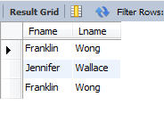

Query
Select e.Fname,e.Lname
FROM EMPLOYEE e
INNER JOIN WORKS_ON w on e.ssn = w.essn
INNER JOIN PROJECT p on p.Pnumber = w.Pno
INNER JOIN DEPARTMENT d on d.Dnumber = p.Dnum
WHERE e.ssn
not in (
select e.ssn
FROM EMPLOYEE e
INNER JOIN WORKS_ON w on e.ssn = w.essn
INNER JOIN PROJECT p on p.Pnumber = w.Pno
INNER JOIN DEPARTMENT d on d.Dnumber = p.Dnum
WHERE d.Dnumber <> e.Dno);

Results
