**Cryptocurrency Prediction (Research Base Project)**



**By**

**Meher Ali**

**(15-Arid-1395)**

**Supervised by**

**Dr. Saud Altaf**

**uNIVERSITY iNSTITUTE OF Information Technology**

**pmas Arid Agriculture UNIVERSITY**

**Rawalpindi**

**2019**

**Cryptocurrency Prediction (Research Base Project)**

**By**

**Meher Ali**

**(15-Arid-1395)**

**Supervised by**

**Dr. Saud Altaf**

**A project submitted in partial fulfillment of the requirements of the degree of**

**bachElor OF SCIENCE IN INFORMATION tECHNOLOGY**

**(BSit)**

**uNIVERSITY iNSTITUTE OF Information Technology**

**pmas Arid Agriculture UNIVERSITY**

**Rawalpindi**

**2020**

**Dedicated to our beloved parents, teachers and to all those, who taught us the best kind of knowledge to do research on this project**.

**PROJECT IN BRIEF**

Project Title: **Cryptocurrency Prediction (Research Base Project)**

Organization: University Institute of Information Technology

Undertaken By: **Meher Ali (15-ARID-1395)**

Supervised by: **Dr. Saud Altaf**

Date Started: October 1st, 2019

Date Completed: July 10th, 2020

Technology Used: Android Studio, Machine Learning, Blockchain

Operating System: Windows 10

System Used: HP Elite Book G1, 500 GB HDD, 12 GB RAM

# ACKNOWLEDGMENT

Allah The Almighty, who gave us the strength to work to complete this project on time and with the best possible quality and our family and friends who supported us in every step of life and mostly the past four years of university life.

We would like to thank and sincerely acknowledge the help of our supervisor Dr. Saud Altaf whose complete guidance, support and encouragement gave us a real motivation in doing this project.

We would like to thank all the volunteers who helped us out while testing of this application.

Lastly, we would like to thank all the faculty members of UIIT department for their help, time, and support that was gladly given to us on the time of need.

**Meher Ali**

**(15-Arid-1395)**

# DECLARATION

We hereby declare that this project, neither whole nor as a part has been copied out from any source. It is further declared that we have developed this project and accompanied report entirely on the basis of our personal efforts. If any part of this project is proved to be copied out from any source or found to be reproduction of some other. We will stand by the consequences. No Portion of the work presented has been submitted of any application for any other degree or qualification of this or any other university or institute of learning.

**Meher Ali**

**(15-Arid-1395)**

# CERTIFICATION

It is certified that the contents and form of the project entitled “Cryptocurrency Prediction” submitted by Meher Ali (15-arid-1395) has been found satisfactory for the requirements of

**PMAS – Arid Agriculture University, Rawalpindi**

**For the award of the degree of**

**BACHELOR OF SCIENCE IN INFORMATION TECHNOLOGY (BSIT)**

Supervisor:

Dr. Saud Altaf

Examiner 1:

Examiner 2:

Dated: ________________________

**Director:** ________________________

Dr. Yasir Hafeez

# ABSTRACT

The purpose of this document is to consider the future prospects of blockchain technology and cryptocurrencies in financial markets, as well as in others. In order to be eligible to get a tender awarded, the procedure requires economic operators to prove their integrity. Blockchain are one of the latest technologies that had a huge impact on the banking industry and gains a lot of traction lately, has the potential to bring about significant improvements by innovating the process.

For most of history, humans have used commodity currency. Cryptocurrency is the name given to a system that uses cryptography to allow the secure transfer and exchange of digital tokens in a distributed and decentralised manner. These tokens can be traded at market rates for fiat currencies. Fiat currency is a more recent development, first used around 1000 years ago, and today it is the dominant form of money. But this mayn’t be the end of monetary history. Cryptocurrency is neither commodity money nor fiat money – it is a new, experimental kind of money. The first cryptocurrency was Bitcoin, which began trading in January 2009. Since then, many other cryptocurrencies have been created employing the same innovations that Bitcoin introduced, but changing some of the specific parameters of their governing algorithms. The cryptocurrency experiment may or mayn’t ultimately succeed, but it offers a new mix of technical and monetary characteristics that raise different economic questions than other kinds of currency.

# TABLE OF CONTENTS

Contents

ACKNOWLEDGMENT V

DECLARATION VI

CERTIFICATION VII

ABSTRACT VIII

TABLE OF CONTENTS IX

LIST OF ABBREVATIONS XIII

LIST OF FIGURES XIV

LIST OF TABLES XV

Introduction 16

1.1. Project Overview 18

1.1.1. Issues Covered 18

1.2. Project Aims 19

1.3. Project Objectives 19

1.4. Project Scope: 20

1.5. Problem Statement: 20

1.6. Research Scope*:* 21

1.7. Proposed System: 22

1.7.1. Proposed System Components: 22

1.7.2. Proposed System Output: 22

1.8. Introduction To Tools & Technology Used: 22

1.8.1. Android Studio: 23

1.8.2. Java Language: 23

1.8.3. Web Scraping: 24

Chapter Summary: 24

***Chapter 2*** 25

Methodology 25

2.1. Methodology of Research and Its Limitations 26

2.2. Data Acquisition 27

2.3. Valuing Cryptocurrency 28

2.3.1. Cryptocurrency Mining and Hash Rate 28

2.3.2. Market Expectation 28

2.3.3. Implications of Historical Prices 29

2.4. How Does Cryptography Work? 29

2.4.1. Cryptography Methods Used In Cryptocurrencies 30

3. Literature Review 31

3.1. Access Control 31

3.2. Cryptocurrency Has Revolutionized The Payment System: 32

3.3. The Future of Cryptocurrency: 34

3.4. Scalability 34

3.5. Privacy 35

3.6. Consolidation 35

3.7. The Rise of The Crypto Startup 35

3.8. Emerging Markets 36

3.8.1. Central Bank Digital Currencies (CBDCs) 36

3.8.2. Maturing Market Structure 37

Chapter Summary: 37

***Chapter 3*** 38

Response of Governments and Financial Institutions 38

4.1. Big Banks 38

4.1.1. China 39

4.1.2. South Korea 40

4.1.3. United States of America 41

4.1.4. Switzerland 41

4.1.5. European Union 42

5. Analysis of Cryptocurrency in Today’s Environment 43

5.1. SWOT Analysis 43

5.2. PESTLE Analysis 44

6. Use Cases 44

Chapter Summary: 45

***Chapter 4*** 46

Project Management 46

7.1. Milestones 46

7.2. Cryptocurrency Works 46

7.3. Risk Management System 49

7.4. Cryptocurrency Price Analysis 49

Chapter Summary 50

*Chapter 5* 51

Project Implementation 51

8.1. Programming Language 51

8.1.1. Java 51

8.1.2. Python 51

8.2. System Requirement 52

Chapter Summary 52

*Chapter 6* 53

Software Testing 53

9.1. Cryptocurrency 53

9.1.1. Predications 53

9.1.2. Selling and Buying 53

9.1.3. User ID 53

9.1.4. Payment Method 53

Chapter Summary 53

*Chapter 7* 54

Conclusion and Future Work 54

10.1. Discussion 54

10.2. Conclusion 55

10.3. Future Work 55

10.3.1. Exchanging Payments 55

10.3.2. Moving Forward 56

References 56

Screenshots 58

# LIST OF ABBREVATIONS

# LIST OF FIGURES

# LIST OF TABLES

***Chapter 1***

# Introduction

Blockchain is the technology which allows cryptocurrencies to exist. Pakistan’s financial industry should enable availability of easy to understand educational material for potential investors and provide cheap investment advisory to people seeking to invest in the capital markets. However, a majority of middle class and lower-class investors shy away from investments in financial markets assuming illegitimacy. Financial institutions were the first to pay notice to it, as it was in simple words a new payment system.

Since the beginning of the industrial revolution the world has been in a constant state of technological disruption. Most people still have a hard time understanding why the blockchain is so significant, stating that the current systems for conducting financial transactions seem to work well enough. The blockchain has the potential to eliminate the need for many of the jobs in the financial service sector currently performed by humans. Financial intermediation and insurance services could all be performed on a blockchain without the need for a single entity to serve as middleman.

At their basic level, they enable a community of users to record transactions in a shared ledger within that community, such that under normal operation of the blockchain network no transaction can be changed once published. In 2008, the blockchain idea was combined with several other technologies and computing concepts to create modern cryptocurrencies: electronic cash protected through cryptographic mechanisms instead of a central repository or authority.

We describe the main cryptocurrencies and the blockchain generation they belong to, beginning with the first cryptocurrency, Bitcoin, which is currently the largest and most successful cryptocurrency. Bitcoin was the first cryptocurrency to be released and was created by Satoshi Nakamoto, who also invented blockchain technology (Nakamoto, 2008).

The cryptocurrency as we know it today might not exist had there not been the economic crash of 2008. What Mr. Nakamoto saw was the banking industry losing its core purpose and becoming an overtly greedy money-producing mechanism. Because the banks had lost sight of their boundaries and relative power, he felt that there had to be an alternative.

As a result, Bitcoin came to fruition in 2009 when Satoshi Nakamoto, whose true identity has never been revealed, launched the first blockchain network into the world. Alongside his new network, Nakamoto had published a book where he went into extensive detail explaining why cryptocurrencies are a superior choice and better solution to our current financial system. This book is called “Bitcoin: A Peer-to-Peer Electronic Cash System”, hailed by the most fanatical of cryptocurrencies as a manifesto of sorts.

The first issue that he identifies is the interference of financial intermediaries in nearly every transaction that has been made in our economy. There is always a third-party present when money is transferred or moved from point A to point B. This third-party is often a bank or other financial institution given the responsibility to regulate and provide surveillance to the economy. He explains that not only does this waste time, the added fees that are charged by these intermediaries are essentially an unwanted burden on us. The second thing Mr. Nakamoto identifies is that our current system requires the financial institution because there exists a fundamental lack of trust between two parties who do not know each other.

# Project Overview

The purpose of this document is to consider the future prospects of blockchain technology and cryptocurrencies in financial markets, as well as in others. Cryptocurrencies use decentralized control as opposed to centralized digital currency and central banking systems. Bitcoin, the first and most popular cryptocurrency, is paving the way as a disruptive technology to long standing and unchanged financial payment systems that have been in place for many decades. Crypto investment can help a common man because it has a high return on investments.

Within the Bitcoin, blockchain, information representing electronic cash is attached to a digital address. Bitcoin users can digitally sign and transfer rights to that information to another user and the Bitcoin blockchain records this transfer publicly, allowing all participants of the network to independently verify the validity of the transactions. The Bitcoin blockchain is stored, maintained, and collaboratively managed by a distributed group of participants. This, along with certain cryptographic mechanisms, makes the blockchain resilient to attempts to alter the ledger later.

The use of blockchain technology is not a silver bullet, and there are issues that must be considered such as how to deal with malicious users, how controls are applied, and the limitations of the implementations. Beyond the technology issues that need to be considered, there are operational and governance issues that affect the behaviour of the network. For example, in permissioned blockchain networks, described later in this document, there are design issues surrounding what entity or entities will operate and govern the network for the intended user base.

# Issues Covered

The basic aspects which we have covered in our final year project (fyp) as these are the main issues to be solved which would benefit both the user, admin and supplier. These are the following.

* **New Payment gateway**– Cryptocurrency payment gateways to accept Bitcoin Ethereum, Litecoin, and other coins as payment for different merchants.
* **Banking system aren’t involved** – In cryptocurrency the baking system aren’t involved.
* **No security risk** – Cryptocurrency is a P2P (Peer-to-peer) network system and they can’t hacked easily. In P2P transactions the electronic money are transfers made from one person to another through an intermediary
* **No transaction limit** – Unlike the banking system, in cryptocurrency there is no limit to transactions.
* **More Confidential Transactions** – Third party isn't involved in transactions.
* **Secure payment method** – They can't hackable and the payment system are secured.

# Project Aims

In this project my aim is to collect all the relevant information about these new technology, organize the knowledge in a way, that I will be able to highlight their advantages and disadvantages next to their impact on the banking industry and vice versa. We will develop an app in which all the previous records of digital coins will be uploaded online by using app. We aim to setup an android application platform for investors to generate and visualize investment portfolios in the Pakistani capital markets that tailor to their specific risk tolerance and future investment objectives using artificial intelligence techniques or some algorithmic techniques. The user interface has been specifically designed for the end-user of this application. It has made sure at every point, that application should be user friendly and self-explanatory rather than face difficulties how use this application.

# Project Objectives

The result of this study is aimed to contribute theoretical and practical implication of Bitcoin (BTC) and most importantly Cryptocurrency, in today's era. Whereas, the primary objectives are as follows:

* **Is Bitcoin (BTC) the best Cryptocurrency?** – Examining the rise of Bitcoin (BTC) and analysis as to whether it is the best form of currency to use block-chain technology.
* **What's next for the Cryptocurrency market?** – Providing insights as to what’s next in this Cryptocurrency market and will other currencies provide better usage application.
* **The cryptocurrency is that it isn’t controlled by any central authority** – The decentralized nature of the blockchain makes cryptocurrencies theoretically immune to the old ways of government control and interference.
* **Cryptocurrencies can be sent directly** – Between two parties via the use of private and public keys. These transfers can be done with minimal processing fees, allowing users to avoid the steep fees charged by traditional financial institutions.

# Project Scope:

Some economic analysts predict a big change in crypto is forthcoming as institutional money enters the market. Moreover, there is the possibility that crypto will be floated on the NASDAQ, which would further add credibility to blockchain and its uses as an alternative to conventional currencies. Some predict that all that crypto needs is a verified exchange traded fund (ETF). An ETF would definitely make it easier for people to invest in Bitcoin, but there still needs to be the demand to want to invest in crypto, which some say may not automatically be generated with a fund.

# Problem Statement:

In Pakistan only 3% of the people invest in cryptocurrency or stock market however 56% of people do savings. Which means 53% of people either have no or little knowledge of investing in cryptocurrency or stock market. Many people don't invest because of fear and ignorance. Most people have little to no knowledge about digital currency history. Also most people don't know how the cryptocurrency works, don't have a digital wallet or brokerage account, and there are a lot of working people who don't have access to even that. There's a common perception that the cryptocurrency is a zero sum game, and is essentially gambling. And if you don't know what you're doing, if you try to be a day trader, or you attempt to pick some coins on advice from your friend, or barber, or whatever, it basically is gambling. To invest for wealth accumulation you need to invest for a long time, at least 10 years, and preferably 20 to 40 years.

# Research Scope*:*

This study focused on the identification and evaluation of a blockchain technology in the procurement sector. The scope of the research was thereby explicitly limited to solutions based on the implementation of blockchain technology, possibly consisting of combinations of blockchain technology with traditional methods.

Cryptocurrencies and blockchain are a monstrous topic. There are several hundreds of cryptocurrencies and the applications of blockchain technology are also numerous. To make this research a useful and focused one, we have to narrow it down. To do this, the research attaches to multiple connecting factors, defining its scope.

Firstly, the research is limited to cryptocurrencies and blockchain. This means that other types of assets than cryptocurrencies, such as tokens or crypto securities, are not within the scope of this research. We will explain how these assets differ from cryptocurrencies further on. We will also not elaborate on derivatives of cryptocurrencies, which are essentially investment instruments. Blockchain will be scrutinized to the extent cryptocurrencies run on this technology.

Secondly, the research relates to the legal context of cryptocurrencies and blockchain. The focus is, hence, a legal one. This means that we will not elaborate on all the technical aspects – and there are many – relating to cryptocurrencies and blockchain. We will only touch upon those to the extent necessary to understand the legal context. We will also not take an economic, criminological or any other approach than a legal one.

Thirdly, the legal context is addressed in connection with the implications for financial crime, money laundering and tax evasion. Therefore, we will only scrutinize the legal context of cryptocurrencies and blockchain to the extent relevant in connection with financial crime, money laundering and tax evasion. We will not deep dive into other legal queries than those related to money laundering, terrorist financing and tax evasion, such as the qualification of cryptocurrencies under tax laws or the protection of investors in cryptocurrencies (whether or not consumers) under financial services laws.

# Proposed System:

Cryptocurrency is a form of payment that can be exchanged online for goods and services. Cryptocurrencies work using a technology called blockchain. Blockchain is a decentralized technology spread across many computers that manages and records transactions. Part of the appeal of this technology is its security.

Like any currency, cryptocurrencies can be used to buy goods and services. But unlike other currencies, cryptocurrencies are digital and use cryptography to provide secure online transactions.

# Proposed System Components:

There will be some components used in this project:

* Blockchain for cryptocurrency and digital coins
* Machine Learning
* XML for page layout
* Java for interaction
* Firebase for database
* Android Studio

# Proposed System Output:

The Android base hardware that generate results and according to that result output is shown to user/driver. Communication facilities will also be feature of android application.

# Introduction To Tools & Technology Used:

This Application is developed in android studio using the java language. Tools and technology used in this project described below.

* Android Studio.
* Java and XML Language.
* Web Scraping

# Android Studio:

Android Studio is the official integrated development environment (IDE) for Google’s Android operating system, built on JetBrains IntelliJ IDEA software and designed specifically for Android development. It is available for download on Windows, macros and Linux based operating systems. It is replacement for the Eclipse Android Development Tools as the primary IDE for native Android Application development.

Android Studio was announced on May 16, 2013 at Google I/O conference. It was in early access preview stage starting from version 0.1 in May 2013, then entered beta stage starting from version 0.8 which was released in June 2014. The first stable build was released on December 2014, starting from version 1.0. Android 10 is the 10th major release and the 17th version of the Android mobile operating system. It was released on September 3, 2019.

* Better app indexing.
* Faster Development of fresh builds.
* Faster programming and Testing.
* Inclusive app development.
* More accurate programming.
* Simple and interactive development environment (IDE), easy to be use.

# Java Language:

Java is defined by a specification and consists of a programming language, a compiler, core libraries and a runtime (Java virtual machine). The Java runtime allows software developers to write program code in other languages than the Java programming language which still runs on the Java virtual machine.

* Java is easy to learn.
* Java is object oriented programming language.
* Android Studio allows you to create modular programs and reusable code.
* Good support for distributed system.

# Web Scraping:

Web scraping or web data extraction is data scraping used for extracting data from websites. Web scraping software may access the World Wide Web directly using the Hypertext Transfer Protocol, or through a web browser. While web scraping can be done manually by a software user, the term typically refers to automated processes implemented using a bot or web crawler. It is a form of copying, in which specific data is gathered and copied from the web, typically into a central local database or spreadsheet, for later retrieval or analysis.

Web scraping is used for contact scraping, and as a component of applications used for web indexing, web mining and data mining, online price change monitoring and price comparison, product review scraping (to watch the competition), gathering real estate listings, weather data monitoring, website change detection, research, tracking online presence and reputation, web mashup and, web data integration.

# Chapter Summary:

In this chapter we discuss the project overview, project aim and objective, problem statement, tools and technology, and research scope. In this chapter we describe the blockchain technology (What is blockchain and how they works?). Blockchain technology is still new and should be investigated with the mindset of “how could blockchain technology potentially benefit us?” rather than “how can we make our problem fit into the blockchain technology paradigm?”

***Chapter 2***

# Methodology

This chapter presents the purpose behind the literature review within the field of research, the specific method and steps behind the literature search and data acquisition and finally a reflection and critique of the methodology. The chapters of the study are the following:

**The history of the blockchain and bitcoin**

* Popularity and usage of the technology
* The hype around bitcoin in the end of 2017
* Alternative coins (Ethereum, Litecoin, Dash, Ripple) and market capitalization
* Is it an investment instrument or an alternative payment method?
* Explaining the blockchain technology in details

**Risks of the blockchain technology**

- Is it a problem to be unregulated? Possibilities for manipulation?

* The “50% +1” rule and the role of Mining Pools
* ICOs and liquidity risk

- Environmental impacts and the power needs of Bitcoin Mining

* Is it a sustainable way of doing business?

- Explaining the sources of volatility of the bitcoin

* Do big hedge funds invest in bitcoin?

- Security risks of the blockchain technology (including historical examples)

* Does it really provide anonymity for the user?
* Lost bitcoins
* AML and Terrorism funding involving the technology

**Introduction of the PSD2 (Payment Services Directive) regulation**

* History of the Payment Service Directive
* Innovation brought with the PSD2: the appearance of PISPs and AISPs

**Conclusion**:

* Will the bitcoin and the blockchain survive?

# Methodology of Research and Its Limitations

The primary focus of this research project is to provide a holistic analysis for the viability of cryptocurrencies in relation to how it has been perceived and responded to by the largest stakeholders. These stakeholders are governments and financial institutions of regions where these coins are increasing in demand; United States, Bermuda, European countries, Singapore, China, and South Korea. Furthermore the existence of bias should always be considered heavily, as well as the purpose of writing regarding this topic. Another layer adding to the difficulty of objectiveness is that the time-lapse between present day and the first cryptocurrency is merely 10 years. The last 10 years have showed extreme variance in the perception of digital currencies; therefore, the date of publication needs to be considered in relation with what happened that year in the crypto markets.

A great disservice to cryptocurrency and the blockchain technology is that there is no public spokesperson or figurehead providing answers to our questions. Mr. Satoshi Nakamoto is an anonymous figure, and no one has taken the steps to take his role. The result is that the “crypto community” has split into different groups campaigning for different objectives. Meanwhile, governments and financial institutions have organized in a better manner and tackled cryptocurrencies with greater unity. Research in this topic shows there to be more objectivity from traditional finance-oriented author, and more subjectivity from a proponent of cryptocurrency. We can attribute this to the lack of an organization for cryptocurrency and its relatively young age. Nevertheless, we recognizes that the cryptocurrencies need to be approached with an open mind and that the current financial institutions are reluctant to let these new forms of finance take off independently. Another limitation is the technological intricacies of blockchain. We understands that while this is a limitation, the general user and researcher of cryptocurrencies is unlikely to understand this technology and its very miniscule details either.

The last true limitation of this topic is that each cryptocurrency has its own story, identity and core purpose. According to coinmarketcap.com, there are approximately 5,596 cryptocurrencies being traded with a total market capitalisation of $1.9 trillion ($190,502,700,594) as of March, 2020.

It would be ludicrous to analyse each individual cryptocurrency for this reason. As a result, this paper will primarily focus on Bitcoin when discussing cryptocurrencies due to its overwhelming dominance in the cryptocurrency markets.



Figure 1: Coin Market Cap showing trading volumes (Coinmarketcap.com)

# Data Acquisition

We started the project thesis with a broader perspective on blockchain and how it would be commercialized. Supply chain was identified as one of the main potential benefactors of blockchain technology, thus the thesis was narrowed down to blockchain and supply chain. After narrowing down the scope, the authors started looking deeper into potential use cases for blockchain in the supply chain and started acquiring relevant academic sources. The search for academic literature started by searching for supply chain. The search supply chain definition on Google Scholar led to several definitions of supply chain from the first page. A definition of trust was found by searching for trust definition on Google Scholar. Transparency articles were found using the keywords transparency, information sharing and supply chain on Google Scholar. A search using the keywords trust and supply chain lead to the article “Understanding trust in supply chain relationships” (B.S. Sahay 2003) which is a comprehensive article covering supply chain relationships and trust.

# Valuing Cryptocurrency

# Cryptocurrency Mining and Hash Rate

The technical methodology that partially determines the value is the hash rate / mining rate at which these currencies are mined at. Even with scarcity increasing, the value does not rise, but can even-plummet. To combat this, many miners have joined together and created large “pools” where all the computer processing power is invested to, and each one gets a share relative to their output and energy consumption. Below is a chart depicting the path that Bitcoin will undergo assuming that rate of mining stays relatively constant until its last coin will be mined.

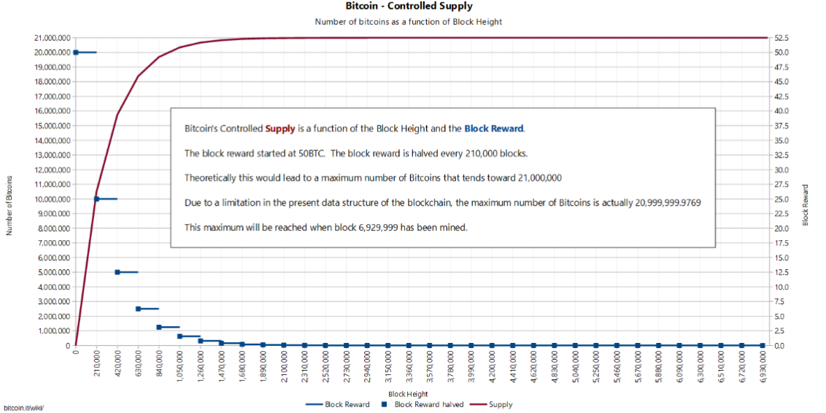

Figure 2: Controlled supply of Bitcoin by bitcoin.it/wiki (2018)

As the reader can see, the controlled supply of bitcoin will stagnate at around the 20 millionth bitcoin. The block height consequently is an inverse of the supply. The controlled supply chart does not present information on the difficulty, hash rate, or rate at which bitcoin is mined.

# Market Expectation

While the hash rate and mining efficiency determines the rate of bitcoin accumulation, the primary source for valuing cryptocurrencies is market expectation. The crypto markets have long been studied and researched to find any logical trends, with very little results. Because there has not been any clear indicator of how the crypto markets react to outside variables, coupled with the relatively short amount of existence, cryptocurrency prices fluctuate and change frequently daily. These prices are predominantly based on how the largest currencies relative to market share are valued. For example, Bitcoin and Ethereum have been the two giants whose prices in return have affected the prices of the rest of the coins. Even though there is no monopoly, the fact of the matter is that the largest currencies are the ones who shift the market itself. What historical prices and trends have indicated is that the cryptocurrency exchanges go through frequent periods of bullish behavior. A bullish market is one where prices and expectations increase over a short period. What happens afterwards some argue to be a “dip” “crash” or even “stabilization” in which prices go down hard and fast, recovering back to a comfortable medium within the next few days. Some view the bullish behavior and its frequency as an indicator of insider-coordination within large “whales”, or pools of people owning bitcoin. As a result, some claim that the price of bitcoin to be manually controlled by these large coin holders. This in return has called for more involvement from authorities and supervision.

# Implications of Historical Prices

What we can derive from the historical data and some of the largest crashes of bitcoin is that the market is still young and fragile. Many opponents of cryptocurrency argue that these datasets prove how unstable and short lasting this alternative form of finance is. On the other side we have the proponents who claim that the cryptocurrency market is experiencing growing pains, therefore must often adjust and correct the pricing. Were the cryptocurrency market based on raw output, its value would be based on the number of users trading and mining relative to the hash rate. The pricing is more subject to change via outside forces and market expectations.

# How Does Cryptography Work?

Think about receiving radio signals on your car’s radio that allows you to listen to the broadcast. This broadcast is public knowledge and open to everyone. By contrast, think about defense level communications, like that between soldiers on a combat mission. This communication will be secure and encrypted. It will be received by and known to only the intended participants instead of being open to the whole world. Cryptocurrency’s cryptography works in a similar way.

In the simplest terms, cryptography is a technique to send secure messages between two or more participants – the sender encrypts/hides a message using a type of key and algorithm, sends this encrypted form of message to the receiver, and the receiver decrypts it to generate the original message.

Encryption keys are the most important aspect of cryptography. They make a message, transaction or data value unreadable for an unauthorized reader or recipient, and it can be read and processed only by the intended recipient. Keys make the information “crypto”, or secret.

# Cryptography Methods Used In Cryptocurrencies

There are multiple methods exist for encryption in cryptography.

1. The first one is symmetric encryption cryptography. It uses the same secret key to encrypt the raw message at source, transmit the encrypted message to the recipient, and then decrypt the message at the destination. A simple example is representing alphabets with numbers – say, ‘A’ is ‘01’, ‘B’ is ‘02’, and so on. A message like “HELLO” will be encrypted as “0805121215,” and this value will be transmitted over the network to the recipient. Once received, the recipient will decrypt it using the same reverse methodology – ‘08’ is ‘H’, ‘05’ is ‘E’, and so on, to get the original message value “HELLO.” Even if unauthorized parties receives the encrypted message “0805121215,” it will be of no value to them unless they know the encryption methodology. The above is one of the simplest examples of symmetric encryption, but lots of complex variations exist for enhanced security. This method offers advantages of simple implementation with minimum operational overhead, but suffers from issues of security of shared key and problems of scalability.
2. The second cryptography method is asymmetric encryption cryptography, which uses two different keys – public and private – to encrypt and decrypt data. The public key can be disseminated openly, like the address of the fund receiver, while the private key is known only to the owner. In this method, a person can encrypt a message using the receiver’s public key, but it can be decrypted only by the receiver's private key. This method helps achieve the two important functions of authentication and encryption for cryptocurrency transactions.
3. The third cryptography method is hashing, which is used to efficiently verify the integrity of data of transactions on the network. It maintains the structure of blockchain data, encodes people’s account addresses, is an integral part of the process of encrypting transactions that occur between accounts, and makes block mining possible. Additionally, Digital Signatures complement these various cryptography processes, by allowing genuine participants to prove their identities to the network.

Multiple variations of the above methods with desired levels of customization can be implemented across various cryptocurrency networks.

# Literature Review

The literature review consists mainly of journal articles, guidelines, and legislature provided by experts and stakeholders with knowledge in the topic. Furthermore, the author has decided to take datasets that detail how cryptocurrencies operate in theory by models, as well as historical data of pricing and other variables. To arrive at a suitable conclusion, the data and research gathered will take into account some of the largest cryptocurrency markets in the world; Bermuda, China, Japan, Hong Kong, United States, European Union, Switzerland, and South Korea.

The purpose of this data is to understand a reasonable future road for cryptocurrencies as it stands, not as it should be. Because each form of regulation attempts to classify these coins under a certain category, this dissertation is essentially attempting to find out if government’s can incorporate cryptocurrencies into their financial policies. The paper also addresses the financial institutions stance and leverage in politics and the financial markets, because they have a great deal of influence in legislature.

# Access Control

The goal of access control is to check and restrict the actions that authorized users can perform within a computer system. Access control restrictions include what a user could perform directly as well as what programs can be executed on behalf of the users who are permitted to execute those programs. Access controls depend on cooperation with other existing security services. The following concepts are commonly used in the access control community.

**Object:** Resource to which the subject requests access (file, database, network resource, cloud service, and device, etc.)

**Subject:** in the form of user, device, process, or application requesting to access an object

**Permission:** The rules that govern who has access to which resources (For example, a manager may have permissions to see the dashboards while an accountant may keep track of the transactions on the general ledger)

**Access Control List (ACL):** Access control lists are a list of permissions that are associated with an object. It specifies who or which processes are granted access to the given object.

The development of access control systems is typically a multi-stage based on the following concepts:

**Security policy:** A set of high-level rules, which access control should be governed. (For example, managers can see to the dashboards)

**Security model:** A formal representation specified and enforced by security policies. It may establish a formal model of access rights, a model of computation, or model of distributed computing.

**Security mechanism:** A low-level implementation based on the security policy and model. It can be hardware or software.

# Cryptocurrency Has Revolutionized The Payment System:

In the recent times, the cryptocurrency has brought about transformational change in the online payment system. In the coming of years the different kinds of cryptocurrencies will expand at a faster rate. Various kinds of cryptocurrencies have come into existence such as the Litcoin, Tether, Ethereum, XRP, Dash, and many more. But the most successful cryptocurrency that has captured the attention of the tech freaks is the Bitcoin. The value of one Bitcoin unit in terms of the U.S. dollar. This rising trend shows that the innovative currency has gained high popularity and it will further gain more popularity due to its usefulness and unique value.

Most of the types of cryptocurrencies are fundamentally built by the professional computer experts and scientists who emphasize on overall feasibility, effectiveness and security aspects of this virtual payment model.

# The Future of Cryptocurrency:

These cryptocurrency uses the “peer-to-peer” technological model that enables different kinds of functions such as the issuance of currency, the processing activities relating to the transactions, and the verification process. This technology-based virtual model has grown to a large degree just in a decade and it is expected that the trend is likely to continue in the future as well.

In the recent years, this cryptography technology has come under high scrutiny so that the overall security aspects of the new model can be strengthened for its users. The main limitations that are presently faced by this innovative cryptocurrency model include the threats and risks from the online hacker, erase of the sensitive data from the computer system. In spite of the challenges that are faced by the Bitcoin cryptocurrency, the total number of the merchants that have started using the cryptocurrency has increased in the recent years.

Some economic analysts predict a big change in crypto is forthcoming as institutional money enters the market. Moreover, there is the possibility that crypto will be floated on the NASDAQ, which would further add credibility to blockchain and its uses as an alternative to conventional currencies. Some predict that all that crypto needs is a verified exchange traded fund (ETF). An ETF would definitely make it easier for people to invest in Bitcoin, but there still needs to be the demand to want to invest in crypto, which might not automatically be generated with a fund.

Currently, the exact future of the Bitcoin can’t be determined due to the dynamic nature of the technology and innovation. The emergence of the “Bitcoin” currency system has sparkled a lot of debate about the future of the cryptocurrency and its application for the customers in the coming times. In the coming years, the future of the Bitcoin cryptocurrency can be understood in a better and simplified manner.

# Scalability

In the 2020s, I believe we’ll see layer two solutions, or new blockchains come out which increase transaction throughput by several orders of magnitude. Just like broadband replacing 56k modems led to many new applications on the internet (YouTube, Uber, etc), I believe scalability is a pre-requisite for the utility phase of crypto to really get going. Once we see blockchains with several orders of magnitude scalability improvements, we will also see new applications start to develop more rapidly (see “the rise of the crypto start-up” below).

# Privacy

In addition to scalability, I think we’ll also see privacy integrated into one of the dominant chains in the 2020s. Just like how the internet launched with HTTP, and only later introduced HTTPS as a default on many websites, I believe we’ll eventually see a “privacy coin” or blockchain with built in privacy features get mainstream adoption in the 2020s. It doesn’t make sense in most cases to broadcast every payment you make on a transparent ledger.

# Consolidation

There are a number of high quality teams working on next generation protocols today and there are great teams working on layer two scaling solutions for existing chains. My prediction is that we will see consolidation of chains (in developer mindshare, user base, and market cap) in the decade to come. The chains that make the most progress on scalability, privacy, developer tools, and other features will see the most gains.

# The Rise of The Crypto Startup

This decade we will see a new type of startup become commonplace: the crypto startup. Just like the dot com craze kicked off the idea of an internet startup, I believe that by the end of the 2020’s almost every tech start-up will have some sort of cryptocurrency component. What defines a crypto startup?

Two things. First, it will raise money using crypto (from a much larger pool of global capital). Second, they will bring together global communities and marketplaces at a pace we have never seen before in traditional startups (which have to painfully expand country by country, integrating each country’s payment methods and regulations one at a time).

There are myriad regulatory questions this open up, but the advantages are so strong, I think the market will find a way. These crypto startups will have the challenge that all startups have: making something people want. The next 100M people who get exposure to cryptocurrency will not come from them caring about cryptocurrency, but because they are trying to play some game, use a decentralized social network, or earn a living, and using cryptocurrency is the best/only way to use that particular application.

# Emerging Markets

Other than crypto startups (which will largely start off being a first world phenomenon), the other area of adoption will be in emerging markets where the existing financial systems are a much bigger pain point. In particular, countries with high inflation rates and large remittance markets where crypto can really shine. In 2019, GiveCrypto.org made cryptocurrency payments to 5,000 people in Venezuela, and over 90% of them were able to create at least one transaction with a local store that accepts crypto or a local cash out partner. This indicates that the tools have started to cross a threshold of usability in emerging markets (where unreliable internet, older smartphones, and a lack of education can be challenges). In the 2020’s, I think we will see cryptocurrency adoption in emerging markets scale to hundreds of millions of users, with at least one country “tipping” so that the majority of transactions in their economy happen in cryptocurrency.

# Central Bank Digital Currencies (CBDCs)

While Libra (blockchain digital currency proposed by the American social media company Facebook) drew the ire of just about everyone in Washington DC. Whereas, China took the initiative by beginning to digitize the yuan, and making blockchain one of their core technology investments. The U.S. is playing a bit of catch up now, and active discussions are taking place about how the dollar can be digitized. CENTRE, with its USD Coin, may be the solution that U.S. turns to, or the Fed may try to implement their own digitized dollar using blockchain.

# Maturing Market Structure

During the last decade, many of the companies we think of as cryptocurrency exchanges were actually brokerages, exchanges, custodians, and clearing houses bundled into one. During the 2020’s I think we’ll see the cryptocurrency market structure evolve to more closely resemble the traditional financial world, with these functions being separated out from a legal and regulatory point of view. This is already happening to some extent. Coinbase Custody, for instance, is a separate company with its own board, regulated as a NY Trust Company. Coinbase Pro will separate into a brokerage and exchange as well.

By the end of the decade, most tech startups will have a crypto component, just like most tech startups use the internet and machine learning today. Governments and institutions will move into the cryptocurrency space in a big way as well.

# Chapter Summary:

In this chapter we discuss the literature review, methodology, methodology of research and its limitations, data acquisition, Cryptocurrency values, privacy, scalability and maturing market structure. In this chapter we briefly describe the blockchain technology and how does cryptography work? It is the future of cryptocurrency?

***Chapter 3***

# Response of Governments and Financial Institutions

# Big Banks

The response of the big banks has mainly been a defensive one focused on maintaining the current status quo. Cryptocurrencies and the blockchain network could ideally replace the current financial system by erasing the need of the intermediaries. An ideal scenario for the banks would be to implement the crypto-technology into their current system, absorb the markets, and expand their operations. However, cryptocurrency operates without centralized control, and likely its community would detest the “opportunity” that banks would provide. Big banks have not ruled out cryptocurrency yet, and what remains to be seen is how these two financial mediums will coexist, if possible.

Even though banks have been known to take highly risky investments and essentially gambled on money with derivatives, these terms have been on their playing field. Cryptocurrencies are a whole new platform where individual investors dare to take risks, not entire banks. For example, banks like Metro Bank and other large British banks have left cryptocurrency investors no choice but to relocate their funds to regions such as Gibraltar and Poland, where regulation is less strict.

If the questions above have answers that satisfy banks; their future will not be endangered, the decision on how to proceed comes next. This presents us with a few follow up questions:

* 1. Would the banks try to adopt cryptocurrencies, or would there be a schism between the two?
  2. What if the blockchain technology could be adopted without adapting its currencies?

The response of the Big Banks, notably in the United States, has been collectively antagonistic towards cryptocurrency. There is no agenda to promote investor’s and employees of the companies to consider diversifying their portfolio with these investments. The most obvious reason is the conflict of interest between these two financial platforms and how they threaten each other’s survival. However, the derivatives market and certain risky investors have gone ahead and took initiative, without full support from banks. The banks are aware of the importance of listening to their customers who experience “fear of missing out”, making them aware that there is a niche market for this. In summary, while banks are hesitant to give any thought to cryptocurrencies and see it as a threat to their existence, there are cases of risky investors within investment banks who fill a niche role and have involved themselves in the industry.

# China

The significance that China has and will have for the future of cryptocurrencies is unsurmountable. This is largely due to the rise of China as an economic leader in the world. Even with a restricted market, China can allow these digital currencies greater growth and expansion than in most western countries. The blurry lines between regulation of cryptocurrencies and its adoption are why large factory sized mining operations conducted business in China. These mining factories take advantage of cheap fixed costs such as electricity, rent, and lighting. Unsurprisingly, China has become the largest “miner” of currencies such as bitcoin in the world.

China’s government will continue to limit the potential of these digital markets until there is stability and regulation. Financial regulators are aware of its prospects and possible gains in the future but take precautions in order minimize risk. Therefore cryptocurrencies are listed as a “virtual commodity” instead of what their original purpose is. China’s stance emits the notion that while they are open to the future of it, right now they want to play it safe and keep it under strict guidelines and out of the banks reach.

China has been maintaining a defensive stance even though they have the capabilities to lead this new technology to unseen heights. The primary reason for this is that China exercises an authoritarian state capitalistic model with incremental reform and emphasis on growth through exports. China’s leaders want to manage the economy from the topdown and ensure that plans coincide with the government’s path. Technology such as blockchain can provide a boost to China, but only when it can fit into their ideology. The conundrum arises when we consider how the ideology that Mr. Satoshi Nakamoto spread conflicts and quarrels with China’s planned capitalistic model. Digital currencies are reluctant for state interference and third-parties parties in general. Furthermore, China as of 2017 has the second largest unbanked population in the world (Yang 2016 referencing World Bank 2016).

The problem lies in that Bitcoin does not require a bank account to access, therefore the millions of “unaccounted” cryptocurrency ownes could form their own market that is separate from official bank accounts. In such a controlled country, the possibility of a split in the type of market would create too large a gap for authorities to manage.

The response of China towards cryptocurrency has proven that while it does not fully support or approve of its widespread utilization, they have not completely ruled it out of the equation. The qualms that the Chinese have against cryptocurrency are largely based on a difference of ideology and currently the incompatibility to regulate it. Deciding that these coins are not currency but rather a commodity prevents large Chinese banks from adopting it as a contender to the renminbi. They have gone as far as banning initial coin offerings (ICO’s) so that the market cannot expand its boundaries further. On the other hand, they are quite aware of its prospects and the widespread and highly professional mining operations that are conducted in large factories in certain regions of China.

These mining projects are the reason why bitcoin is the most “mined” or “harvested” cryptocurrency in china, as well as the world. The fact of the matter is that China has not turned its gaze from this new technology and are merely putting certain counter mechanisms to decrease its growth in order to figure out a proper way to possibly integrate it. Unfortunately, from the perspective of cryptocurrency enthusiasts and investors, it would mean to abide by Chinese expectations of economic theory and giving up anonymity and free market expectations.

# South Korea

Before the crypto boom took off in late 2017, the South Korean government had already banned Initial Coin Offerings in September. According to J. Kwon in CNN Tech; “The country is home to three of the world's biggest bitcoin exchanges. On any given day, South Korea accounts for as much as 20% of all bitcoin trades around the world.” (Kwon 2017). This was back in December of 2017, when the demand for trading crypto was so high that local traders in South Korea came up with the term “Kimchi Premium”; the premium paid for Bitcoin by 15-25% over global prices.

Politically, the South Koreans also fear that these currencies are potential sources of investment for North Korean armament. There has been discussion on the possibility of North Korea also mining cryptocurrencies. However, because there is very little proof of the relationship between cryptocurrency and North Korean military prowess, this paper will not delve into this matter.

# United States of America

The response of the United States government on the status of bitcoin has been passive. USA has yet to classify it according to their legislature, instead treading on a grey and murky territory as Kaplanov explains;

“Bitcoins fall within a gray area under U.S. law in which they are not necessarily outlawed but still give rise to contractual obligations. Therefore, they should be treated like a local or community currency under the law—receiving full authority as a medium of payment under contract law, requiring taxation on income” (Kaplanov 2012: 150).”

Lastly, the United States government needs to distinguish the boundaries of cryptocurrency on a federal and state level. If the responsibility of creating a framework is left to the states, the result would be much like how gambling is treated in legislature. This would be a severe setback for the longevity and usability of cryptocurrencies in the United States. It would be in the interest of all stakeholders that legislature be drawn up at a federal level instead.

# Switzerland

What makes Switzerland proactive in the cryptocurrency market is that while it recognizes the absence of solid regulation in the market for digital currencies, they have initiated a categorization for future ICO “tokens”. Tokens are the coins that are paid out from initial coin offerings, which they divided into 3 categories. These categories should encompass all current and future tokens.

The figure in the next page represents the Swiss vision of how cryptocurrencies to be classified within three prominent categories. These three categories are based upon the usability, purpose, and overall value that they bring. It is important to note that not all countries or individuals think of cryptocurrencies as being innately different from one another, while some such as the Swiss government find there to be great contrasts within the crypto markets.

|  |  |  |  |  |
| --- | --- | --- | --- | --- |
| Payment tokens |  | Utility tokens |  | Asset tokens |
| • Synonymous with cryptocurrencies, intended to be used as a means of payment for acquiring goods or services, or as a method of value transfer.  o Not securities   * Purpose of payment tokens is to act as a means   of payment   * Not analogous in their function to traditional   Securities | • Provide access to digitally to an application or service through usage of blockchain technology.  o Not securities  ▪ If sole purpose is to confer digital access rights to an application or service and can be used in this way at the point of issue  o Securities  ▪ If utility token additionally or only has an investment purpose at the point of issue | • Debt or equity that promise a share or future cash flows into a company’s future capital flows. Similar to equities, bonds, or derivatives.  o Securities  ▪ Asset tokens have functions that are equal to modern bonds, derivatives and shares therefore possess same classification |

Categorization of Tokens in Switzerland

# European Union

The European Union has managed to set things in motion regarding the implementation of cryptocurrency in legislature. While some could say this to be because of a generally positive reception of this technology in Europe, it is also likely because the EU needs to respond quickly to avoid bureaucratic problems. Furthermore, the European Union has not prohibited or limited the mining operations like China, and there is a growing market here that is establishing a long-term production for these currencies.

The approach that the EU has taken is to start with an open mind and consider the possible outcomes of coins such as bitcoin. In 2014, the European Banking Authority (EBA) published an analysis and opinion concerning the risks of virtual currencies if they are not regulated. What they found was that while the legality of digital currencies is murky, there are merits to its existence. Their analysis was completed by utilizing a tool “which can build EU legislation concerning cryptocurrency in the future” (Nahornia, Leonova & Skorokhod 2016: 116). Even without a clear roadmap for cryptocurrency, the European Union is attempting to construct a rigid framework for it.

# Analysis of Cryptocurrency in Today’s Environment

# SWOT Analysis

Strengths

* Peer-to-peer network
* Transaction speed
* Blockchain Technology
* Disintermediation

Weaknesses

* Lack of regulation
* Tarnished image
* Increasing transaction costs
* No central figurehead or spokesperson / community fragmented
* Oversaturated by new currencies and initial coin offering’s

Opportunities

* Digital payment system
* Replace current legal tenders
* Can be beneficial to third world countries
* Similarity to gold standard era

Treats

* Current financial system
* Government regulation
* Grey and black market funding
* Susceptible to bubble

# PESTLE Analysis

Political

* Government regulation
* Taxation
* Classification

Social

* Anonymity
* Representation of crypto community Classification

Legal

* Black market
* Conflict of interest for banks Representation of crypto community

Economic

* Fiat money
* Comparison to current legal tenders
* Physical vs digital

# Use Cases

|  |  |
| --- | --- |
| Use case UC1 | View Coins |
| Primary Actor | First Consumer |
| Secondary Actor | Second Consumer |
| Pre-Condition | * Consumer must sign up. * Consumer must login. |
| Post-Condition | * Consumer views cryptocurrency values * Consumer sale and purchase digital coins |
| Main Success Scenario | * Transition successfully * Security * No third party involved |
| Special Requirements | Access the authentications |

|  |  |
| --- | --- |
| Use case UC2 | Cryptocurrency payments |
| Primary Actor | Consumer |
| Secondary Actor | Admin |
| Pre-Condition | * Consumer must sign up. * Consumer must login. * Consumer payment method |
| Post-Condition | * Consumer views the transition payment date |
| Main Success Scenario | * Transition are successful |
| Special Requirements | If the coins aren’t sends, the payments will be send after 24 to 48 hours. |

# Chapter Summary:

In the chapter 3 we discuss the government’s policy (including Chinese polices, United States policies and European policies), analysis of cryptocurrency, and also we describe the Use Cases.

***Chapter 4***

# Project Management

# Milestones

**Goal A1:**

* Identify Customers
* New payment gateway
* Market Analysis
* Awareness of Blockchain technology

**Goal A2:**

* Design and Infrastructure
* Transition successfully

# Cryptocurrency Works

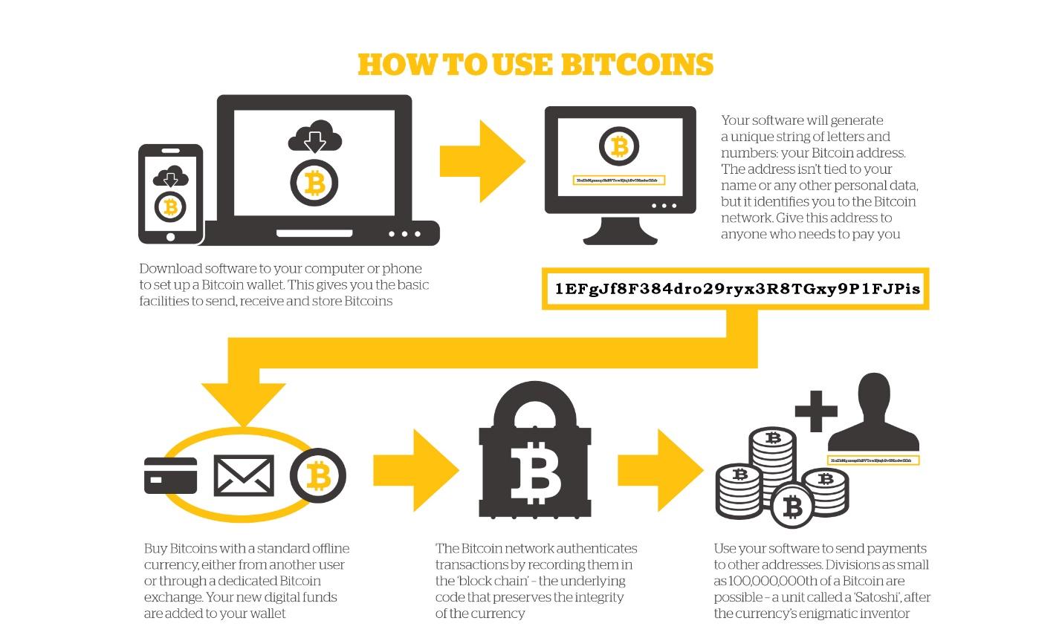

Figure 3: bitcoin.org

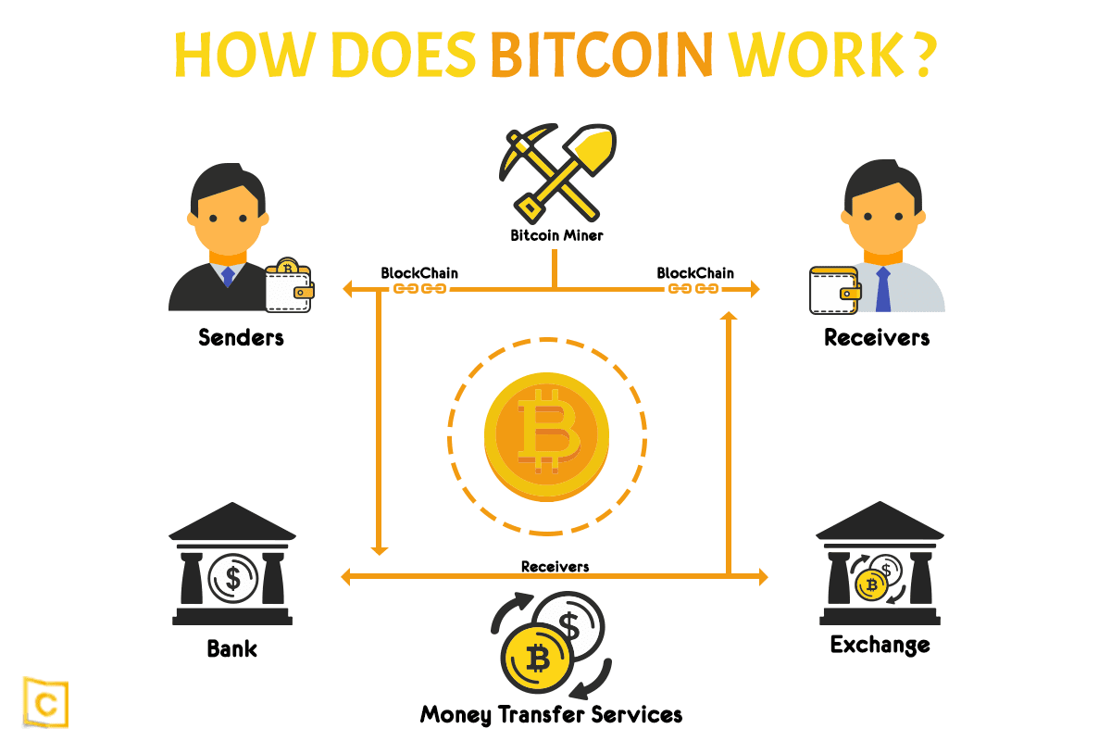

Figure 4: medium.com

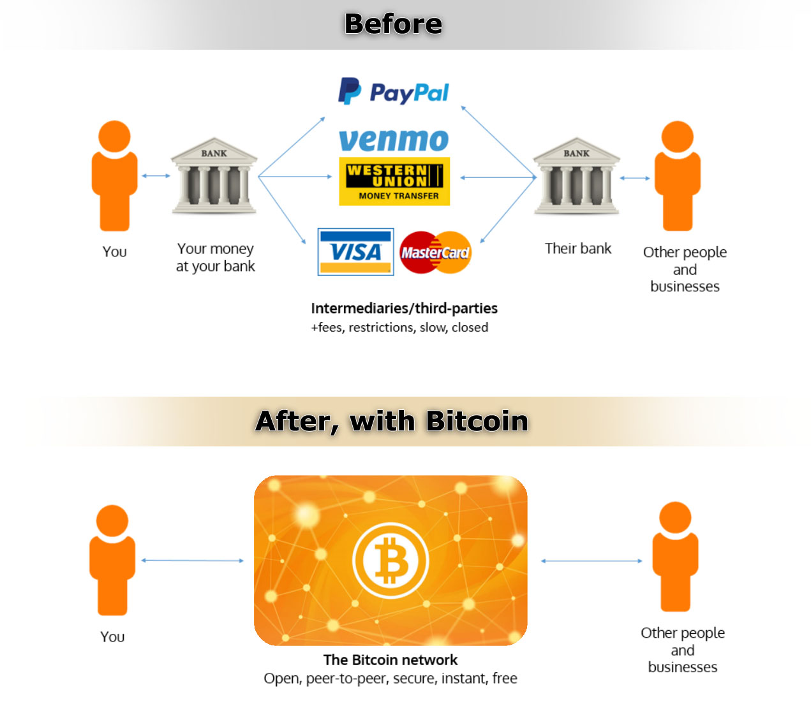Figure 5: reddit.com

# Risk Management System

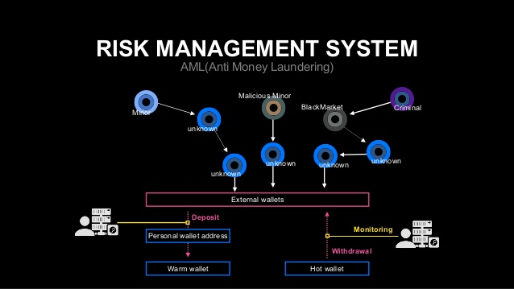

Figure 6: slidesharecdn.com

# Cryptocurrency Price Analysis

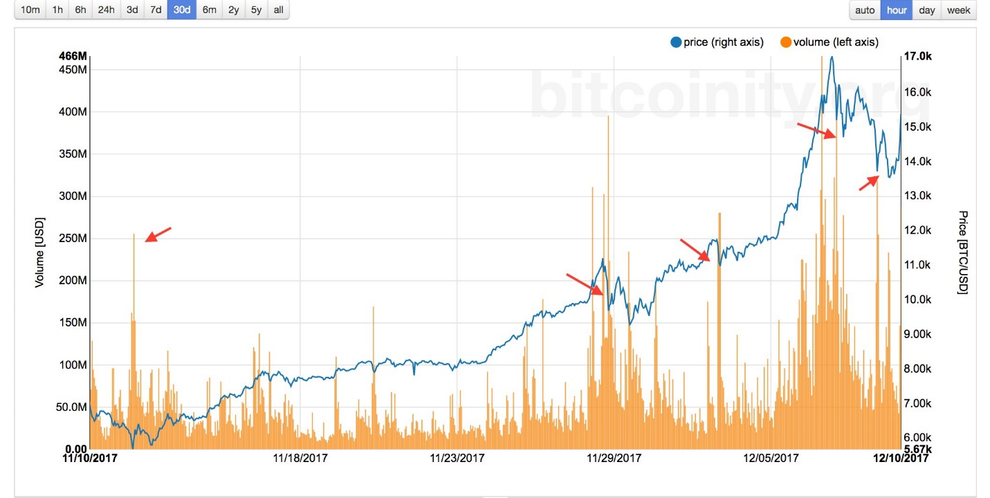

Figure 7: medium.com

# Chapter Summary

In the chapter 4 we discuss the project management. In project management we discuss the milestones, cryptocurrency works, risk management system, and cryptocurrency price analysis.

# *Chapter 5*

# Project Implementation

# Programming Language

# Java

Java is a high-level programming language developed by Sun Microsystems. It was originally designed for developing programs for set-top boxes and handheld devices, but later became a popular choice for creating web applications.

Java was designed to have the look and feel of the C++ programming language, but is simpler to use and enforces an object-oriented programming model. For example, most Java programs contain classes, which are used to define objects, and methods, which are assigned to individual classes. Java can be used to create complete applications that may run on a single computer or be distributed among servers and clients in a network. It can also be used to build a small application module or applet for use as part of a webpage.

Java is also known for being more strict than C++, meaning variables and functions must be explicitly defined. This means Java source code may produce errors or "exceptions" more easily than other languages, but it also limits other types of errors that may be caused by undefined variables or unassigned types.

# Python

Python is an interpreted, object-oriented, high-level programming language with dynamic semantics. It is open source, which means it is free to use, even for commercial applications. Its high-level built in data structures, combined with dynamic typing and dynamic binding, make it very attractive for Rapid Application Development, as well as for use as a scripting or glue language to connect existing components together.

Python's simple, easy to learn syntax emphasizes readability and therefore reduces the cost of program maintenance. Python supports modules and packages, which encourages program modularity and code reuse. The Python interpreter and the extensive standard library are available in source or binary form without charge for all major platforms, and can be freely distributed. Python offers dynamic data type, ready-made class, and interfaces to many system calls and libraries. It can be extended, using the C or C++ language.

# System Requirement

Following are the system requirements that must be fulfilled while implementing cryptocurrency prediction project:

* Windows 8 or above.
* RAM 8 GB or above
* Android 7.0 and above
* Cloud database and hosting sever

# Chapter Summary

This chapter is about how we implemented our cryptocurrency project. In this chapter, we described the programing language, tools and technologies which were used during implementation. In this chapter. We have also discussed basic system specifications which are necessary in game implementation.

# *Chapter 6*

# Software Testing

This chapter is going to highlight and document the test that ran on our project to ensure its durability and responsiveness.

# Cryptocurrency

# Predications

In my final year project (FYP), we analyze the different types of cryptocurrency data, and predict the coins value. It is much easier for the customer to buy or sell digital coins.

# Selling and Buying

We're selling or buying various kinds of digital coins including bitcoin, ethereum, Cardano, XRP and some other coins.

# User ID

Each customer has a unique identity. The customer can easily find another customer where he sold or bought digital coins.

# Payment Method

We used different kind of payment method including digital wallets, banks, PayPal, Stripe, and other payment method to collect the money.

# Chapter Summary

In the chapter we discuss the software testing. In software testing we predict the digital coins, user analysis, payment method and selling or buying the cryptocurrency coins.

# *Chapter 7*

# Conclusion and Future Work



# Discussion

As a learning point of view this project provided us with a knowledge and experience that is beneficial for future. Blockchain technology has become popular due to its successful adoption for cryptocurrencies like Bitcoin. Blockchains act as decentralized systems for recording and documenting transactions that take place involving a particular digital currency. It can be difficult to send and receive large sums of money, which is why cryptocurrencies are the new face of finance in your business. This distributed digital ledger has many advantages as it can keep the records of all data or money transaction made between any two parties in a secure, immutable, and transparent manner.

According to Forbes, with time the trust factor in the capabilities of blockchain is expected to rise. The real impact of a distributed ledger is still under speculation, but given the spurt of applications already crowding the markets, it is only a matter of time before blockchain penetrates every industry sector.

While Bitcoin and other cryptocurrencies grew intensely popular among the general financial and investment worlds in late 2017 and early 2018, they have since become more of a niche area for cryptocurrency enthusiasts. However, blockchain technology remains a quickly-growing area of growth for companies across a host of industries. It is possible that blockchain technology will ultimately be seen as the most important innovation to come out of the cryptocurrency boom.

Here are some practical applications of blockchain in the insurance industry:

* Blockchain ensures integrity of personal information, offering full control to the insurer.
* Blockchain reduces operational cost by automating insurance processes.
* Blockchain helps detect and prevent fraud.
* Blockchain enhances trust among all parties involved in an insurance contract or claim.
* Blockchain can help develop efficient actuarial models, based on the most updated information.

During the designing phase, we have learnt:

* Blockchain technology
* Python and Java language
* Machine Learning

During testing and implementation finding a bug and its fixture was totally a new and healthy experience. One of the most important aspects of the project was how to document our project properly. 

# Conclusion

The project was a lot of fun, along with the learning that will be of great benefit to our career growth and future. After many difficulties and failures, we have reached our modules. It gave us a lot of knowledge and developed the ability to carry out a final year project. We are very grateful to our supervisor who has helped us in every phase of development. He made it possible for us to complete this challenging task on time. Providing attractive environments and ideas.

# Future Work

In the future, we develop the payment gateway using blockchain technology. Because everything on a blockchain is open to others on the same network, it will cause more transparency over salaries. It could also help align pay more accurately with performance. That could spell the end for the gender pay gap and other discrimination.

People globally use the method of cryptocurrency, and it is undoubtedly very useful as well. With the help of cryptocurrency, funds can be exchanged faster. Cryptocurrency is simply the future of digital payments, and therefore has a strong effect on the global economic system.

# Exchanging Payments

We are offering crypto buying, selling, sending and spending, even borrowing and a stock exchange system; there is a lot that people want their money to be able to do. I believe that very few companies will be successful by just being a great exchange, so the route to success for most will be to build an ecosystem that people need for everyday life.

# Moving Forward

The way in which people are making payments has been continuously evolving as new wants and needs emerge from the population. The path to mass adoption and acceptance always varies, but what is good to see is the potential of cryptocurrencies are being pushed by a payment method that has already made great strides to be the immediate future - payment apps.

Cryptocurrencies are almost ahead of their time, and there needs to be a stop gap - which can integrate with their possibilities - before there is a real adoption of cryptocurrencies for payments. If cash apps can do that, while offering cryptocurrency options in their multifunctional mandate, then the path for crypto payment adoption is already laid out.

# References

1. <https://lutpub.lut.fi/bitstream/handle/10024/160115/Milan_Halas_Masters_Thesis_2019LUTUniversity.pdf?sequence=1&isAllowed=y>
2. <https://openaccess.leidenuniv.nl/bitstream/handle/1887/64833/MA%20Thesis%20-%20Arthur%20Bos.pdf?sequence=1>
3. <https://skemman.is/bitstream/1946/30832/1/The%20future%20of%20blockchain%20technology%20and%20cryptocurrencies..pdf>
4. <https://pure.tue.nl/ws/portalfiles/portal/102712345/Master_Thesis_Rob_Kuijpers.PDF>
5. <https://www.europarl.europa.eu/cmsdata/150761/TAX3%20Study%20on%20cryptocurrencies%20and%20blockchain.pdf>
6. <https://core.ac.uk>
7. [https://www.coindesk.com](https://www.coindesk.com/)
8. <https://bitcoin.org>
9. [https://coinmarketcap.com](https://coinmarketcap.com/)
10. [https://www.blockchain.com](https://www.blockchain.com/)
11. <https://www.investopedia.com/tech/explaining-crypto-cryptocurrency>
12. <https://blog.coinbase.com>
13. <https://nvlpubs.nist.gov/nistpubs/ir/2018/NIST.IR.8202.pdf>

Screenshots­