Javascript
- 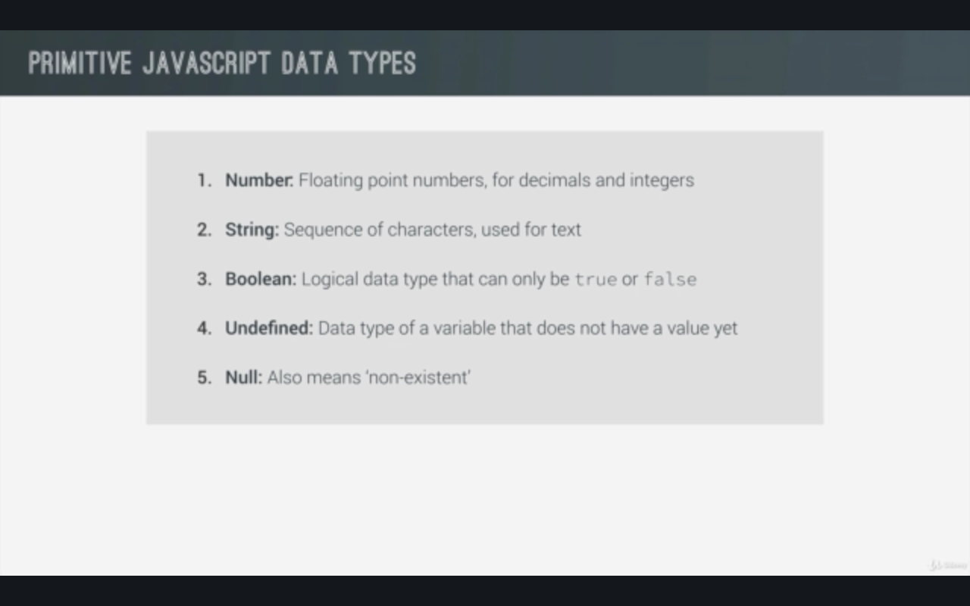

- Javascript has a dynamic typing: datatypes are automatically assigned to variables

- With the help of prompt we can take the input

- === is more strict than == as it doesn’t do type coercion it means if there is height=23 and condition height==’23’ then == will convert ‘23’ into 23

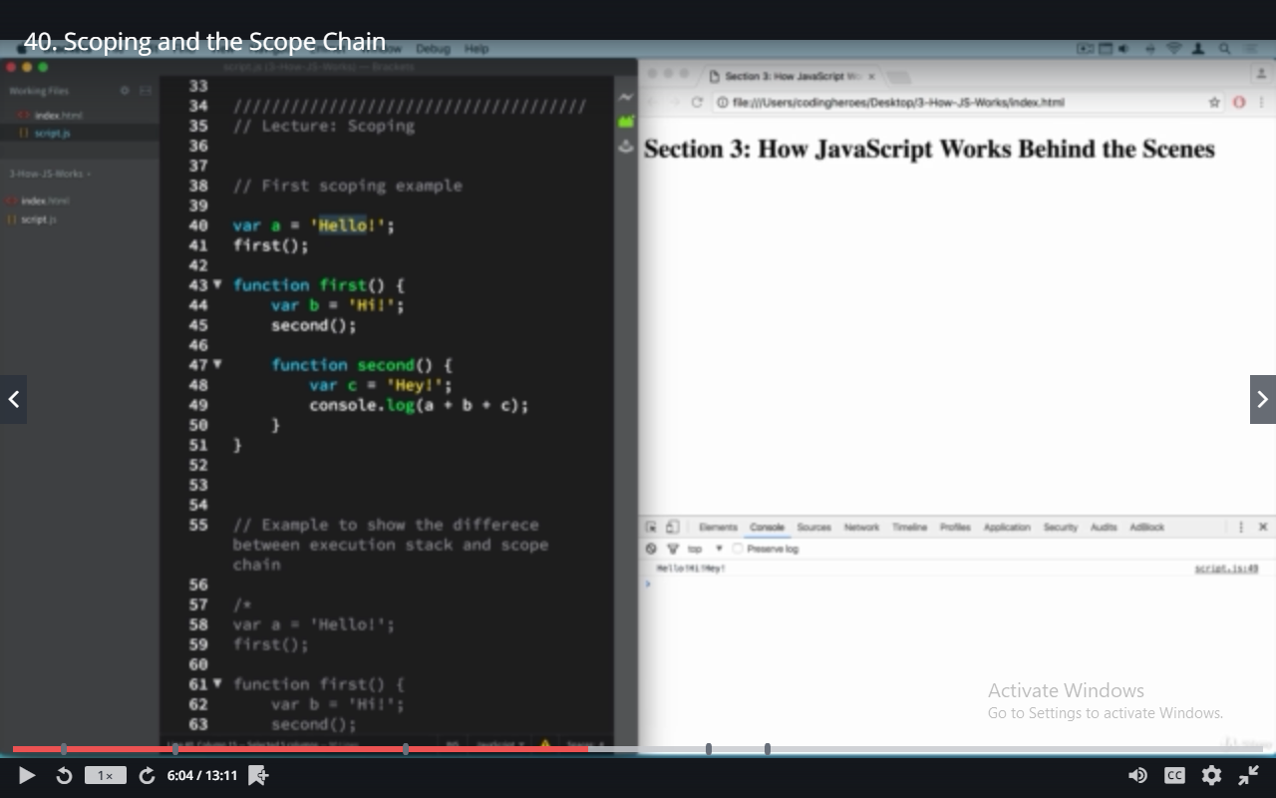

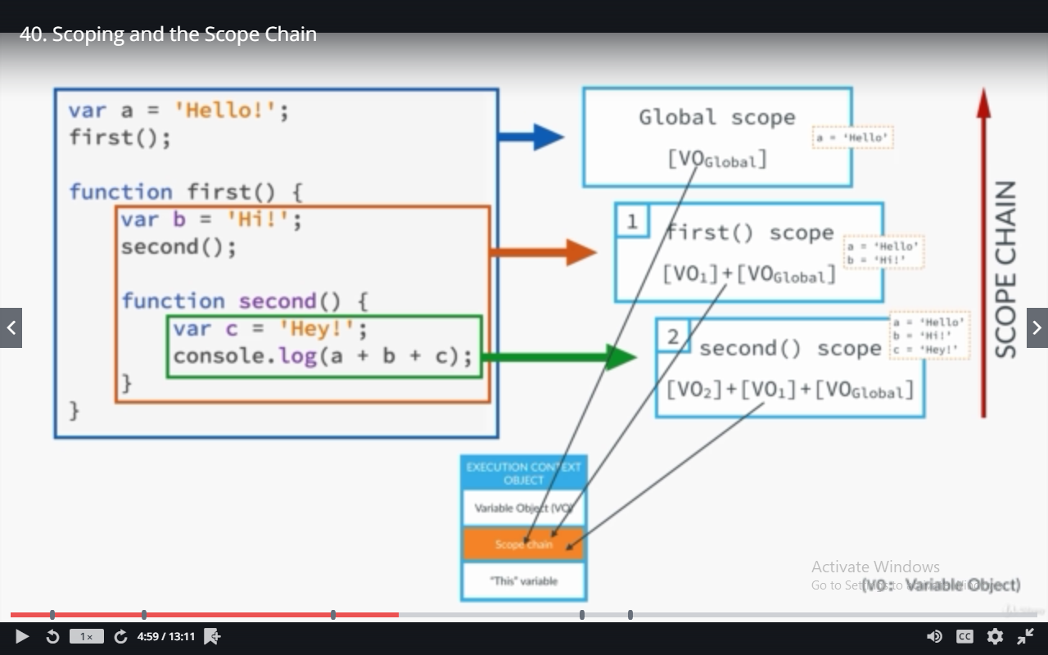

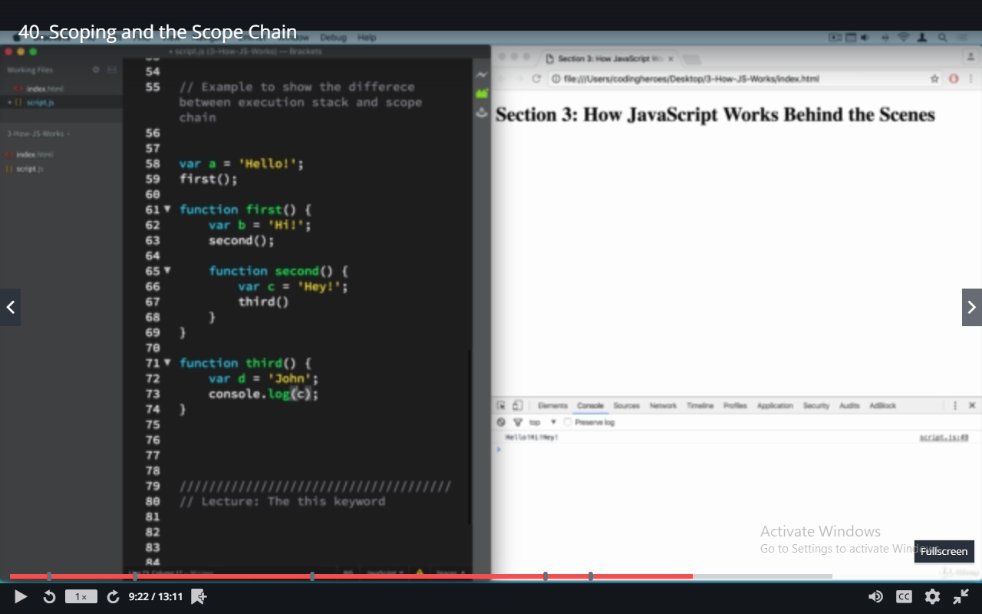
this keyword refers to the object that calls the method
when we call regular function then this keyword points to the window object

