PRE-IMPACT FALL DETECTION ON ESP32
Organized Project Proposal, Implementation and Deployment Report
Prepared from the completed Kaggle training and Wokwi/PlatformIO implementation
Date: 24 August 2026

1. Executive Summary
এই project-এর লক্ষ্য হলো waist-worn inertial sensor ব্যবহার করে body-ground impact-এর আগে fall বা pre-impact alert শনাক্ত করা এবং trained compact neural network-টি কম খরচের ESP32 microcontroller-এ চালানো। Public benchmark dataset ব্যবহার করে Kaggle GPU-তে model training, INT8 quantisation, এবং Wokwi-তে ESP32 firmware verification সম্পন্ন করা হয়েছে।
চূড়ান্ত Wokwi replay demonstration-এ KFall-এর S06T20R01 fall trial replay_data.h-এর মাধ্যমে ESP32 firmware-এ প্রবেশ করেছে। Model ধারাবাহিকভাবে উচ্চ fall probability দিয়েছে এবং threshold অতিক্রম করলে LED ও active buzzer alarm চালু হয়েছে।

2. Project Objectives and Contributions
কোড | Contribution | Completed status
C1 | Cross-dataset generalisation: SisFall, KFall, FallAllD এবং UMAFall দিয়ে evaluation | Kaggle pipeline completed; LODO outputs generated
C2 | Pre-impact/alert-oriented detection using temporal fall information | KFall replay and alert/fall classes integrated
C3 | TinyML deployment: INT8 model on ESP32 with real-time windowing | Wokwi/PlatformIO inference completed

3. End-to-End System Architecture
সম্পূর্ণ data-to-deployment pipeline:
Public datasets → verification → preprocessing → 50 Hz harmonisation → 2 s windows → subject/grouped training → FP32 model → full INT8 quantisation → model_data.h → ESP32 firmware → Wokwi replay/live sensor → probability → LED/buzzer alarm

4. Datasets Used
Dataset | Project role | Important format/processing
SisFall Enhanced | Training and cross-dataset evaluation | Three-class pre-windowed release; current archive has no original subject IDs
KFall | Primary pre-impact source and replay trial | 100 Hz CSV; onset/impact labels in XLSX; low-back IMU
FallAllD | Unseen-domain LODO test | 238 Hz .dat; waist device selected; acceleration and gyro used
UMAFall | Held-out stress test | Semicolon CSV; waist sensor ID selected; resampled to 50 Hz
UP-Fall deliberately বাদ দেওয়া হয়েছে, কারণ sampling-rate mismatch এবং অত্যন্ত বড় multimedia release এই protocol-এর সঙ্গে সামঞ্জস্যপূর্ণ নয়।

5. Preprocessing Protocol
Item | Frozen value
Channels | ax, ay, az, gx, gy, gz
Working sampling rate | 50 Hz
Window length | 2.0 seconds = 100 samples
Stride | 0.5 seconds = 25 samples
Acceleration unit | g
Gyroscope unit | degree/second
Normalisation | Training-only channel mean/std; frozen in model_config.h
Quantisation | INT8; input scale and zero point from TFLite model

6. Model Architecture
Input (100 × 6)
→ Conv1D(24, kernel=7, stride=2) + BatchNorm + ReLU
→ SeparableConv1D(48, kernel=5) + BatchNorm + ReLU + MaxPool
→ SeparableConv1D(64, kernel=3) + BatchNorm + ReLU
→ GlobalAveragePooling1D
→ Dense(32) + ReLU + Dropout(0.3)
→ Dense(3) + Softmax
Classes: 0 = non-fall, 1 = alert, 2 = fall

7. Kaggle Results and Deployment Artifacts
Metric | Observed value
Proposed model grouped-5 F1 | 0.5385686274509804
Proposed model AUC | 0.9585663870104382
Parameters | 8219
INT8 model size | 19.4609375 KB
Estimated tensor memory | 25194 bytes
FP32 → INT8 F1 delta | 1.070234113712376 percentage points
এই metrics Kaggle run-এর output থেকে এসেছে। SisFall release-এর subject-ID limitation এবং simulated/replayed data-এর সীমাবদ্ধতা paper-এ স্পষ্টভাবে উল্লেখ করতে হবে।

8. Realistic Wiring Diagram
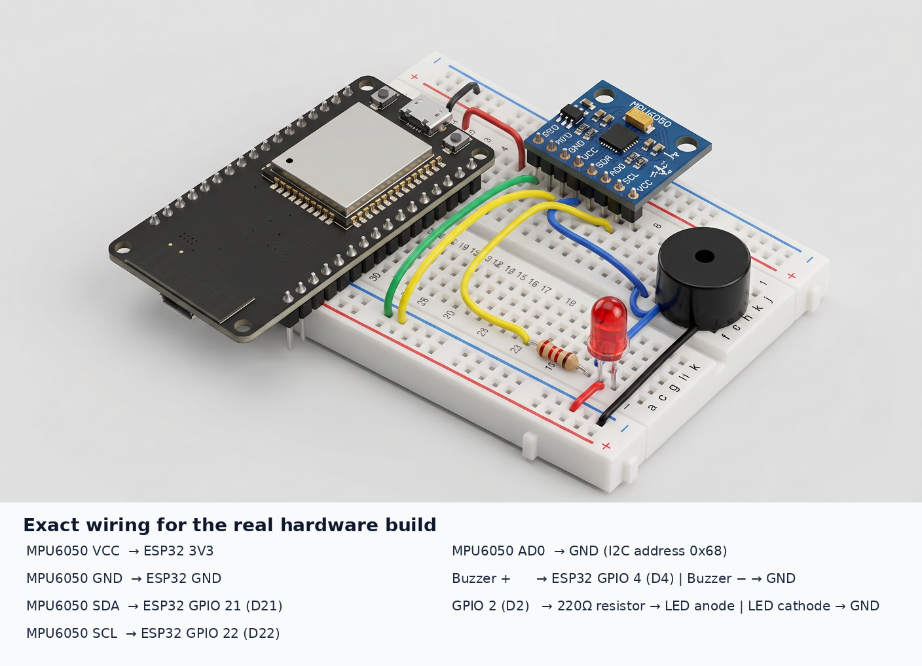

9. Physical Wiring Table
Component pin | ESP32 connection | Note
MPU6050 VCC | 3V3 | 5V ব্যবহার করবে না
MPU6050 GND | GND | Common ground
MPU6050 SDA | GPIO 21 / D21 | I2C data
MPU6050 SCL | GPIO 22 / D22 | I2C clock, 400 kHz
MPU6050 AD0 | GND | Address 0x68
Buzzer + | GPIO 4 / D4 | High signal activates buzzer
Buzzer − | GND | Common ground
LED anode | GPIO 2 / D2 through 220Ω | Series resistor mandatory
LED cathode | GND | Common ground
LiPo + | TP4056 B+ | Only if battery build is used
LiPo − | TP4056 B− | Only if battery build is used
TP4056 OUT+ | ESP32 VIN | Verify regulator/input arrangement
TP4056 OUT− | ESP32 GND | Common ground

10. Physical Setup Procedure
1. Breadboard-এ ESP32 এবং MPU6050 বসাও।
2. MPU6050 VCC-কে ESP32 3V3 এবং GND-কে GND-তে connect করো।
3. SDA → GPIO21 এবং SCL → GPIO22 connect করো।
4. AD0 → GND connect করে 0x68 address নিশ্চিত করো।
5. GPIO4-এ active buzzer এবং GPIO2-তে 220Ω resistorসহ LED connect করো।
6. ESP32-তে USB power দিয়ে প্রথমে serial test করো।
7. Serial output-এ MPU6050 READY এবং I2C address 0x68 নিশ্চিত করো।
8. তারপর physical firmware flash করো।
9. Safe soft-surface movement দিয়ে test করো; মানুষের উপর unsafe fall test করবে না।

11. Physical ESP32 Firmware — Live Sensor Mode
নিচের firmware-টি physical ESP32-তে ব্যবহার করার জন্য। এটি live MPU6050 input ব্যবহার করে। Replay mode নয়; তাই REPLAY_MODE = 0 রাখা হয়েছে।
#include <Arduino.h>
#include <Wire.h>
#include <Adafruit_MPU6050.h>
#include <Adafruit_Sensor.h>
#include <math.h>
#include "TensorFlowLite_ESP32.h"
#include "model_config.h"
#include "model_data.h"
#include "replay_data.h"
#include "tensorflow/lite/micro/all_ops_resolver.h"
#include "tensorflow/lite/micro/micro_error_reporter.h"
#include "tensorflow/lite/micro/micro_interpreter.h"
#include "tensorflow/lite/schema/schema_generated.h"
#define REPLAY_MODE 0
Adafruit_MPU6050 imu;
const int SDA_PIN=21, SCL_PIN=22, BUZZER_PIN=4, LED_PIN=2;
const float GRAVITY=9.80665f, GYRO_RAD_TO_DEG=57.2957795f;
const int WINDOW_SAMPLES=100, MODEL_INPUT_CHANNELS=6, STRIDE_SAMPLES=25;
const float MODEL_THRESHOLD=0.60f;
const unsigned long SAMPLE_INTERVAL_MS=20, ALARM_DURATION_MS=1000, ALARM_COOLDOWN_MS=5000;
const float NORMALIZATION_MEAN[6]=NORM_MEAN;
const float NORMALIZATION_STD[6]=NORM_STD;
constexpr int TENSOR_ARENA_SIZE=64*1024;
uint8_t tensor_arena[TENSOR_ARENA_SIZE] __attribute__((aligned(16)));
static tflite::MicroErrorReporter micro_error_reporter;
static tflite::AllOpsResolver resolver;
const tflite::Model* model=nullptr;
tflite::MicroInterpreter* interpreter=nullptr;
TfLiteTensor* input_tensor=nullptr;
TfLiteTensor* output_tensor=nullptr;
float imu_buffer[WINDOW_SAMPLES][MODEL_INPUT_CHANNELS];
int buffer_head=0, total_samples=0, replay_index=0;
bool model_ready=false, alarm_active=false;
unsigned long last_sample_time=0, alarm_start_time=0;
bool i2c_exists(uint8_t address){ Wire.beginTransmission(address); return Wire.endTransmission()==0; }
void scan_i2c(){
Serial.println("Scanning I2C bus...");
int n=0;
for(uint8_t a=1;a<127;a++) if(i2c_exists(a)){
Serial.print("I2C device found at address: 0x"); if(a<16)Serial.print("0"); Serial.println(a,HEX); n++;
}
Serial.print("Total I2C devices found: "); Serial.println(n);
}
void read_live_sample(float s[6]){
sensors_event_t a,g,t;
imu.getEvent(&a,&g,&t);
s[0]=a.acceleration.x/GRAVITY;
s[1]=a.acceleration.y/GRAVITY;
s[2]=a.acceleration.z/GRAVITY;
s[3]=g.gyro.x*GYRO_RAD_TO_DEG;
s[4]=g.gyro.y*GYRO_RAD_TO_DEG;
s[5]=g.gyro.z*GYRO_RAD_TO_DEG;
}
void read_replay_sample(float s[6]){
if(replay_index>=REPLAY_SAMPLES){
replay_index=0;
Serial.println("KFall replay sequence restarted");
}
for(int c=0;c<6;c++) s[c]=replay_data[replay_index][c];
replay_index++;
}
int8_t quantize_value(float value){
int q=(int)round(value/INPUT_SCALE)+INPUT_ZERO_POINT;
if(q>127)q=127; if(q<-128)q=-128; return (int8_t)q;
}
void fill_input(){
for(int t=0;t<WINDOW_SAMPLES;t++){
int bi=(buffer_head+t)%WINDOW_SAMPLES;
for(int c=0;c<MODEL_INPUT_CHANNELS;c++){
float z=(imu_buffer[bi][c]-NORMALIZATION_MEAN[c])/NORMALIZATION_STD[c];
input_tensor->data.int8[t*MODEL_INPUT_CHANNELS+c]=quantize_value(z);
}
}
}
float output_probability(int c){
return (output_tensor->data.int8[c]-output_tensor->params.zero_point)*output_tensor->params.scale;
}
void start_alarm(float alert_p,float fall_p){
alarm_active=true; alarm_start_time=millis();
digitalWrite(LED_PIN,HIGH); digitalWrite(BUZZER_PIN,HIGH);
Serial.println("==============================");
Serial.println("AI ALARM: POSSIBLE FALL");
Serial.print("Alert probability: ");Serial.println(alert_p,4);
Serial.print("Fall probability: ");Serial.println(fall_p,4);
Serial.println("==============================");
}
void stop_alarm(){
alarm_active=false; digitalWrite(LED_PIN,LOW); digitalWrite(BUZZER_PIN,LOW); Serial.println("AI ALARM: OFF");
}
void run_inference(){
fill_input();
if(interpreter->Invoke()!=kTfLiteOk){ Serial.println("ERROR: TensorFlow Lite model invocation failed"); return; }
float p0=output_probability(0), p1=output_probability(1), p2=output_probability(2);
Serial.print("p_nonfall=");Serial.print(p0,4);
Serial.print(" p_alert=");Serial.print(p1,4);
Serial.print(" p_fall=");Serial.println(p2,4);
unsigned long now=millis();
if((p1>=MODEL_THRESHOLD||p2>=MODEL_THRESHOLD)&&!alarm_active&&now-alarm_start_time>=ALARM_COOLDOWN_MS) start_alarm(p1,p2);
}
bool initialize_model(){
Serial.println("Loading INT8 TensorFlow Lite model...");
model=tflite::GetModel(model_data);
if(model==nullptr){Serial.println("ERROR: model pointer is null");return false;}
static tflite::MicroInterpreter static_interpreter(model,resolver,tensor_arena,TENSOR_ARENA_SIZE,&micro_error_reporter);
interpreter=&static_interpreter;
if(interpreter->AllocateTensors()!=kTfLiteOk){Serial.println("ERROR: AllocateTensors failed");return false;}
input_tensor=interpreter->input(0); output_tensor=interpreter->output(0);
if(input_tensor==nullptr||output_tensor==nullptr){Serial.println("ERROR: model tensors unavailable");return false;}
Serial.print("Input tensor bytes: ");Serial.println(input_tensor->bytes);
Serial.print("Output tensor bytes: ");Serial.println(output_tensor->bytes);
Serial.print("Model bytes: ");Serial.println(model_data_len);
Serial.println("INT8 model loaded successfully");
return true;
}
void setup(){
Serial.begin(115200); delay(1500);
pinMode(BUZZER_PIN,OUTPUT); pinMode(LED_PIN,OUTPUT);
digitalWrite(BUZZER_PIN,LOW); digitalWrite(LED_PIN,LOW);
Serial.println("==============================");
Serial.println("PRE-IMPACT FALL DETECTOR");
Serial.println("==============================");
Wire.begin(SDA_PIN,SCL_PIN); Wire.setClock(400000); scan_i2c();
if(!imu.begin(0x68,&Wire)){Serial.println("ERROR: MPU6050 initialization failed");while(true)delay(1000);}
Serial.println("MPU6050 READY");
imu.setAccelerometerRange(MPU6050_RANGE_16_G);
imu.setGyroRange(MPU6050_RANGE_2000_DEG);
imu.setFilterBandwidth(MPU6050_BAND_21_HZ);
model_ready=initialize_model();
if(!model_ready){while(true){digitalWrite(LED_PIN,!digitalRead(LED_PIN));delay(500);}}
#if REPLAY_MODE
Serial.println("REPLAY MODE ENABLED");
Serial.println("Dataset: KFall");
Serial.println("Trial: S06T20R01");
Serial.print("Replay samples: ");Serial.println(REPLAY_SAMPLES);
#else
Serial.println("LIVE MPU6050 MODE ENABLED");
#endif
Serial.println("SYSTEM READY");
}
void loop(){
unsigned long now=millis();
if(now-last_sample_time<SAMPLE_INTERVAL_MS)return;
last_sample_time=now;
float sample[6];
#if REPLAY_MODE
read_replay_sample(sample);
#else
read_live_sample(sample);
#endif
for(int c=0;c<MODEL_INPUT_CHANNELS;c++)imu_buffer[buffer_head][c]=sample[c];
buffer_head=(buffer_head+1)%WINDOW_SAMPLES;
total_samples++;
if(total_samples>=WINDOW_SAMPLES&&(total_samples-WINDOW_SAMPLES)%STRIDE_SAMPLES==0)run_inference();
if(alarm_active&&now-alarm_start_time>=ALARM_DURATION_MS)stop_alarm();
}

12. Build and Flash Instructions
Project root হিসেবে এই folder ব্যবহার করো:
C:\Users\USER\Downloads\fall_deployment_package\fall_deployment\wokwi
এই files একই structure-এ রাখবে:
wokwi/
├── platformio.ini
├── diagram.json
├── wokwi.toml
└── src/
├── main.cpp
├── model_data.h
├── model_config.h
└── replay_data.h
Physical live mode-এর জন্য main.cpp-এ REPLAY_MODE 0 রাখতে হবে। PlatformIO build command:
& "$env:USERPROFILE\.platformio\penv\Scripts\pio.exe" run
ESP32 board USB দিয়ে connect করার পরে COM port identify করে upload command:
& "$env:USERPROFILE\.platformio\penv\Scripts\pio.exe" run --target upload --upload-port COMx
`COMx`-এর জায়গায় Device Manager-এ দেখা actual COM port বসাবে। Serial monitor:
& "$env:USERPROFILE\.platformio\penv\Scripts\pio.exe" device monitor --port COMx --baud 115200

13. Expected Physical Startup Output
PRE-IMPACT FALL DETECTOR
I2C device found at address: 0x68
MPU6050 READY
Loading INT8 TensorFlow Lite model...
Input tensor bytes: 600
Output tensor bytes: 3
Model bytes: 19928
INT8 model loaded successfully
LIVE MPU6050 MODE ENABLED
SYSTEM READY
p_nonfall=... p_alert=... p_fall=...

14. Replay Mode Reference
KFall S06T20R01 replay test-এর জন্য `replay_data.h` এবং replay-enabled main.cpp ব্যবহার করা হবে। তখন:
#define REPLAY_MODE 1
Replay mode-এ MPU6050 slider/live data input নয়; KFall trial-এর 50 Hz resampled data model-এ যায়। Replay data শেষ হলে sequence loop করে।

15. Limitations and Validity
• Wokwi functional verification real hardware latency বা battery life প্রমাণ করে না।
• Current SisFall archive pre-windowed এবং original subject IDs ছাড়া; strict 38-subject LOSO claim করা যাবে না।
• FallAllD এবং UMAFall-এর temporal labels KFall-এর মতো authoritative frame-level onset/impact labels নয়।
• KFall replay result model integration এবং signal-response verification; এটি নতুন independent accuracy evaluation নয়।
• Final deployment paper claim-এর জন্য physical ESP32-তে latency, peak RAM, battery life এবং sensor-to-buzzer timing মাপতে হবে।

16. Reproducibility Checklist
☐ Kaggle notebook version এবং run date সংরক্ষণ করা হয়েছে।
☐ Model file: model.tflite।
☐ Converted model header: model_data.h।
☐ Frozen constants: model_config.h এবং frozen_normalization.json।
☐ KFall replay sample: S06T20R01.csv এবং replay_data.h।
☐ ESP32 pin map ও firmware version সংরক্ষণ করা হয়েছে।
☐ Dataset citation এবং access condition paper-এ উল্লেখ করতে হবে।

17. Conclusion
এই project-এর software-to-simulation pipeline সম্পূর্ণভাবে কার্যকর: Kaggle-trained INT8 model ESP32 firmware-এ load হয়েছে, MPU6050 I2C communication যাচাই হয়েছে, KFall trial replay হয়েছে, model probability output দিয়েছে এবং threshold crossing-এর পর LED/buzzer alarm চালু হয়েছে। পরবর্তী কাজ হলো physical ESP32 board-এ live sensor firmware flash করে deployment measurements নেওয়া।

