dMoney Bug Report
Note on evidence hosting: The source prompt asked for screenshots to be uploaded to Google Drive with shareable links. This environment has no authorized Google Drive/Docs connection (Google Drive requires an OAuth flow that can't be completed in this non-interactive session), so screenshots were captured locally instead and are embedded/linked directly from test-documets/screenshots/ in this repo. For API-only defects that have no corresponding UI screen (raw backend endpoints), the "Evidence" section contains the actual HTTP request/response and matching database query output rather than a screenshot, since no GUI exists to capture for those.

1. Document Information
Field | Value
Project Name | DMoney — Mobile Financial Service (MFS) Platform
Application Name | dmoney-transaction-api (backend) + dmoney-web-react (frontend)
Tester | Claude (AI QA Agent), on behalf of Nowshad
Test Date | 2026-07-28
Test Environment | Local dev — API http://localhost:4000, Frontend (Next.js) http://localhost:3000, MySQL Nowshad on localhost
Build/Version | Not tagged in repo (no version in package.json); commit/working-tree state as of test date

2. Test Scope
- Deposit (Cash-in) — Agent → Customer flow via the agent/cash-in UI page and POST /transaction/deposit
- Withdraw (Cash-out) — Customer → Agent flow via the customer/cash-out UI page and POST /transaction/withdraw
- Limit Management — the TransactionLimits-driven daily/monthly caps enforced by services/limitChecker.js, and the read-side endpoints (GET /transaction/limit/:account, GET /transaction/balance/:account, GET /transaction/statement/:account) that expose limit/balance data. Note: there is no dedicated "Limit Management" page anywhere in the frontend (confirmed by searching src/app and src/components for any admin screen that lists/edits limits) — this module was tested entirely at the API/database level, with one UI screenshot showing how a limit rejection actually surfaces to a customer.

3. Testing Approach
This was a hybrid manual/exploratory pass combining source review, live UI automation, and direct database verification — not black-box guessing:
- Read the actual executing code for Deposit (controllers/transactions/deposit.controller.js), Withdraw (withdraw.controller.js), and the limit system (services/limitChecker.js, controllers/transactions/transactionDetails.controller.js) to know exactly what should happen before testing whether it does.
- Drove the real frontend (Next.js app on port 3000) with Playwright (Chromium) — logging in through the actual OTP flow (OTP read from the Users.otp DB column, since the server persists it regardless of email delivery), then exercising the Cash In and Cash Out screens as a real user would, capturing screenshots at each step.
- Cross-checked every UI result against the underlying Transactions table in MySQL to confirm the ledger actually matches what the screen claims.
- Ran targeted API-level tests (curl) for scenarios that have no UI (the legacy limit endpoint, ownership/IDOR checks, SQL injection probing, and a concurrency race test for duplicate-transaction prevention).
- Every bug below was reproduced at least once with real evidence (screenshot, raw JSON, or SQL query output) captured in this session — nothing here is inferred from documentation alone. Two areas were explicitly tested and found to be working correctly (not bugs): the withdraw endpoint's row-locking prevented a double-spend under concurrent requests, and the Cash Out button's disabled state prevented a rapid double-click from firing two withdraw requests. These are called out in Section 6 so the report isn't one-sided.

4. Bug Summary
Bug ID | Title | Module | Severity | Priority | Status
BUG-001 | Deposit confirmation always shows "Service Fee: ৳0.00" regardless of actual commission charged | Deposit | Low | P3 | Confirmed
BUG-002 | Cash Out page subtitle claims "a 1.5% fee applies" but the actual fee shown after a real withdrawal contradicts it on the same screen | Withdraw | Medium | P2 | Confirmed
BUG-003 | Deposit ledger does not balance — Agent commission is credited without any matching debit (money minted from nothing) | Deposit | Critical | P1 | Confirmed
BUG-004 | Withdraw ledger does not balance — same root cause as BUG-003 | Withdraw | Critical | P1 | Confirmed
BUG-005 | SQL Injection in the balance-lookup query used by both Deposit's and Withdraw's "Current/Remaining Balance" display | Deposit / Withdraw / Limit Management | Critical | P1 | Confirmed
BUG-006 | Broken access control (IDOR) — any authenticated user can read any other account's balance, statement, or limit info | Limit Management | High | P1 | Confirmed
BUG-007 | GET /transaction/limit/:account returns a hardcoded, legacy limit figure completely disconnected from the real daily/monthly limit system | Limit Management | High | P2 | Confirmed
BUG-008 | Agent and Merchant roles have zero daily/monthly transaction limits — only Customer is metered | Limit Management | Medium | P3 | Confirmed
BUG-009 | No proactive limit visibility anywhere in the UI — customers only learn they've hit their daily/monthly cap after a transaction is rejected | Limit Management | Low | P3 | Confirmed

5. Detailed Bug Reports

BUG-001 – Deposit confirmation always shows "Service Fee: ৳0.00" regardless of actual commission charged
Module: Deposit (Cash In)
Severity: Low
Priority: P3
Environment: Local dev, agent/cash-in page, Chromium (Playwright), Agent account salmansrabon+agent@gmail.com
Preconditions: Logged in as an active Agent; target Customer account (01686606902) is active.

Steps to Reproduce
- Log in as Agent salmansrabon+agent@gmail.com.
- Navigate to Cash In.
- Enter Customer Phone Number 01686606902, Amount 50.
- Click Cash In →.

Expected Result
The confirmation panel's "Service Fee" field reflects whatever fee/commission was actually part of this transaction (the API response includes "commission": 1.25 for this exact request).

Actual Result
The confirmation panel always shows "Service Fee: ৳0.00", no matter the amount or the commission actually returned by the API. Verified in src/app/agent/cash-in/page.tsx line 175 — the value is a hardcoded literal ৳ 0.00, never bound to res.data.commission.
Frequency: Always
Reproducibility: 100% (every Agent→Customer deposit)

Evidence

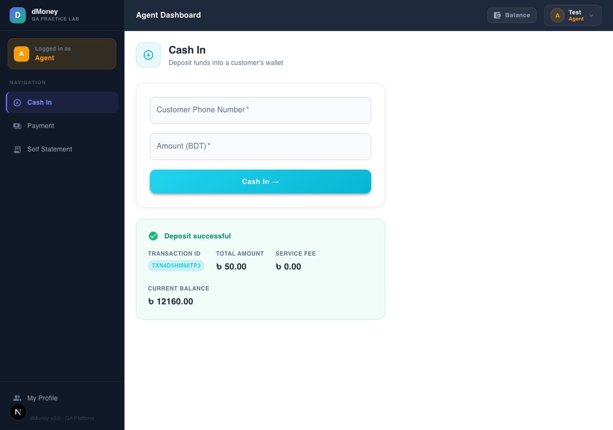

Matching API response for the same request: {"message":"Deposit successful","trnxId":"TXN9NLCOZO8J8","commission":1.25,"currentBalance":12719.5} — the real commission (1.25) is available but never displayed.

Root Cause
src/app/agent/cash-in/page.tsx renders a static ৳ 0.00 for the "Service Fee" label instead of reading res.data.commission.

Suggested Fix
Store res.data.commission in state (mirroring how customer/cash-out/page.tsx already does it correctly for res.data.fee) and render that value instead of the hardcoded literal.

BUG-002 – Cash Out page subtitle claims "a 1.5% fee applies" but contradicts the actual fee shown on the same screen
Module: Withdraw (Cash Out)
Severity: Medium
Priority: P2
Environment: Local dev, customer/cash-out page, Chromium (Playwright), fresh Customer account
Preconditions: Logged in as an active Customer with sufficient balance; target Agent account is active.

Steps to Reproduce
- Log in as a Customer.
- Navigate to Cash Out and note the page subtitle: "Withdraw cash via an agent — a 1.5% fee applies."
- Enter Agent Phone Number 01686606901, Amount 100.
- Click Cash Out →.
- Compare the subtitle's claimed rate against the "Service Fee" figure shown in the result panel.

Expected Result
If the UI advertises a 1.5% fee, a ৳100 withdrawal should show a ৳1.50 fee (or, if the real backend rate differs, the UI copy should match the backend's actual rate/floor).

Actual Result
The result panel shows "Service Fee: ৳5.00" for the same ৳100 withdrawal — 5%, not 1.5%, visible on the same screen as the "1.5% fee applies" claim. The real backend rule (confirmed in sequelizeModel/Commission.js / DB Commissions table) is 1% of amount, floored at a 5 tk minimum — the 1.5% figure in the UI copy doesn't match either the nominal rate (1%) or the effective rate at this amount (5%).
Frequency: Always (the copy is a static string; the fee mismatch appears on every withdrawal below ~500 tk, where the 5 tk floor dominates the true 1% rate)
Reproducibility: 100%

Evidence

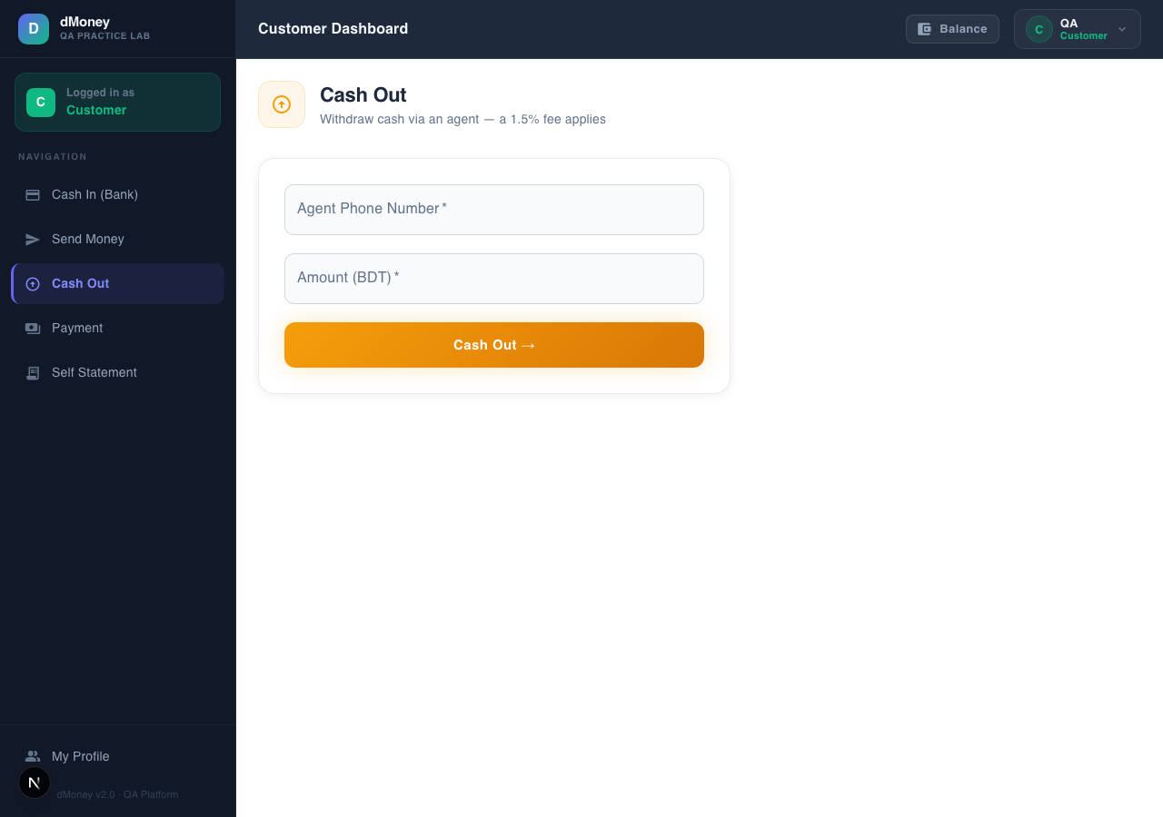
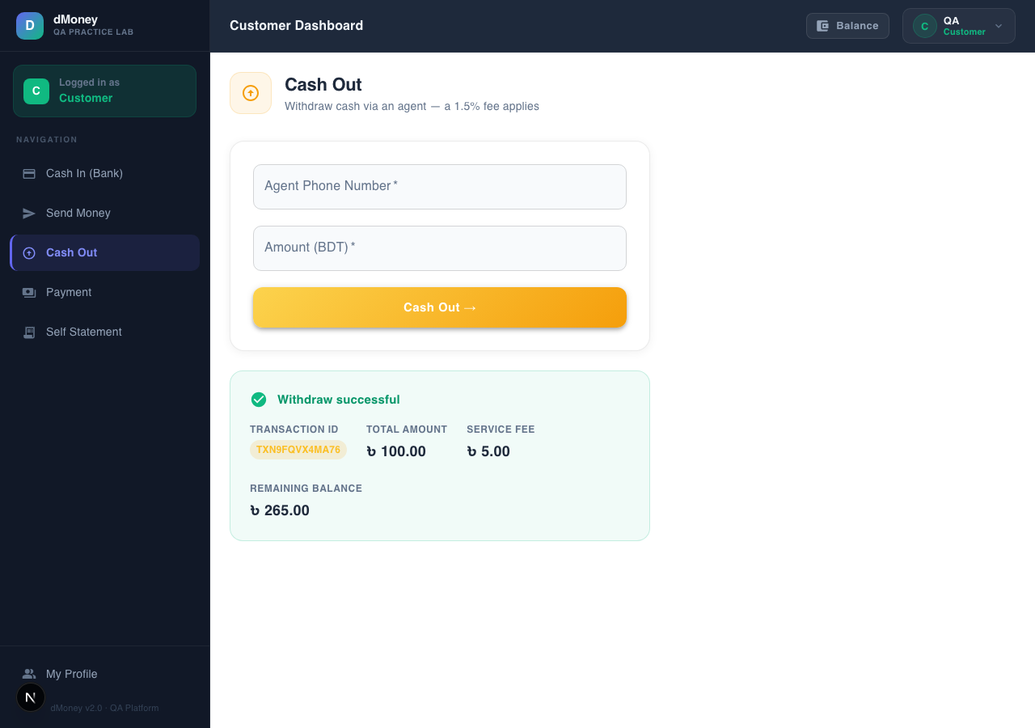

Root Cause
src/app/customer/cash-out/page.tsx line 115 hardcodes the descriptive copy "a 1.5% fee applies" as a string literal, independent of the actual DB-driven commission config that the same page correctly fetches and displays after submission.

Suggested Fix
Either fetch the live rate/floor from the Commission config and interpolate it into the subtitle, or remove the specific percentage claim from static copy entirely (e.g. "a service fee applies — see below").

BUG-003 – Deposit ledger does not balance: Agent commission is credited without any matching debit
Module: Deposit
Severity: Critical
Priority: P1
Environment: Local dev API, POST /transaction/deposit, direct MySQL verification
Preconditions: Active Agent account, active Customer account, Agent has sufficient balance.

Steps to Reproduce
- As Agent 01686606901, call POST /transaction/deposit with {"from_account":"01686606901","to_account":"01686606902","amount":50}.
- Note the returned trnxId.
- Query SELECT account, debit, credit FROM transactions WHERE trnxId='<trnxId>'.

Expected Result
Total debit across all rows for the trnxId should equal total credit (a balanced double-entry ledger), per the project's own documented design principle that "every financial operation must write matched, balanced ledger rows."

Actual Result
For a 50 tk deposit (2.5% agent commission = 1.25 tk):
account debit credit
01686606901 50 1.25 <- Agent: debited 50, credited its own commission
01686606902 0 50 <- Customer: credited 50
Total debit = 50, total credit = 51.25. The 1.25 tk commission is credited to the Agent without being debited from SYSTEM, the customer, or anyone else — money is created on every single deposit.
Frequency: Always
Reproducibility: 100% — reproduced on a live, fresh transaction (TXN9NLCOZO8J8), not just historical data.

Evidence
$ curl -X POST http://localhost:4000/transaction/deposit ... -d '{"from_account":"01686606901","to_account":"01686606902","amount":50}'
{"message":"Deposit successful","trnxId":"TXN9NLCOZO8J8","commission":1.25,"currentBalance":12719.5}

$ mysql ... -e "SELECT trnxId, SUM(debit), SUM(credit) FROM transactions WHERE trnxId='TXN9NLCOZO8J8' GROUP BY trnxId"
trnxId SUM(debit) SUM(credit)
TXN9NLCOZO8J8 50 51.25

Root Cause
controllers/transactions/deposit.controller.js (Agent→Customer flow) writes debitTrnx = { account: from_account, debit: amt, credit: commission } and creditTrnx = { account: to_account, credit: amt } — the commission is added as a credit on the Agent's own row with no corresponding debit anywhere else.

Suggested Fix
Fund the commission from SYSTEM: add a third ledger row debiting SYSTEM for the commission amount (matching the pattern already correctly used in the SendMoney and Payment controllers), so total debits equal total credits for every trnxId.

BUG-004 – Withdraw ledger does not balance: Agent commission is credited without any matching debit
Module: Withdraw
Severity: Critical
Priority: P1
Environment: Local dev API, POST /transaction/withdraw, direct MySQL verification
Preconditions: Active Customer with sufficient balance, active Agent.

Steps to Reproduce
- As Customer 01686606902, call POST /transaction/withdraw with {"from_account":"01686606902","to_account":"01686606901","amount":100}.
- Query the resulting trnxId's rows in Transactions.

Expected Result
Balanced ledger (total debit = total credit) for the transaction.

Actual Result
account debit credit description
01686606902 105 0 Withdraw (100 amount + 5 fee)
01686606901 0 102.5 Withdraw (100 amount + 2.5 commission)
SYSTEM 0 5 Withdraw Service Charge
Total debit = 105, total credit = 107.5. The 2.5 tk agent commission is minted from nothing — identical root cause to BUG-003.
Frequency: Always
Reproducibility: 100% — reproduced live (trnxId TXN0Q13BD7MBI).

Evidence
$ curl -X POST http://localhost:4000/transaction/withdraw ... -d '{"from_account":"01686606902","to_account":"01686606901","amount":100}'
{"message":"Withdraw successful","trnxId":"TXN0Q13BD7MBI","fee":5,"currentBalance":8865.5}

$ mysql ... -e "SELECT * FROM transactions WHERE trnxId='TXN0Q13BD7MBI'"
id account debit credit description
126 01686606902 105 0 Withdraw
127 01686606901 0 102.5 Withdraw
128 SYSTEM 0 5 Withdraw Service Charge

Root Cause
controllers/transactions/withdraw.controller.js writes the Agent's credit as amt + commission with no offsetting debit for the commission portion.

Suggested Fix
Same as BUG-003 — debit SYSTEM for the commission amount instead of creating it unbacked.

BUG-005 – SQL Injection in the balance-lookup query (affects Deposit's and Withdraw's balance displays)
Module: Deposit / Withdraw / Limit Management (shared backend service)
Severity: Critical
Priority: P1
Environment: Local dev API
Preconditions: Public registration is open (no auth required); attacker needs any valid JWT (even their own, freshly self-registered).

Steps to Reproduce
- Register a new Customer via the public POST /user/register endpoint with phone_number set to the 11-character string zz'OR'1'='1 (registration only validates phone_number length, not character format — confirmed via Joi.string().min(11).max(11) with no pattern).
- Using any valid JWT (does not need to belong to the account just created), call GET /transaction/balance/zz'OR'1'='1 (URL-encoded).
- Compare the returned balance against SELECT SUM(credit)-SUM(debit) FROM transactions (the whole ledger's grand total).

Expected Result
A brand-new account with zero transactions should return a balance of 0, or a 404 if account matching failed.

Actual Result
The endpoint returned 10000362.75 — which exactly equals the ledger-wide grand total at that moment — proving the injected OR '1'='1' clause bypassed the intended per-account WHERE filter and aggregated across the entire Transactions table.
Frequency: Always
Reproducibility: 100%, fully self-contained (attacker needs no special privileges — public registration + any authenticated session).

Evidence
$ curl -X POST http://localhost:4000/user/register -d '{"name":"QA SQLi POC2","email":"qa.sqli.poc2@gmail.com","password":"1234","phone_number":"zz'OR'1'='1","nid":"1234567","role":"Customer"}'
{"message":"Registration successful...","user":{"id":39,...,"phone_number":"zz'OR'1'='1",...}}

$ curl -G "http://localhost:4000/transaction/balance/zz%27OR%271%27%3D%271" -H "Authorization: Bearer <any valid JWT>" -H "X-AUTH-SECRET-KEY: ROADTOSDET"
{"message":"User balance","balance":10000362.75}

$ mysql -e "SELECT SUM(credit)-SUM(debit) AS grand_total FROM transactions;"
grand_total
10000362.75 <- exact match, confirming full-table injection
No screenshot applies — this is a raw API/database-level defect with no corresponding UI screen exercising attacker-controlled account identifiers.

Root Cause
services/getBalance.js builds its SQL via raw string concatenation: "...WHERE t.\account\='" + account + "'". Combined with phone_number having no format validation at registration, this is directly exploitable.

Suggested Fix
Use parameterized queries (sequelize.query(sql, { replacements: [account] })), matching the safe pattern already used elsewhere in the same codebase (e.g. the FOR UPDATE balance locks inside the transaction controllers). Additionally, restrict phone_number to digits only at registration.

BUG-006 – Broken access control (IDOR): any authenticated user can read any other account's balance, statement, or limit
Module: Limit Management (and shared by Deposit/Withdraw balance checks)
Severity: High
Priority: P1
Environment: Local dev API
Preconditions: Any valid JWT + the shared partner key (X-AUTH-SECRET-KEY) — no elevated role required.

Steps to Reproduce
- Log in as any Customer, obtain a JWT.
- Call GET /transaction/balance/<any other account's phone number> — e.g. the Admin account 01686606909.
- Call GET /transaction/limit/<any other account> similarly.

Expected Result
403 Forbidden, since the requested account does not belong to the caller.

Actual Result
$ curl http://localhost:4000/transaction/balance/01686606909 -H "Authorization: Bearer <customer JWT>" -H "X-AUTH-SECRET-KEY: ROADTOSDET"
{"message":"User balance","balance":-5000}

$ curl http://localhost:4000/transaction/limit/01686606909 -H "Authorization: Bearer <customer JWT>" -H "X-AUTH-SECRET-KEY: ROADTOSDET"
{"message":"User limit","limit":10000}
The Customer's token successfully retrieved the Admin account's balance and limit info. The same is true for GET /transaction/statement/:account (retrieves another user's full transaction history).
Frequency: Always
Reproducibility: 100%

Evidence
Raw request/response above; no UI screen exposes this attacker-controlled path (the frontend only ever calls these endpoints for the logged-in user's own phoneNumber from localStorage), so there is no corresponding screenshot — the vulnerability is only reachable by calling the API directly, bypassing the UI.

Root Cause
controllers/transactions/transactionDetails.controller.js — getBalanceByAccount, getStatementByAccount, and getTransactionLimitByAccount all check only that the requested account exists, never that it matches req.user.identifier.

Suggested Fix
Add an ownership check (req.user.identifier must resolve to the same account as :account), or restrict these reads to Admin + self.

BUG-007 – GET /transaction/limit/:account returns a hardcoded, legacy figure disconnected from the real limit system
Module: Limit Management
Severity: High
Priority: P2
Environment: Local dev API
Preconditions: Any authenticated account.

Steps to Reproduce
- Call GET /transaction/limit/01777000111 for a Customer account.
- Compare the returned figure against the account's actual configured daily/monthly limits in the TransactionLimits table (5,000/day, 50,000/month) and against services/limitChecker.js, which is what actually gates transactions.

Expected Result
The endpoint should reflect the same limit logic that checkCustomerLimits() enforces (daily/monthly amount + count caps).

Actual Result
{"message":"User limit","limit":9915} — this number comes from an entirely different, legacy formula: 10000 - (SUM(credit) WHERE description='Deposit') + (SUM(debit) WHERE description='Withdraw'), hardcoded to a base of 10000. It has no relationship whatsoever to the 5,000/day or 50,000/month figures actually enforced elsewhere, and is not called anywhere in the frontend (confirmed via a full-repo search — the frontend never references this endpoint), meaning it's dead, misleading code that any direct API consumer (e.g. a partner integration) would reasonably rely on and be misled by.
Frequency: Always
Reproducibility: 100%

Evidence
$ curl http://localhost:4000/transaction/limit/01777000111 -H "Authorization: Bearer <token>" -H "X-AUTH-SECRET-KEY: ROADTOSDET"
{"message":"User limit","limit":9915}

# Actual enforced limits for this same Customer, from the real system:
$ mysql -e "SELECT * FROM transactionlimits WHERE role='Customer';"
period max_amount max_count
daily 5000.00 10
monthly 50000.00 50

Root Cause
controllers/transactions/transactionDetails.controller.js → getTransactionLimitByAccount implements an old/unrelated limit formula that was apparently never updated when TransactionLimits + limitChecker.js were introduced.

Suggested Fix
Either rewrite this endpoint to surface real remaining daily/monthly quota (reusing limitChecker's usage query), or remove it to avoid misleading API consumers.

BUG-008 – Agent and Merchant roles have zero daily/monthly transaction limits
Module: Limit Management (Withdraw)
Severity: Medium
Priority: P3
Environment: Local dev, code + DB review
Preconditions: N/A

Steps to Reproduce
- Inspect withdraw.controller.js: the daily/monthly limit check (checkCustomerLimits) is only invoked if (fromRole === "Customer").
- Query SELECT * FROM transactionlimits; — only two rows exist, both role='Customer'.

Expected Result
If daily/monthly caps are an intentional anti-fraud/AML control, they should plausibly apply to Merchant withdrawals too (Merchants can withdraw through the same endpoint as Customers).

Actual Result
A Merchant can withdraw any amount, any number of times per day, with no cap — the exact same protection Customers are held to simply doesn't exist for Merchant (or Agent) accounts. Confirmed by database inspection (no TransactionLimits rows for those roles) and by the code's explicit fromRole === "Customer" gate.
Frequency: Always (structural, not timing-dependent)
Reproducibility: 100%

Evidence
$ mysql -e "SELECT role, period, max_amount, max_count FROM transactionlimits;"
role period max_amount max_count
Customer daily 5000.00 10
Customer monthly 50000.00 50
No rows for Agent or Merchant. No screenshot applies (a code/data-level absence, not a UI-visible state).

Root Cause
withdraw.controller.js line ~65: if (fromRole === "Customer") { const limitCheck = await checkCustomerLimits(...) } — Merchant withdrawals skip this block entirely.

Suggested Fix
Confirm intended business rule with product; if Merchants should be capped, add TransactionLimits rows for role Merchant and extend the withdraw/payment controllers to check them.

BUG-009 – No proactive limit visibility anywhere in the UI
Module: Limit Management
Severity: Low
Priority: P3
Environment: Local dev, Chromium (Playwright), Customer account that had already exhausted its daily cap from earlier testing
Preconditions: Customer has used all 10 allowed daily transactions.

Steps to Reproduce
- Log in as a Customer who has already hit today's 10-transaction cap.
- Open Send Money (or Cash Out / Payment).
- Observe the form before submitting anything.
- Fill in a valid recipient and amount, then submit.

Expected Result
Some indication of remaining daily/monthly quota should ideally be visible before the user attempts a transaction (e.g. "7 of 10 transactions used today"), so the rejection isn't a surprise.

Actual Result
The form shows no limit information at all until after submission, at which point the user gets a rejection: "Daily transaction limit reached. You have used all 10 allowed transactions for this daily period." This matches the backend correctly (see Section 6 for confirmation the enforcement itself is accurate) — the finding is purely that the UI has no proactive indicator anywhere (confirmed via full-repo search: no page references remainingAmount/remainingCount/daily/monthly limit data).
Frequency: Always
Reproducibility: 100%

Evidence

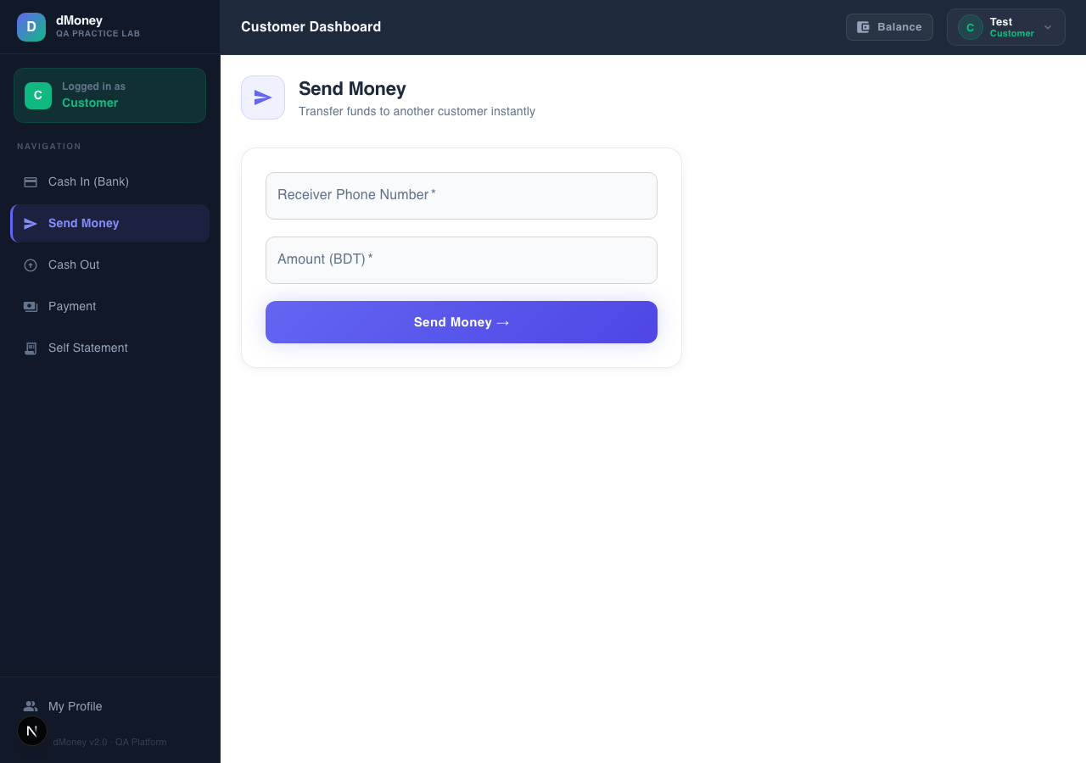
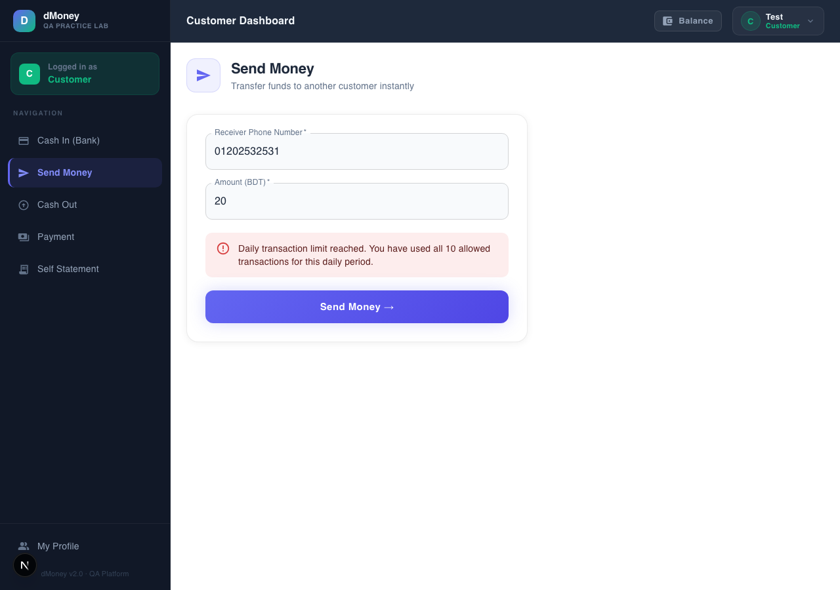

Root Cause
The frontend never calls or surfaces the details object (usedAmount, usedCount, remainingAmount, remainingCount) that the backend's checkCustomerLimits() already returns on rejection, and doesn't proactively fetch it before the user acts.

Suggested Fix
Show a small "today's remaining limit" indicator on Send Money/Cash Out/Payment forms, sourced from a lightweight limit-status endpoint (once BUG-007's endpoint is fixed to reflect real data).

6. Overall Observations
- Total bugs found: 9 confirmed (Critical: 3, High: 2, Medium: 2, Low: 2).
- Bugs by severity: Critical — BUG-003, BUG-004, BUG-005. High — BUG-006, BUG-007. Medium — BUG-002, BUG-008. Low — BUG-001, BUG-009.
- Common patterns:
  - Two of the three Critical bugs (BUG-003, BUG-004) share one root cause: agent commissions are added as an unfunded credit rather than being debited from SYSTEM — the exact pattern that SendMoney and Payment do get right elsewhere in the same codebase, suggesting the fix is a matter of applying an already-proven pattern consistently.
  - Several Limit Management issues (BUG-006, BUG-007, BUG-009) stem from the same underlying gap: the read/reporting side of the limit system was never built out to the same standard as the write-side enforcement (limitChecker.js itself is solid — see below).
  - UI copy (BUG-001, BUG-002) is static and disconnected from the live backend values the same screens already fetch and could easily display correctly.
- High-risk areas: The Deposit and Withdraw money-creation defects (BUG-003/004) are the most severe — they compound with every transaction and would misstate real reserves in a production MFS deployment. The SQL injection (BUG-005) is trivially exploitable by any self-registered user, using only the public registration endpoint.
- What was tested and found to be working correctly (explicitly verified, not assumed):
  - Duplicate transaction prevention — concurrency: two simultaneous POST /transaction/withdraw requests for the same customer, together exceeding their balance, were correctly serialized by the code's FOR UPDATE row lock — only one succeeded, the other correctly returned "Insufficient balance." No double-spend occurred.
  - Duplicate transaction prevention — UI double-click: firing two near-simultaneous clicks on the Cash Out button produced exactly one POST /transaction/withdraw network request, confirming the disabled={loading} guard works as intended.
  - Daily count-limit boundary: the 10th transaction of the day was accepted and the 11th was rejected with an exact, correctly-worded message — the boundary is precisely enforced, no off-by-one error.
- Recommendations:
- Fix BUG-003/BUG-004 first — fund agent commissions from SYSTEM, matching the already-correct SendMoney/Payment pattern.
- Fix BUG-005 immediately — parameterize the balance query and restrict phone_number format at registration.
- Add ownership checks to close BUG-006, and either fix or retire the dead endpoint behind BUG-007.
- Decide, document, and (if needed) implement Merchant/Agent limits (BUG-008) as a deliberate product decision rather than an accidental gap.
- Treat BUG-001/002/009 as a small, low-risk UI cleanup pass — wire up already-available API fields instead of hardcoded copy.

