KL UNIVERSITY
Koneru Lakshmaiah Education Foundation
(Deemed to be University)
PROJECT REPORT
FinServe
Intelligent Banking Analytics Platform
Applying Advanced Data Structures and Algorithms to Real Banking Data
Submitted by
Name | Student ID
Meher Bhoyar | 250031378
Adarsh Kumar | 2500030273
David | 2500031000

October 2026

Table of Contents
Abstract 3
1. Introduction 3
2. Problem Statement 3
3. Objectives 4
4. System Architecture 4
5. Technology Stack 5
6. Dataset Used 6
7. Modules and Algorithms 8
8. REST API Design 10
9. User Interface 11
10. Implementation and Execution 11
11. Outcomes and Results 11
12. Conclusion and Future Scope 12
References 13
Appendix A: Output Screenshots 14

Abstract
FinServe is an intelligent banking analytics and algorithmic settlement platform that shows how advanced Data Structures and Algorithms (DSA) solve realistic problems in the financial domain. Modern banks process enormous volumes of transactions, documents and compliance rules; naive approaches such as repeated linear scans, manual reconciliation and exhaustive rule checking do not scale. FinServe replaces them with provably efficient algorithms.
The platform is organised into six modules and 25 algorithms: exact and multi-pattern string matching for fraud detection (KMP, Z-Function, Rabin-Karp, Aho-Corasick); suffix structures for document indexing (Suffix Array, SA-IS, Kasai LCP, Suffix Automaton); dynamic programming for data cleansing and portfolio selection; network flow for interbank settlement and case allocation (Ford-Fulkerson, Edmonds-Karp, Dinic, Bipartite Matching, Min-Cut); NP-completeness reductions with approximation for compliance and monitoring; and randomised and parallel algorithms for risk and anomaly analysis (Monte Carlo, Las Vegas Quickselect, Blelloch Prefix Sum, Work-Span analysis).
The backend is written in pure Java 17 with no third-party libraries and exposes 25 REST endpoints. The frontend is a React 19 single-page application built with Vite. The system runs on a real Kaggle bank-transaction dataset of 2,512 transactions with 16 attributes (595 account and merchant entities), and five built-in preset datasets. Sample outcomes include a maximum interbank liquidity throughput of 900 lakhs/day and an optimal investment portfolio with a 15.2% return on investment.
Keywords: string matching, suffix array, dynamic programming, maximum flow, NP-completeness, Monte Carlo, parallel prefix sum, fraud detection, banking analytics.

1. Introduction
Banking is one of the most data-intensive industries. Every card swipe, UPI payment, wire transfer and loan agreement produces records that must be searched, validated, reconciled, settled and audited, often in real time. Regulators additionally require institutions to detect money laundering (AML), enforce Know-Your-Customer (KYC) rules and quantify risk. The quality of the underlying algorithms directly decides whether these tasks finish in milliseconds or hours.
Data Structures and Algorithms are usually taught through isolated textbook examples. FinServe was built to connect that theory to practice: each algorithm is placed in a concrete banking scenario, runs on real transaction data, and returns results through a professional web interface. The project therefore serves two purposes: a working analytics engine, and a demonstration of why algorithm choice, time complexity and problem reductions matter in industry.
The platform is deliberately dependency-free on the Java side. The HTTP server, JSON serialiser and JSON parser are implemented from scratch using only the standard Java SE runtime, so that every line of the algorithmic core is visible and explainable.

2. Problem Statement
Banks and financial institutions face several recurring technical challenges. Each one maps to a classical algorithmic problem:
- Fraud and AML detection. Suspicious phrases such as shell company, structuring or smurfing are hidden in millions of free-text transaction narratives. Scanning for each keyword separately is too slow.
- Document search and audit. Audit reports, loan covenants and compliance filings are large unstructured texts that analysts must search for arbitrary substrings and duplicated clauses.
- Dirty data. Misspelt counterparty names and mistyped account numbers break automated reconciliation, but a mistake in an account number is far more dangerous than one in a name.
- Settlement bottlenecks. Interbank payments must be routed through a capacity-limited network; operators need to know the maximum throughput and which channel is the single point of failure.
- Compliance consistency. Dozens of regulatory rules must be satisfiable together, and finding collusion rings or minimal monitoring sets are NP-hard problems.
- Risk and scale. Portfolio risk (VaR) cannot be computed in closed form, outliers must be found exactly, and batch analytics must scale across processor cores.

Formal problem statement
To design and implement a unified, dependency-free banking analytics platform that applies advanced string, suffix-structure, dynamic-programming, network-flow, NP-completeness and randomised/parallel algorithms to a real transaction dataset, exposes every algorithm through a documented REST API, and presents the results in an interactive web interface, while analysing the time and space complexity of each technique.
Banking problem | Algorithmic technique | Module
Keyword and code detection in text | KMP, Rabin-Karp, Aho-Corasick | Module 1: String
Fast substring and duplicate search | Suffix Array, SA-IS, LCP, Automaton | Module 2: Suffix
Name correction, investment choice | Edit distance, Bitmask DP, Matrix-Chain | Module 3: DP
Settlement capacity and case allocation | Max-Flow, Matching, Min-Cut | Module 4: Flow
Rule validation, collusion, monitoring | SAT, Karp reductions, Vertex Cover | Module 5: NP
Risk, outliers, scalable analytics | Monte Carlo, Quickselect, Prefix Sum | Module 6: Rand/Parallel

3. Objectives
- Implement 25 algorithms from six algorithmic families in pure Java 17 with documented time and space complexity.
- Map each algorithm to a realistic banking use case so that its purpose is clear.
- Load and process a real-world Kaggle transaction dataset and support custom CSV/JSON uploads with automatic column mapping.
- Expose all algorithms through a REST API with OpenAPI 3.0 / Swagger documentation.
- Build a responsive React interface with per-module workspaces, report views and raw JSON output.
- Demonstrate polynomial-time reductions between NP-hard problems and the use of approximation algorithms with provable guarantees.

4. System Architecture
FinServe follows a three-tier architecture. The browser runs a React single-page application served by the Vite development server on port 5173. Every request to a path starting with /api is proxied to a lightweight Java HTTP server on port 8080, which routes it to the matching algorithm engine. A central DatasetManager supplies the active dataset to all engines.
Layer | Components | Responsibility
Presentation | React 19, React Router, Vite, Canvas background | Dashboard, six module pages, dataset manager, report modal
API | ApiServer, SwaggerDocs, JsonUtil | Routing, CORS, JSON parsing and serialisation, OpenAPI documentation
Algorithm engines | module1_string to module6_rand (25 classes) | Run the algorithms and return structured results
Data | DatasetManager, DatasetPresets, SampleDataGenerator, models | Load CSV/JSON, presets, synthesise accounts and documents

Request flow
- The user selects a module and enters parameters in the React page (for example a budget or a search pattern).
- The page sends an HTTP request to /api/moduleN/... which Vite proxies to port 8080.
- ApiServer decodes the query string or JSON body and obtains the active transactions, accounts or documents from DatasetManager.
- The relevant algorithm class runs and returns a result map, which JsonUtil serialises.
- The frontend renders the result as a report (badges, tables, metric cards) or as raw JSON.

Source code organisation
The backend is organised into the packages com.finserve.model (Account, Transaction, FinancialDocument), data (dataset loading and presets), server (ApiServer, SwaggerDocs), util (JsonUtil) and six algorithm packages named module1_string, module2_suffix, module3_dp, module4_flow, module5_np and module6_rand. The roughly 7,200 lines of Java are compiled with a simple javac command through run.sh.

5. Technology Stack
Technology | Used in | Purpose
Java 17 (Java SE) | Backend core | Implements all 25 algorithms and data models with no third-party libraries
com.sun.net.httpserver | ApiServer | Built-in HTTP server for REST endpoints, CORS handling and routing
Custom JsonUtil | util package | Reflection-free JSON serialiser and recursive-descent parser
React 19 | Frontend | Component-based single-page user interface
Vite 8 | Frontend tooling | Fast dev server, hot reload, production build and /api proxy
React Router 7 | Frontend | Client-side routes for the dashboard, datasets and six modules
lucide-react | Frontend | Icon set used across navigation and cards
HTML5 Canvas, CSS variables | BackgroundEffect, index.css | Animated particle and wave background; glassmorphism design system
OpenAPI 3.0 / Swagger UI | SwaggerDocs | Interactive API documentation at /swagger on port 8080
Kaggle dataset (CSV) | Data layer | Real bank transaction data used as the default dataset
oxlint | Frontend quality | Fast JavaScript/JSX linting
IntelliJ IDEA, shell script | Development | IDE for the Java project; run.sh compiles and starts the server

Why pure Java? Avoiding frameworks such as Spring keeps start-up instant, keeps the project small enough to read end to end, and shows that the algorithms, not the framework, carry the intelligence of the system.

6. Dataset Used

6.1 Primary dataset
The default dataset is the Kaggle bank transaction data file bank_transactions_data_2.csv, loaded automatically when the server starts. It contains 2,512 transaction records described by 16 attributes, including device identifiers, IP addresses, merchant routing and failed-login telemetry, which are typical inputs for fraud analysis. The file has no missing values.
Property | Value | Detail
Records | 2,512 | One row per transaction
Attributes | 16 | Identity, money, context, customer and behaviour fields
Distinct accounts / merchants | 495 / 100 | Together 595 account entities indexed in FinServe
Date range | Jan 2023 to Jan 2024 | TransactionDate from 2023-01-02 to 2024-01-01
Transaction type | Debit 1,944 | Credit 568 | 77.4% debit, 22.6% credit
Channel | Branch 868 | ATM 833 | Online 811 | Nearly even split across three channels
Amount | 0.26 to 1,919.11 | Mean 297.59, median 211.14 (shown as ₹298 average in the UI)
Account balance | 101.25 to 14,977.99 | Mean 5,114.30
Customer age | 18 to 80 | Mean 44.7; occupations Student, Doctor, Engineer, Retired
Locations / devices | 43 / 681 | Distinct cities and distinct device IDs
Login attempts | 1 to 5 | 2,390 records with one attempt; 122 with two or more

6.2 Attributes
Attribute | Meaning
TransactionID, AccountID, MerchantID | Unique identifiers for the transaction, the customer account and the merchant
TransactionAmount, AccountBalance | Value of the transaction and balance of the account
TransactionDate, PreviousTransactionDate | Timestamp of the transaction and of the previous one on the account
TransactionType, Channel | Debit or Credit; Branch, ATM or Online
Location, DeviceID, IP Address | City, device used and network address, useful for spotting unusual access
CustomerAge, CustomerOccupation | Demographic information about the account holder
TransactionDuration, LoginAttempts | Time taken (seconds) and number of login attempts, behavioural risk signals

6.3 How the dataset is used by FinServe
The DatasetManager reads the CSV and normalises column names, so files such as Kaggle PaySim or Credit Card Fraud also load (for example customer_id and account_id become the sender account, amt and value become the amount, is_fraud becomes the FLAGGED status). When a file contains only transactions, the manager synthesises Account entities and regulatory audit dossiers, so all six modules keep working on any uploaded data. Switching datasets in the UI re-indexes every module immediately.
Module | Data it consumes
1 String | Transaction narratives and payment codes (SWIFT, IFSC, NEFT, UPI); the 14-keyword AML watchlist
2 Suffix | All narratives joined into one searchable corpus; regulatory documents DOC001 to DOC004
3 DP | Counterparty names, account numbers and memos; investment options with yields, costs and conflicts
4 Flow | Interbank network of bank nodes with channel capacities; fraud cases and analyst skills
5 NP | Regulatory rules, suspicious inter-account links and system dependencies
6 Rand/Parallel | Transaction amounts, portfolio returns and running balances

6.4 Preset datasets
Preset | Volume | Description
Bank Transactions Data 2 (default) | 2,512 txns, 595 accounts | Real-world Kaggle data with login telemetry and device IDs
AML Suspicious Activity | 250 txns, 40 accounts | Shell companies, smurfing, offshore layering
Global SWIFT and Forex | 200 txns, 30 accounts | Cross-border settlements in 12 currencies
Retail High-Volume | 500 txns, 60 accounts | UPI, card POS, EMI and e-commerce payments
Synthetic Indian Banking | 100 txns, 20 accounts | Seeded baseline across Indian metro branches

The platform also ships four regulatory documents (an audit report, an AML policy, an annual statement summary and a high-value risk assessment) and a watchlist of 14 AML indicators: shell company, money laundering, structuring, smurfing, layering, offshore, suspicious, flagged, round-tripping, over-invoicing, freeze, compliance, threshold and unauthorized.

7. Modules and Algorithms
This section explains every module, the algorithms it contains, how each one works and what it is used for in FinServe.

7.1 Module 1: Exact String Algorithms
Module 1 searches transaction narratives, payment codes and routing identifiers. Each algorithm solves a different flavour of the pattern-matching problem, and all run in linear time instead of the O(n·m) cost of naive search.
Algorithm (source file) | Complexity | How it works | Banking use in FinServe
KMP  Transaction​Code​Search | O(n + m) time, O(m) space | Builds a failure (lps) table of the longest proper prefix that is also a suffix, so the text pointer never moves backwards. | Finds payment codes, tokens and SWIFT references in ledger descriptions
Z-Function  Pattern​Analyzer | O(n + m) | Z[i] is the length of the longest substring starting at i that matches the prefix of the string. | Reveals recurring payments, standing orders and repeated billing scripts
Rabin-Karp  Financial​Code​Lookup | O(n + m) average, O(nm) worst | Slides a polynomial rolling hash (base 256, prime 10^9+7) over the text and verifies only when hashes match. | Verifies SWIFT, IFSC and routing codes across thousands of records
Aho-Corasick  Fraud​Pattern​Detector | O(n + m + z) | Builds a trie of all keywords, adds failure links by BFS, then scans the text once emitting every match. | Detects all 14 AML watchlist phrases simultaneously

7.2 Module 2: Suffix Structures and Indexing
Module 2 pre-processes text once so that later queries are almost instant. It is used for large narrative corpora and long compliance documents.
Algorithm (source file) | Complexity | How it works | Banking use in FinServe
Suffix Array, prefix doubling  Transaction​Indexer | Build O(n log² n), query O(m log n) | Sorts all suffixes by doubling the compared prefix length; a binary search then locates any pattern. | Sub-millisecond substring search over transaction narratives
SA-IS  Document​Indexer | Build O(n) | Classifies suffixes as S-type or L-type, buckets the leftmost S-type suffixes and induces the full order. | Indexes multi-megabyte audit reports and loan covenants
Kasai LCP  Repeated​Pattern​Finder | O(n) | Uses the inverse suffix array (rank) to compute longest common prefixes of neighbouring suffixes in one pass. | Finds duplicate contracts, repeated boilerplate and identical transactions
Suffix Automaton  Substring​Query​Engine | Build O(n), query O(m) | Online construction of the minimal automaton accepting every suffix (a DAWG). | Tests substring existence, counts distinct substrings, finds longest common substring

7.3 Module 3: Advanced Dynamic Programming
Module 3 uses dynamic programming to clean noisy data and to choose the best financial operations under constraints.
Algorithm (source file) | Complexity | How it works | Banking use in FinServe
Levenshtein / Damerau  Description​Corrector | O(m · n) time and space | Fills a table of minimal insertions, deletions, substitutions (and adjacent transpositions), then backtracks to show the operations. | Auto-corrects misspelt counterparty names and memos
Weighted Edit Distance  Data​Error​Handler | O(m · n) | Same table, but substituting a digit costs 3.0, a letter 1.0 and a special character 0.5. | Protects account numbers, IBANs and amounts during reconciliation
Bitmask DP  Operation​Combinator | O(2^n · n) time, O(2^n) space | Represents each subset of operations as a bitmask and keeps the best yield that fits the budget and avoids conflicting pairs. | Selects the optimal investment portfolio (FD, mutual funds, equities, bonds, real estate, ETFs)
Matrix-Chain Multiplication  Analysis​Optimizer | O(n³) time, O(n²) space | Tries every split point and stores the cheapest cost of each sub-chain, giving the optimal parenthesisation. | Orders chained data joins and compliance filters to minimise computation

7.4 Module 4: Network Flow and Matching
Module 4 models the banking system as a flow network. Nodes are banks, branches and clearing houses; edge capacities are the maximum value a channel can carry.
Algorithm (source file) | Complexity | How it works | Banking use in FinServe
Ford-Fulkerson, DFS  Transaction​Flow​Analyzer | O(E · maxFlow), O(V²) space | Repeatedly finds any augmenting path with DFS and pushes flow along it until none remain. | Maximum clearing throughput; flags saturated corridors
Edmonds-Karp, BFS  Network​Capacity​Analyzer | O(V · E²) | Always chooses the shortest augmenting path, which guarantees polynomial running time. | Models multi-tier reserve clearing pools
Dinic's Algorithm  Large​Network​Processor | O(V² · E) | Builds BFS level graphs and sends blocking flows with DFS using current-arc pointers. | High-throughput bulk settlement on dense interbank meshes
Bipartite Matching  Analyst​Case​Assigner | O(V · E) | Grows a matching using augmenting paths between cases and analysts. | Assigns fraud and AML cases to analysts with the right skills
Max-Flow Min-Cut  Critical​Channel​Identifier | O(V · E²) | After max flow, the saturated edges between reachable and unreachable nodes form the minimum cut. | Identifies single points of failure that throttle liquidity

7.5 Module 5: NP-Completeness and Reductions
Module 5 treats compliance problems that are believed to have no fast exact algorithm. It shows how one NP-hard problem converts to another in polynomial time and how approximation gives usable answers at scale.
Algorithm (source file) | Complexity | How it works | Banking use in FinServe
3-SAT  Rule​Constraint​Validator | O(2^n · m) | Tests truth assignments of n variables against m clauses to see whether all rules can hold together. | Checks KYC, account age, limit and wire rules for mutual satisfiability
3-SAT to CLIQUE  Constraint​Analyzer | O(2^n), O(V²) space | Karp reduction: one node per literal in each clause, edges between non-contradictory literals of different clauses; a k-clique proves satisfiability. | Proves rule consistency through graph connectivity
CLIQUE to INDEPENDENT-SET to VERTEX-COVER  Conflict​Analyzer | O(2^n) | Complement graphs turn cliques into independent sets, and an independent set is the complement of a vertex cover. | Largest collusion ring, safest sub-portfolio and minimum oversight set
Vertex-Cover 2-Approximation  Dependency​Cover​Solver | O(V + E) | Takes both endpoints of any uncovered edge until all edges are covered; the result is at most twice the optimum. | Monitors all inter-system dependencies with a provable guarantee

7.6 Module 6: Randomised and Parallel Algorithms
Module 6 uses randomness to estimate quantities that cannot be computed exactly and parallelism to scale batch analytics.
Algorithm (source file) | Complexity | How it works | Banking use in FinServe
Monte Carlo Simulation  Monte​Carlo​Risk​Estimator | O(S · N), error O(1/√S) | Samples thousands of portfolio return paths and reads the loss quantiles from the sorted results. | Value-at-Risk and Expected Shortfall at 95% and 99% confidence
Las Vegas Quickselect and IQR  Las​Vegas​Fraud​Detector | Expected O(n), worst O(n²) | Random pivots give exact medians and quartiles (always correct, only the time is random); outliers lie beyond Q1 - 1.5 IQR and Q3 + 1.5 IQR. | Detects statistical outlier transactions
Blelloch Parallel Scan  Parallel​Prefix​Sum​Reducer | Work O(n), span O(log n) | An up-sweep reduces the array as a tree and a down-sweep distributes partial sums. | Running balances and parallel tree reduction of liquidity metrics
Work-Span and Brent's Theorem  Work​Span​Analyzer | O(1) analysis | Computes work W, span S and parallelism W/S, then bounds the time on p cores by T_p ≤ W/p + S. | Projects speedup of high-volume batch pipelines

8. REST API Design
All algorithms are available as HTTP endpoints under /api, documented with OpenAPI 3.0 and testable in Swagger UI at http://localhost:8080/swagger. Responses are JSON objects produced by the custom serialiser. There are 25 module endpoints plus system and dataset endpoints.
Group | Endpoints
Module 1 | /api/module1/search-code, lookup-code, analyze-patterns, detect-fraud
Module 2 | /api/module2/index-transactions, index-documents, find-patterns, substring-query
Module 3 | /api/module3/correct-description, handle-error, combine-operations, optimize-analysis
Module 4 | /api/module4/transaction-flow, network-capacity, large-network, assign-analysts, critical-channels
Module 5 | /api/module5/validate-rules, analyze-constraints, analyze-conflicts, solve-dependencies
Module 6 | /api/module6/monte-carlo-risk, las-vegas-fraud, parallel-analytics, work-span-analysis
Datasets | /api/dataset/presets, active, switch, upload, transactions, accounts, documents, export
System | /api/health, /api/data/summary, /api/openapi.json, /swagger

9. User Interface
The interface is a React 19 single-page application with a modern glassmorphism design. A floating navigation bar links to Overview, Datasets and the six module pages, shows a live backend online/offline indicator, and includes a global search box across all 25 procedures. A canvas layer draws a living background of liquidity waves and cursor-tracking particles.
- Dashboard: key statistics, a quick-find search, fast-jump buttons (SWIFT Verifier, AML Watchlist, Substring Archive, Portfolio Allocator, Liquidity Router, Policy Validator, Monte Carlo VaR) and a Swagger link.
- Module pages: a shared layout with a collapsible sidebar, parameter inputs, run buttons and collapsible theory panels for each algorithm.
- Result modal: a report view with status badge, operational objective, metric cards, tables and colour-coded channel load, plus a raw JSON view, copy button and maximise option.
- Dataset Manager: five tabs (Presets and Overview, Live Transaction Ledger, Accounts and Entities, Regulatory Dossiers, Import Custom/Kaggle CSV) with one-click CSV export.

10. Implementation and Execution
The project needs JDK 17 or higher and Node.js. The steps below start the complete system.
- Compile and start the backend with ./run.sh (it runs javac into the out folder and then java -cp out com.finserve.Main). The server prints the loaded counts and listens on port 8080.
- In the frontend folder run npm install once, then npm run dev to start Vite on port 5173.
- Open http://localhost:5173 for the interface, /datasets to switch or upload data, and http://localhost:8080/swagger for the API documentation.
- Check http://localhost:8080/api/health to confirm the backend is online.
Synthetic data is generated with a fixed random seed (42), so results are reproducible between runs. The project can also be opened in IntelliJ IDEA by marking src as the Sources Root and running com.finserve.Main.

11. Outcomes and Results
Running the platform on the default 2,512-transaction dataset produced the following verified results (see Appendix A for screenshots).
Feature | Observed outcome
Dashboard | 2,512 transactions and 595 accounts in the active in-memory ledger; 25 procedures across 6 DSA modules
Dataset Manager | 2,512 transactions, 595 accounts indexed, 4 audit filings, gross volume ₹7.5 L and ₹298 average transaction
Interbank Liquidity Flow Analyzer (Module 4) | Maximum liquidity throughput of 900 lakhs/day across 13 channels; Source Bank to Mumbai and Mumbai to Chennai are 100% loaded (bottlenecks), Delhi 88%, Bangalore 17%
Asset Portfolio Optimizer (Module 3) | From 8 operations (256 subsets) and a budget of 5,00,000, selected Mutual Fund SIP, Real Estate Fund and Corporate Bonds: capital 4,75,000, annual return 72,000, ROI 15.2%, with no conflicting pair chosen

Algorithmic advantage
Task | Naive approach | FinServe approach
Search one code in a ledger | O(n · m) character comparisons | KMP O(n + m)
Scan for 14 fraud phrases | 14 separate scans | Aho-Corasick, one pass
Repeated substring queries | O(n · m) per query | Suffix Array O(m log n) per query
Optimal investment subset | Trial of 2^n subsets without reuse | Bitmask DP with constraint pruning
Maximum interbank flow | Enumerate all routings | Dinic / Edmonds-Karp, polynomial
Sum running balances | Sequential O(n) span | Parallel scan, O(log n) span

Key outcomes
- A fully working six-module analytics engine with 25 algorithms and no third-party Java dependency.
- Real data integration: the Kaggle dataset loads at start-up and arbitrary Kaggle-style CSVs can be uploaded.
- Operational insight such as saturated settlement corridors and optimal portfolios, returned in an easy-to-read report.
- A documented, testable API and a polished interface suitable for demonstration.
- Practical understanding of complexity, reductions and approximation guarantees.

12. Conclusion and Future Scope
FinServe demonstrates that the right algorithm turns difficult banking problems into tractable ones: linear-time string matching for fraud keywords, suffix structures for instant document search, dynamic programming for reliable reconciliation and portfolio selection, network flow for settlement planning, reductions and approximation for compliance, and randomised and parallel methods for risk and scale. By combining these with a real dataset, a REST API and an interactive interface, the project connects classroom theory to industry practice.
Current limitations are that data is held in memory rather than a database, there is no user authentication, and the dataset has no ground-truth fraud labels for measuring detection accuracy. Possible future work:
- Persist data in a relational or time-series database and stream transactions in real time.
- Add authentication, role-based access and audit logging.
- Combine the rule-based detectors with machine-learning fraud scoring and evaluate precision and recall on labelled data.
- Add further algorithms such as min-cost flow, Hopcroft-Karp matching and graph-based anomaly detection.
- Add automated unit and performance tests, containerise with Docker and deploy to the cloud.

References
- T. H. Cormen, C. E. Leiserson, R. L. Rivest and C. Stein, Introduction to Algorithms, 4th ed., MIT Press, 2022.
- D. Gusfield, Algorithms on Strings, Trees and Sequences, Cambridge University Press, 1997.
- J. Kleinberg and E. Tardos, Algorithm Design, Pearson, 2005.
- D. E. Knuth, J. H. Morris and V. R. Pratt, Fast pattern matching in strings, SIAM Journal on Computing, 1977.
- A. V. Aho and M. J. Corasick, Efficient string matching: an aid to bibliographic search, Communications of the ACM, 1975.
- R. M. Karp, Reducibility among combinatorial problems, in Complexity of Computer Computations, 1972.
- J. Edmonds and R. M. Karp, Theoretical improvements in algorithmic efficiency for network flow problems, Journal of the ACM, 1972.
- E. A. Dinic, Algorithm for solution of a problem of maximum flow in a network with power estimation, Soviet Mathematics Doklady, 1970.
- T. Kasai et al., Linear-time longest-common-prefix computation in suffix arrays and its applications, CPM, 2001.
- G. Nong, S. Zhang and W. H. Chan, Two efficient algorithms for linear time suffix array construction, IEEE Transactions on Computers, 2011.
- G. E. Blelloch, Prefix sums and their applications, Technical Report CMU-CS-90-190, Carnegie Mellon University, 1990.
- Kaggle, Bank Transaction Dataset for Fraud Detection (valakhorasani/bank-transaction-dataset-for-fraud-detection).
- React documentation (react.dev), Vite documentation (vitejs.dev) and Oracle Java SE 17 documentation.

Appendix A: Output Screenshots
The screenshots below were captured from the running FinServe application.
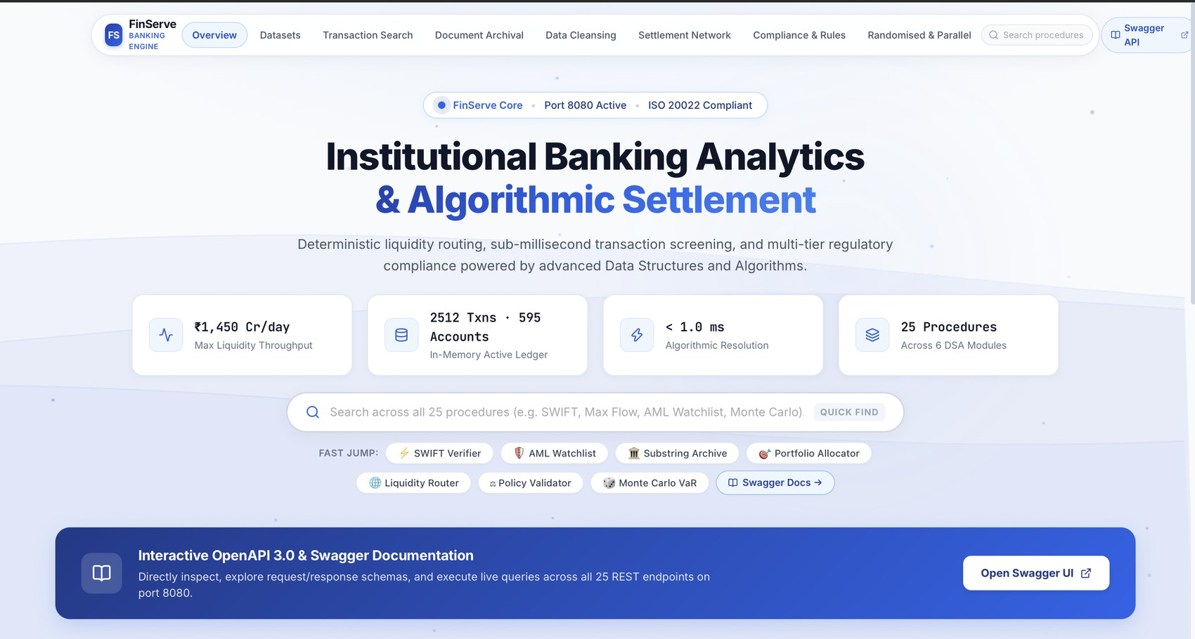
Figure 1: FinServe dashboard with live statistics, procedure search and Swagger access.
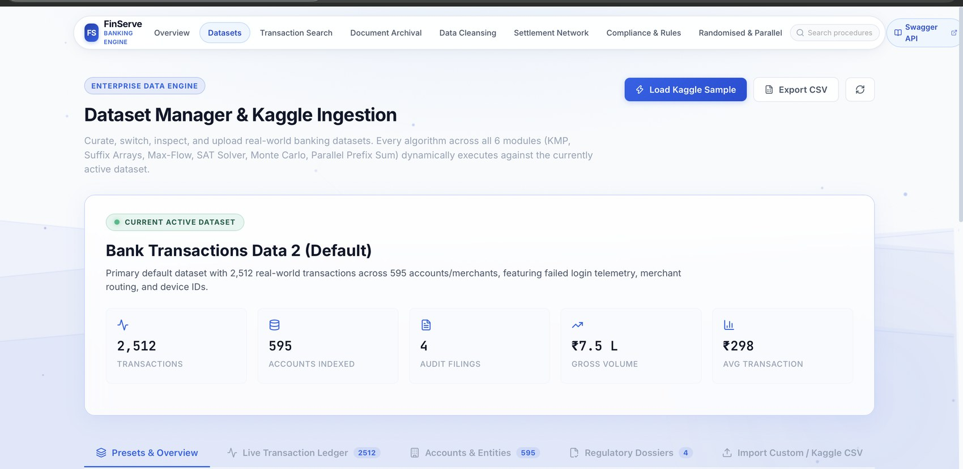
Figure 2: Dataset Manager showing the active Kaggle dataset: 2,512 transactions, 595 accounts, 4 audit filings.
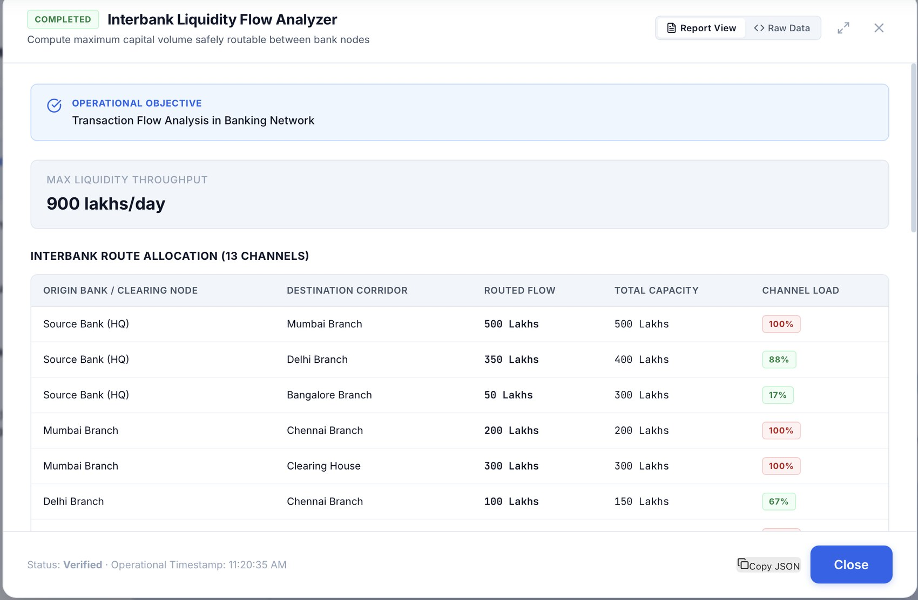
Figure 3: Interbank Liquidity Flow Analyzer (Module 4) reporting 900 lakhs/day maximum throughput and channel load.
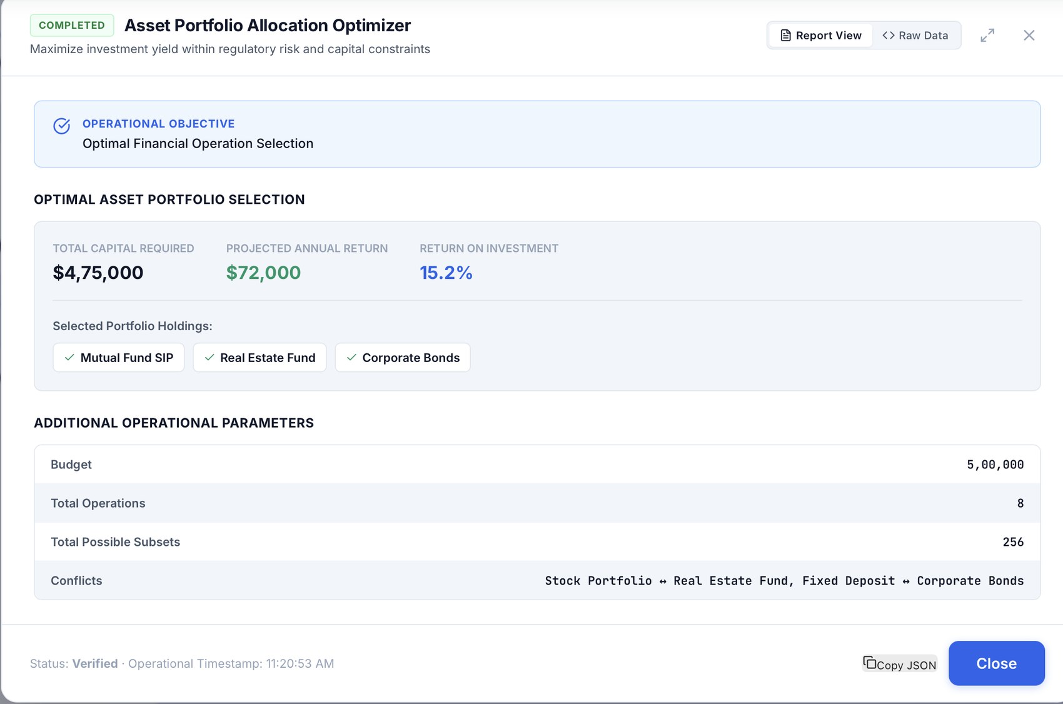
Figure 4: Asset Portfolio Allocation Optimizer (Module 3, bitmask DP) selecting the best holdings within budget.

