**RESULTS**

**a) Green Zone**

(Based on distance beteen the badge user and any other person in proximity)

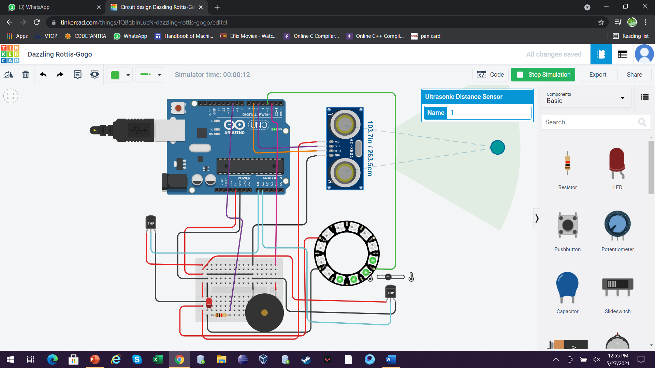

**b) Yellow zone**

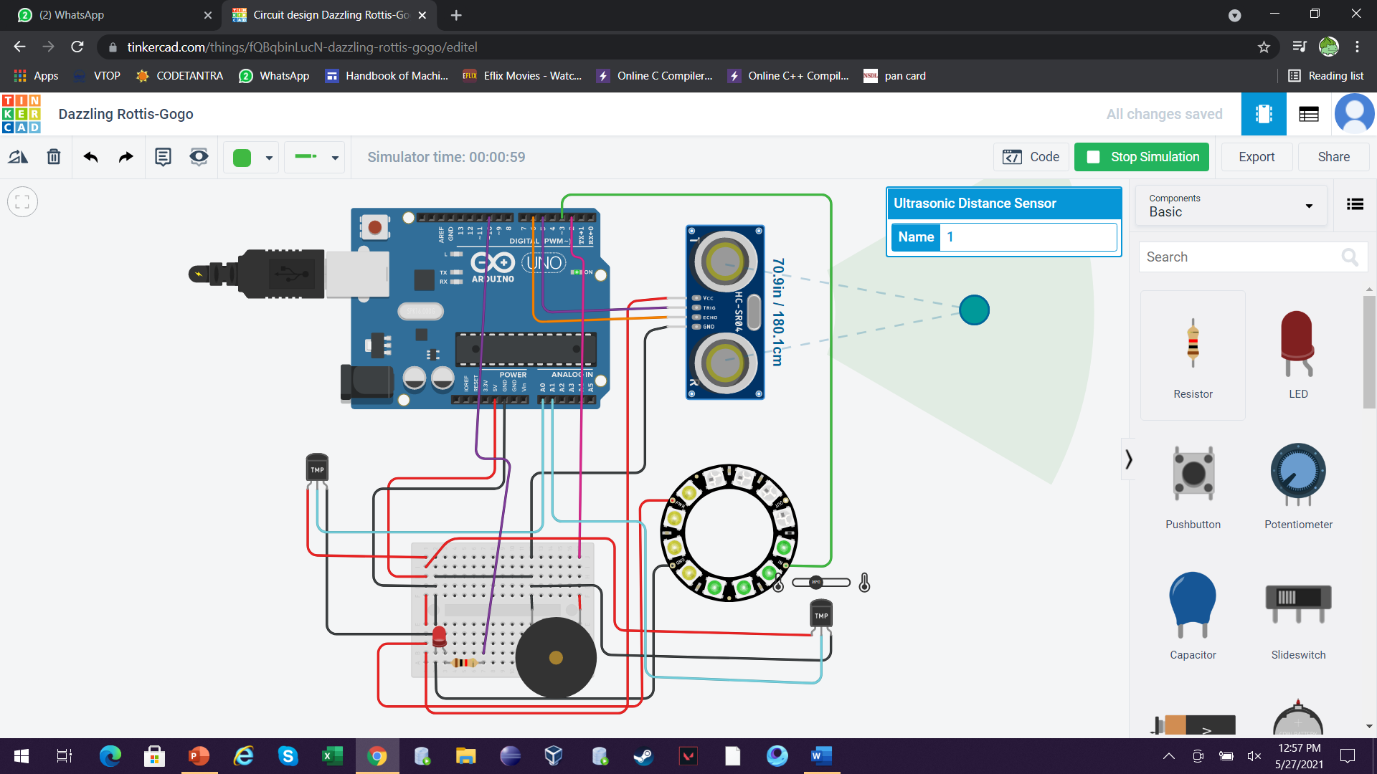

**c) Red zone**

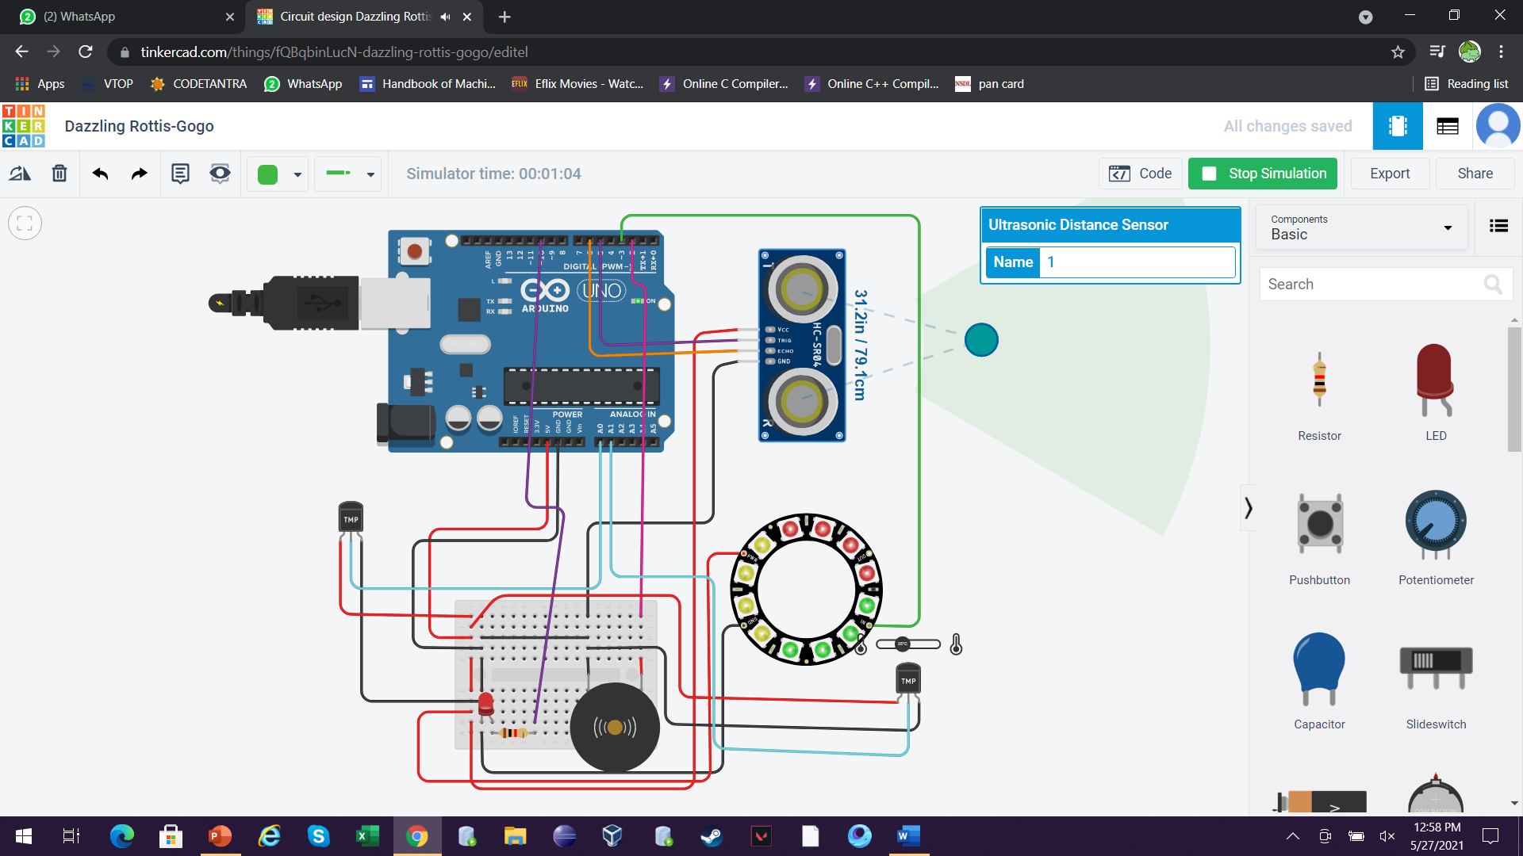

**d)Red LED glowing**

(When body temperature of the badge owner is above the normal human body temperature)

