Project Design Phase-II
Technology Stack (Architecture & Stack)
Date | 18 June 2026
Student Name | K MEHER MADHURI
Project Name | ShopEz - MERN E-Commerce Platform
Maximum Marks | 4 Marks

Technical Architecture:
ShopEz is a MERN-based e-commerce platform consisting of React frontend, Node.js/Express backend, MongoDB database, authentication, product management, shopping cart, and order processing modules.
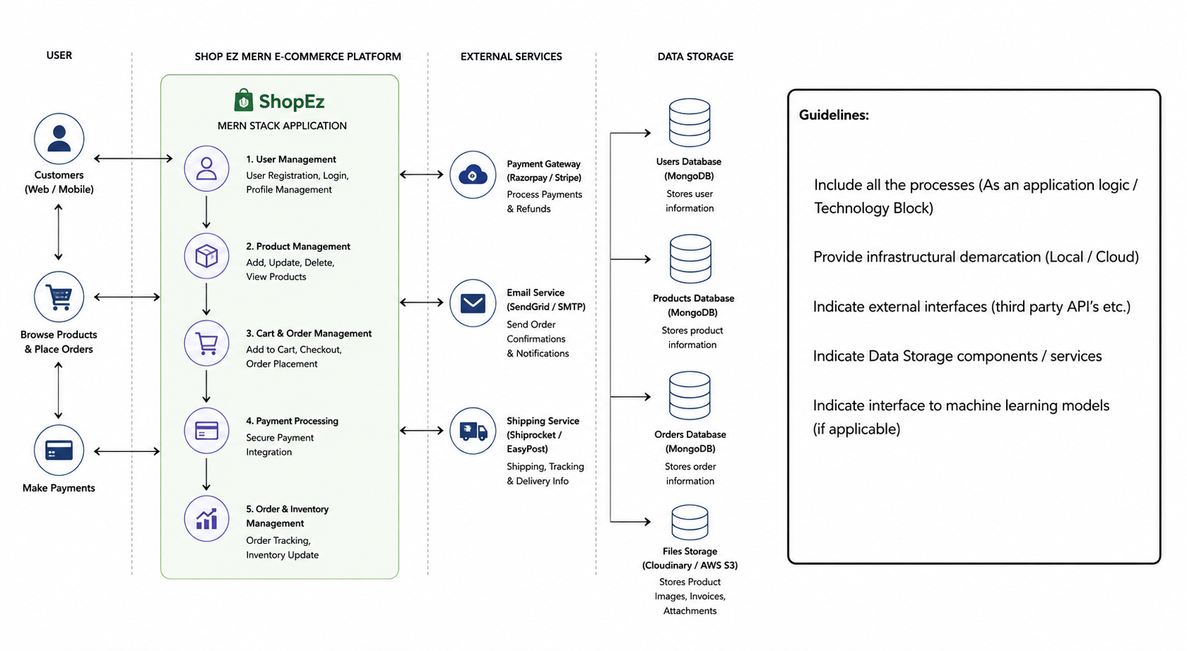
Table-1 : Components & Technologies
S.No | Component | Description | Technology
1 | User Interface | Customer and Admin interfaces | React.js, HTML, CSS, JavaScript
2 | Application Logic-1 | Authentication & Authorization | Node.js, Express.js, JWT
3 | Application Logic-2 | Product & Cart Management | Node.js, Express.js
4 | Application Logic-3 | Order Processing | Node.js, Express.js
5 | Database | Store users, products, orders | MongoDB
6 | Cloud Database | Hosted database service | MongoDB Atlas
7 | File Storage | Product images | Cloudinary / Local Storage
8 | External API-1 | Payment integration | Razorpay / Stripe
9 | External API-2 | Email notifications | Nodemailer
10 | Machine Learning Model | Not Applicable | N/A
11 | Infrastructure | Application deployment | Render, Vercel, GitHub

Table-2 : Application Characteristics
S.No | Characteristics | Description | Technology
1 | Open-Source Frameworks | Frameworks used in project | React.js, Node.js, Express.js, MongoDB
2 | Security Implementations | Authentication and access control | JWT, Password Hashing, HTTPS
3 | Scalable Architecture | Supports growing users and products | MERN Stack
4 | Availability | Accessible online | Render / Vercel Hosting
5 | Performance | Fast UI and API response | React Optimization, MongoDB Indexing

