Project Design Phase-II
Data Flow Diagram & User Stories
Date | 18 June 2026
Student Name | K MEHER MADHURI
Project Name | ShopEz - MERN E-Commerce Platform
Maximum Marks | 4 Marks

Data Flow Diagrams:
ShopEz is a MERN-based e-commerce platform. The Data Flow Diagram illustrates the flow of data between customers, administrators, products, shopping cart, orders, payments, and MongoDB database.
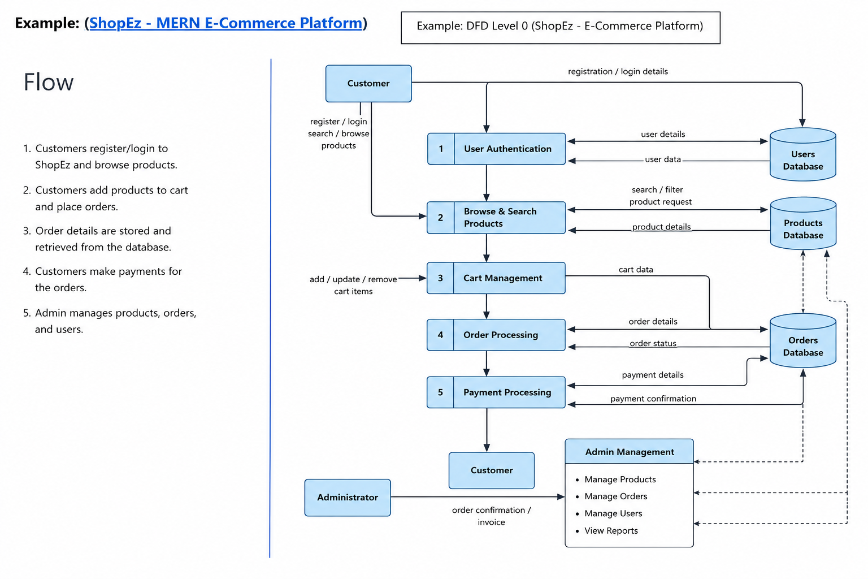

User Stories
User Type | Functional Requirement (Epic) | User Story Number | User Story / Task | Acceptance Criteria | Priority | Release
Customer (Web User) | Registration | USN-1 | Register using email and password | Account created successfully | High | Sprint-1
Customer (Web User) |  | USN-2 | Verify email and login | User can access dashboard | High | Sprint-1
Customer (Web User) | Product Catalog | USN-3 | Browse products | Products displayed correctly | High | Sprint-1
Customer (Web User) |  | USN-4 | Search products | Relevant products displayed | High | Sprint-2
Customer (Web User) | Shopping Cart | USN-5 | Add products to cart | Cart updated successfully | High | Sprint-2
Customer (Web User) | Orders | USN-6 | Place an order | Order confirmation generated | High | Sprint-3
Customer Care Executive | Customer Support | USN-7 | Handle customer queries | Queries resolved | Medium | Sprint-3
Administrator | Product Management | USN-8 | Add/Edit/Delete products | Catalog updated | High | Sprint-3
Administrator | Order Management | USN-9 | Manage orders | Order status updated | High | Sprint-4
Administrator | User Management | USN-10 | Manage users | User records maintained | Medium | Sprint-4

