Ideation Phase
Brainstorm & Idea Prioritization Template
Date | 18 June 2026
Student Name | K MEHER MADHURI
Project Name | ShopEz – MERN Stack E-Commerce Application
Maximum Marks | 4 Marks

Brainstorm & Idea Prioritization Template:
Brainstorming provides a free and open environment that encourages everyone within a team to participate in the creative thinking process that leads to problem solving. Prioritizing volume over value, out-of-the-box ideas are welcome and built upon, and all participants are encouraged to collaborate, helping each other develop a rich amount of creative solutions.

Step-1: Team Gathering, Collaboration and Select the Problem Statement
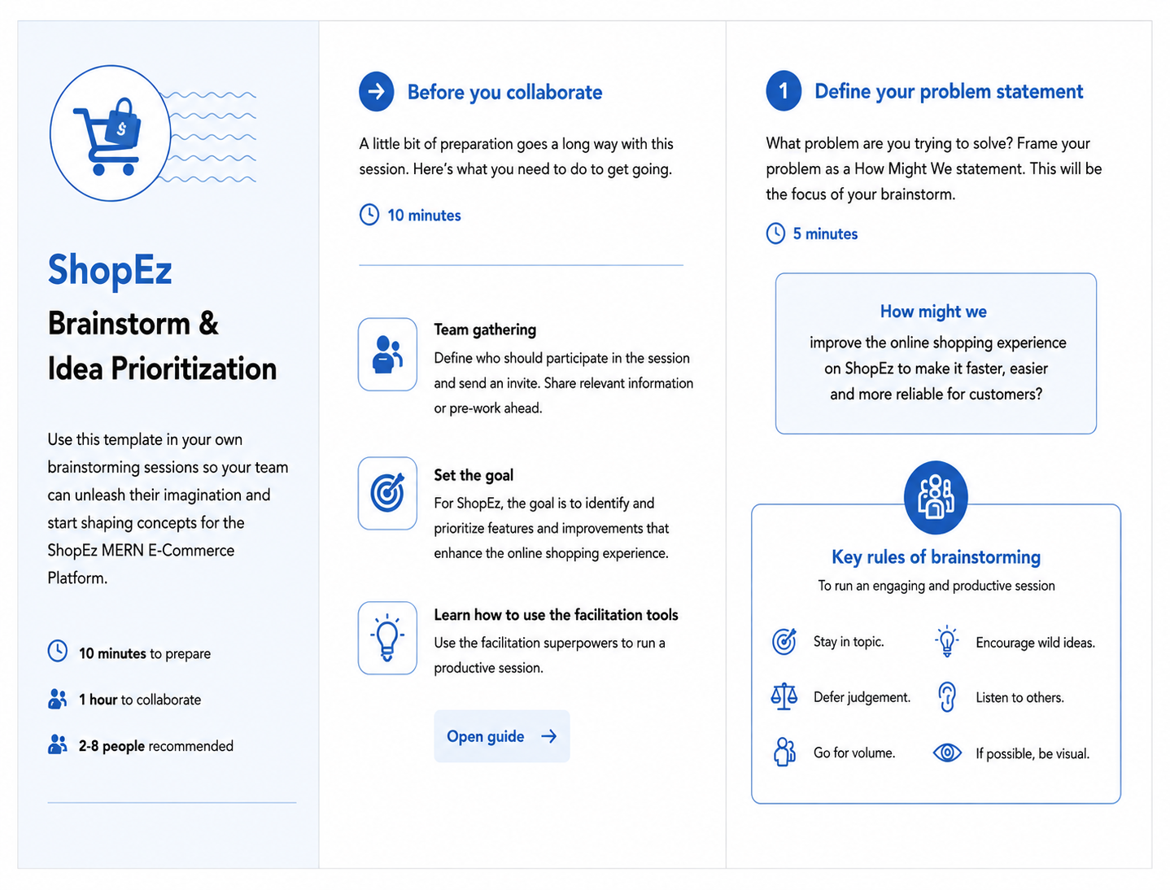
Step-2: Brainstorm, Idea Listing and Grouping
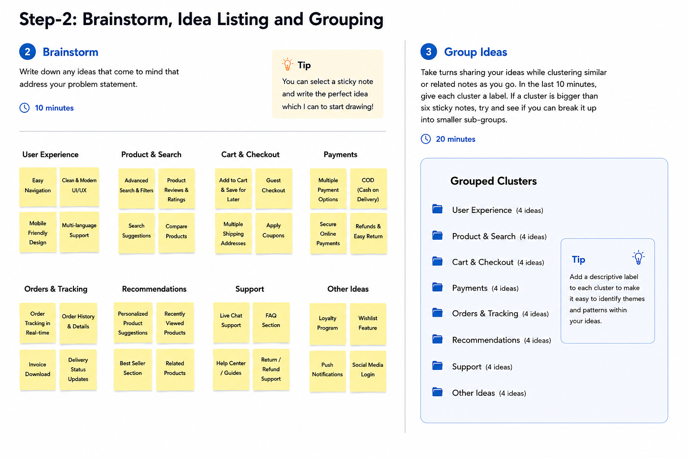

Step-3: Idea Prioritization
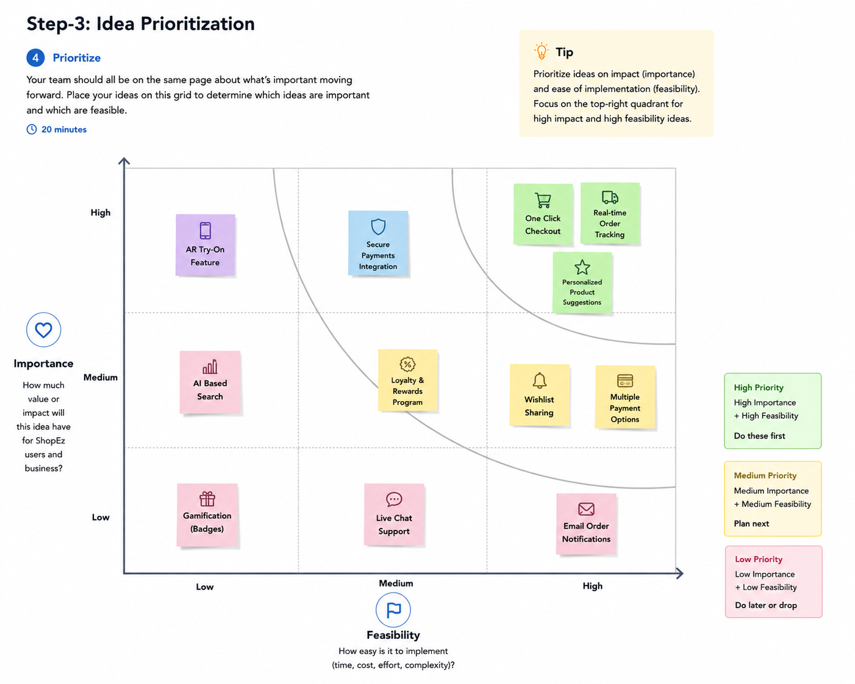

ShopEz – MERN Stack E-Commerce | GitHub: github.com/mehermadhuri/ShopEz-MERN | Deployed: shop-ez-mern-alpha.vercel.app

