Ideation Phase
Define the Problem Statements
Date | 18 June 2026
Student Name | K MEHER MADHURI
Project Name | ShopEz – MERN Stack E-Commerce Application
Maximum Marks | 2 Marks

Customer Problem Statement Template:
Create a problem statement to understand your customer's point of view. The Customer Problem Statement template helps you focus on what matters to create experiences people will love.
A well-articulated customer problem statement allows you and your team to find the ideal solution for the challenges your customers face. Throughout the process, you'll also be able to empathize with your customers, which helps you better understand how they perceive your product or service.
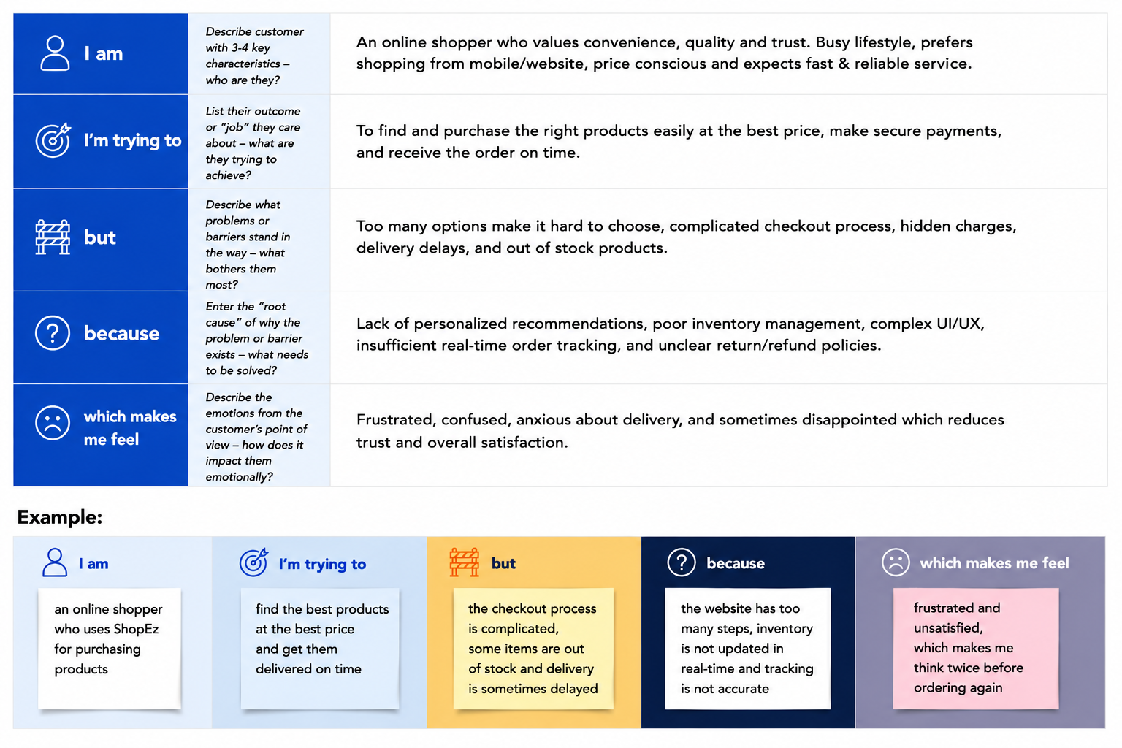

Problem Statement (PS) | I am (Customer) | I'm trying to | But | Because | Which makes me feel
PS-1 | A new user visiting ShopEz for the first time | Register an account and log in to start shopping | Registration and login do not work | The backend server is not deployed and the API URL is not configured in the frontend | Confused and frustrated
PS-2 | A logged-in customer who has added products to cart | Proceed to checkout and place an order | There is no checkout page or order confirmation flow | The cart-to-order feature is not yet implemented in the MERN backend | Disappointed and unable to complete purchase

ShopEz – MERN Stack E-Commerce | GitHub: github.com/mehermadhuri/ShopEz-MERN

