Ideation Phase
Empathize & Discover
Date | 18 June 2026
Student Name | K MEHER MADHURI
Project Name | ShopEz – MERN Stack E-Commerce Application
Maximum Marks | 4 Marks

Empathy Map Canvas:
An empathy map is a simple, easy-to-digest visual that captures knowledge about a user's behaviours and attitudes.
It is a useful tool to helps teams better understand their users.
Creating an effective solution requires understanding the true problem and the person who is experiencing it. The exercise of creating the map helps participants consider things from the user's perspective along with his or her goals and challenges.
Example:
Empathy Map – ShopEz User

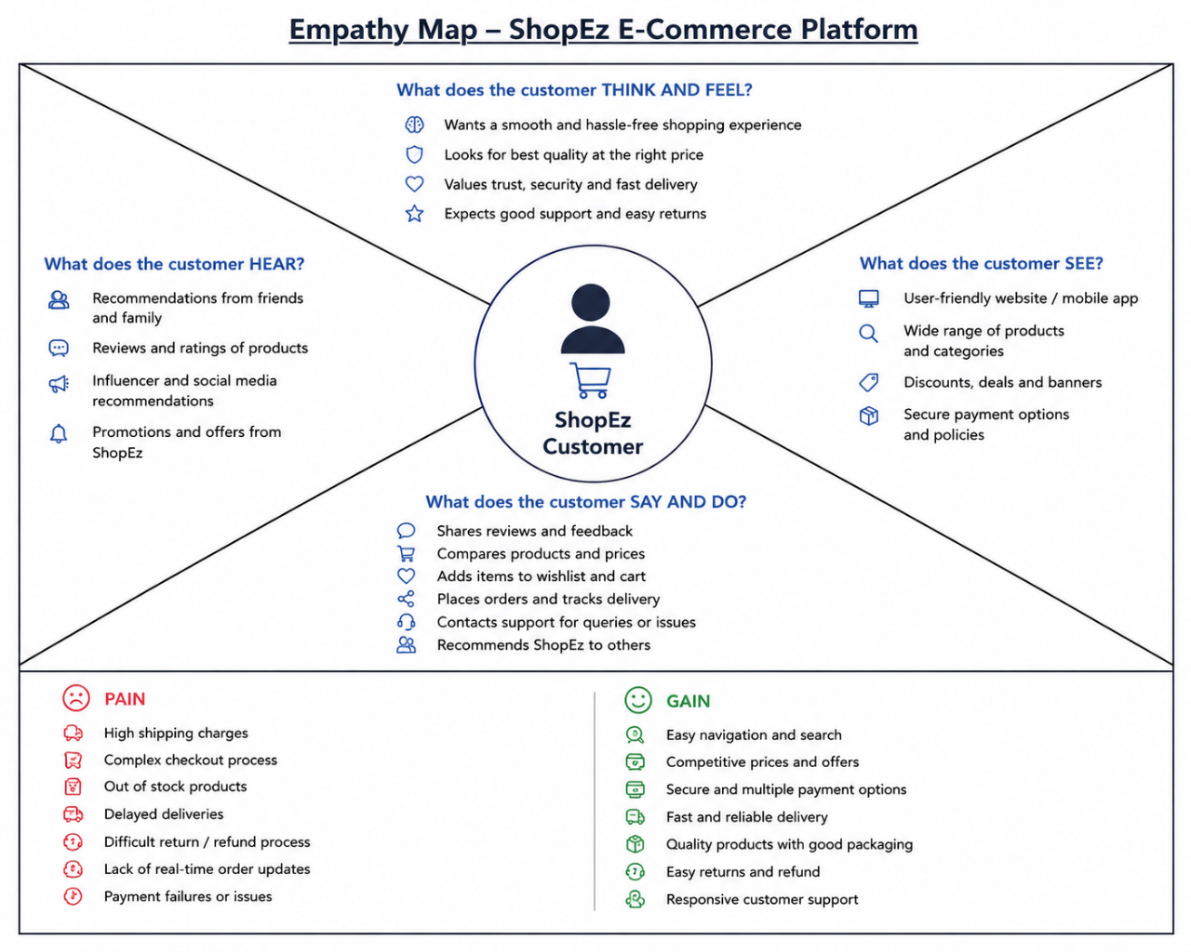
What does he THINK AND FEEL?
• Worried about payment security and data privacy on unknown websites
• Hopes to find quality products at reasonable prices
• Anxious when login fails or cart doesn't update properly

