1.We have a model and making predictions, how would you store predictions in cloud, monitor the performance, set access policies, etc.

For Storing the predictions -‘S3’

Monitoring the performance- ‘CloudWatch’

Set Access Policies: ‘IAM’

We can use the following AWS technologies for different purposes:

* AWS -EMR – To create the cluster, submitting jobs
* Lambda – To trigger the function
* Glue – ETL purpose, writing jobs
* ML Application, AWS Sage maker - For ML purpose
* Redshift: Data warehousing
* Athena – For querying the data.

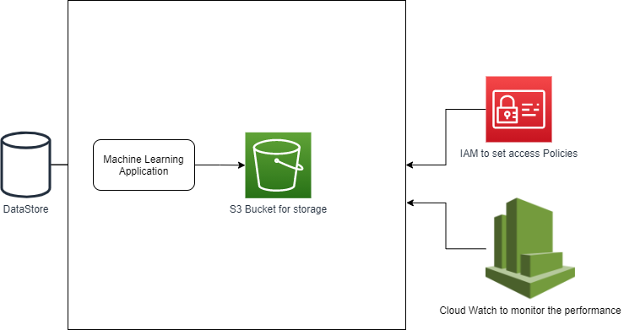

2. We have streaming data coming from various vehicle manufacturers. How would you design a pipeline to consolidate, process, and normalize the data to call ML applications (models)? How would gather the response from the ML applications (models) and report it on the dashboard?

Block Diagram representing the flow

* Kinesis Data Streams is used to collect the data from various streams.
* Kinesis Data Firehose is used to deliver the streaming data to S3.
* Lambda is used to enrich the data before storing it to S3.
* Athena is used for querying the data. Aggregated data is sent to S3.
* Amazon Sage maker is extensively used for machine learning purpose. To train the model and predict the data.
* Predicted data can be stored in S3.
* From S3 data sent to Redshift and be connected to Quick sight/ tableau for creating dashboards.

