East West University

**Project Report**

***Unit Converter***

CSE107

Section: 5

Summer 2017

**Submitted To**

MD Sarwar Kamal **Senior Lecturer**

**Department of Computer Science & Engineering**

**East West University**



**Submitted By**

Mehfuj Ahmed Anik 2017-1-60-135

Anan Aiman Tuba 2016-1-63-017

Zannatul Ferdous Meem 2012-1-68-031

**System Design:** The project is done on Java platform and it is coded on Netbeans IDE as front end. For saving data (Database) MySQL is used as back end .The Program comes with a Graphical User Interface (GUI) as well for as it was a part of our project. The main feature of the program is to convert various kind of units with the graphical interface. As the additional feature, we made an option to save the inputs and outputs to see them in future. A number of classes and functions were used to add all the features of the program.

**Program Output:**

1. Selecting Unit, giving input and getting the result.

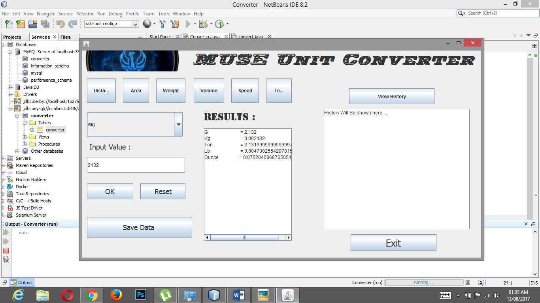

2 . Saving data into database.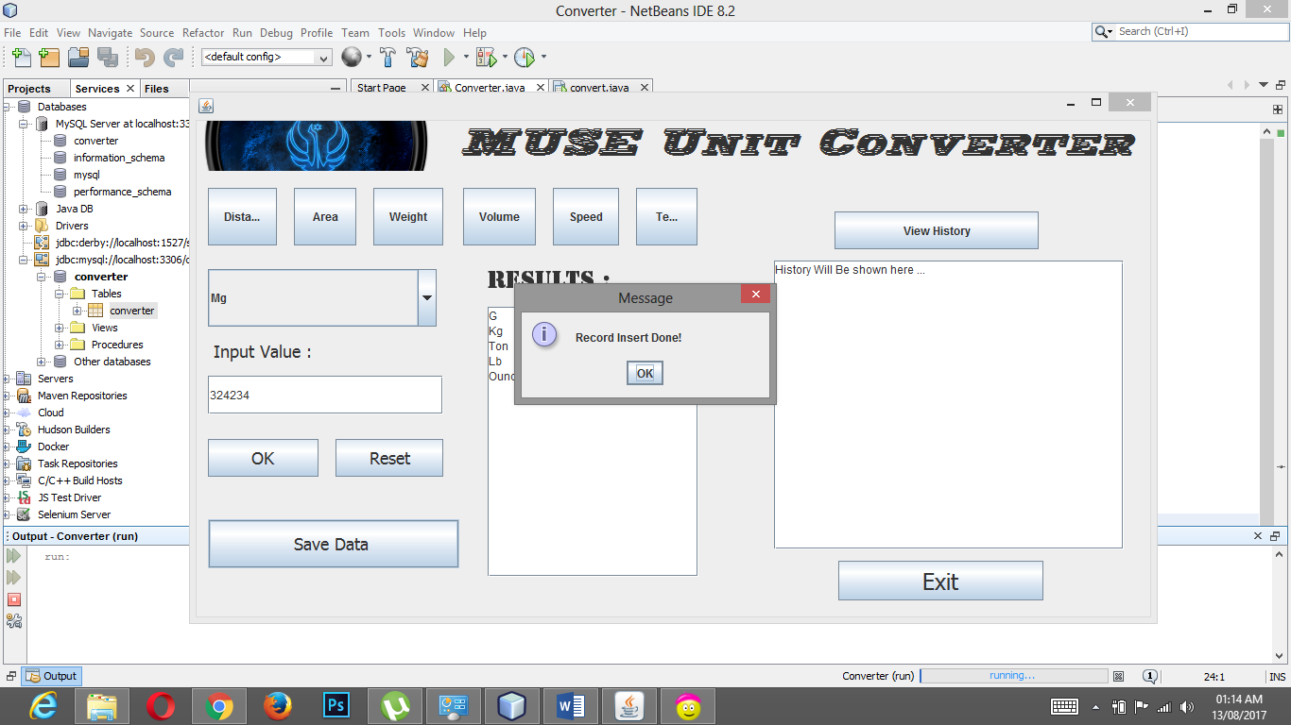

**3 .** Viewing the saved data .

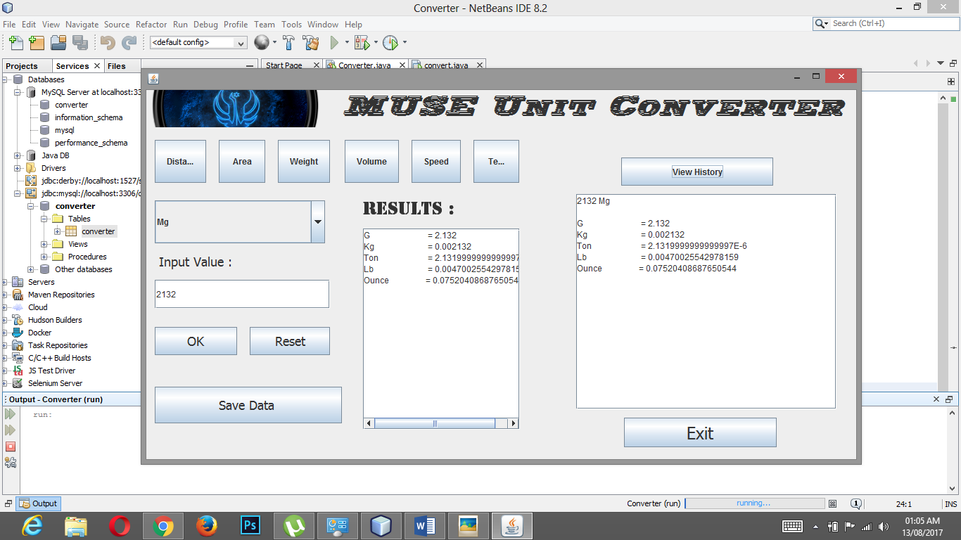

**Source Code:**

package converter;

import java.sql.Connection;

import java.sql.DriverManager;

import java.sql.PreparedStatement;

import java.sql.ResultSet;

import java.sql.SQLException;

import java.sql.Statement;

import javax.swing.JOptionPane;

public class convert extends javax.swing.JFrame {

String X;

/**

* Creates new form convert

*/

public convert() {

initComponents();

}

@SuppressWarnings("unchecked")

// <editor-fold defaultstate="collapsed" desc="Generated Code">

private void initComponents() {

jButton1 = new javax.swing.JButton();

jButton2 = new javax.swing.JButton();

jButton3 = new javax.swing.JButton();

jButton4 = new javax.swing.JButton();

jButton5 = new javax.swing.JButton();

jTextField1 = new javax.swing.JTextField();

combo = new javax.swing.JComboBox<>();

jLabel1 = new javax.swing.JLabel();

jButton6 = new javax.swing.JButton();

jButton7 = new javax.swing.JButton();

jLabel2 = new javax.swing.JLabel();

Save = new javax.swing.JButton();

exit = new javax.swing.JButton();

reset = new javax.swing.JButton();

jScrollPane1 = new javax.swing.JScrollPane();

jTextArea1 = new javax.swing.JTextArea();

jScrollPane2 = new javax.swing.JScrollPane();

jTextArea2 = new javax.swing.JTextArea();

jLabel3 = new javax.swing.JLabel();

jButton8 = new javax.swing.JButton();

private void jButton1ActionPerformed(java.awt.event.ActionEvent evt) {

combo.setModel(new javax.swing.DefaultComboBoxModel<>(new String[] { "mm", "cm", "m", "km", "inc", "ft" }));

}

private void jButton2ActionPerformed(java.awt.event.ActionEvent evt) {

combo.setModel(new javax.swing.DefaultComboBoxModel<>(new String[] { "Mm Square", "Cm Square", "M Square", "Km Square", "Acre", "Ft Square" }));

}

private void jButton3ActionPerformed(java.awt.event.ActionEvent evt) {

combo.setModel(new javax.swing.DefaultComboBoxModel<>(new String[] { "Mg", "G", "Kg", "Ton", "Pound", "Ounce" }));

}

private void jButton6ActionPerformed(java.awt.event.ActionEvent evt) {

String a1 = jTextField1.getText();

Double a=Double.parseDouble(a1);

// for distance

if (combo.getSelectedItem().equals("mm")) {

resultmm(a);

X="mm";

}

if (combo.getSelectedItem().equals("cm")) {

resultcm(a);

X="cm";

}

if (combo.getSelectedItem().equals("m")) {

resultm(a);

X="m";

}

if (combo.getSelectedItem().equals("km")) {

resultkm(a);

X="km";

}

if (combo.getSelectedItem().equals("inc")) {

resultinc(a);

X="inch";

}

if (combo.getSelectedItem().equals("ft")) {

resultft(a);

X="ft";

}

//for Area

if (combo.getSelectedItem().equals("Mm Square")) {

resultmms(a);

X="Mm Square";

}

if (combo.getSelectedItem().equals("Cm Square")) {

resultcms(a);

X="cm Square";

}

if (combo.getSelectedItem().equals("M Square")) {

resultms(a);

X="M Square";

}

if (combo.getSelectedItem().equals("Km Square")) {

resultkms(a);

X="Km Square";

}

if (combo.getSelectedItem().equals("Acre")) {

resultacr(a);

X="Acre";

}

if (combo.getSelectedItem().equals("Ft Square")) {

resultfts(a);

X="Ft Square";

}

// For Weight

if (combo.getSelectedItem().equals("Mg")) {

resultmg(a);

X="Mg";

}

if (combo.getSelectedItem().equals("G")) {

resultg(a);

X="G";

}

if (combo.getSelectedItem().equals("Kg")) {

resultkg(a);

X="Kg";

}

if (combo.getSelectedItem().equals("Pound")) {

resultpon(a);

X="Pound";

}

if (combo.getSelectedItem().equals("Ton")) {

resultton(a);

X="Ton";

}

if (combo.getSelectedItem().equals("Ounce")) {

resultoz(a);

X="Ounce";

}

// For volume

if (combo.getSelectedItem().equals("Milli lItre")) {

resultml(a);

X="Milli Litre";

}

if (combo.getSelectedItem().equals("Cubic C.meter")) {

resultccm(a);

X="Cubic C.meter";

}

if (combo.getSelectedItem().equals("Litre")) {

resultlt(a);

X="Litre";

}

if (combo.getSelectedItem().equals("Cubic Meter")) {

resultcmt(a);

X="Cubic Meter";

}

if (combo.getSelectedItem().equals("Cubic Inch")) {

resultci(a);

X="Cubic Inch";

}

if (combo.getSelectedItem().equals("Cubic Foot")) {

resultcf(a);

X="Cubic Foot";

}

// for speed

if (combo.getSelectedItem().equals("m/s")) {

resultmps(a);

X="m/s";

}

if (combo.getSelectedItem().equals("kmph")) {

resultkmph(a);

X="kmph";

}

if (combo.getSelectedItem().equals("mph")) {

resultmph(a);

X="mph";

}

if (combo.getSelectedItem().equals("knot")) {

resultkn(a);

X="knot";

}

if (combo.getSelectedItem().equals("ft/s")) {

resultfs(a);

X="ft/s";

}

// for temperature

if (combo.getSelectedItem().equals("Kelvin")) {

resultkl(a);

X="Kelvin";

}

if (combo.getSelectedItem().equals("Celsius")) {

resultcl(a);

X="Celcius";

}

if (combo.getSelectedItem().equals("Fahrenheit")) {

resultfh(a);

X="Fahrenheit";

}

}

private void jTextField1ActionPerformed(java.awt.event.ActionEvent evt) {

}

private void comboActionPerformed(java.awt.event.ActionEvent evt) {

// TODO add your handling code here:

}

private void exitActionPerformed(java.awt.event.ActionEvent evt) {

System.exit(0);

}

private void resetActionPerformed(java.awt.event.ActionEvent evt) {

jTextField1.setText(null);

jTextArea1.setText("Results will be shown here....");

jTextArea2.setText("History Will Be shown here ...");

combo.removeAllItems();

}

private void jButton4ActionPerformed(java.awt.event.ActionEvent evt) {

combo.setModel(new javax.swing.DefaultComboBoxModel<>(new String[] { "Milli lItre", "Cubic C.meter", "Litre", "Cubic Meter", "Cubic Inch", "Cubic Foot" }));

}

private void jButton5ActionPerformed(java.awt.event.ActionEvent evt) {

combo.setModel(new javax.swing.DefaultComboBoxModel<>(new String[] { "m/s","kmph", "mph", "knot", "ft/s" }));

}

private void jButton8ActionPerformed(java.awt.event.ActionEvent evt) {

combo.setModel(new javax.swing.DefaultComboBoxModel<>(new String[] { "Kelvin", "Celsius", "Fahrenheit"}));

}

private void SaveActionPerformed(java.awt.event.ActionEvent evt) {

try {

theQuery("insert into converter(input1,input2,output)values('"+jTextField1.getText()+"','"+X+"','"+jTextArea1.getText()+"')" );

JOptionPane.showMessageDialog(null,"Record Insert Done!");

} catch (Exception e) {

JOptionPane.showMessageDialog(null, e);

}

}

private void jButton7ActionPerformed(java.awt.event.ActionEvent evt) {

try

{

String sql = "select * from converter;" ;

DriverManager.registerDriver(new com.mysql.jdbc.Driver());

Connection cn=DriverManager.getConnection("jdbc:mysql://localhost:3306/converter","root","");

PreparedStatement ps=cn.prepareStatement(sql);

ResultSet rs=ps.executeQuery();

while(rs.next())

{

jTextArea2.setText(rs.getString("input1")+" "+rs.getString("input2")+"\n\n"+rs.getString("output"));

}

}catch(Exception ex)

{

JOptionPane.showMessageDialog(null,ex.getMessage());

}

}

// Functions of Distance

public void resultmm(double a2)

{

Double km = a2/1000000;

Double cm =a2/100;

Double m =a2/1000;

Double ft = a2*0.00328084;

Double inc = a2*0.0393700787;

String mm1= Double.toString(km);

String mm2= Double.toString(cm);

String mm3= Double.toString(m);

String mm4= Double.toString(ft);

String mm5= Double.toString(inc);

jTextArea1.setText("Km\t= "+mm1+"\nCm\t= "+mm2+"\n M\t ="+mm3+"\nFt\t ="+mm4+"\nInc\t= "+mm5);

}

public void resultcm(double a2)

{

Double mm=a2*10;

Double m1=a2/100;

Double km1= a2/100000;

Double ft1 = a2*0.032808399;

Double inc1=a2*0.03937007874;

String cm1 = Double.toString(mm);

String cm2 = Double.toString(m1);

String cm3= Double.toString(km1);

String cm4= Double.toString(ft1) ;

String cm5= Double.toString(inc1);

jTextArea1.setText("Km\t= "+cm3+"\nM\t= "+cm2+"\nMm\t ="+cm1+"\nFt\t ="+cm4+"\nInc\t= "+cm5);

}

public void resultm(double a2)

{

Double mm2=a2*1000;

Double cm2 =a2*100;

Double km2 =a2/1000;

Double ft2 =a2*3.280839895;

Double inc2=a2*39.37007874;

String m1 = Double.toString(mm2);

String m2 = Double.toString(cm2);

String m3 = Double.toString(km2);

String m4 = Double.toString(ft2);

String m5 = Double.toString(inc2);

jTextArea1.setText("Mm\t= "+m1+"\nKm\t= "+m3+"\nCm\t ="+m2+"\nFt\t ="+m4+"\nInc\t= "+m5);

}

public void resultkm(double a2)

{

Double mm2=a2*1000000;

Double cm2 =a2*100000;

Double M2 =a2*1000;

Double ft2 =a2*3280.839895;

Double inc2=a2*39370.07874;

String m1 = Double.toString(mm2);

String m2 = Double.toString(cm2);

String m3 = Double.toString(M2);

String m4 = Double.toString(ft2);

String m5 = Double.toString(inc2);

jTextArea1.setText("Mm\t= "+m1+"\nM\t= "+m3+"\nCm\t ="+m2+"\nFt\t ="+m4+"\nInc\t= "+m5);

}

public void resultft(double a2)

{

Double mm2=a2*304.8;

Double cm2 =a2*30.48;

Double M2 =a2*0.3048;

Double M1 =a2*0.0003048;

Double inc2=a2*12;

String m1 = Double.toString(mm2);

String m2 = Double.toString(cm2);

String m3 = Double.toString(M2);

String m4 = Double.toString(M1);

String m5 = Double.toString(inc2);

jTextArea1.setText("Mm\t= "+m1+"\nM\t= "+m3+"\nCm\t ="+m2+"\nKm\t ="+m4+"\nInc\t= "+m5);

}

public void resultinc(double a2)

{

Double mm2=a2*25.4;

Double cm2 =a2*2.54;

Double km2 =a2*0.0000254;

Double ft2 =a2*0.083333333;

Double M2=a2*0.0254;

String m1 = Double.toString(mm2);

String m2 = Double.toString(cm2);

String m3 = Double.toString(km2);

String m4 = Double.toString(ft2);

String m5 = Double.toString(M2);

jTextArea1.setText("Mm\t= "+m1+"\nKm\t= "+m3+"\nCm\t ="+m2+"\nFt\t ="+m4+"\nM\t= "+m5);

}

// Until this line

//Functions of area

public void resultmms(double a3)

{

Double kms = a3/100000;

kms=kms/10000000;

Double ms=a3/1000000;

Double cms=a3/100;

Double acr=a3/404685.6422;

acr=acr/10000;

Double fts= a3/92903.04;

String skm= Double.toString(kms);

String sms= Double.toString(ms);

String scms= Double.toString(cms);

String sacr= Double.toString(acr);

String sfts= Double.toString(fts);

jTextArea1.setText("Km Square\t ="+skm+"\nM Square \t ="+ms+"\nCm Square\t ="+cms+"\nAcre \t ="+acr+"\nFoot Square\t ="+fts);

}

public void resultcms(double a3)

{

Double kms = a3/100000;

kms=kms/100000;

Double ms=a3/10000;

Double mms=a3*100;

Double acr=a3/404685.6422;

acr=acr/100;

Double fts= a3*0.001076391;

String skm= Double.toString(kms);

String sms= Double.toString(ms);

String scms= Double.toString(mms);

String sacr= Double.toString(acr);

String sfts= Double.toString(fts);

jTextArea1.setText("Km Square\t ="+skm+"\nM Square \t ="+ms+"\nMm Square\t ="+mms+"\nAcre \t ="+acr+"\nFoot Square\t ="+fts);

}

public void resultms(double a3)

{

Double kms = a3/1000000;

Double mms=a3*1000000;

Double cms=a3*1000;

Double acr=a3*0.0002571054;

Double fts= a3*10.763910417;

String skm= Double.toString(kms);

String sms= Double.toString(mms);

String scms= Double.toString(cms);

String sacr= Double.toString(acr);

String sfts= Double.toString(fts);

jTextArea1.setText("Km Square\t ="+skm+"\nMm Square \t ="+mms+"\nCm Square\t ="+cms+"\nAcre \t ="+acr+"\nFoot Square\t ="+fts);

}

public void resultkms(double a3)

{

Double mms = a3*1000000;

mms=mms*1000000;

Double ms=a3*1000000;

Double cms=a3*100000;

cms=cms*100000;

Double acr=a3*247.10538147;

Double fts= a3*10763910.417;

String skm= Double.toString(mms);

String sms= Double.toString(ms);

String scms= Double.toString(cms);

String sacr= Double.toString(acr);

String sfts= Double.toString(fts);

jTextArea1.setText("Mm Square\t ="+skm+"\nM Square \t ="+ms+"\nCm Square\t ="+cms+"\nAcre \t ="+acr+"\nFoot Square\t ="+fts);

}

public void resultacr(double a3)

{

Double kms = a3*0.0040468564;

Double ms=a3*4046.8564224;

Double cms=a3*40468564.224;

Double mms=a3*4046856422.4;

Double fts= a3*43560;

jTextArea1.setText("Km Square\t ="+kms+"\nM Square \t ="+ms+"\nCm Square\t ="+cms+"\nMm Square\t ="+mms+"\nFoot Square\t ="+fts);

}

public void resultfts(double a3)

{

Double kms = a3/10763910.417;

Double ms=a3*0.09290304;

Double cms=a3*929.0304;

Double mms=a3*92903.04;

Double acr= a3/43560;

jTextArea1.setText("Km Square\t ="+kms+"\nM Square \t ="+ms+"\nCm Square\t ="+cms+"\nMm Square\t ="+mms+"\nAcre \t ="+acr);

}

// until this

// Functions of weight

public void resultmg(double a4)

{

Double g=a4/1000;

Double kg=a4/1000000;

Double ton=a4/100000;

ton=ton/10000;

Double oz=a4/28349.523125;

Double pn=a4/453592.37;

jTextArea1.setText("G \t = "+g+"\nKg \t = "+kg+"\nTon\t = "+ton+"\nLb \t = "+pn+"\nOunce \t= "+oz);

}

public void resultg(double a4)

{

Double mg=a4*1000;

Double kg=a4/1000;

Double ton=kg/1000;

Double oz=a4/28.349523125;

Double pn=a4/453.59237;

jTextArea1.setText("Mg \t = "+mg+"\nKg \t = "+kg+"\nTon\t = "+ton+"\nLb \t = "+pn+"\nOunce \t= "+oz);

}

public void resultkg(double a4)

{

Double mg=a4*1000000;

Double g=a4*1000;

Double ton=a4/1000;

Double oz=a4*35.27396195;

Double pn=a4*2.2046226218;

jTextArea1.setText("Mg \t = "+mg+"\nG \t = "+g+"\nTon\t = "+ton+"\nLb \t = "+pn+"\nOunce \t= "+oz);

}

public void resultton(double a4)

{

Double mg=a4*1000*1000*1000;

Double kg=a4*1000;

Double g=kg*1000;

Double oz=a4*35273.96195;

Double pn=a4*2204.6226218;

jTextArea1.setText("Mg \t = "+mg+"\nKg \t = "+kg+"\nG\t = "+g+"\nLb \t = "+pn+"\nOunce \t= "+oz);

}

public void resultpon(double a4)

{

Double mg=a4*453592.37;

Double kg=a4*0.45359237;

Double g =a4*453.59237;

Double oz=a4*16;

Double ton=a4*0.0005;

jTextArea1.setText("Mg \t = "+mg+"\nKg \t = "+kg+"\nG\t = "+g+"\nTon \t = "+ton+"\nOunce \t= "+oz);

}

public void resultoz(double a4)

{

Double mg=a4*28349.523125;

Double kg=a4*0.0283495231;

Double g =a4*28.3495231;

Double pon=a4*0.0625;

Double ton=a4/35273.96195;

jTextArea1.setText("Mg \t = "+mg+"\nKg \t = "+kg+"\nG\t = "+g+"\nTon \t = "+ton+"\nLb \t= "+pon);

}

// Untill this line

public void resultml(double a5)

{

Double cm= a5;

Double l= a5/1000;

Double m= a5/1000000;

Double in = a5*0.0610237441;

Double ft = a5/28316.846592;

jTextArea1.setText("Cm Cube\t = "+cm+"\nLitre\t = "+l+"\nMitre Cube\t = "+m+"\nCubic Inch\t = "+in+"\nCubic Foot\t = "+ft);

}

public void resultccm(double a5)

{

Double ml= a5;

Double l= a5/1000;

Double m= a5/1000000;

Double in = a5*0.0610237441;

Double ft = a5/28316.846592;

jTextArea1.setText("Milli Litre\t = "+ml+"\nLitre\t = "+l+"\nMitre Cube\t = "+m+"\nCubic Inch\t = "+in+"\nCubic Foot\t = "+ft);

}

public void resultlt(double a5)

{

Double cm= a5*1000;

Double ml= a5*1000;

Double m= a5/1000;

Double in = a5*61.023744;

Double ft = a5*0.0353146667;

jTextArea1.setText("Cm Cube\t = "+cm+"\nMilli Litre\t = "+ml+"\nMitre Cube\t = "+m+"\nCubic Inch\t = "+in+"\nCubic Foot\t = "+ft);

}

public void resultcmt(double a5)

{

Double cm= a5*1000000;

Double ml= a5*1000000;

Double l= a5*1000;

Double in = a5*61023.7441;

Double ft = a5*35.314666721;

jTextArea1.setText("Cm Cube\t = "+cm+"\nLitre\t = "+l+"\nMilli Litre\t = "+ml+"\nCubic Inch\t = "+in+"\nCubic Foot\t = "+ft);

}

public void resultci(double a5)

{

Double cm= a5*16.387064;

Double ml= a5*16.387064;

Double l= a5*0.016387064;

Double m = a5/61023.7441;

Double ft = a5/1728;

jTextArea1.setText("Cm Cube\t = "+cm+"\nLitre\t = "+l+"\nMilli Litre\t = "+ml+"\nCubic Meter\t = "+m+"\nCubic Foot\t = "+ft);

}

public void resultcf(double a5)

{

Double cm= a5*28316.846592;

Double ml= a5*28316.846592;

Double l= a5*28.316846592;

Double in = a5*1728;

Double m = a5*0.0283168466;

jTextArea1.setText("Cm Cube\t = "+cm+"\nLitre\t = "+l+"\nMilli Litre\t = "+ml+"\nCubic Inch\t = "+in+"\nCubic Meter\t = "+m);

}

// until this line ;

public void resultmps(double a6)

{

Double kh=a6*0.06;

Double mh=a6*2.2369362921;

Double kn=a6*1.94384449;

Double ft=a6*3.280839;

jTextArea1.setText("Kmph\t = "+kh+"\nmph\t = "+mh+"\nknot\t = "+kn+"\nft/s\t = "+ft);

}

public void resultkmph(double a6)

{

Double mps=a6*0.2777777;

Double mh=a6*0.62137119;

Double kn=a6*0.5399568;

Double ft=a6*0.911344415;

jTextArea1.setText("m/s\t = "+mps+"\nmph\t = "+mh+"\nknot\t = "+kn+"\nft/s\t = "+ft);

}

public void resultmph(double a6)

{

Double kh=a6*1.6093;

Double mps=a6*0.44704;

Double kn=a6*0.8689762;

Double ft=a6*1.46666666;

jTextArea1.setText("Kmph\t = "+kh+"\nm/s\t = "+mps+"\nknot\t = "+kn+"\nft/s\t = "+ft);

}

public void resultkn(double a6)

{

Double kh=a6*1.852;

Double mh=a6*1.15077944;

Double mps=a6*0.51444444;

Double ft=a6*1.6878098;

jTextArea1.setText("Kmph\t = "+kh+"\nmph\t = "+mh+"\nm/s\t = "+mps+"\nft/s\t = "+ft);

}

public void resultfs(double a6)

{

Double mps=a6*0.3048;

Double mh=a6*0.6818181818;

Double kh=a6*1.0972;

Double kn=a6*0.5924838013;

jTextArea1.setText("Kmph\t = "+kh+"\nmph\t = "+mh+"\nm/s\t = "+mps+"\nknot/s\t = "+kn);

}

// untill this line

public void resultkl(double a7)

{

Double cl=a7-273;

Double fh=9/5*(a7 - 273) + 32;

jTextArea1.setText("Celsius\t = "+cl+"\nFahrenheit\t = "+fh);

}

public void resultcl(double a7)

{

Double kl=a7+273;

Double fh=9/5*a7 + 32;

jTextArea1.setText("Kelvin\t = "+kl+"\nFahrenheit\t = "+fh);

}

public void resultfh(double a7)

{

Double kl=5/9 *(a7 - 32) + 273;

Double cl=(a7-32)*5/9;

jTextArea1.setText("Kelvin\t = "+kl+"\nCelsius\t = "+cl);

}

public void theQuery(String query) throws SQLException

{

Connection con = null;

Statement st = null;

try{

con = DriverManager.getConnection("jdbc:mysql://localhost:3306/converter","root","");

st = con.createStatement();

st.executeUpdate(query);

}

catch(Exception ex){

JOptionPane.showMessageDialog(null,ex.getMessage());

}

}

public class Converter {

/**

* @param args the command line arguments

*/

public static void main(String[] args) {

// TODO code application logic here

convert obj=new convert();

obj.setVisible(true);

}

}

**Disk/CD**: No disk or CD is attached.

**Program Execution:**

1. Compile without errors: Yes.
2. User Friendly: Yes
3. Error free during runtime: Yes