Make or Buy Decision

Q

uestion # 1:

Part (a)

The Break even analysis for the make & buy options is given in the following figure:

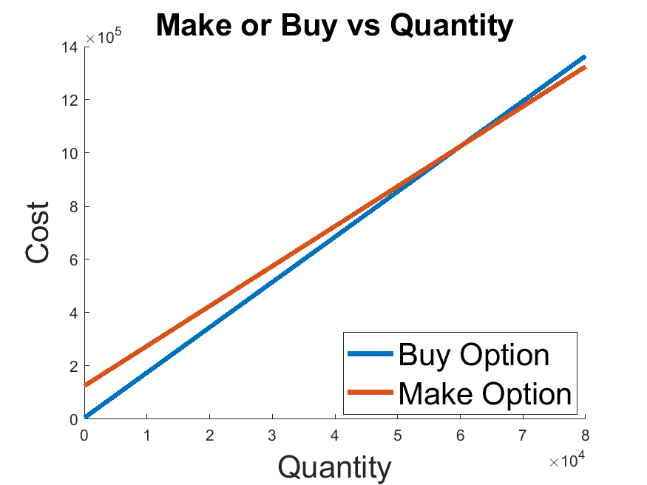

Figure 1

$$B_{cost}(Q) = B_{fc} + B_{vc}*Q$$

$$M_{cost}(Q) = M_{fc} + M_{vc}*Q$$

From the above graph, we may observe that the break even point lies approximately around 6000. Calculating Accurately by equating the buy and make equations, we get the exact point:

$$B/E Point= 60000$$

Total cost at this point is:

$$Cost@BE= 1025000$$

Part (b)

Given a requirement of 150,000, the make option is cheaper as compared to the make option (refer to figure 1).

The cost savings would be defined as:

$$savings=B_{cost}(150,000)-M_{cost}(150,000)$$

$$savings= 180,000$$

Q

uestion # 2

Make option:

$$fixed cost=\$50, 000 \\ variable cost=\$25$$

Buy option:

$$fixed cost=\$1000 \\ variable cost= ?$$

Solution:

The criterion is defined as follows:

$${\left(fixed cost\right)}_{buy}+{20000*\left(variable cost\right)}_{buy}<{\left(fixed cost\right)}_{make}+20000*{\left(variable cost\right)}_{make}$$

Then, $${\left(variable cost\right)}_{buy}<({\left(fixed cost\right)}_{make}+Q*{\left(variable cost\right)}_{make}-{\left(fixed cost\right)}_{buy})/Q$$

Substituting values, $${\left(variable cost\right)}_{buy}<\$27.4500$$

Hence the maximum cost is $27.45.

**Other criterions to look for:** As discussed in the lectures, the firm should look at the seller’s standing in the market and work on developing good long terms relationships with them. In the above analysis, this factor is not accounted for.

Q

uestion # 3

$$Q= 20,000 units$$

**Make option:**

$$fixed cost=\$50,000 \\ variable cost=\$8$$

**Buy option:**

$$fixed cost=\$600 \\ variable cost=\$10$$

**Part (a)**

The breakeven plot for both buy & make is given below:

Figure 3

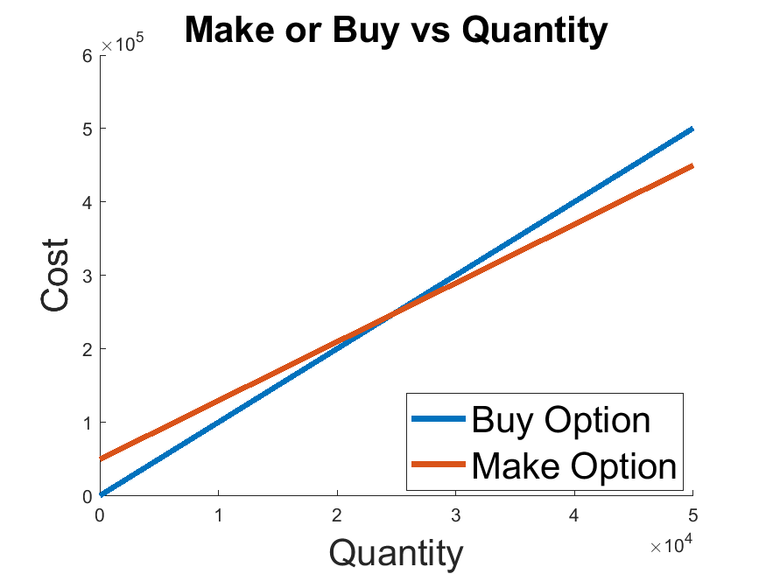

As is being observed, the breakeven point lies at 24,700 units. Since the requirement is only of 20,000 units, the buy option would be cheaper (refer to figure 3).

The total cost at the breakeven point is given as follows:

$$Total Cost @ BE= M_{cost}=B_{cost}\left(@24,700\right)= B_{fc} + B_{vc}*24700$$

$$Total Cost @ BE=\$247,600$$

Part (b)

Total cost for both options is given below:

$$Cost_{buy option}=\$200600 \\ Cost_{make option}=\$210000$$

As evident, the buy option is cheaper (as was suggested in the previous part). The total savings would be:

$$savings=make cost-buy cost \\ savings=\$9400$$

Total Cost of Ownership

Q

uestion # 1

The total cost analysis can be found in the attached excel file *[****sheet-name****: Q1].* The overall costs are:



It can be seen that cost of supplier 1 is less than that of supplier 2. Hence we should go with supplier 1.

Q

uestion # 2

The total cost analysis can be found in the attached excel file *[****sheet-name****: Q2].* The overall costs are:



It can be observed that the cheapest option to go with is supplier 2.

**Notes**

The following MATLAB script was used in obtaining the graphs/solution:

**Question # 1 (a and b)**

Q = 1: 160000;

Bfc = 5000; Bvc = 17; %buying fixed cost (Bfc) and variable cost (Bvc)

Mfc = 125000; Mvc = 15; %Making fixed cost (Mfc) and variable cost (Mvc)

B = Bfc + Bvc*Q;

M = Mfc + Mvc*Q;

hold on

fs = 20

plot(Q, B, 'linewidth', 3)

plot(Q, M, 'linewidth', 3)

title('Make or Buy vs Quantity', 'fontsize', fs)

xlabel('Quantity', 'fontsize', fs)

ylabel('Cost', 'fontsize', fs)

legend('Buy Option', 'Make Option','fontsize', fs, 'location', 'best')

hold off

print -dpng q1.png

BE = (B==M);

BE = find(BE)

B(BE)

savings = B(150000) - M(150000)

**Question # 2:**

fc_make = 50000; vc_make = 25;

Q = 20000;

fc_buy = 1000;

variable_buy = (fc_make + Q*vc_make - fc_buy)/Q

**Question # 3:**

Q = 1:50000;

Bfc = 600; Bvc = 10;

Mfc = 50000; Mvc = 8;

B = Bfc + Bvc*Q;

M = Mfc + Mvc*Q;

hold on

fs = 20

plot(Q, B, 'linewidth', 3)

plot(Q, M, 'linewidth', 3)

title('Make or Buy vs Quantity', 'fontsize', fs)

xlabel('Quantity', 'fontsize', fs)

ylabel('Cost', 'fontsize', fs)

legend('Buy Option', 'Make Option','fontsize', fs, 'location', 'best')

hold off

print -dpng q3.png

BE = (B==M);

BE = find(BE) %find break even point's index

price_at_BE = B(BE) %check cost @ BE point

%part b

price_buy_option = B(20000)

price_make_option = M(20000)

savings = price_make_option - price_buy_option