CSE 565 HW 2 REPORT

244201001033 AKCAN ERCAN

**Contents**

* The list of your object selected
* Your features detected on the objects
* The details of your object recognition algorithm for each of the 3 feature detectors
* The final confusion matrix for the 10 object recognition experiments for 3 different algorithms.
* Discussion about performance and the reasons for failures.
* The list of selected object

I selected last 10 objects in rgbd-dataset; rubber_eraser, scissors, shampoo, soda_can, sponge, stapler, tomato, toothbrush, toothpaste, water_bottle.

There are **182,851** items, totally **675.7 MB.**

I saw bunch of sub-folder in each main folder. All sub-folder has three main picture;

* + for example tomato object has 8 sub-folder;
    - *tomato_1, tomato_2, tomato_3, tomato_4, tomato_5, tomato_6, tomato_7, tomato_8*
  + And tomato_1 has 3 main file;
    - *tomato_1_1_1_crop.png, tomato_1_1_1_depthcrop.png, tomato_1_1_1_loc.txt*
  + As you can see, actually we need ..._crop.png, so I selected all pictures where includes name with ***_crop.png*** with sub-folder and main folder. The final folder and images;
  + The sum of trained object, I mean sum of *_crop.png* files are **45,697** images.

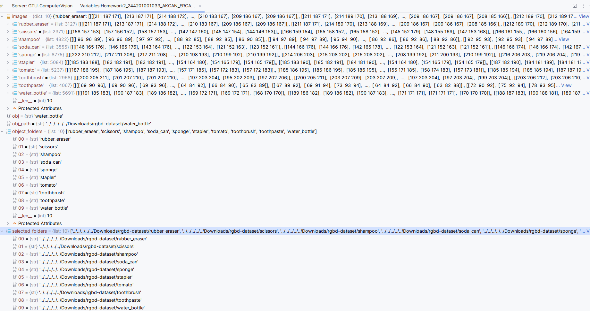

* + I selected 3 different feature detector (descriptor): ***SIFT***, ***ORB*** and ***BRISK***
* The features detected on the objects
  + When I try to show features detected on the objects, I got an error. Actually, features have two element; List {cv2.KeyPoint} and ndarray : { 33, 228}. I found these features for 3 detectors. In that place I will show detected features in PyCharm IDE. As you can see, each features have different KeyPoint in List (actually tupple) and different dimension of ndarray.

It is impossible for me to show all the features anyway, because there are so many features.

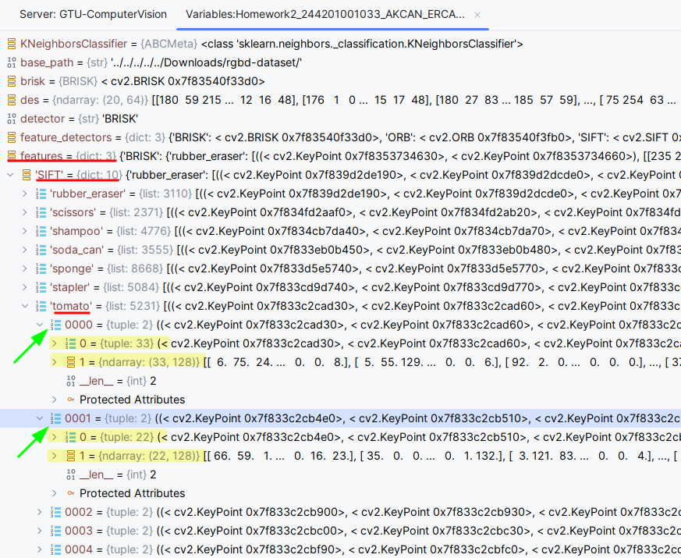

* + We also understand here that each descriptor didn’t captured the same number of features. I mean; the sift descriptor described **5231** features for tomato object while the orb descriptor described **320** features object and brisk descriptor described **1347** features for tomato object.

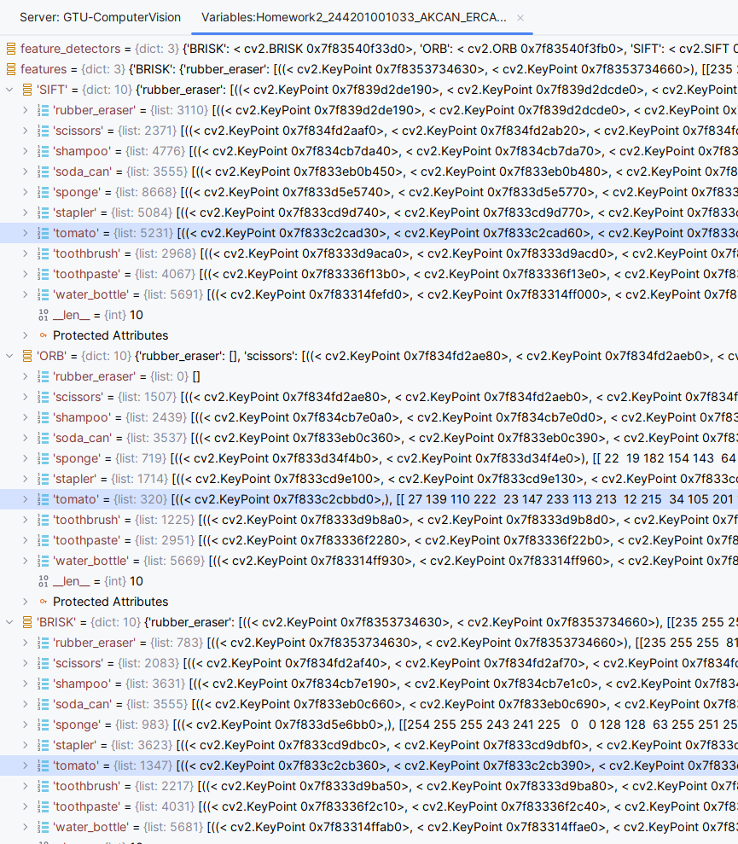

* + Actually, this operation was effective about our performance. So each descriptor didn’t captured the same number of features, ***Since each detector has its good and bad points, the performance of each detector will be different accordingly.***
* The details of your object recognition algorithm
  + My object recognition algorithm has some steps;
    - Take an image,
    - Convert gray scale,
    - Detect and compute for each detectors: *SIFT, ORB & BRISK,*
    - If detector give description without none,
    - Add features to relevant key: *SIFT, ORB & BRISK,*
    - For loop for all image.

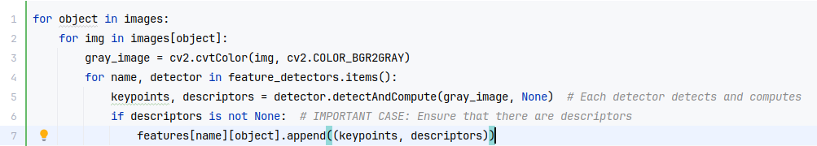

* + The simple steps !
* The final confusion matrices

It took approximately **24 minutes** for all the algorithms to run and the results to appear.

There 3 different confusion matrix; ***SIFT, ORB & BRISK***

* + Evaluating classifier: **SIFT**, Accuracies: **0.9157340355497038**

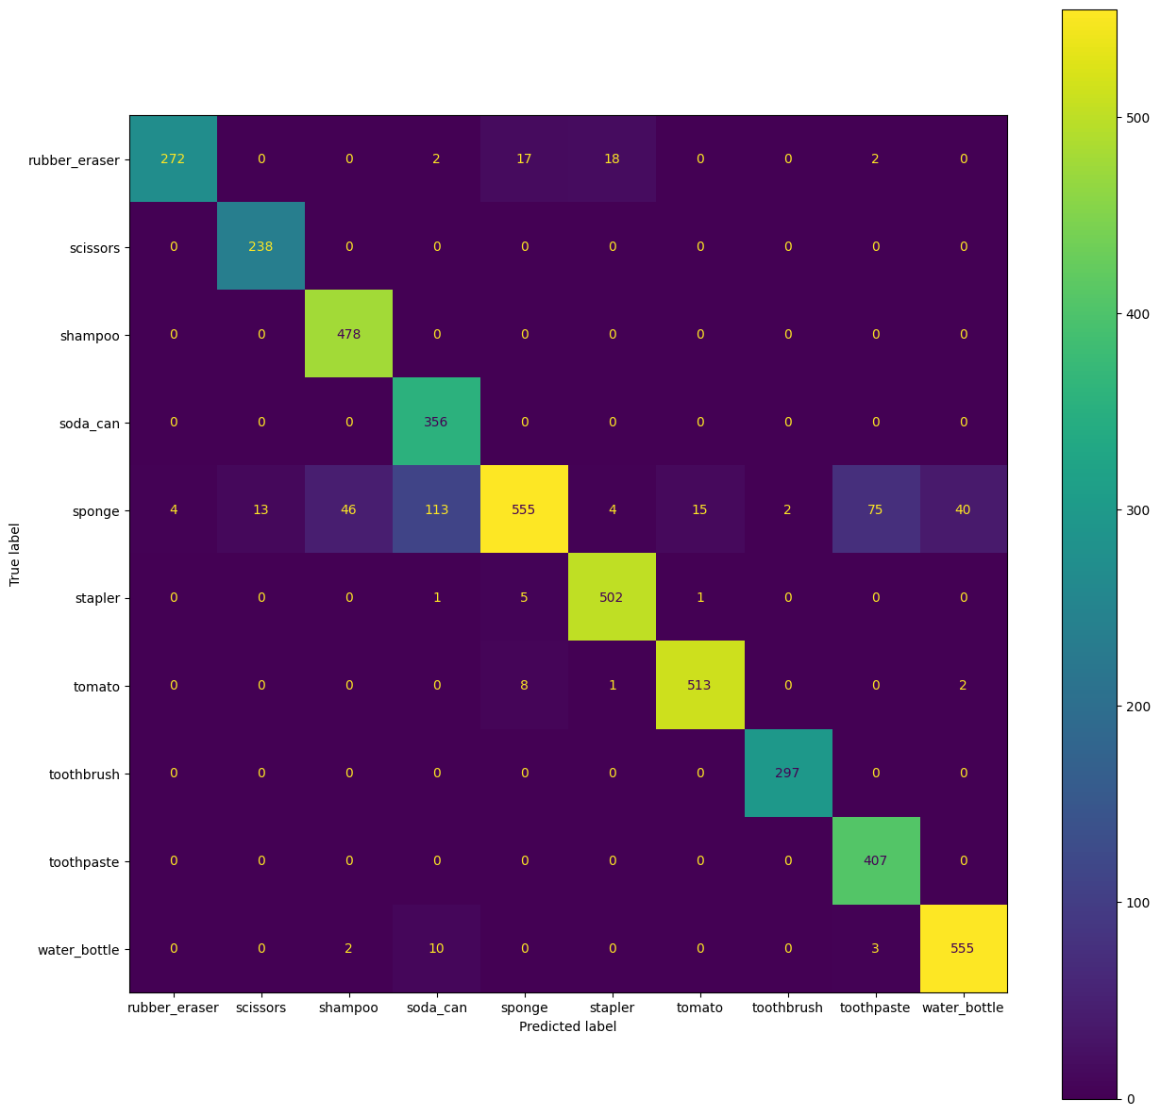

* + Evaluating classifier: **ORB**, Accuracies: **0.7533565390353059**

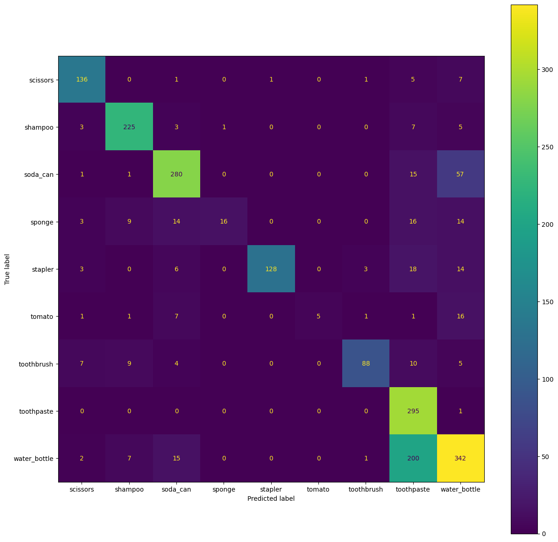

* + Evaluating classifier: **BRISK**, Accuracies: **0.8189285714285715**

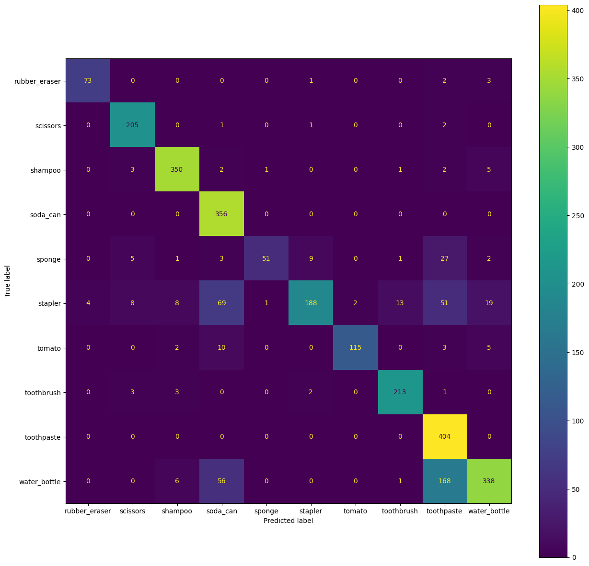

* Discussion

# As we can see, **SIFT** is better for accuracy and failures.

# We also discuss above section that each descriptor didn’t captured the same number of features. I mean; the sift descriptor described ***5231*** features for *tomato* object while the orb descriptor described ***320*** features for *tomato* object and brisk descriptor described ***1347*** features for *tomato* object.

These results occur from the methods that each algorithm uses when detecting features. Because if the algorithm cannot detect a feature for each image, it cannot say anything about the image, so the accuracy rate decreases.

