CSE 565 HW 3 REPORT

244201001033 AKCAN ERCAN

**Contents**

* Choosing stereo images,
* My over segmentation method / correspondence algorithm,
  + *Add Padding*
  + *Loop*
  + *Searching*
  + *Shifting*
  + *Block Comparison*
  + *Calculate*
* Results,
* Comparing,
* Discussion
* Choosing stereo images

I selected *Barn 2* images from [Middlebury](http://vision.middlebury.edu/stereo/data/scenes2001/) page. As we can see, the **barn2** folder includes nine stereo images and two disparity images.

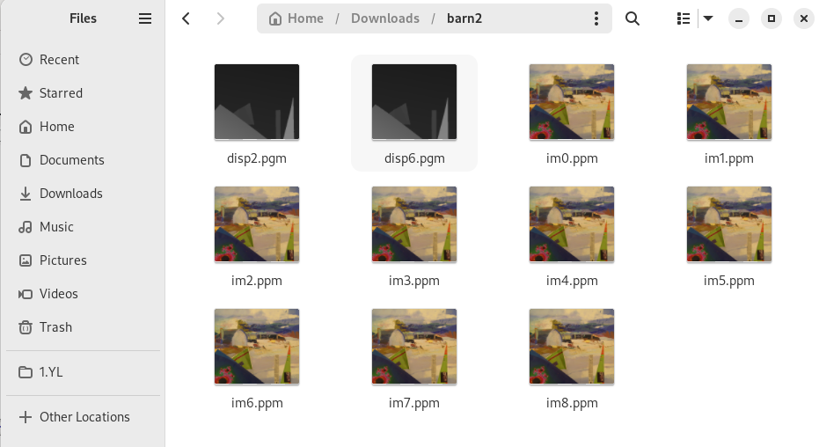

**P.S. *Please don’t forget to change barn2 folder location with respect to your local folder.***

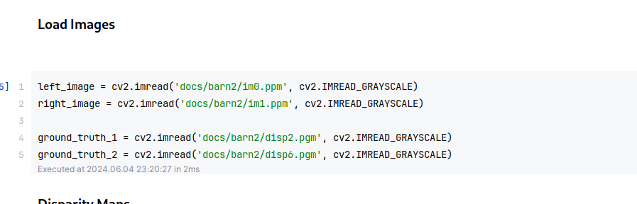

* My over segmentation method
  + Firstly; for over segmentation; we need to disparity map which we use depth difference between right and left image based on block searching. General steps for finding disparity map;
    1. **Add Padding** For run our method running on image edges, I will add some padding to left and right images. The padding size depends on block size.
    2. **Loop** For each block, find best shift value using SSD (Sum of Squared Differences) method,
    3. **Searching** On each pixel blocks for defining search bounds,
    4. **Shifting** If right shift is true; the bounds are determined accordingly,
    5. **Block Comparison** Get a block in left image and compare all blocks of right image and calculate SSD and update,
    6. **Calculate** Disparity map for smallest shifting value.

1. **Add Padding;**

I set block size = 27. Many of times trying, I found optimal number block size = 27.

Because our images’ size → *430px* * *381px.* Padding size → 27 // 2 ~ 13. This value is good enough for *430px * 381px* size*.*

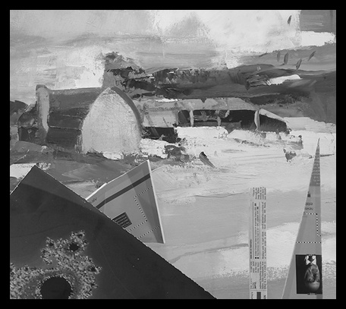Figure 1: Right Image With 13px Padding

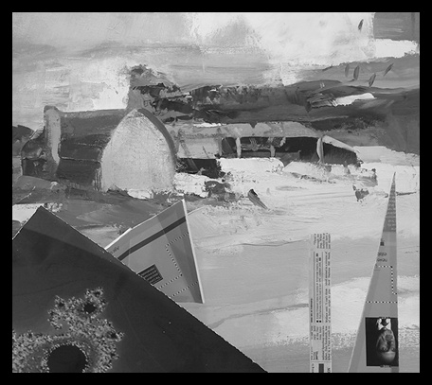Figure 2: Left Image With 13px Padding

1. **Loop**
   * row: 1 col: 197 i: 141 best_distance: 244673.0 shift: 140 ssd: 241750.0
   * row: 5 col: 371 i: 369 best_distance: 392034.0 shift: 368 ssd: 207117.0
   * row: 10 col: 201 i: 157 best_distance: 374462.0 shift: 150 ssd: 395361.0
   * row: 15 col: 154 i: 129 best_distance: 18136.0 shift: 88 ssd: 26906.0
   * …
   * …
   * …
   * row: 369 col: 322 i: 307 best_distance: 457334.0 shift: 285 ssd: 556516.0
   * row: 374 col: 208 i: 194 best_distance: 6831.0 shift: 169 ssd: 11226.0
   * row: 379 col: 117 i: 74 best_distance: 259053.0 shift: 46 ssd: 494437.0
2. **Searching**

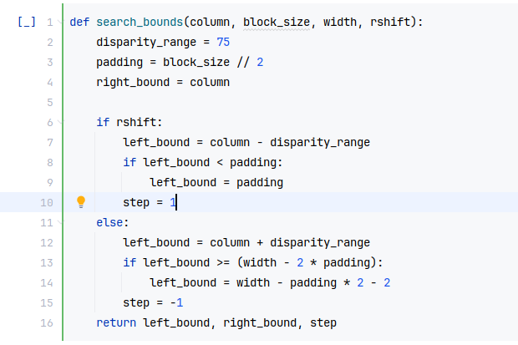

1. **Shifting (if rshift == True)**

For example, *col = 20 and disparity_range = 75:*

*left_bound = 20 - 75 = -55.* but because of padding*; left_bound = 13.*

*right_bound = 20.*

*step = 1.*

1. **Block Comparison**

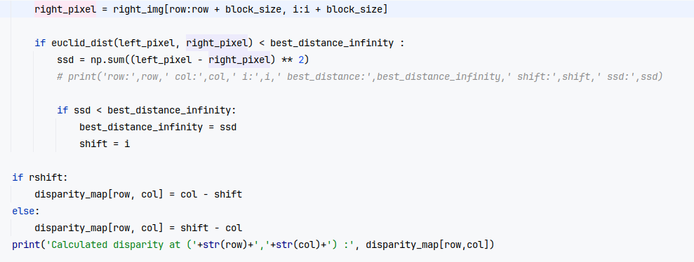

1. **Calculate**

Calculated disparity at (319,306) : 2.0

Calculated disparity at (319,307) : 2.0

Calculated disparity at (319,308) : 2.0

Calculated disparity at (319,309) : 2.0

Calculated disparity at (319,310) : 2.0

Calculated disparity at (319,311) : 2.0

…

…

Calculated disparity at (320,9) : 9.0

Calculated disparity at (320,10) : 10.0

Calculated disparity at (320,11) : 11.0

Calculated disparity at (320,12) : 12.0

Calculated disparity at (320,13) : 13.0

Calculated disparity at (320,14) : 1.0

Calculated disparity at (320,15) : 2.0

…

Calculated disparity at (380,348) : 2.0

Calculated disparity at (380,349) : 2.0

Calculated disparity at (380,350) : 2.0

Calculated disparity at (380,351) : 2.0

Calculated disparity at (380,352) : 68.0

Calculated disparity at (380,353) : 3.0

Calculated disparity at (380,354) : 4.0

Calculated disparity at (380,355) : 4.0

* Results,

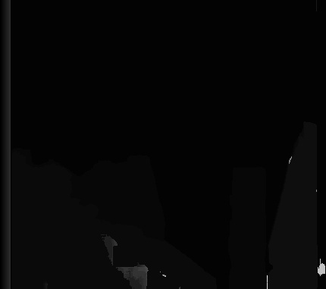Figure 3: Disparity Map lr block27

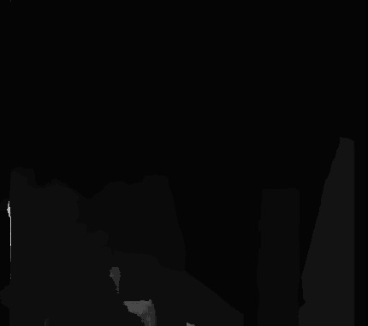Figure 4: Disparity Map rl block27

* Comparing

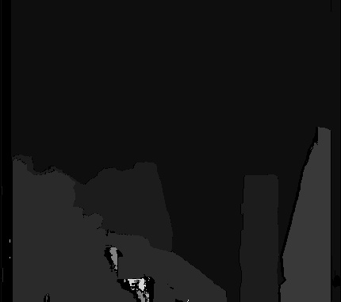Figure 5: Consistency Map block 27 disp2

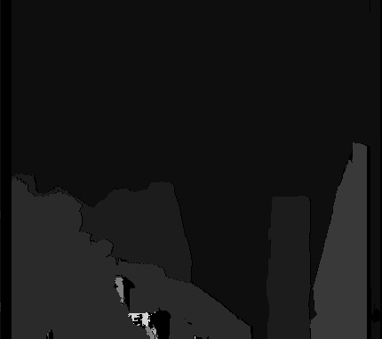Figure 6: Consistency Map block 27 disp6

* Discussion
  + **Without Consistency Check**
    - RMSE for left-right (block_size=27) 53.284250746797234
    - RMSE for right-left (block_size=27) 61.22323398963955
  + **With Consistency Check**
    - RMSE for disp2 (block_size=27) after Consistency check: 51.28792009553811
    - RMSE for disp6 (block_size=27) after Consistency check: 50.491453621857595
  + **Reasons for failures**
    - **block_size**; Larger block sizes can produce smoother but less accurate disparity maps. Smaller blocks can give more accurate but noisier results. So I set block_size=27. It must check for optimum value.
    - **disparity_range;** I set 75, this wont be suitable for the maximum disparity in the images.
    - **shift**; If the value is not correctly calculated, it can result in incorrect disparity values in the map.
  + **General Checks and Improvements**
    - Test different block sizes,
    - Try methods other than SSD, for example SAD (Sum of Absolute Differences),
    - Examine Shift Values.