# HW1_AKCAN_ERCAN_244201001033

*Note: My Jupyter notebook file that in zip file includes performance notes and my comments of all parts (part1 to part7). But in some case, the notebook file will not work properly, so I maked a report file.*

### PERFORMANCE REPORT OF PART 1

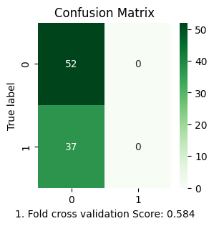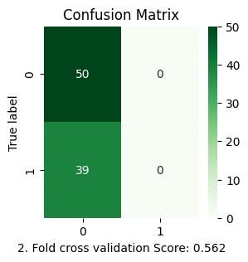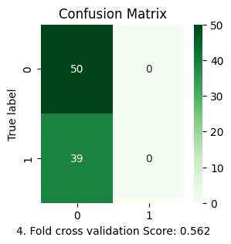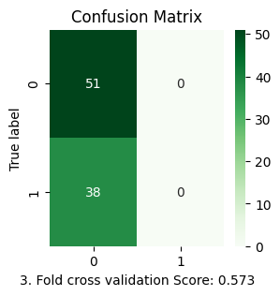

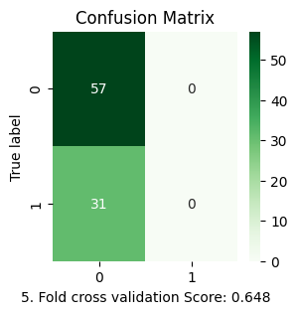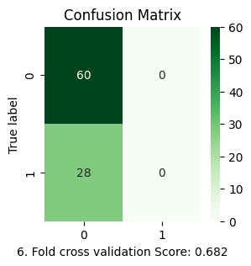

Average accuracy of each fold: 0.6017407218249914

### PERFORMANCE REPORT OF PART 2

*Mean Squared Error (MSE)* is a metric commonly used to evaluate the performance of a regression model. It measures the average of the squares of the errors,  
which are the differences between actual values and predicted values.

MSE quantifies the average squared difference between actual values and predicted values. A smaller MSE indicates better agreement between the predicted and actual values,  
whereas a larger MSE suggests poorer model performance.

1. Fold cross validation R2 Score: -0.231

1. Fold cross validation Mean Squared Error Score: 4987660.337

1. Fold cross validation Root Mean Squared Error Score: 2233.307

2. Fold cross validation R2 Score: -0.047

2. Fold cross validation Mean Squared Error Score: 4018453.588

2. Fold cross validation Root Mean Squared Error Score: 2004.608

3. Fold cross validation R2 Score: -0.027

3. Fold cross validation Mean Squared Error Score: 3839372.071

3. Fold cross validation Root Mean Squared Error Score: 1959.432

4. Fold cross validation R2 Score: -1.109

4. Fold cross validation Mean Squared Error Score: 7246175.576

4. Fold cross validation Root Mean Squared Error Score: 2691.872

5. Fold cross validation R2 Score: -0.000

5. Fold cross validation Mean Squared Error Score: 3332690.376

5. Fold cross validation Root Mean Squared Error Score: 1825.566

6. Fold cross validation R2 Score: -0.374

6. Fold cross validation Mean Squared Error Score: 4565092.800

6. Fold cross validation Root Mean Squared Error Score: 2136.608

Average R2 Score: -0.2978891453732393

Average Mean Squared Error: 4664907.458162335

Average Root Mean Squared error: 2141.898729503668

### PERFORMANCE REPORT OF PART 3

1. ROC Optimum threshold= [1]

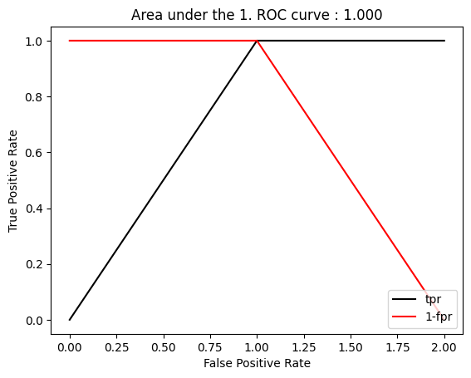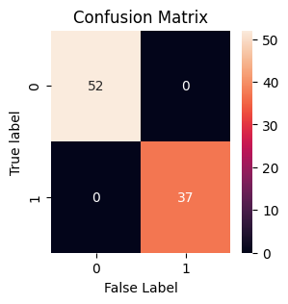

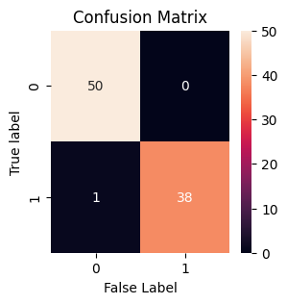2. ROC Optimum threshold= [1]

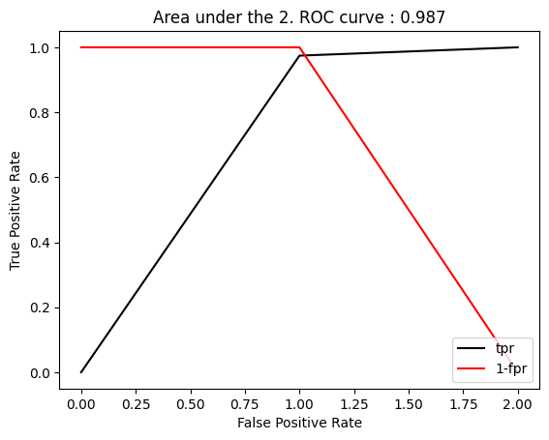

3. ROC Optimum threshold= [1]

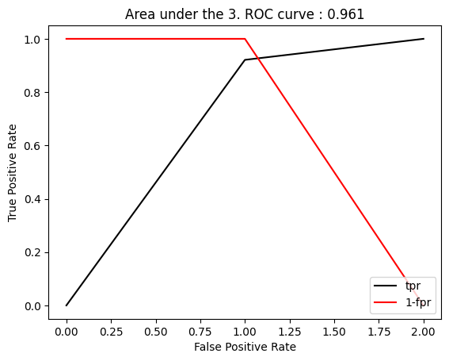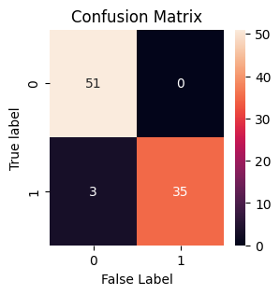

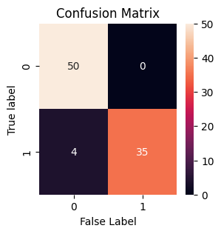4. ROC Optimum threshold= [1]

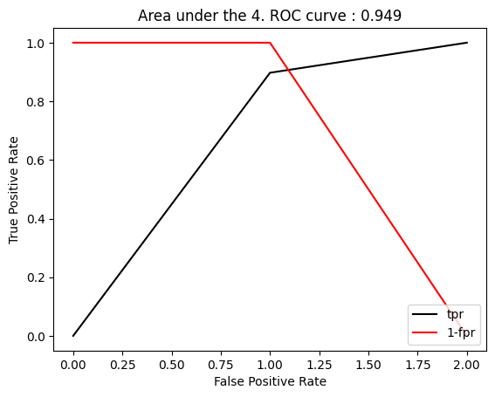

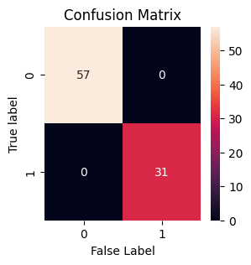5. ROC Optimum threshold= [1]

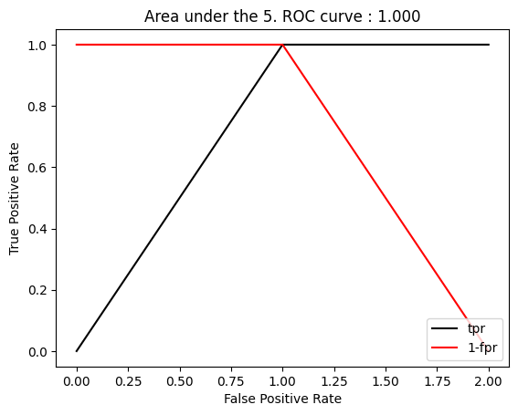

6. ROC Optimum threshold= [1]

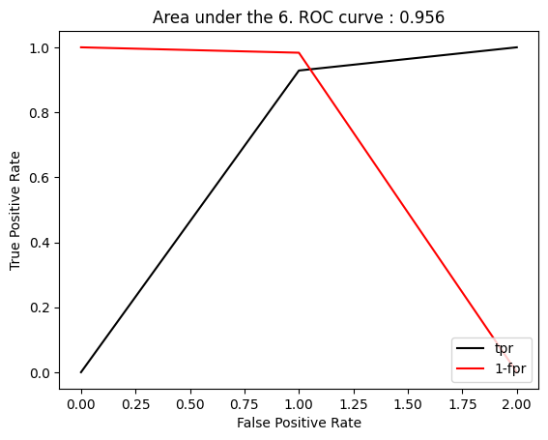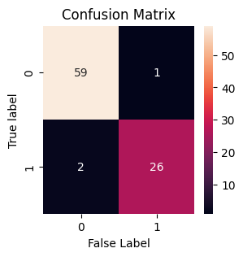

### PERFORMANCE REPORT OF PART 4

1. Fold cross validation R2 Score: 0.778

1. Fold cross validation Mean Squared Error Score: 899930.742

1. Fold cross validation Root Mean Squared Error Score: 948.647

2. Fold cross validation R2 Score: 0.837

2. Fold cross validation Mean Squared Error Score: 625414.807

2. Fold cross validation Root Mean Squared Error Score: 790.832

3. Fold cross validation R2 Score: 0.769

3. Fold cross validation Mean Squared Error Score: 862797.510

3. Fold cross validation Root Mean Squared Error Score: 928.869

4. Fold cross validation R2 Score: 0.773

4. Fold cross validation Mean Squared Error Score: 779232.268

4. Fold cross validation Root Mean Squared Error Score: 882.741

5. Fold cross validation R2 Score: 0.730

5. Fold cross validation Mean Squared Error Score: 899567.795

5. Fold cross validation Root Mean Squared Error Score: 948.455

6. Fold cross validation R2 Score: 0.781

6. Fold cross validation Mean Squared Error Score: 726488.043

6. Fold cross validation Root Mean Squared Error Score: 852.343

R2 Score Mean After 6-fold cross validation: 0.778

Mean Squared Error: 798905.194

Root Mean Squared Error: 891.981

Final R2 Score After k-fold cross validation with test data: 0.801

### PERFORMANCE REPORT OF PART 5

1-fold ROC Optimum threshold= [1]

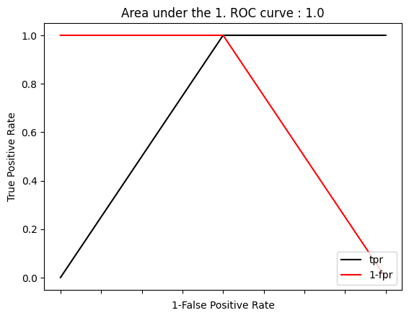

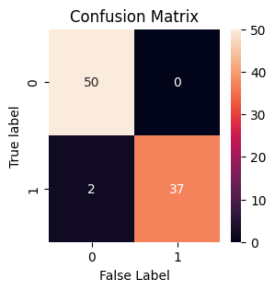2-fold ROC Optimum threshold= [1]

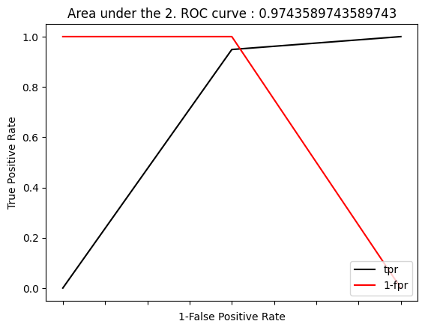

3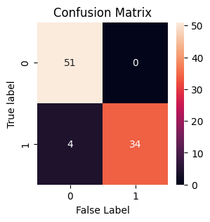-fold ROC Optimum threshold= [1]

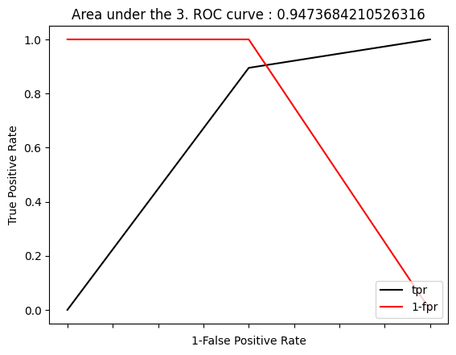

4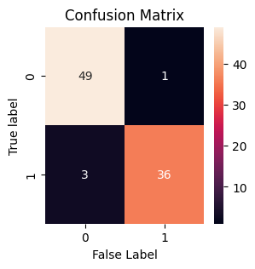-fold ROC Optimum threshold= [1]

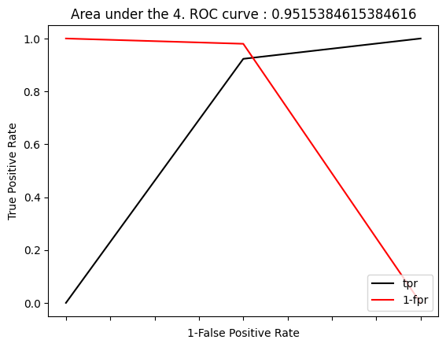

5-fold ROC Optimum threshold= [1]

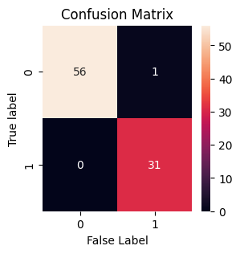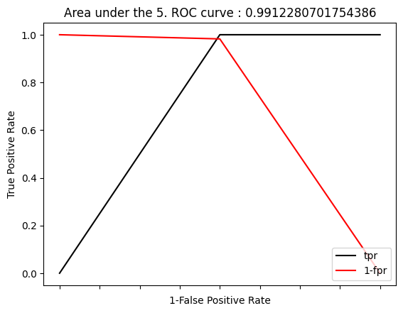

6-fold ROC Optimum threshold= [1]

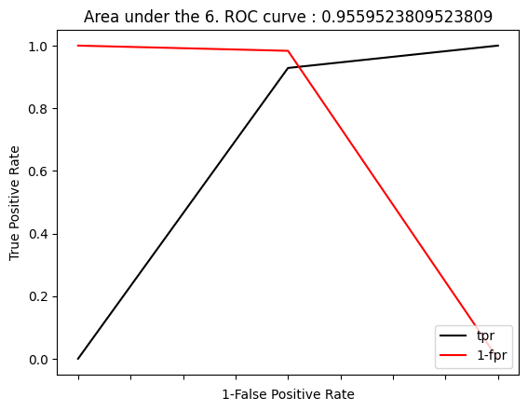

### PERFORMANCE REPORT OF PART 6

1. Fold Cross Validation accuracy: 1.0

2. Fold Cross Validation accuracy: 0.9775280898876404

3. Fold Cross Validation accuracy: 0.9775280898876404

4. Fold Cross Validation accuracy: 0.9775280898876404

5. Fold Cross Validation accuracy: 0.9886363636363636

6. Fold Cross Validation accuracy: 0.9659090909090909

K-Fold Cross Validation accuracy mean: 0.9811882873680626

#### Set Of Rules Of My Tree

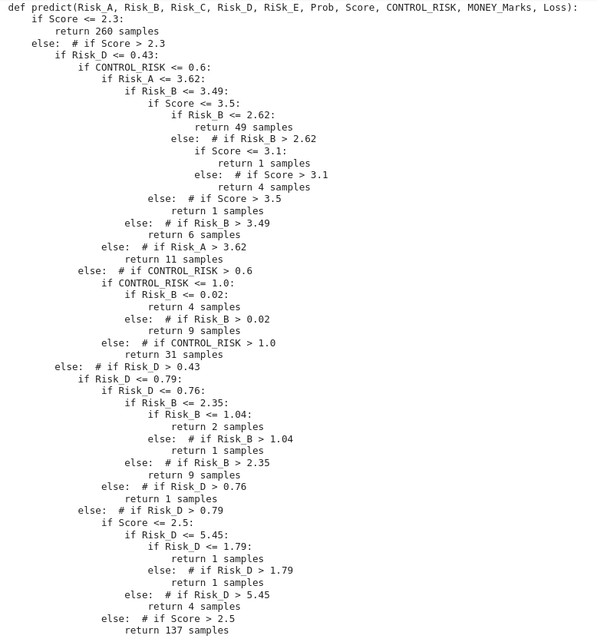

### PERFORMANCE REPORT OF PART 7

1. Fold Cross Validation accuracy: 0.7899286128857734

2. Fold Cross Validation accuracy: 0.8075311327290042

3. Fold Cross Validation accuracy: 0.7145883614469619

4. Fold Cross Validation accuracy: 0.7193515339416912

5. Fold Cross Validation accuracy: 0.6732596626955536

6. Fold Cross Validation accuracy: 0.7543892769527831

Final R2 Score After k-fold cross validation with test_data: 0.798

#### Set Of Rules Of My Tree

