**PROJECT REPORT**

1.Firstly we created a temblate to show processes on the screen.

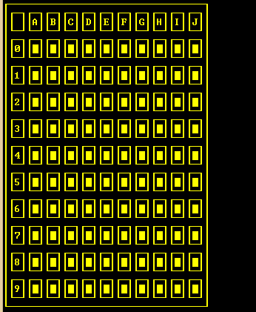

2. We created an array in the background to make calculations. Firstly each component of this array is assigned to 0.

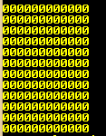

3. We put randomly the bombs into the array. at that time the value of input is considered. We provided that the first input and its neighbours have not a bombs. It is provided in the following way. If input and its neighboards coincided a random bomb,the bomb is slided another component of array. The bombs is assigned as 9 into the array.

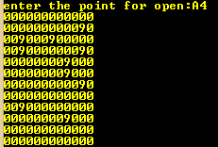

4. After that we generated a loop. The loop is made that the number of bombs have placed into the component of array which has neighbours the value of which has 9. Also we put the value 1 to edges with another loop.

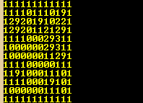

5. If tha value of input coincide to zero in array, the zero is converted ten. Then the neighbours of input is controled. The neighbour is pushed into stack if the value of neighbour is zero after converting ten. After that the components is poped from the stack. It is followed to process as above. This process stop when the has empty.

**NOTE:** The addresses of components of array is sent to stack.

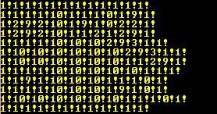

6. Finally, we created a loop to remodel the temblate. The loop is opened boxes which has 10 on the background. Also another boxes which has the value of neighbour has 10 on the background is opened numerical value with this loop.

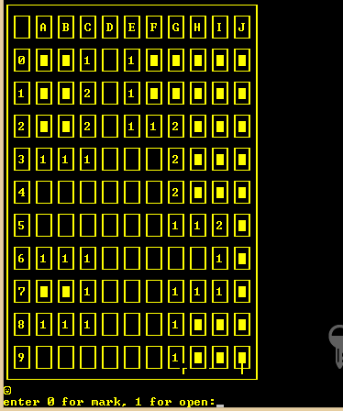

**HOW TO PLAY**

Select a difficulty level then enter any square. Check the numbers to find bombs. As you uncover tiles you will see numbers revealed. A number means that there are that number of bombs touching that tile (both sides, top/bottom, and diagonally). If you see a 1 on the board, it means that square is touching exactly 1 mine and mark known safe squares. Eliminate squares that can't possibly contain mines. Say you found a 1, and you're pretty sure where the mine for that 1 is. You can open all the other squares around that 1 to open them because the 1 can only be in contact with a single mine. Use all of the numbers in a given area to figure out where the mines are. When you're reasonably certain you've found a mine, identify it on the square. Keep moving through a process of elimination. As you go around the board, mark potential mines . If you find that you've marked more mines than the game allows, go back and re-evaluate them. After you master beginner, move on to intermediate. As you go on, you'll notice yourself losing less often.