CLUSTERING

The MNIST data set, which is in binary format, is present in the repository in Project2/data/mnist folder. The program loads the train and test data in numpy array format. Images which are classified as 2, 3, 8, and 9 are used in the program. Others are filtered. In order to eliminate effects of the order of the data, the train set and the test set are shuffled before running the K-means clustering algorithm.
The program has an option of linear normalization. Pixel values between 0 and 255 can be mapped to 0.0 and 1.0.

There are two similarity measures, which are euclidean and cosine. In euclidean similarity, the distance between two vectors are calculated. Since we want closer vectors to yield higher similarity, the inverse of the distance is used to represent the similarity. In order to avoid any division by zero error, the output is clamped to 10⁶ if the distance is less than 10⁻⁶. The cosine similarity, on the other hand, measures the angle between two vectors. The smaller the angle, the higher the cosine value.

K-means clustering algorithm is implemented as follows:

Select random k points as initial centroids.
Initialize a kXn membership matrix of zeros.

Repeat
1- Form k clusters by assigning all points to the closest centroid and update the membership matrix.
2- Count the number of point changes for each cluster (How many points have joined the cluster, how many of them have left in step 1).
3- Recompute the centroid of each cluster by taking the average of the points in corresponding cluster.
Until the number of changes for each cluster is less than or equal to stop_threshold.

Return k centroids, kXn membership matrix

After we run the K-means clustering algorithm, we get the centroids. However, we don’t know which centroid corresponds to which class. In order to figure out this, we form a kXk matrix, and measure the similarity between each training points and each centroid. The matrix is updated so that matrix[i][j] corresponds to the sum of similarities of ith class (2, 3, 8, or 9) points and jth centroid. Each centroid is mapped to the class which has the highest sum of similarities.

In each step, SSE of the model is calculated. It is printed along with the number of point changes for each cluster.

In order to classify a test point, we use this map. First, similarities between the test point and each centroid are measured. We find the centroid which has the highest similarity. Second, we use the map to find the corresponding class of the centroid. The class that we find is our prediction for the test point.

Is Normalization Important?
In the original data, all pixel values are between 0 and 255. Mapping this interval to [0,1] linearly has no effect in terms of neither euclidean nor cosine similarities. When we apply linear normalization to [0,1], all distances are scaled by 1/255. Therefore, the relative magnitude of two distance values remains constant, which results in no change on K-means algorithm’s output. Similarly, when two vectors are scaled by some positive factor, the angle between the vectors does not change. Therefore, the cosine similarity of the vectors remains constant. The gaussian normalization is also implemented with mean = 0, and std = 1. It yields slightly lower accuracy on the test data. The accuracies of models which are trained with different measures and normalization techniques can be seen below.

Accuracies on the Test Data
 | Linear | Gaussian
Euclidean | 77.61 % | 73.37%
Cosine | 75.55% | 73.04%

Cosine Similarity or Euclidean Similarity?
As you can see on the table above, using euclidean or cosine similarity does not make any difference in terms of test accuracy. We see a similar behavior for SSE as well. The plots of SSE values for different models can be seen below.

Euclidean + Linear Euclidean + Gaussian
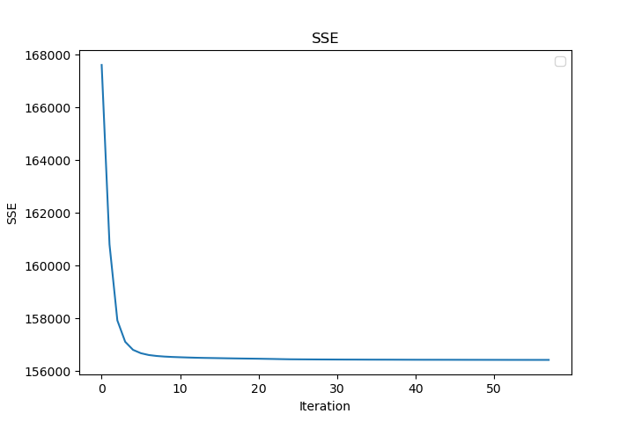
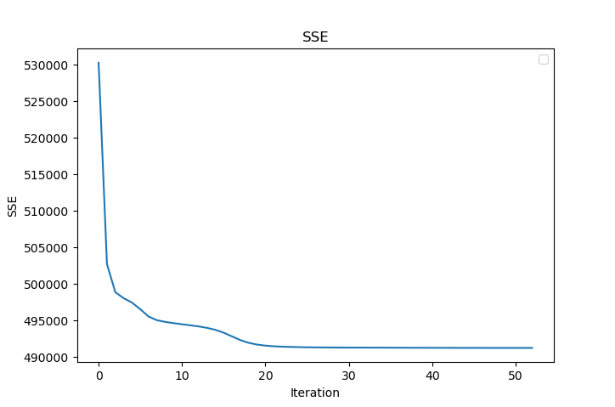
Cosine + Linear Cosine + Gaussian
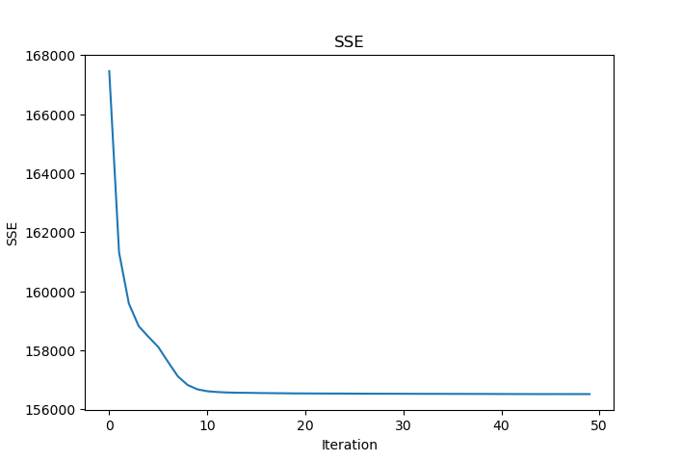
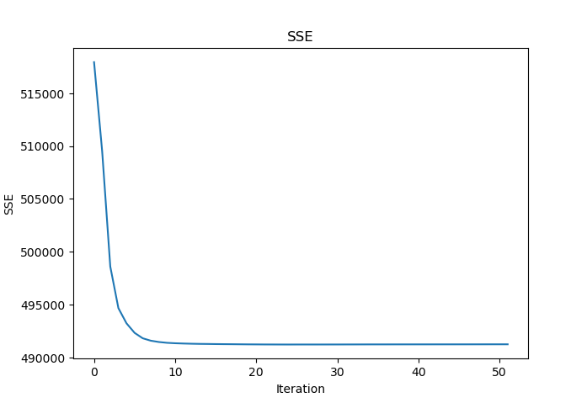

Plots of Centroids Generated from Different Models
Euclid + Linear
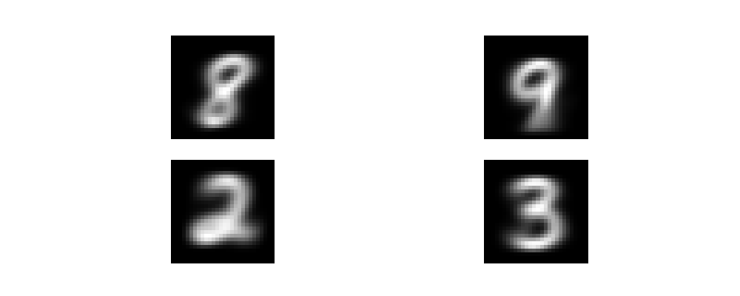

Euclid + Gaussian
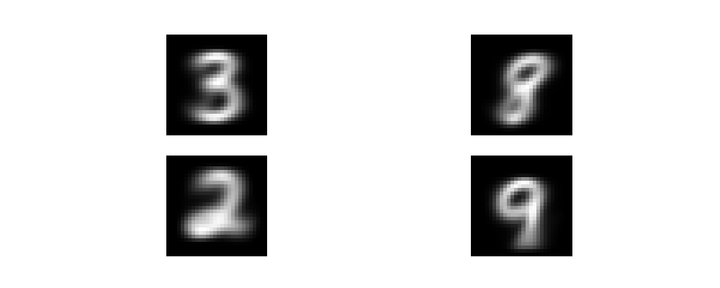

Cosine + Linear
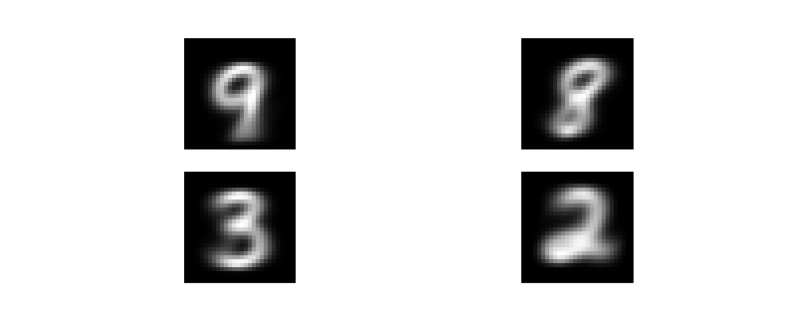

Cosine + Gaussian
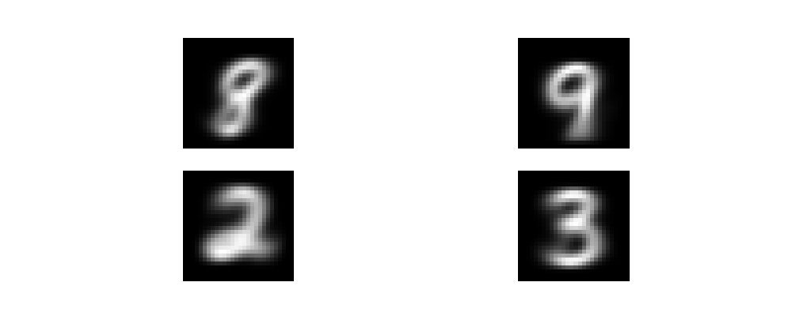

As you can see, neither the similarity measure nor the normalization method affects the centroids significantly. All configurations generate similar centroids.

How to run
You can run the program with the following commands:

1- python3 clustering.py cos: cosine similarity and no normalization
2- python3 clustering.py cos linear: cosine similarity and linear normalization
3- python3 clustering.py cos gaussian: cosine similarity and gaussian normalization

4- python3 clustering.py euclid: euclidean similarity and no normalization
5- python3 clustering.py euclid linear: euclidean similarity and linear normalization
6- python3 clustering.py euclid gaussian: euclidean similarity and gaussian normalization

