First of all I am a medicine doctor. But ı do not want to do this job in turkey anymore. Because our working conditions are very bad. Our salaries are very low. So ı want to realize my dream and ı want to enter IT World. I have taken a course which center is america for 2 months. İn this time I have learnt python basic and plus, html5 css, mysql workbench and agile and made a Project in jira. I want to say that İ can learn easily and ı can apply this what ı learnt affectively in my life. I have not got a background about manuel tester but ı belive that i can learn this job very quickly and ı improve myself in very short time. Because ı belive myself. I can achive a thing what ı want.

I am a doctor. But I dont want to make this job in turkey. So i decided that i  try to find different job. And i found this job in internet. I can do this job because i am interested in tecnolojies programes and aplications. I believe I have all the criteria needed for this job. And I also have strong administrative, communication, problem solving and time management skills. I think This makes me an ideal candidate for this position

**Software Development Life Cycle** is a process used by the software industry to design, develop and test high-quality software. It aims to produce high-quality software that meets or exceeds customer expectations, reaches completion within time and cost estimates. Below diagram depicts various phases involved in SDLC.

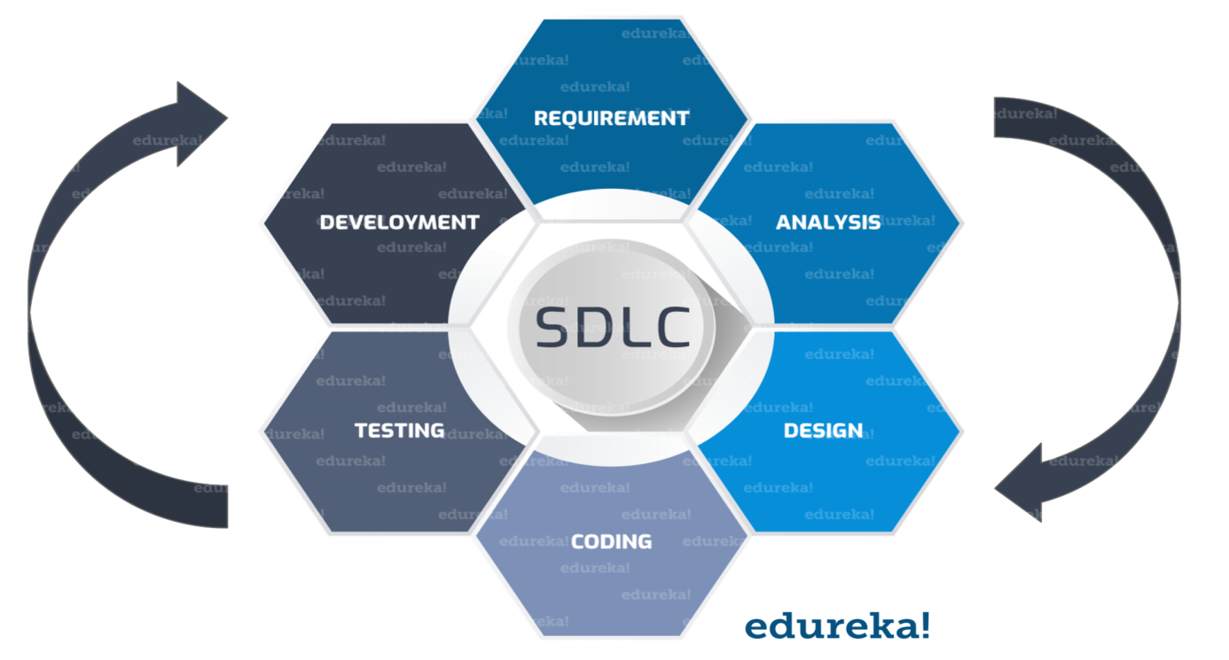

**What is Verification and Validation in Software Testing?**

**Verification:**Verification is a static analysis technique. Here, testing is done without executing the code. Examples include – reviews, inspection, and walk through.

**Validation:** Validation is a process of dynamic analysis where we perform testing by executing the code. Examples include functional and non-functional testing techniques.

1. **What is Software testing**

**We can say that software testing is an activity to check or verify the software functionality to ensure that the testing result matches to the expected functionality or not.**

**Types of software testing**

1. **System testing**
2. **İntegration testing**
3. **Sanity testing**
4. **Regression testing\***
5. **Smoke testting\***
6. **Adhoc testing**
7. **Exploratory testing**
8. **Acceptance testing(alpha and beta)\***
9. **Difference between manual and automation testing?**

**Some of the majör diffrences are:**

1. **Software testing can be done manually and automation testing is done through automation tools such as Selenium, Qtp, Test complete, Silk Test etc.(now robotic testing high demand)**
2. **For manual testing coding knowledge is not required but for automation testing coding skills are required.**
3. **Automation testing is best suited for big application or software’s those who are completed or about complete because it make testing easy for functionality who have lots of test steps and repetitive testing is required.**
4. **What is bug?**

**When software tester perform testing and finds that actual results is not matching to the expected results. The that result is said to be bug and it needs to be reported.**

**Bug tracking tool is basically software which is use to log bugs. Fo e.g. bugzilla, fogbugz,TFS**

**Test case and use case**

Use Cases are parts of the product, program, and project that you're designing and creating. So essentially you're creating the process flows and requirements that go into that section.

On the opposite end, Test Cases are used to test requirements that were set prior in order to see if it performs to the specifications that were agreed upon by the BA and customer.

To simplify it, the Use Cases are the detailed creation of a project and Test Cases are the testing of the requirements that the project needs to accomplish.

**Errors defect failure**

Testing is the process of identifying defects, where a **defect** is any variance between actual and expected result . “A mistake in code is called **Error .**”

Error found by tester is called defect , Defect accepted by development team is called **Bug**. And build does not meet the requirements then it is **Failure.**