**Name: Mehmet Nuri Akyol**

**Student Number: 213910467**

**Hypothesis: Between 1880 to 2000 years teams avarage wins are have difference to 2000 to 2015 years. Between 2000 to 2015 years teams have very similar wins rate and I want to proof these are correct.**

**Codes:**

**Firstly, I import my working codes which are :**

import thinkstats2

import thinkplot

import pandas as pd

import numpy as np

teams = pd.read_csv("Teams.csv")

from __future__ import print_function, division

%matplotlib inline

**After that I have to divide years and I have to calculate teams wins to years and I did these with this codes:**

_1880to_2000 = teams[teams.yearID < 2000]

win_to_years=_1880to_2000.W

win_to_years

**And I measured avarage wins relation with years :**

year_win_rate=dict()

for i in range(1880,2000):

year_win_rate[i] = teams.W[teams.yearID == i].mean()

year_win_rate

**After these codes I plot the graphs with pmf, cdf and hist with these codes:**

year_win_rate_graph = thinkstats2.Hist(year_win_rate)

thinkplot.Hist(year_win_rate_graph)

thinkplot.Config(xlabel="years", ylabel="win")

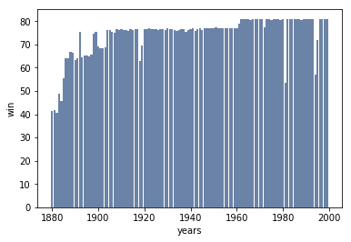

This graph is working with hist.

And I work with pmf and cdf :

year_win_rate_graphpmf = thinkstats2.Pmf(year_win_rate)

thinkplot.Pmf(year_win_rate_graphpmf)

thinkplot.Config(xlabel="years", ylabel="win")

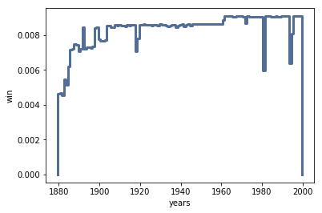

After pmf, I use Cdf graphs with this code and grahps:

year_win_rate_graphcdf = thinkstats2.Cdf(year_win_rate)

thinkplot.Cdf(year_win_rate_graphcdf)

thinkplot.Config(xlabel="years", ylabel="wins")

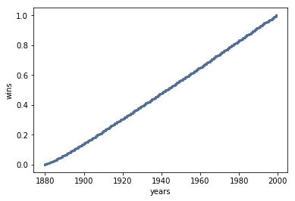

**And this point I finished first part of project I measured 1880 to 2000 years teams wins rate and after this point I want to proof 2000 to 2015 years team wins and difference between early years**.

_2000to_2017 = teams[teams.yearID > 2000]

win_to_yearsup=_2000to_2017.W

win_to_yearsup

year_win_rateUp=dict()

for i in range(2000,2017):

year_win_rateUp[i] = teams.W[teams.yearID == i].mean()

year_win_rateUp

**I will divide years again. And after this I will plot hist, pmf and cdf graphs for this datas.**

year_win_rateUp_graph = thinkstats2.Hist(year_win_rateUp)

thinkplot.Hist(year_win_rateUp_graph)

thinkplot.Config(xlabel="years", ylabel="win")

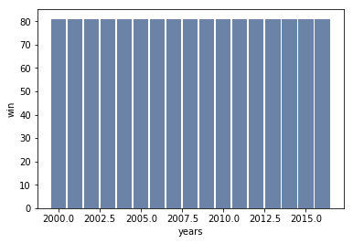

**And after hist , I will plot pmf and cdf graphs:**

year_win_rateUp_graphpmf = thinkstats2.Pmf(year_win_rateUp)

thinkplot.Pmf(year_win_rateUp_graphpmf)

thinkplot.Config(xlabel="years", ylabel="win")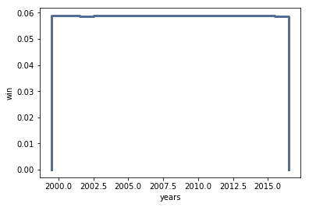

**And I have code for cdf graphs with these codes and I plotted cdf graphs:**

year_win_rateUp_graphcdf = thinkstats2.Cdf(year_win_rate)

thinkplot.Cdf(year_win_rateUp_graphcdf)

thinkplot.Config(xlabel="years", ylabel="wins")

**As a result, from these graphs, it is clear that the games won by teams until 1880 to 2000 are more irregular than 2000 to 2015 teams won games.**