1. Aşağıdaki programın çıktısı ne olacaktır?

1. **In a class, one method has two overloaded forms. One form is defined as static and another form is defined as non-static. Is that method properly overloaded?**
2. **In the below class, is ‘method’ overloaded or duplicated?**

1. **Method signature consists of**

a) Method Name, Return Type and Number Of Arguments  
b) Access Modifier, Method Name and Types Of Arguments  
c) Method Name, Number Of Arguments, Types Of Arguments and Order Of Arguments  
d) Return Type, Access Modifier and Order Of Arguments

1. **In the below Class X, is ‘method’ properly (duzgunce) overloaded?**

1. **What will be the output of the following program?**

1. **What will be the outcome of the below program?**

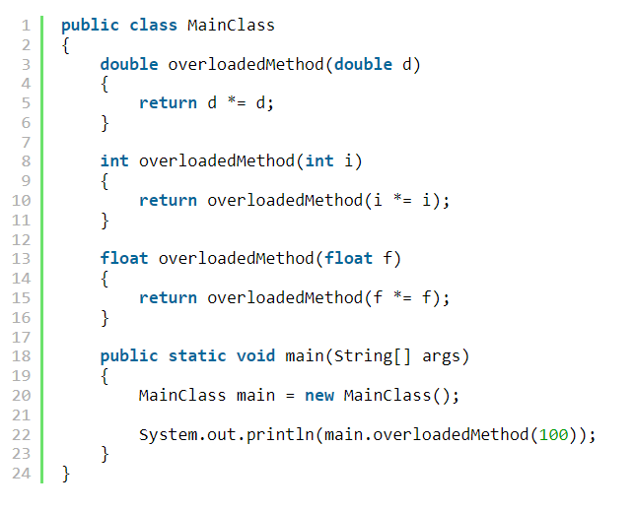

1. **Method Overriding shows static polymorphism. True or false?**
2. **In a class, One method has 4 overloaded forms. All have different access modifiers (private, default, protected and public). Is that method properly overloaded?**
3. **What will be the outcome of the following program?**

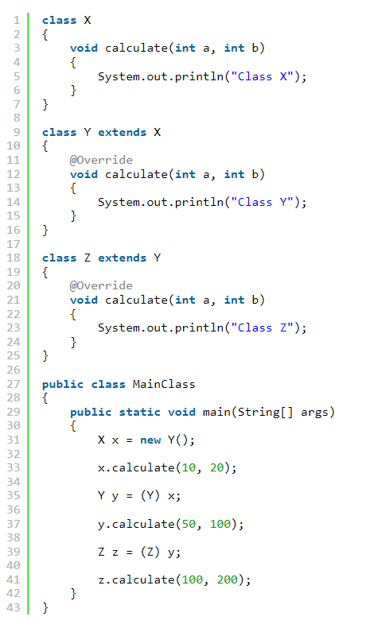

1. **Can you find out the error in the following code?**

1. **What will be the output of the following program?**

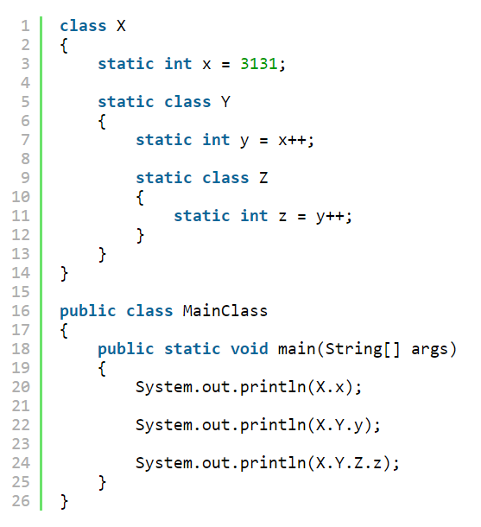

1. **Static nested classes can have only static members in them. True OR False?**
2. **How do you access field ‘i’ of class ‘XYZ’ in the below example?**
3. **Does below program print “SUCCESS” on the console when you run it?**

**CODING**

1. Write a program for calculating Matrix Operations.

Addition.

Multiplication**. (Onur B.)**

1. Room adinda bir class olusturun. Class in nitelikleri roomno,roomtype,roomarea ve ACmachine olsun. Bu class icin bir setdata ve displaydata methodlari olusturun ve main method da olsuturulan variable lar icin setdata ya degerler gonderin ve print edin**…(Salih B.)**
2. 9 Araliktaki 4. Soru **(mali)**
3. **Cem Abi**

1. Kenan Beyin gonderdigi project1 age,checknumber,days (Kubra H.)
2. Kenan Beyin gonderdigi project1 factorile,get,main(Zeynep H.)
3. Kenan Beyin gonderdigi project1 perfectsquare,printeven,random(Mustafa B)