Question 1 - Convolution

🡺 ***fspecial("laplacian", 0.5)***

This filter finds edges in the given photo.

🡪 *Zero Padding*  🡪 *Border Padding*

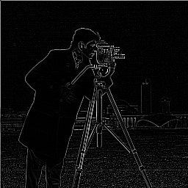 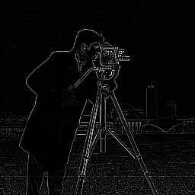

🡺 ***fspecial("gaussian", 5, 5)***

This filter removes noise and details by giving blur to image.

🡪 *Zero Padding* 🡪 *Border Padding*

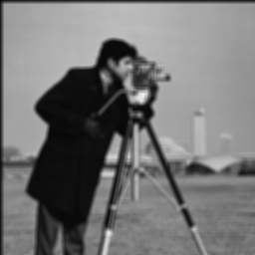 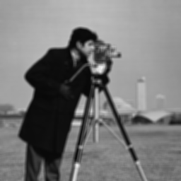

🡺 ***fspecial("sobel")***

This filter emphasizing the edges of given picture.

🡪 *Zero* *Padding* 🡪 *Border Padding*

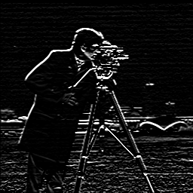 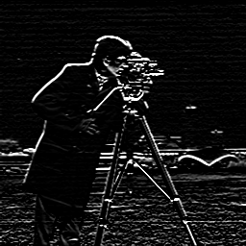

🡺 ***fspecial("motion", 40, 135)***

Filter generates a highly blurred image.

🡪 *Zero Padding* 🡪 *Border Padding*

