Question 2 – Face Detection

***Sample Templates***

 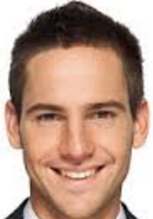 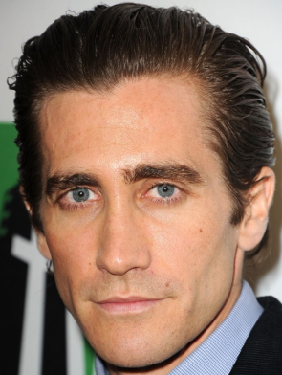 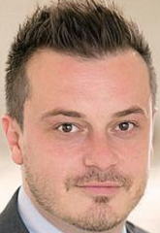

***Average Template***

Average template created after all sample templates resizedto same and smaller side. This way average template is more accurate to find faces.

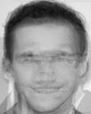 Size of average template = 101 x 126

***Input and Output Images***

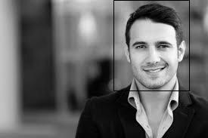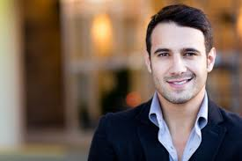Due to given templates having no beard and no long hair, classifier cannot identify faces that have long beard or long hair. Also classifier runs with O(n^4) so if the input image is large, it takes more and more time. However this problem can be solved by allowing only fixed size input image, but this will narrows the spectrum of classifier. Due to that reason, algorithm couldn’t be run by taking correlation pixel by pixel so the given algorithm travels the input image by jumping across pixels. This jump value is adjustable however in the primitive test, when jump ratio is 50 which means each 50th pixel’s correlation with average template will be calculated, algorithm have hard time to identify the whole face, it mostly finds the half part of the face. However when jump ratio set to 30, even though algorithm slowed down a lot, accuracy of finding faces increased. (Given pictures have 30 as jump ratio) (Images resized in order to have proper look on the report.)

🡺🡺🡺🡺

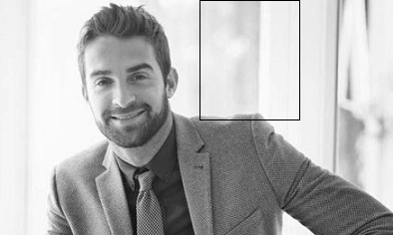

🡺🡺🡺🡺

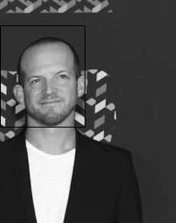As seen in the top, due to given face have noises that is not available in the average template which is beard, classifier have hard time to identify the face.

🡺🡺🡺🡺



