Project Report

1-Problem Description : Writing a java program that draws a soccer ball by using dollar marks and underscore characters. However it should be solved by using for loops and methods.
2-Problem Solution : The easiest way to heandle the two tasks is by creating two methods which contain parameter and for loops.
The first method consist of parameter and for loop . It prints underscore characters when it is called with a value.
The second method consist of parameter and for loop ,too. It prints dollar marks when it is called with a value.
In the main method , methods are called with a value according to number of characters in the line. . Also ,“System.out.print(“ “)” is used to space out and “System.out.println()” is used after any line due to pass the other line.

3-Implementation:
/*
* This program draws a ball with underscore characters and dollar marks
* Author:Mehmet Emin Arslan
*/
public class MEA2015400114 {
//This method accepts and integer parameter n and prints underscore characters n times
public static void underscore(int n){
//Index of the for loop k controls the number of underscore characters
for(int k=1;k<=n;k++)
System.out.print("_");
}
//This method accepts and integer parameter n and prints dollar marks n times
public static void dollar(int n){
//Index of the for loop k controls the number of dollar marks
for(int k=1;k<=n;k++)
System.out.print("$");
}
public static void main(String[] args){
//line1
underscore(12); //Underscore characters are called 12 times by us() method
dollar(13); //Dollar marks are called 13 times by d() method
System.out.println(); //A new line is started as the line is completed

//line2
underscore(8);
dollar(7);
System.out.print(" ");
underscore(9);
dollar(3);
System.out.println();

//line3
underscore(5);
dollar(9);
System.out.print(" ");
underscore(11);
System.out.print(" ");
dollar(4);
System.out.println();

//line4
underscore(4);
dollar(2);
underscore(1);
dollar(3);
underscore(4);
dollar(2);
System.out.print(" ");
underscore(8);
System.out.print(" ");
dollar(1);
underscore(2);
dollar(2);
System.out.println();

//line5
underscore(3);
dollar(1);
underscore(3);
dollar(1);
underscore(8);
dollar(1);
System.out.print(" ");
underscore(6);
System.out.print(" ");
dollar(1);
underscore(6);
dollar(2);
System.out.println();

//line6
underscore(2);
dollar(1);
underscore(3);
dollar(1);
System.out.print(" ");
underscore(9);
System.out.print(" ");
dollar(8);
underscore(7);
dollar(2);
System.out.println();

//line7
underscore(1);
dollar(1);
underscore(3);
dollar(2);
System.out.print(" ");
underscore(8);
System.out.print(" ");
dollar(9);
underscore(8);
dollar(2);
System.out.println();

//line8
dollar(2);
underscore(3);
dollar(1);
System.out.print(" ");
underscore(9);
System.out.print(" ");
dollar(10);
underscore(8);
dollar(1);
System.out.println();

//line9
dollar(1);
underscore(3);
dollar(2);
System.out.print(" ");
underscore(7);
dollar(14);
underscore(7);
dollar(1);
System.out.println();

//line10
dollar(1);
underscore(2);
dollar(5);
System.out.print(" ");
underscore(2);
System.out.print(" ");
dollar(3);
underscore(3);
dollar(7);
underscore(2);
System.out.print(" ");
dollar(4);
underscore(3);
dollar(2);
System.out.println();

//line11
dollar(11);
System.out.print(" ");
underscore(7);
System.out.print(" ");
dollar(3);
underscore(8);
dollar(5);
System.out.println();
//line12
dollar(1);
underscore(1);
dollar(7);
System.out.print(" ");
underscore(10);
System.out.print(" ");
dollar(1);
underscore(10);
dollar(4);
System.out.println();

//line13
dollar(1);
underscore(1);
dollar(7);
System.out.print(" ");
underscore(10);
System.out.print(" ");
dollar(1);
underscore(10);
dollar(4);
System.out.println();

//line14
underscore(1);
dollar(1);
underscore(1);
dollar(6);
System.out.print(" ");
underscore(9);
System.out.print(" ");
dollar(2);
underscore(10);
System.out.print(" ");
dollar(3);
System.out.println();

//line15
underscore(2);
dollar(1);
underscore(1);
dollar(2);
underscore(2);
dollar(2);
System.out.print(" ");
underscore(8);
System.out.print(" ");
dollar(1);
underscore(9);
dollar(2);
underscore(1);
dollar(2);
System.out.println();

//line16
underscore(3);
dollar(2);
underscore(5);
dollar(3);
System.out.print(" ");
underscore(3);
System.out.print(" ");
dollar(5);
underscore(4);
dollar(3);
underscore(3);
dollar(1);
System.out.println();

//line17
underscore(4);
dollar(2);
System.out.print(" ");
underscore(5);
System.out.print(" ");
dollar(15);
underscore(3);
dollar(2);
System.out.println();

//line18
underscore(5);
dollar(3);
System.out.print(" ");
underscore(5);
System.out.print(" ");
dollar(10);
underscore(4);
dollar(2);
System.out.println();

//line19
underscore(7);
dollar(4);
System.out.print(" ");
underscore(2);
System.out.print(" ");
dollar(9);
underscore(2);
dollar(3);
System.out.println();

//line20
underscore(10);
dollar(5);
System.out.print(" ");
underscore(5);
System.out.print(" ");
dollar(4);
System.out.println();

//line21
underscore(14);
dollar(7);
System.out.println();
}
}

4-Output of the Program:
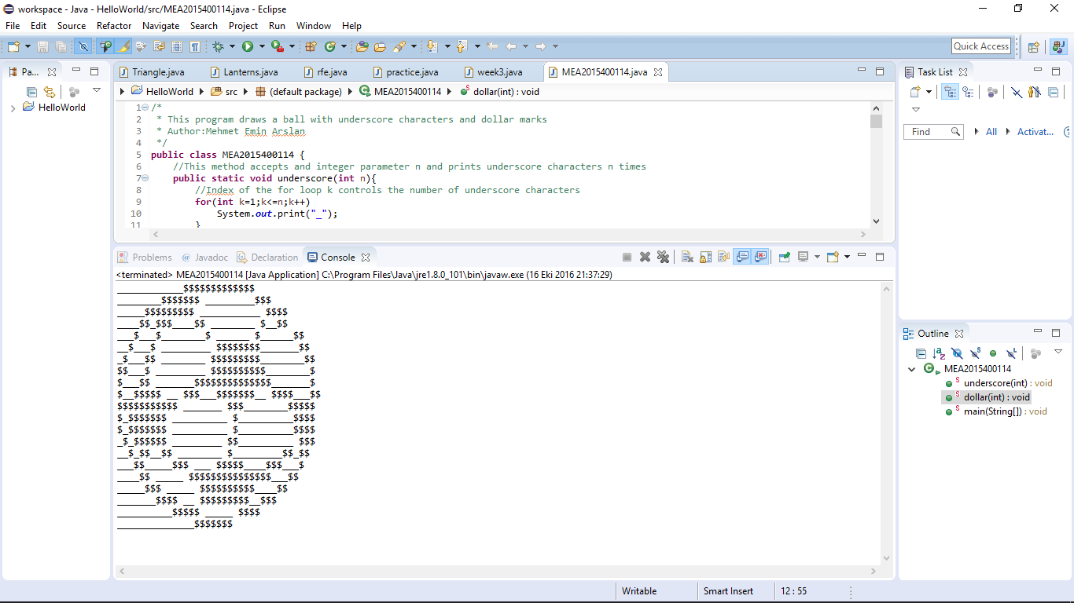
5-Conclusion : As seen from the output, program is able to handle the requested figure. Thanks to parameters and for loops , for loops is not used repeteadly.

