Project Report

1-Problem Description : Writing a game that plays with user. Game contains a board which consist of 36 charactrers. User and computer can do 2 kind of action. One of them change .The other one move. They enter type of action and enter a coordinate.
2-Problem Solution : ı used 4 method.one of them changes the charecters according to coordinates. The other one moves the characters.
The other one prints board. The last one check the rows and columns. If all lines includes same charecters game is finished. Change , move and
the method which checks winner returns boolean. If change and move methods return false program takes a new coordinare. If win method
returns true program will finish and print the gamer who wins the game. In addition, Computers select the coordinates randomly.

3-Implementation:
package cmpe150;
import java.util.*;
import java.io.*;

public class Assigment3 {
public static void main(String[] args)throws FileNotFoundException{
char[][] board=new char[6][6];
Scanner console=new Scanner(System.in);
Scanner input=new Scanner(new File("input.txt"));
Random rand=new Random();
//This array keeps 16 move coordinates
String[] move=new String[16];
System.out.println("Do you want to play a new game(N) or continue an ongoing game(O)?");
//This if statement fills board from input.txt
if(console.nextLine().equalsIgnoreCase("o")){
for(int i=0;i<6;i++){
for(int j=0;j<6;j++){
board[i][j]=(input.next()).charAt(0);
}
}
}
//This else statement fills the board with B
else{
for(int i=0;i<6;i++){
for(int j=0;j<6;j++){
board[i][j]='B';
}
}
}
print(board);
System.out.println("To make a change enter C after that enter coordinate; to make a move enter M after that enter coordinate."
+ "For example \"C 0 0\" or \"M 0 0 0 5\"");
System.out.println("Enter a coordinate");
//i is used for playing turns
int i=0;
while(i<2){
//when i==0 user plays
if(i==0){
//Action is refers to coordinate
String action=console.nextLine();
//This if statement responsible for doing change and move actions
if(action.charAt(0)=='C'||action.charAt(0)=='c'){
if(change(action,'X',board)){
print(board);
i++;
}else{
System.out.println("Wrong coordinate.Enter a new coordinate again.");
}
if(win(board)){
i=2;
}
}
else if(action.charAt(0)=='M'||action.charAt(0)=='m'){
if(move(action,board,'X')){
print(board);
i++;
}
else{
System.out.println("Wrong coordinate.Enter a new coordinate again.");
}
if(win(board)){
i=2;
}
}
else{
System.out.println("Wrong coordinate.Enter a new coordinate again.");
}
}

//computers turn
else{
int action=rand.nextInt(2);
//if action is 0 program will change the one characters. Otherwise it will move the one "O" character
if(action==0){
int coordinate1=rand.nextInt(6);
String coordinate="";
int coordinate2=0;
if(coordinate1==0||coordinate1==5){
coordinate2=rand.nextInt(6);
coordinate=" "+coordinate1 +" "+coordinate2;
}
else{
int z=rand.nextInt(2);
if(z==0){
coordinate2=0;
coordinate=" "+coordinate1 +" "+coordinate2;
}
else{
coordinate2=5;
coordinate=" "+coordinate1 +" "+coordinate2;
}
}

if(change(coordinate,'O',board)){
System.out.println("C"+coordinate+"\n");
print(board);
i--;
}

if(win(board)){
i=2;
}
}
// it will move the one "O" character
else if(action==1){
String coordinate="";
int coordinate11=rand.nextInt(6);
int coordinate12=rand.nextInt(2);
int coordinate21=0;
int coordinate22=0;
if(coordinate12==0){
coordinate12=0;
}else{
coordinate12=5;
}

if((coordinate11==0&&coordinate12==0)||(coordinate11==5&&coordinate12==5)){
coordinate21=rand.nextInt(2);
if(coordinate21==0){
coordinate22=5;
coordinate=" "+coordinate11+" "+coordinate12+" "+coordinate21+" "+coordinate22;
}else{
coordinate21=5;
coordinate22=0;
coordinate=" "+coordinate11+" "+coordinate12+" "+coordinate21+" "+coordinate22;
}
}else if((coordinate11==0&&coordinate12==5)||(coordinate11==5&&coordinate12==0)){
coordinate21=rand.nextInt(2);
if(coordinate21==0){
coordinate22=0;
coordinate=" "+coordinate11+" "+coordinate12+" "+coordinate21+" "+coordinate22;
}else{
coordinate21=5;
coordinate22=5;
coordinate=" "+coordinate11+" "+coordinate12+" "+coordinate21+" "+coordinate22;
}
}else{
move[0]=" 1 0 1 5";
move[1]=" 1 5 1 0";
move[2]=" 2 0 2 5";
move[3]=" 2 5 2 0";
move[4]=" 3 0 3 5";
move[5]=" 3 5 3 0";
move[6]=" 4 0 4 5";
move[7]=" 4 5 4 0";
move[8]=" 0 1 5 1";
move[9]=" 5 1 0 1";
move[10]=" 0 2 5 2";
move[11]=" 5 2 0 2";
move[12]=" 0 3 5 3";
move[13]=" 5 3 0 3";
move[14]=" 0 4 5 4";
move[15]=" 5 4 0 4";
int h=rand.nextInt(16);
coordinate=move[h];
}
if(move(coordinate,board,'O')){
System.out.println("M"+coordinate+"\n");
print(board);
i--;
}
if(win(board)){
i=2;
}
}
}
}
}
//This method is used for making change and returns boolean.if coordinate is not on the outer square it returns false
public static boolean change(String coordinate,char a,char[][] board){
int row=coordinate.charAt(2)-'0';
int column=coordinate.charAt(4)-'0';
if(((row==0||row==5)||(row>0&&row<5&&(column==0||column==5)))&&(board[row][column]=='B')){
board[row][column]=a;
return true;
}
else{
return false;

}
}
//This method used for making move and returns boolean.if coordinate is not suitable it returns false
public static boolean move(String coordinate,char[][] board,char k){
int row1=coordinate.charAt(2)-'0';
int column1=coordinate.charAt(4)-'0';
int row2=coordinate.charAt(6)-'0';
int column2=coordinate.charAt(8)-'0';
if((row1==0||row1==5||(row1>0&&row1<5&&(column1==0||column1==5)))
&&(row2==0||row2==5||(row2>0&&row2<5&&(column2==0||column2==5)))&&(board[row1][column1]==k)){

if(row1==row2){
char a=board[row1][column1];
for(int i=0;i<5;i++){
board[row1][(column1+i)%6]=board[row1][(column1+i+1)%6];
}
board[row2][column2]=a;
}
else if(column1==column2){
char a=board[row1][column1];
for(int i=0;i<5;i++){
board[(row1+i)%6][column1]=board[(row1+i+1)%6][column1];
}
board[row2][column2]=a;

}
return true;
}
else{
return false;
}
}

//This method used for printing board
public static void print(char[][] board){
for(int i=0;i<6;i++){
for(int j=0;j<6;j++){
System.out.print(board[i][j]+" ");
}
System.out.println();
}
}
//This method is used to determining winner and returns boolean. when game was finished it returns true
public static boolean win(char[][] board){
int i=0;
while(i<6){
int count1=0;
int count2=0;
for(int j=0;j<5;j++){
if(board[i][j]==board[i][j+1]){
count1++;
}
if(board[j][i]==board[j+1][i]){
count2++;
}

if((count1==5&&board[i][j]!='B')||(count2==5&&board[j][i]!='B')){
System.out.print("player "+board[i][j]+" win");
i=6;
return true;
}
}
i++;
}
return false;
}
}

4-Output of the Program:
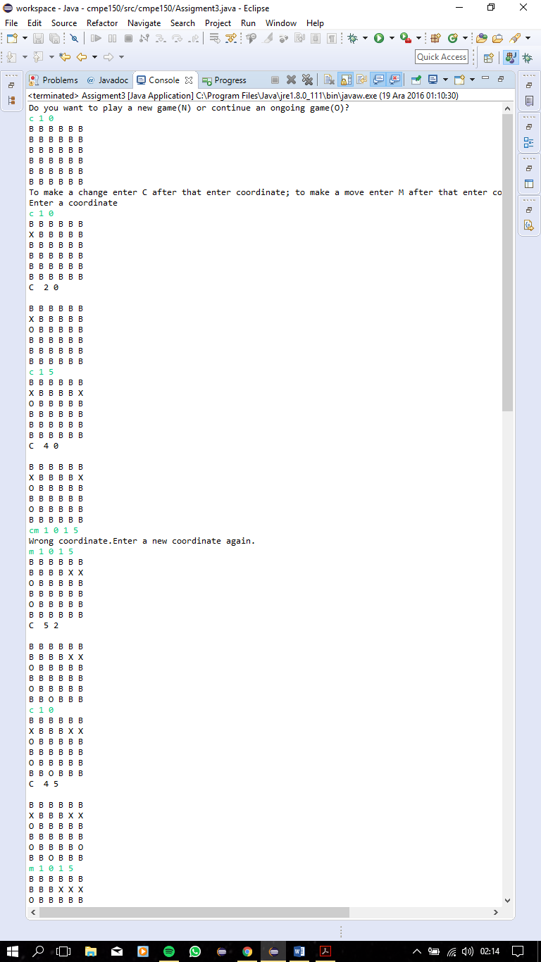

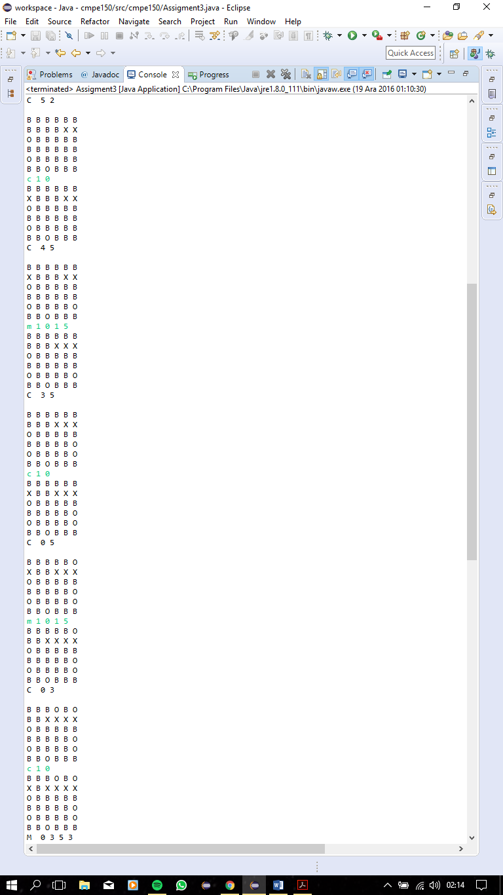
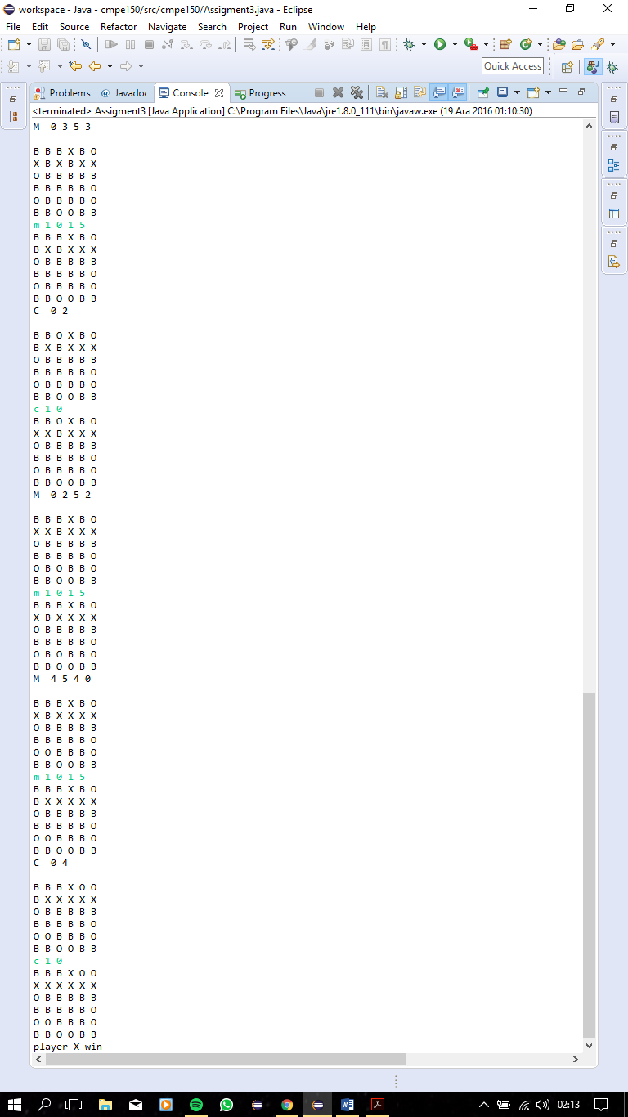

5-Conclusion :
I have made game correctly and ı have not gotten any compiler errors.

