Software Design Document
(SDD)

Project Name | HEALTH AI Co-Creation & Innovation Platform
Course | Software Project IV - SENG 384
Group No / Name | Mehmet Can Ergüden
Group Members | Mehmet Can Ergüden - 202328022
Submission Date | 04/05/2026
Version | 2.0
Revision History
Date | Version | Change Description | Author
08/04/2026 | 1.0 | Initial version | Mehmet Can Ergüden
04/05/2026 | 2.0 | Added architectural, deployment, component, ER, UI, security, and state diagrams; updated API and design sections. | Mehmet Can Ergüden

Table of Contents
Table of Contents 2
1. Introduction 3
1.1 Purpose 3
1.2 Scope 3
1.3 Reference Documents 3
1.4 Definitions and Abbreviations 3
2. Architectural Design 3
2.1 Architectural Overview 3
2.2 Layers 3
2.3 Deployment Diagram 3
3. Component Design 3
3.1 Component List 3
3.2 Component Interaction Diagram 4
4. Database Design 4
4.1 ER Diagram 4
4.2 Table Definitions 4
4.2.1 users 4
4.2.2 posts 4
4.2.3 meeting_requests 5
4.2.4 activity_logs 5
5. API Design 5
5.1 Authentication (Auth) 5
5.2 Post Management (Posts) 5
5.3 Meeting Requests (Meetings) 6
5.4 Admin 6
6. UI Design 6
6.1 Screen List and Navigation 6
6.2 Wireframes / Mockups 6
7. Security Design 6
8. State Diagrams 7
8.1 Post Lifecycle 7
8.2 Meeting Request Lifecycle 7
9. SRS–SDD Traceability Matrix 7
10. Appendices (Optional) 7

(Right-click and select “Update Field” in Word to refresh)

1. Introduction

1.1 Purpose
The purpose of this Software Design Document (SDD) is to describe the architectural, component-level, database, API, user interface, security, and state design of the HEALTH AI Co-Creation & Innovation Platform. This document explains how the functional and non-functional requirements defined in the SRS are addressed at the design level. It serves as a technical guide for developers, testers, administrators, and project stakeholders during implementation and evaluation.

1.2 Scope

This SDD covers the design of a secure full-stack web platform that enables structured partner discovery between engineers and healthcare professionals. The design includes user registration, role-based access control, text-only post management, search and filtering, NDA-based meeting request workflow, admin moderation, notifications, and audit logging. The system does not include medical advice, patient data storage, file repository functionality, financial transactions, contract management, or internal video meeting services.

1.3 Reference Documents
The following documents are referenced in this SDD:

- HEALTH AI – Software Requirements Specification (SRS), Version 1.0
- European HealthTech Co-Creation & Innovation Platform Project Brief
- HEALTH AI source code and project structure analysis

1.4 Definitions and Abbreviations
Term Definition
SDD Software Design Document
SRS Software Requirements Specification
API Application Programming Interface
REST Representational State Transfer
JWT JSON Web Token
ORM Object-Relational Mapping
RBAC Role-Based Access Control
GDPR General Data Protection Regulation
NDA Non-Disclosure Agreement
CRUD Create, Read, Update, Delete
UI User Interface
DB Database
Prisma ORM used for database access
Next.js Full-stack React framework used for frontend and API routes

2. Architectural Design

2.1 Architectural Overview
The HEALTH AI platform is designed as a full-stack monolithic web application using Next.js App Router architecture. The frontend and backend API routes are implemented within the same codebase. The frontend is responsible for rendering the user interface and sending REST-style requests to the backend API routes. The backend API handlers process authentication, authorization, business rules, post workflows, meeting requests, admin actions, notifications, and audit logging.

The system follows a layered architecture. The Presentation Layer contains Next.js pages and React components. The Business Logic Layer contains API route handlers, validation rules, lifecycle transitions, and access control checks. The Data Access Layer uses Prisma ORM to interact with the database. The Database Layer stores users, posts, meeting requests, notifications, and audit logs. External email and meeting services are currently represented as mocked integrations.

The general request flow is:

Browser → Next.js UI → API Route Handler → Authentication/RBAC Check → Business Logic → Prisma ORM → SQLite Database → API Response → UI Update

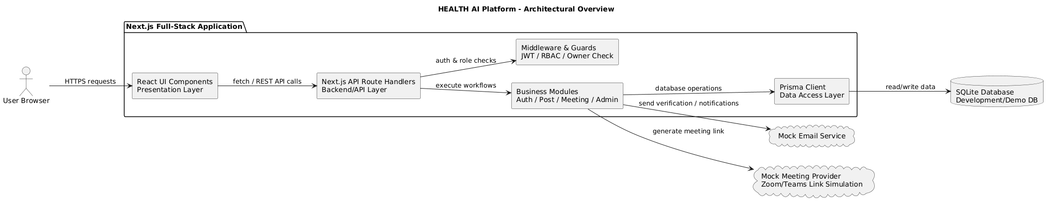

2.2 Layers
Layer | Responsibility | Technology Choice
Presentation | Provides user interface, page rendering, forms, dashboard views, post cards, modals, and admin screens. | Next.js, React, TypeScript, Tailwind CSS, Radix UI
Business Logic | Handles validation, workflows, post lifecycle, meeting request workflow, NDA acceptance, RBAC, admin operations, and audit triggers. | Next.js API Route Handlers, TypeScript, Middleware
Data Access | Performs database operations and maps application models to database tables. | Prisma ORM
Database | Stores persistent application data such as users, posts, meeting requests, notifications, and audit logs. | SQLite for development/demo

2.3 Deployment Diagram
The application is prepared for containerized deployment using Docker. The Next.js application runs inside a web container and includes both frontend rendering and backend API routes. Prisma is used inside the application container to access the SQLite database file. In the current implementation, email verification and meeting link generation are mocked. In a production environment, these mocked services can be replaced with real services such as SendGrid for email and Zoom or Microsoft Teams APIs for meeting links.
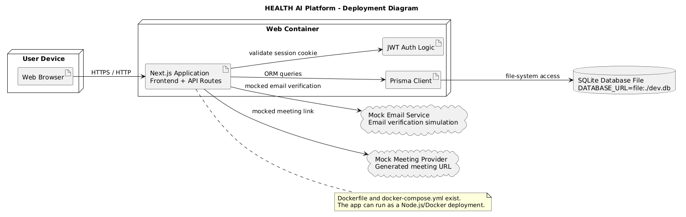

3. Component Design
The system is divided into several functional modules. Each module is responsible for a specific part of the platform. These modules communicate through frontend actions, API route handlers, Prisma database operations, and shared helper functions such as authentication and audit logging.

3.1 Component List
Component | Responsibility | Technology / Notes
AuthModule | Handles registration, login, logout, email verification, password hashing, and JWT-based session creation. | Next.js API routes, TypeScript, bcrypt, jose JWT
User/ProfileModule | Manages user profile information such as biography, expertise, location, institution, and profile completeness. | Next.js pages, Prisma User model
PostModule | Handles post creation, editing, viewing, searching, filtering, status management, and text-only post structure. | Next.js API routes, Prisma Post model
MatchingModule | Supports search, filtering, local/city-based matching, and match indicators on post cards. | Query parameters, filtering logic, frontend post cards
MeetingModule | Handles meeting requests, NDA acceptance, proposed time slots, accept/decline actions, and mocked meeting link generation. | Next.js API routes, Prisma MeetingRequest model
AdminModule | Provides admin dashboard, user suspension, post moderation, platform statistics, and access to audit logs. | Admin pages, requireAdmin guard, Prisma
AuditModule | Records important system events such as login, post creation, meeting request actions, and admin actions. | src/lib/audit.ts, Prisma AuditLog model

3.2 Component Interaction Diagram
The following component interaction diagram shows how the main system components communicate with each other. The frontend UI sends requests to functional modules through API routes. These modules use Prisma ORM for database access and call AuditModule or NotificationModule when important events occur.

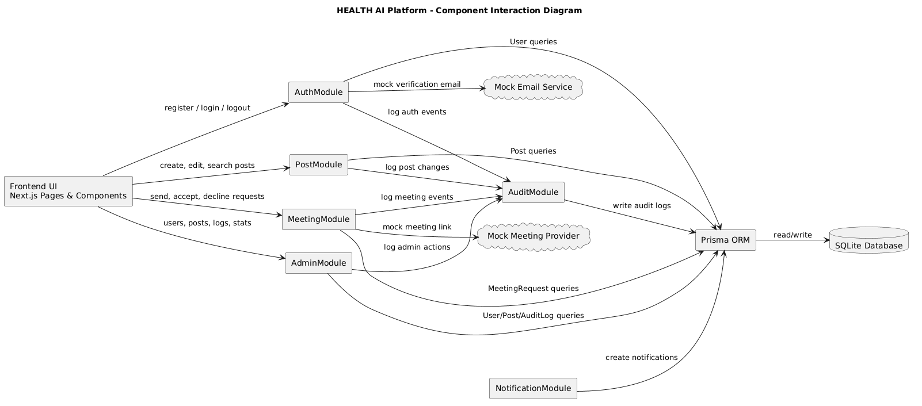

4. Database Design

4.1 ER Diagram
The database design is based on the core entities required for structured partner discovery, post management, meeting request workflow, notification delivery, and audit logging. The main entities are User, Post, MeetingRequest, Notification, and AuditLog.

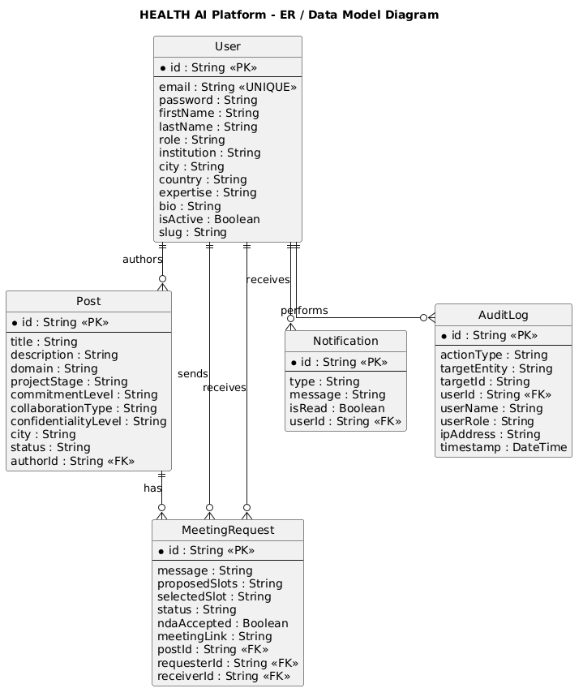

4.2 Table Definitions

4.2.1 users
Field Name | Data Type | Required | Constraint | Description
id | String / CUID | Yes | PK | Unique user identifier
email | VARCHAR(255) | Yes | UNIQUE, .edu check | Institutional email address
password | VARCHAR(255) | Yes | Encrypted | Hashed password
firstName | VARCHAR(100) | Yes | — | User first name
lastName | VARCHAR(100) | Yes | — | User last name
role | ENUM / String | Yes | engineer / healthcare / admin | User role for RBAC
institution | VARCHAR(255) | No | — | User institution
city | VARCHAR(100) | No | — | User city
country | VARCHAR(100) | No | — | User country
expertise | TEXT / JSON String | No | — | User expertise areas
bio | TEXT | No | — | Short profile biography
isActive | Boolean | Yes | Default: true | Indicates whether the account is active
slug | VARCHAR(255) | No | UNIQUE if enforced | Profile URL identifier

4.2.2 posts
Field Name | Data Type | Required | Constraint | Description
id | String / CUID | Yes | PK | Unique post identifier
authorId | String / CUID | Yes | FK → users.id | User who created the post
title | VARCHAR(255) | Yes | — | Post title
description | TEXT | Yes | Text-only | High-level post explanation
domain | VARCHAR(100) | Yes | — | Working domain such as cardiology imaging
projectStage | VARCHAR(100) | Yes | — | Idea, concept validation, prototype, pilot, etc.
commitmentLevel | VARCHAR(100) | Yes | — | Required collaboration commitment
collaborationType | VARCHAR(100) | No | — | Advisor, co-founder, research partner, etc.
confidentialityLevel | VARCHAR(100) | Yes | — | Public short pitch or details in meeting only
city | VARCHAR(100) | No | — | City for local matching
country | VARCHAR(100) | No | — | Country of the post creator or project
expiryDate | DateTime | No | — | Expiration date for the post
status | ENUM / String | Yes | draft / active / meeting_scheduled / partner_found / expired | Current post lifecycle state
createdAt | DateTime | Yes | Auto-generated | Post creation timestamp

4.2.3 meeting_requests
Field Name | Data Type | Required | Constraint | Description
id | String / CUID | Yes | PK | Unique meeting request identifier
postId | String / CUID | Yes | FK → posts.id | Related post
requesterId | String / CUID | Yes | FK → users.id | User who sends the meeting request
receiverId | String / CUID | Yes | FK → users.id | User who receives the meeting request
message | TEXT | Yes | — | Introductory message from requester
proposedSlots | TEXT / JSON String | Yes | — | Proposed meeting date/time options
selectedSlot | TEXT / JSON String | No | — | Selected slot after acceptance
status | ENUM / String | Yes | pending / scheduled / declined / completed / cancelled | Meeting request lifecycle state
ndaAccepted | Boolean | Yes | Must be true before request | Indicates NDA acceptance
meetingLink | VARCHAR(500) | No | Mocked external URL | External meeting link generated after acceptance

4.2.4 activity_logs
Field Name | Data Type | Required | Constraint | Description
id | String / CUID | Yes | PK | Unique log entry identifier
userId | String / CUID | No | FK → users.id | User who performed the action
userName | VARCHAR(255) | No | — | Name of the acting user
userRole | VARCHAR(50) | No | — | Role of the acting user
actionType | VARCHAR(100) | Yes | — | Type of action such as LOGIN, CREATE_POST, REMOVE_POST
targetEntity | VARCHAR(100) | No | — | Entity affected by the action
targetId | VARCHAR(255) | No | — | ID of the affected entity
ipAddress | VARCHAR(100) | No | GDPR-minimized optional field | IP address if available
timestamp | DateTime | Yes | Auto-generated | Time of the action

4.2.5 notifications
Field Name | Data Type | Required | Constraint | Description
id | String / CUID | Yes | PK | Unique notification identifier
userId | String / CUID | Yes | FK → users.id | User who receives the notification
type | VARCHAR(100) | Yes | — | Notification type
message | TEXT | Yes | — | Notification message
isRead | Boolean | Yes | Default: false | Indicates whether the notification was read
createdAt | DateTime | Yes | Auto-generated | Notification creation time

5. API Design
This section defines the main REST-style API endpoints used by the HEALTH AI platform. The backend is implemented using Next.js API Route Handlers. Each endpoint is grouped according to its module and includes its HTTP method, endpoint path, purpose, authorization requirement, and related SRS reference.

5.1 Authentication (Auth)
Method | Endpoint | Description | Auth | SRS Ref.
POST | /api/auth/register | Creates a new user account with .edu email restriction and role selection | Public | FR-01, FR-03
POST | /api/auth/login | Authenticates user and creates JWT session cookie | Public | FR-02
GET | /api/auth/me | Returns current authenticated user information | Authenticated | FR-04
POST | /api/auth/logout | Ends the current user session | Authenticated | —

5.2 Post Management (Posts)
Method | Endpoint | Description | Auth | SRS Ref.
GET | /api/posts | Lists posts with search and filter query parameters | Authenticated | FR-20, FR-21
POST | /api/posts | Creates a new text-only post | Authenticated | FR-10, FR-13
GET | /api/posts/:id | Returns details of a selected post | Authenticated | FR-20
PATCH | /api/posts/:id | Updates an existing post; owner or admin only | Owner/Admin | FR-11
DELETE | /api/posts/:id | Deletes a post; owner or admin only | Owner/Admin | FR-41

5.3 Meeting Requests (Meetings)
Method | Endpoint | Description | Auth | SRS Ref.
GET | /api/meetings | Lists incoming, outgoing, and scheduled meeting requests | Authenticated | FR-31
POST | /api/meetings | Sends a meeting request with NDA acceptance and proposed time slots | Authenticated | FR-30
POST | /api/meetings/:id/accept | Accepts a meeting request, selects a time slot, and generates a mocked meeting link | Receiver | FR-31
POST | /api/meetings/:id/decline | Declines a pending meeting request | Receiver | FR-31
POST | /api/meetings/:id/cancel | Cancels a meeting request if implemented | Requester/Participant | FR-32

5.4 Admin
Method | Endpoint | Description | Auth | SRS Ref.
GET | /api/admin/stats | Returns platform statistics for admin dashboard | Admin | FR-40
GET | /api/admin/users | Lists all registered users | Admin | FR-40
POST | /api/admin/users/:id/suspend | Suspends or deactivates a user account | Admin | FR-41
GET | /api/admin/posts | Lists all posts for moderation | Admin | FR-41
DELETE | /api/admin/posts/:id | Removes an inappropriate post | Admin | FR-41
GET | /api/admin/logs | Lists audit log records | Admin | FR-50, FR-51

6. UI Design

6.1 Screen List and Navigation
This section describes the main screens of the HEALTH AI platform and the navigation structure between them. The interface is designed to be simple, professional, and understandable for first-time users. The most important UI flows are registration, post discovery, post creation, meeting request submission, meeting management, and admin moderation.

Screen | Description | Access
Registration | Allows new users to create an account using an institutional .edu email and select a role. | Public
Login | Allows registered users to sign in. | Public
Verify Email | Allows the user to verify email address after registration. | Public
Dashboard | Main authenticated landing area after login. | Authenticated
Posts Feed | Lists posts with search, filters, local match tags, and post cards. | Authenticated
Create Post | Allows Engineer or Healthcare Professional users to create text-only collaboration posts. | Authenticated
Post Detail | Shows detailed post information and opens the meeting request modal. | Authenticated
Meeting Request Modal | Allows users to accept NDA, write a message, and propose time slots. | Authenticated
Meetings Page | Shows incoming, outgoing, scheduled, and past meeting requests. | Authenticated
Profile Page | Allows users to manage profile information such as bio, expertise, and location. | Authenticated
Admin Dashboard | Shows platform statistics and recent administrative information. | Admin
Admin Users Page | Allows admins to view and suspend users. | Admin
Admin Posts Page | Allows admins to view and remove inappropriate posts. | Admin
Admin Logs Page | Allows admins to view audit logs. | Admin

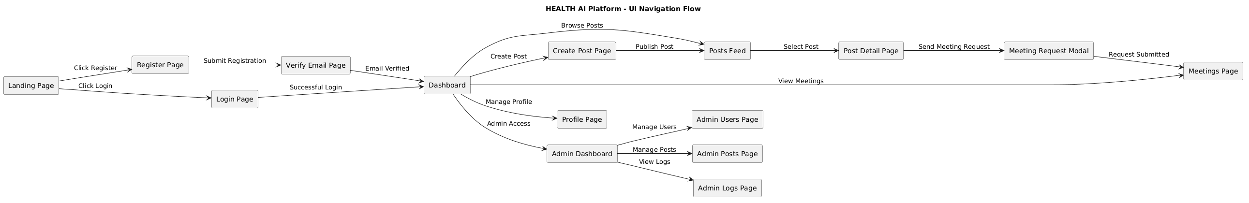

6.2 Wireframes / Mockups
The following wireframes represent the most important user interface screens of the system. These screens were selected because they directly support registration, post discovery, post creation, meeting request workflow, and admin management.

. 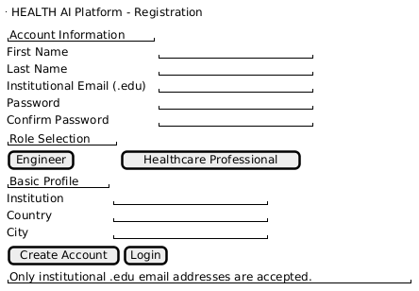
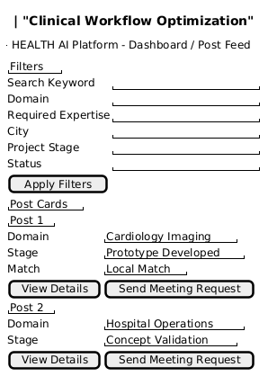
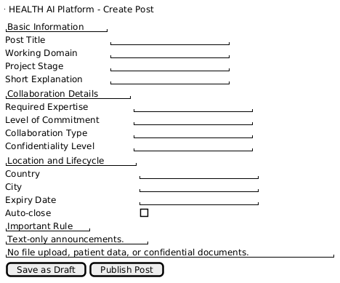
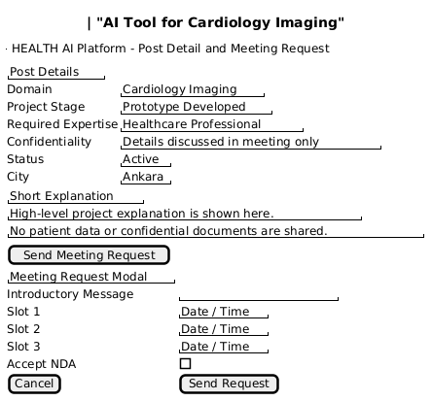

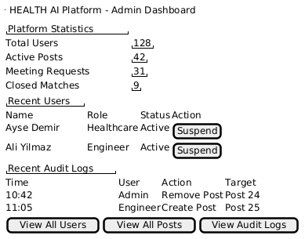

7. Security Design
This section explains how the security and GDPR-related requirements are addressed at the design level. The platform is designed to minimize sensitive data exposure by preventing file uploads, avoiding patient data storage, using role-based access control, protecting sessions, hashing passwords, and maintaining audit logs for critical operations.

Security Requirement | Design Decision | SRS Ref.
Authentication | The system uses JWT-based session management with HTTP-only cookies. | FR-02, NFR Security
Password storage | User passwords are hashed using bcrypt before being stored. | NFR Security
.edu email restriction | Registration checks whether the user email belongs to an institutional .edu domain. | FR-01
Email verification | Email verification exists but is currently mocked with a fixed verification flow. | FR-02
Authorization / RBAC | Role-based access control separates Engineer, Healthcare Professional, and Admin permissions. Admin-only pages and APIs are protected by admin guards. | FR-03, FR-04
Owner authorization | Post update and delete operations are restricted to the post owner or admin. | FR-11, FR-41
NDA before meeting | Meeting request creation requires NDA acceptance before submission. | FR-30
File upload prevention | The UI and database design do not include file upload fields, reducing the risk of patient data or technical document exposure. | FR-13
Audit logging | Critical actions such as login, post creation, meeting request events, and admin actions are written to audit logs. | FR-50, FR-51
GDPR / data minimization | The system avoids storing patient data and limits logs to operational metadata such as user ID, role, action type, target entity, and timestamp. | FR-51, NFR Privacy
External meetings | Meetings occur outside the platform through mocked external links; no meeting recordings are stored. | FR-30, FR-31
Rate limiting | Not fully implemented in the current code. It is recommended for production deployment. | NFR Security
Session timeout | Not clearly implemented in the current code. It should be configured in production. | NFR Security

8. State Diagrams

8.1 Post Lifecycle
This section describes the lifecycle states of posts and meeting requests. State diagrams are used to show how system objects move between states based on user actions or system events.
Transition | Trigger / Event
Draft → Active | User clicks the “Publish Post” button.
Draft → Removed | User deletes a draft before publishing.
Active → Meeting Scheduled | A meeting request for the post is accepted.
Active → Partner Found | Post owner manually marks the post as partner found.
Active → Expired | The expiry date is reached.
Active → Removed | Admin removes the post or owner deletes it.
Meeting Scheduled → Partner Found | Collaboration is formed after the meeting.
Meeting Scheduled → Active | Meeting is cancelled or no collaboration is formed.
Partner Found → Closed | The post is closed and no longer receives new meeting requests.
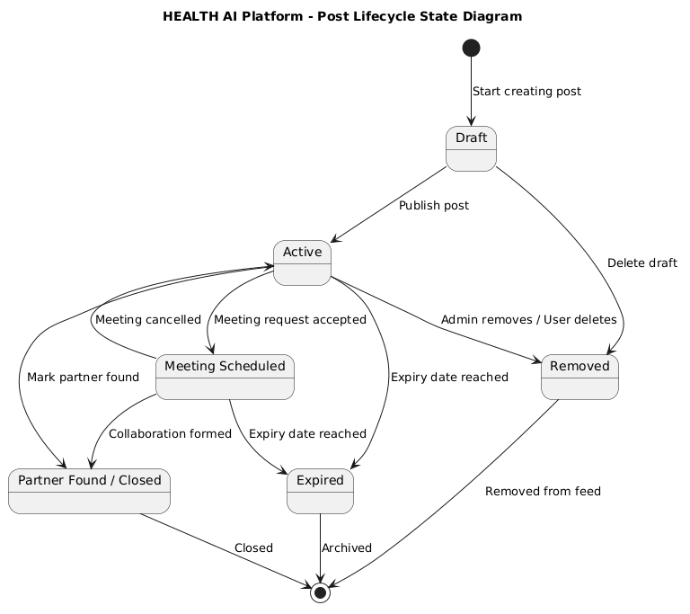

8.2 Meeting Request Lifecycle
The meeting request lifecycle begins when an authenticated user sends a meeting request after accepting the NDA and proposing time slots. The request remains pending until the receiver accepts, declines, or the requester cancels it. When the request is accepted, the system schedules the meeting and generates a mocked external meeting link.

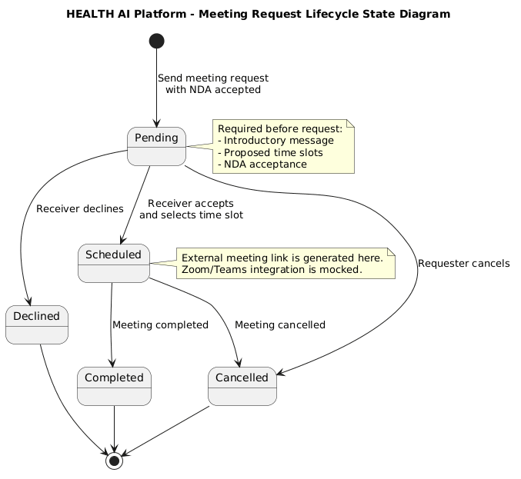

9. SRS–SDD Traceability Matrix
The following traceability matrix shows how the main SRS requirements are addressed by the SDD components, API sections, database design, UI design, security design, and state diagrams.
SRS Ref. | Requirement Summary | SDD Component | SDD Section
FR-01 | .edu email restriction | AuthModule | Section 3.1, 5.1, 7
FR-02 | Email verification and login | AuthModule | Section 3.1, 5.1, 7
FR-03 | Role selection | AuthModule / UserModule | Section 3.1, 5.1, 6.1
FR-04 | Role-Based Access Control | AuthModule / AdminModule | Section 3.1, 5.4, 7
FR-10 | Post creation | PostModule | Section 3.1, 5.2, 6.1
FR-11 | Post confidentiality level and editing | PostModule | Section 4.2.2, 5.2
FR-12 | Post lifecycle states | PostModule | Section 8.1
FR-13 | No file uploads / text-only posts | PostModule / Security Design | Section 4.2.2, 7
FR-20 | Search and filtering | MatchingModule / PostModule | Section 3.1, 5.2, 6.1
FR-21 | City-based matching and tags | MatchingModule | Section 3.1, 6.1
FR-30 | NDA before meeting request | MeetingModule | Section 3.1, 5.3, 7
FR-31 | Accept/decline meeting request and propose slots | MeetingModule | Section 5.3, 8.2
FR-32 | Cancel meeting request | MeetingModule | Section 5.3, 8.2
FR-40 | Admin dashboard and user visibility | AdminModule | Section 3.1, 5.4, 6.1
FR-41 | Suspend users and remove posts | AdminModule | Section 3.1, 5.4, 7
FR-50 | Audit logging | AuditModule | Section 3.1, 4.2.4, 5.4
FR-51 | GDPR-safe log fields | AuditModule / Security Design | Section 4.2.4, 7
NFR-01 | Search response performance | PostModule / MatchingModule | Section 3.1, 5.2
NFR-02 | Page load performance | Presentation Layer | Section 2.2, 6.1
NFR-04 | HTTPS and secure communication | Deployment / Security Design | Section 2.3, 7
NFR-05 | Usability and learnability | UI Design | Section 6.1, 6.2
NFR-07 | Accessibility and responsive layout | Presentation Layer | Section 6.1, 7

