Xilinx ISE 14.7 Installation Guide
(Windows 11 + WSL2 + Docker)

Author: Mehmet Gök
Boğaziçi University
Department of Electrical & Electronics Engineering
Document Date: February 28, 2026
Revision: 1.0

1) Install Visual Studio Code from the Microsoft Store or download it from:
https://code.visualstudio.com/download

2) Open VS Code. From the top menu, click on “Terminal” and select “New Terminal.” 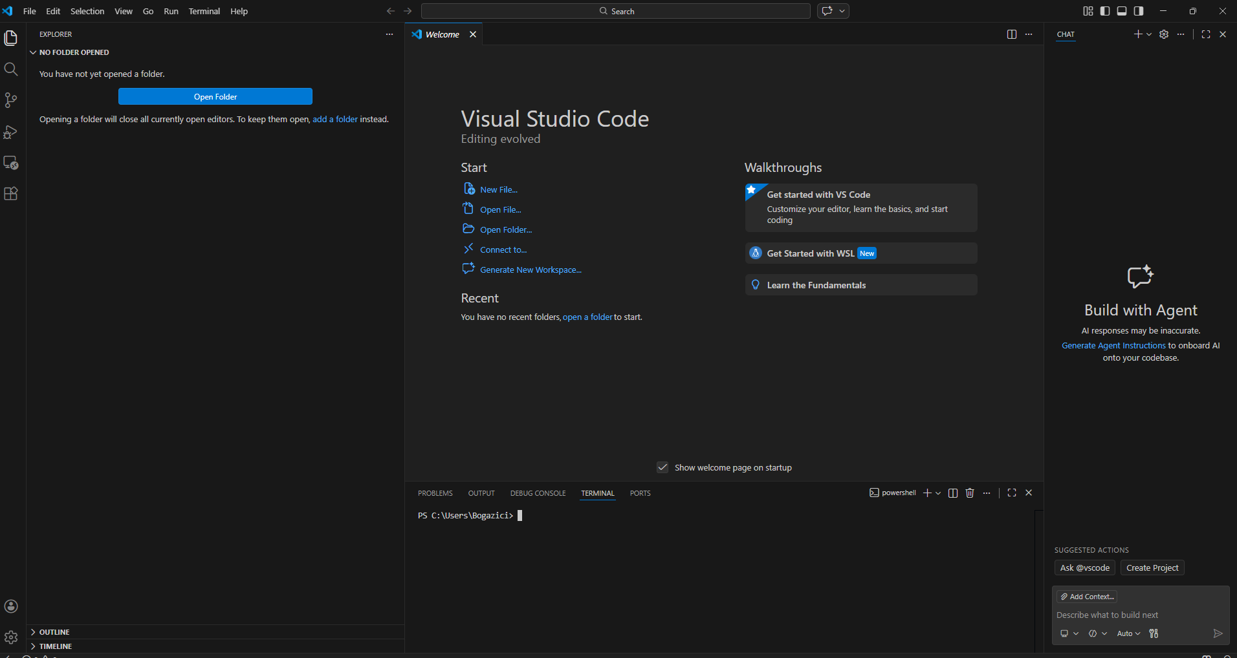
3) In the terminal, type:
wsl --install
This process may take some time.

4) After installation completes, reboot your system. Open the VS Code again and create a new terminal.
Run the following command: wsl --install -d Ubuntu
Ubuntu will be installed. You will be prompted to create a username and password.

5) Download Docker Desktop for Windows from: https://docs.docker.com/desktop/setup/install/windows-install/ During installation, make sure the WSL2 option is enabled. Restart your PC after installation.
6) Download Xilinx ISE 14.7 from: https://www.xilinx.com/support/download/index.html/content/xilinx/en/downloadNav/vivado-design-tools/archive-ise.html Create a free account and download: Xilinx_ISE_DS_Lin_14.7_1015_1.tar (Full Linux installer)

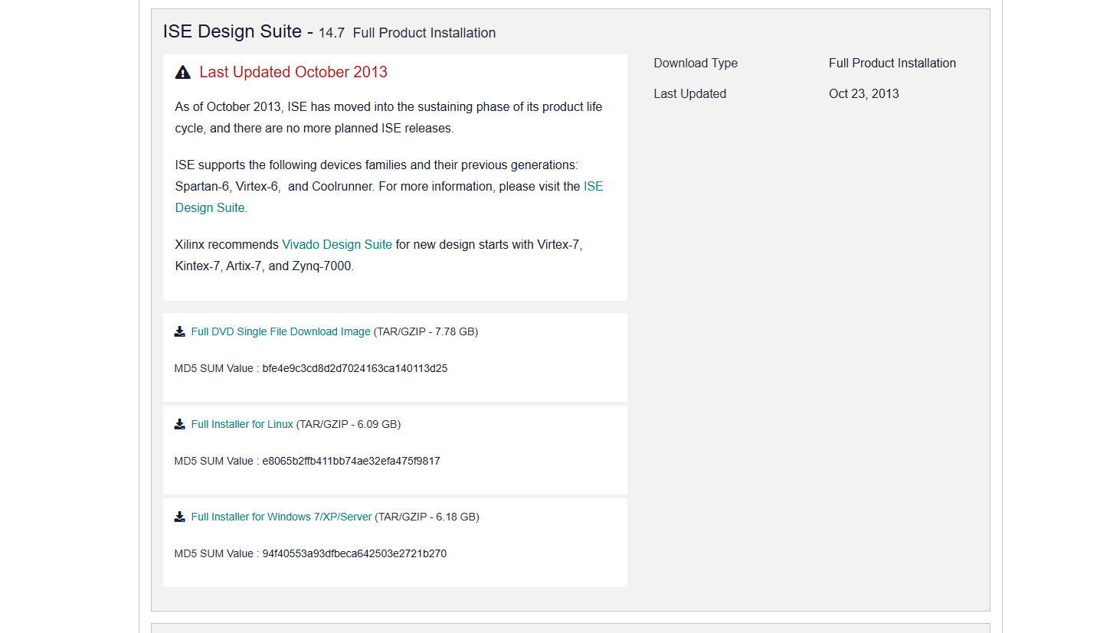

Also generate a license file from:
https://account.amd.com/en/forms/license/license-form.html
Select “ISE WebPack” and generate a node-locked license.
The license file will be sent to your email.

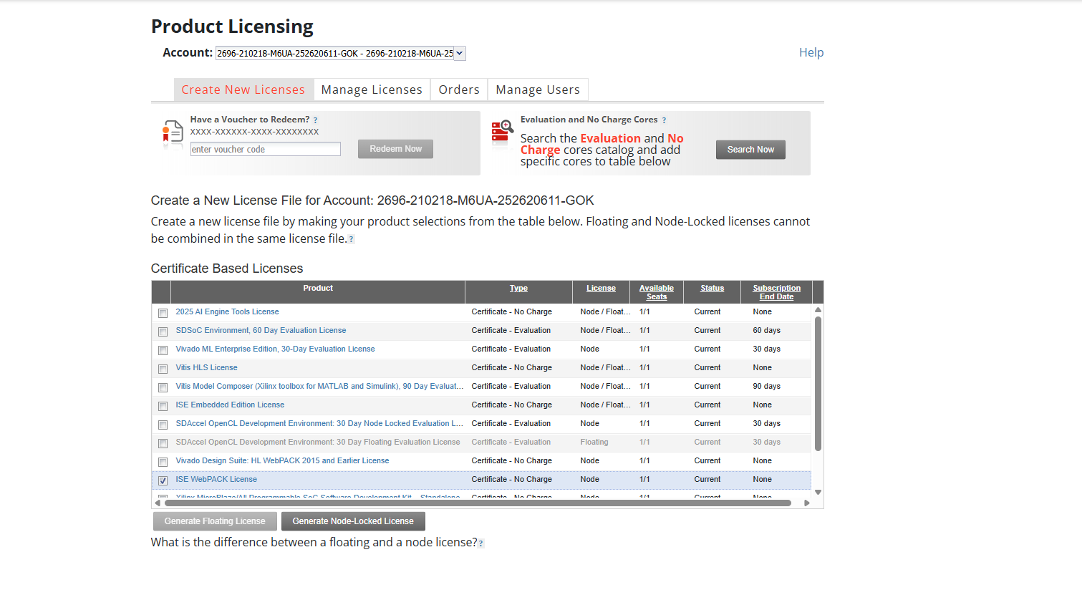
7) Open Docker Desktop → Settings → Resources → WSL Integration. Enable Ubuntu integration and click “Apply & Restart.”
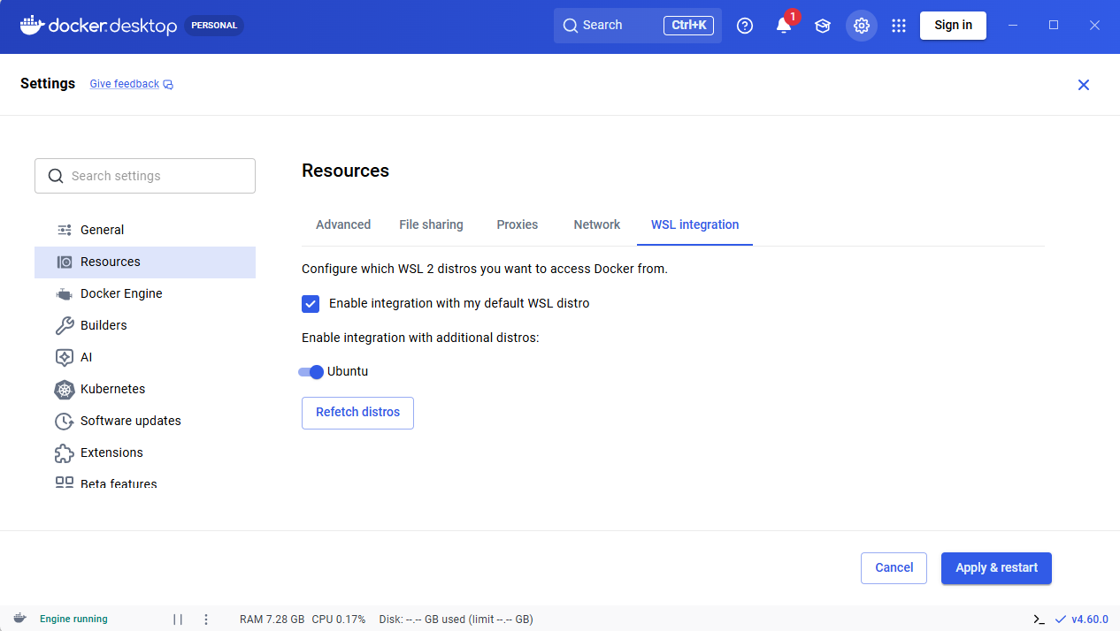

8)
In VS Code, open a terminal and type:
wsl
You are now inside Ubuntu. Copy the installer:
cd #this will take you to home of ubuntu user
cp /mnt/c/Users/<YourUsername>/Downloads/Xilinx_ISE_DS_Lin_14.7_1015_1.tar .
Copy the license file:
cp /mnt/c/Users/<YourUsername>/Downloads/Xilinx.lic .
Verify files using (type in the terminal):
ls
Verify Docker using (type in the terminal):
docker --version
9-)
Create working directory:
mkdir -p ~/tools/ISE
mv ~/Xilinx* ~/tools/ISE/
cd ~/tools/ISE
Create a Dockerfile by simply copy pasting below in terminal:
cat <<EOF > Dockerfile
# Use Ubuntu 16.04 (Compatible with ISE era tools)
FROM ubuntu:16.04
# Enable 32-bit architecture (ISE is a 32-bit app disguised as 64-bit)
RUN dpkg --add-architecture i386
# Install dependencies (Fixes missing library errors like libXi.so, libXrender, etc.)
RUN apt-get update && apt-get install -y \\
build-essential \\
git \\
sudo \\
locales \\
libx11-6 libx11-6:i386 \\
libglib2.0-0 libglib2.0-0:i386 \\
libsm6 libsm6:i386 \\
libxrender1 libxrender1:i386 \\
libfontconfig1 libfontconfig1:i386 \\
libxext6 libxext6:i386 \\
libxi6 libxi6:i386 \\
libxrandr2 libxrandr2:i386 \\
libxcursor1 libxcursor1:i386 \\
libxinerama1 libxinerama1:i386 \\
libxft2:i386 \\
libxtst6:i386 \\
libncurses5:i386 \\
libstdc++6:i386 \\
xutils-dev \\
&& rm -rf /var/lib/apt/lists/*

# Create a 'developer' user to avoid running as root
RUN useradd -m -s /bin/bash developer && \\
echo "developer ALL=(ALL) NOPASSWD:ALL" > /etc/sudoers.d/developer

# Set Locale
RUN locale-gen en_US.UTF-8
ENV LANG en_US.UTF-8
ENV LANGUAGE en_US:en
ENV LC_ALL en_US.UTF-8
USER developer
WORKDIR /home/developer
EOF

Type “ls“ you should see Dockerfile if everything corrects
Build Docker image (type below in terminal with order):
sudo usermod -aG docker $USER
newgrp docker
docker build -t ise-14.7 . #will take time do not forget “.” At the end
mkdir -p ~/xilinx-install
sudo apt update && sudo apt install x11-xserver-utils -y
xhost + #type your password if ask
10-)
Run the installer inside Docker
-------------------------command starts---------------------------
docker run -it --rm --net=host -e DISPLAY=$DISPLAY -v /tmp/.X11-unix:/tmp/.X11-unix -v $(pwd)/Xilinx_ISE_DS_Lin_14.7_1015_1.tar:/installer.tar -v ~/xilinx-install:/opt/Xilinx ise-14.7 bash -c "tar -xf /installer.tar; cd Xilinx_ISE_DS_Lin_14.7_1015_1; ./xsetup"
-------------------------command ends---------------------------
this will take time, if everything successful you will see
Do NOT install cable drivers.

After above finished we need to get our mac address simply copy paste below
cp Xilinx.lic ~/xilinx-install/
be sure you are still in ~/tools/ISE/
after this simply copy the below command
-------------------------command starts---------------------------
alias ise='xhost +local:docker > /dev/null; docker run -it --rm --net=host -e DISPLAY=$DISPLAY -e XILINXD_LICENSE_FILE=/opt/Xilinx/Xilinx.lic -v /tmp/.X11-unix:/tmp/.X11-unix:rw -v $HOME/xilinx-install:/opt/Xilinx -v $(pwd):/work -w /work ise-14.7 bash -c "source /opt/Xilinx/14.7/ISE_DS/settings64.sh && ise"'
-------------------------command ends---------------------------
Then you can type
ise
then terminal leaves and gui will welcome you as below :
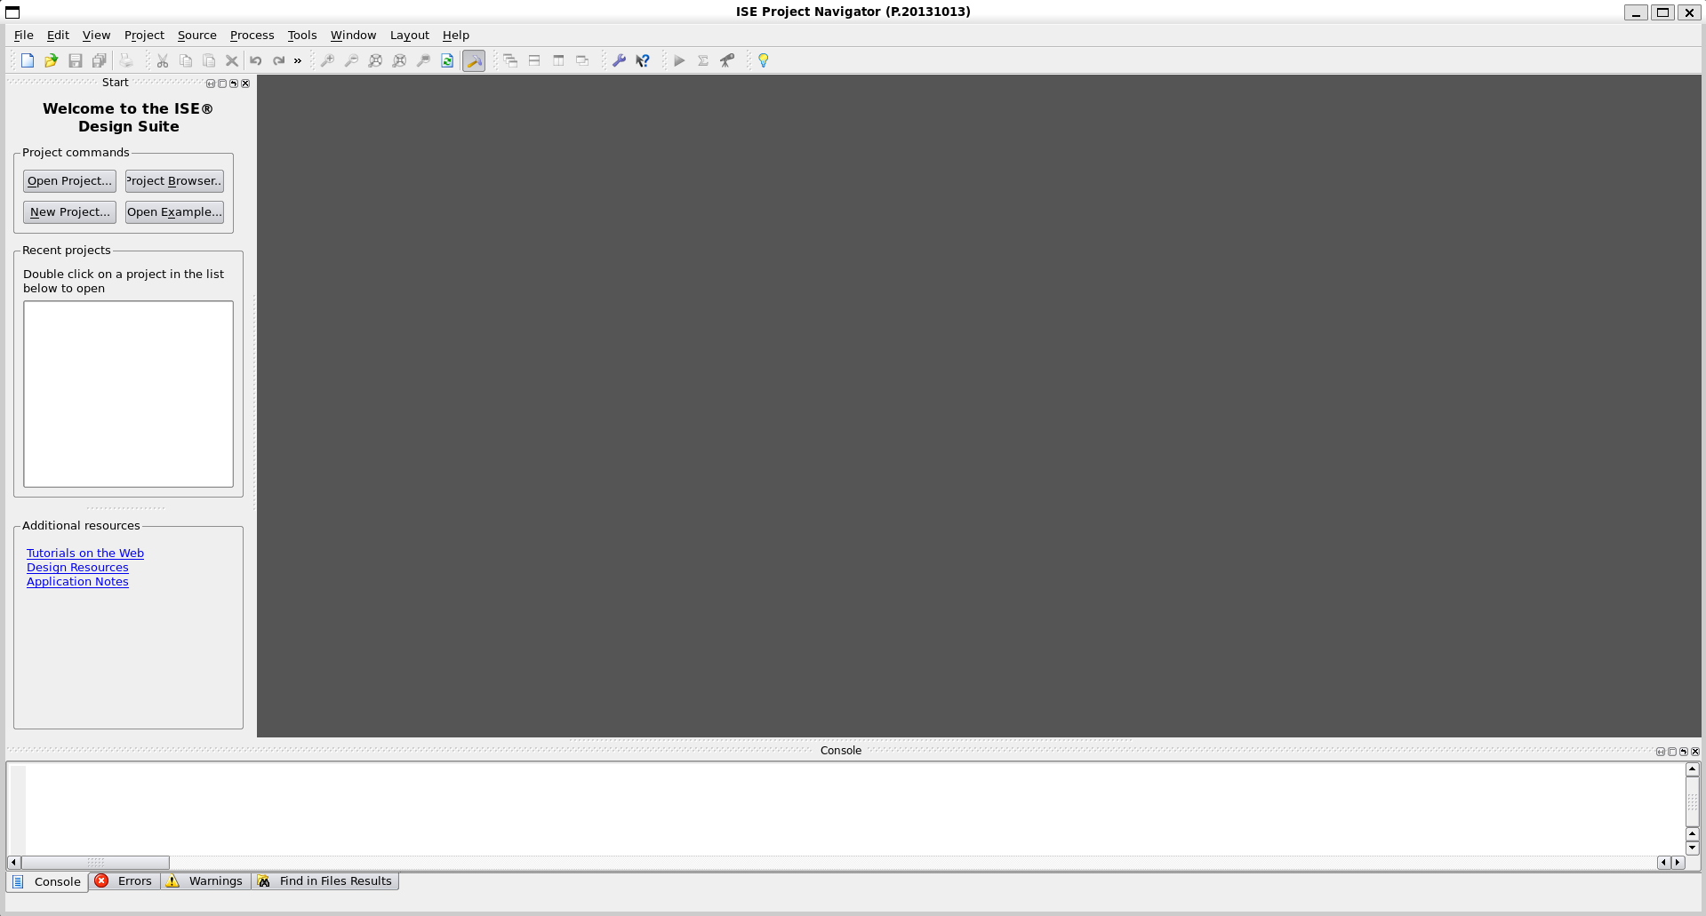
This is the main place we develop our hdl codes.
I strongly suggest creating separate folder for this projects like simply type
mkdir -p ~/fpga_project
Cd ~/fgpa_project
Type ise afterwards projects will be created in this folder
Note: every time you open wsl first it will open terminal at /mnt/c…. kind of place
Simply write cd and enter it will guide you to ubuntu home directory.

11-)
Switch back to host machine your windows version and go to site below:
https://digilent.com/reference/software/adept/start?srsltid=AfmBOoownrZvrs34LBzzZEgiPC7cWKAD4nv8F__mhaoblDF1wesVRRA5
download windows version of digilent adept2 from this link
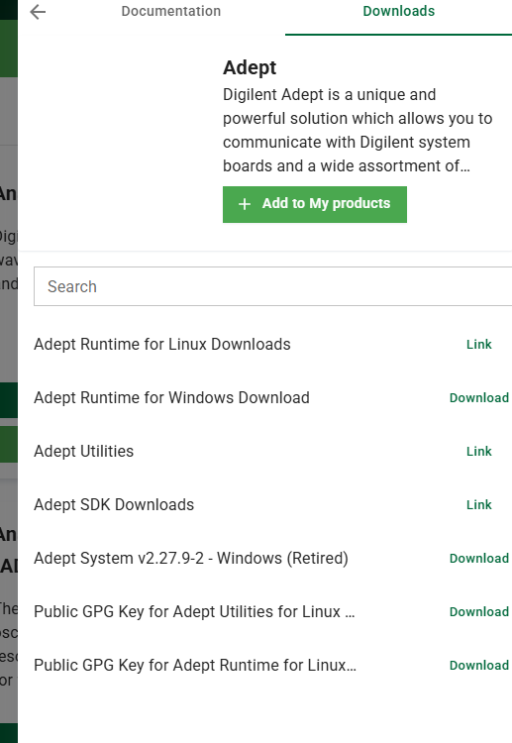
V2.27.9-2 retired And install it by click next next next
After this simply type adept in windows search bar
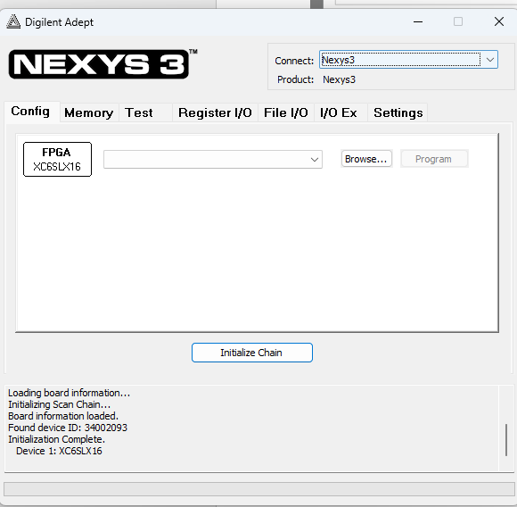
Connect nexsys via usb to pc it should show up as above and from here you can simply upload .bit files
But here comes to question how can I found my bit files which is inside wsl
Simply say browse in above screen
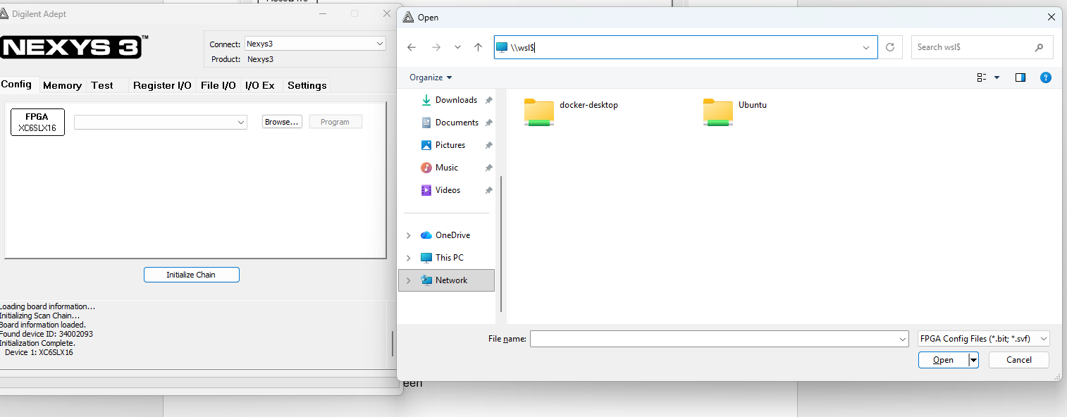
double click in search bar and type \\wsl$ then enter u can see wsl distros there open ubuntu-> home -> Bogazici -> wherever path you put your project
Bogazici in your case will be your username
Upload and run
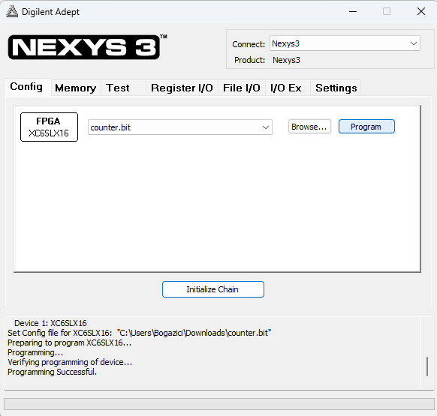
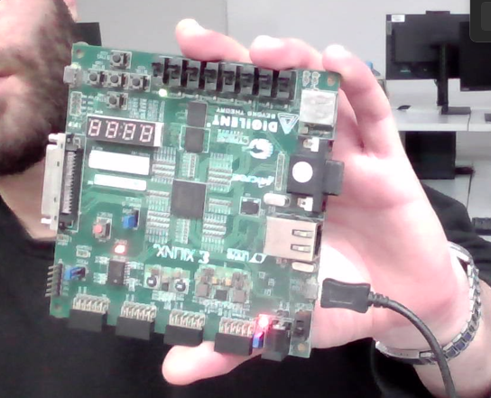
Congrats. Done should be light up near red button.

