**Circuit Simulation with Non Ideal Elements**

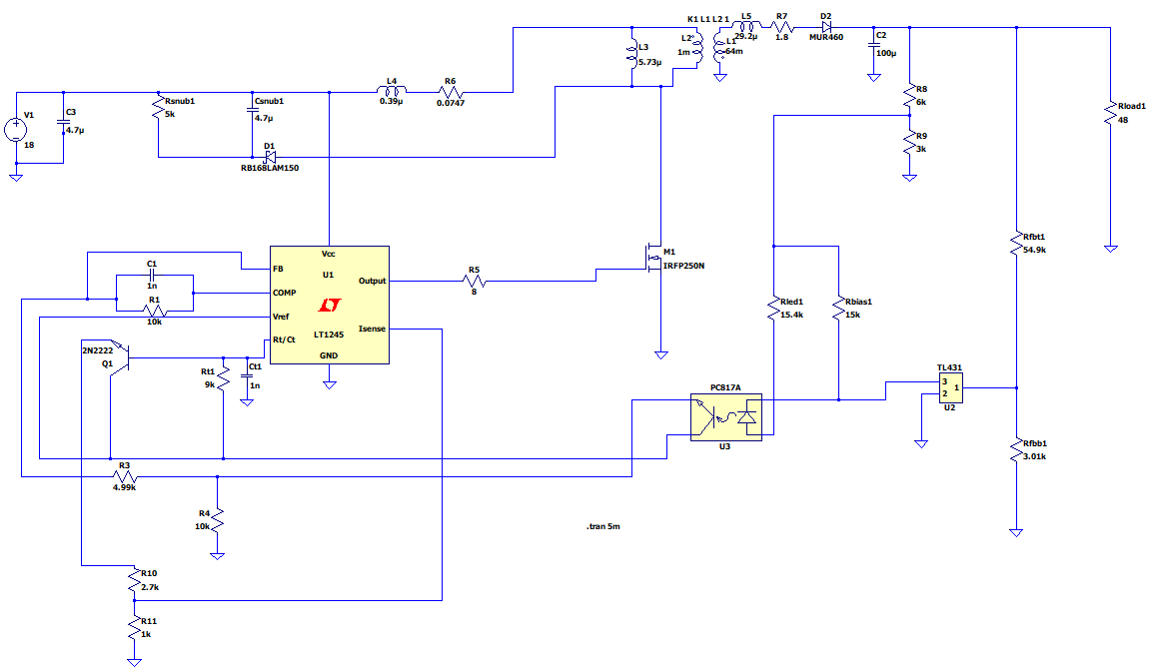

Fig. 18 Circuit Schematic with Non-Ideal Components

The circuit in Figure 18 is simulated. The controller model LT1245 in the simulation is the equivalent of our controller UC3845. As seen from Figure 20, the output voltage reaches 48V in less than 3ms. Maximum and minimum values are shown in Figure 21, in which the ripple is less than 2%.

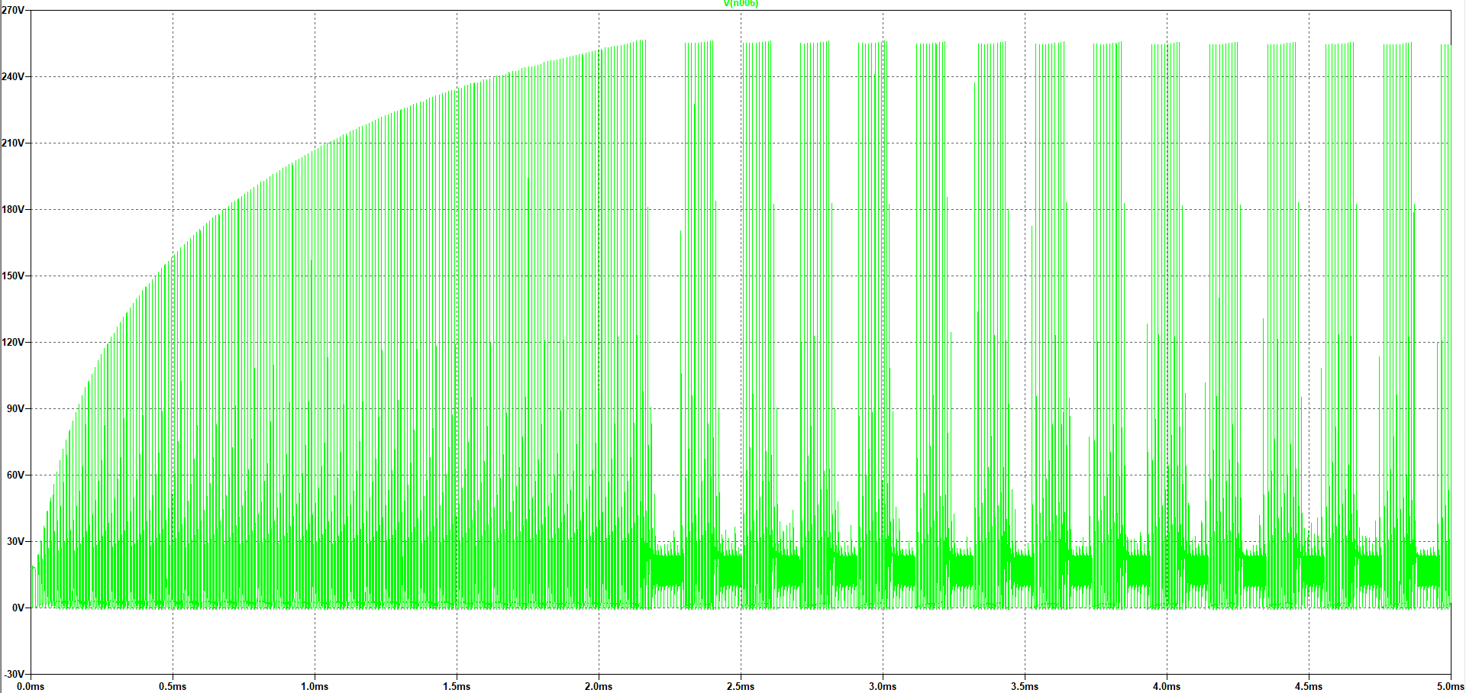

Fig. 19 MOSFET Drain-Source Voltage

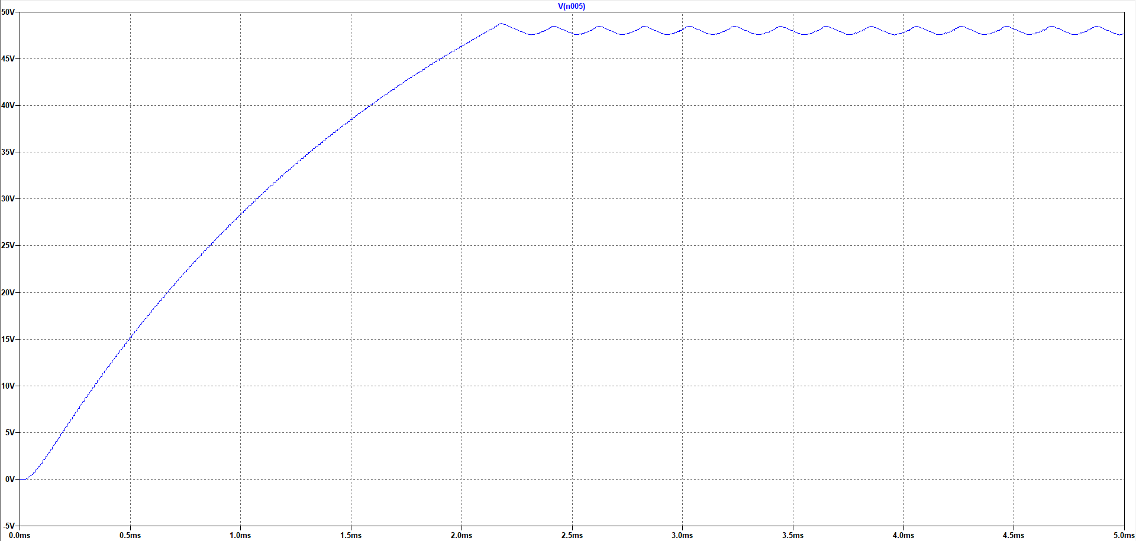

Fig. 20 Output Voltage Transient

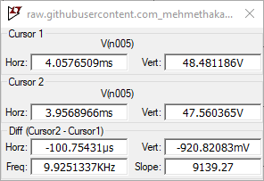

Fig. 26 Output Voltage Data