Introduction

The present investigation concerns the design of an isolating converter. The initial step involves selecting a suitable topology, which is accomplished by verifying the desired ratings. The duty cycle and turns ratio is determined. The magnetic design of the transformer is then expounded upon in detail, taking into consideration the relevant properties. Subsequently, the process of component selection is elucidated about MOSFETs and diodes. Controller selection follows, as the project necessitates closed-loop, isolated control. Finally, the simulation is conducted, employing the calculated specifications in ideal case and in non-ideal case with the chosen components.

Converter Topologies

*Flyback Converter*

A flyback converter is a type of DC-DC converter that uses a transformer to store energy during the on-time of the switching transistor and transfer it to the output during the off-time.

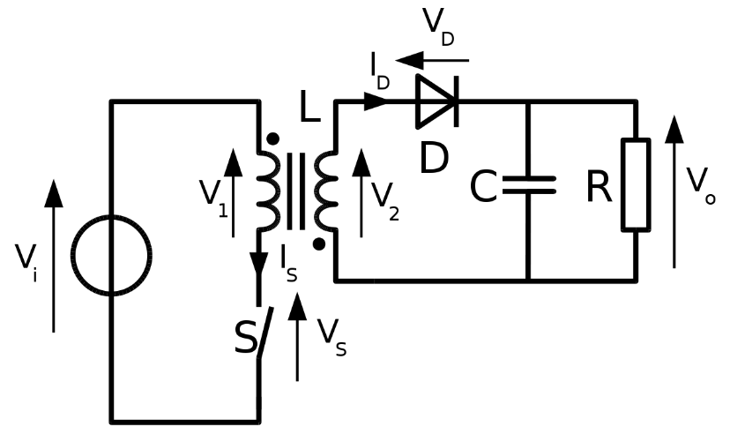

Fig. x Flyback Converter Topology

Advantages

Compared to other types of DC-DC converters, flyback converters have a simpler construction. They are simple to design and debug because of this.

The flyback converter is a low-cost choice for many applications due to its straightforward construction.

Galvanic isolation between the input and output is provided by flyback converters, which is helpful in situations that need for electrical separation.

Flyback converters are appropriate for use in situations where the input voltage may change because they can handle a large input voltage range.

It is simple to design the flyback converter to offer multiple outputs, which is helpful in some applications.

Disadvantages

Depending on the design and operating conditions, the flyback converter's efficiency is generally between 70% and 85% lower than that of other types of DC-DC converters.

Flyback converters that employ transformers might have considerable output ripple, which would not be acceptable for applications that need low noise levels.

Because of their low power efficiency, flyback converters might not be appropriate for high-power applications.

The flyback converter's cost and size may increase due to the transformer's potential size and weight.

To guarantee that the circuit performs correctly and effectively, the flyback converter has to be designed carefully. Inadequate design can lead to issues like decreased efficiency and greater output ripple.

*Forward Converter*

A forward converter is a type of DC-DC converter that uses a transformer to step down the input voltage to a lower voltage level.

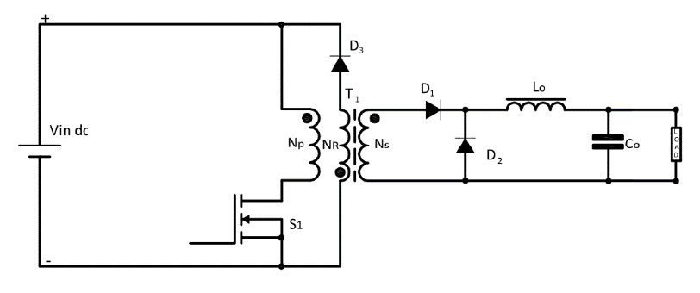

Fig. x Forward Converter Topology

Advantages

Depending on the design and operating circumstances, forward converters can reach high efficacy levels, frequently in the region of 85% to 95%. Power is transmitted in both directions during each switching cycle, which is made possible by the employment of a transformer.

Since forward converters may be made to have a high-power density, they can be used in situations where there is a lack of available space.

Even in the presence of input voltage or load current changes, forward converters often offer strong regulation of the output voltage.

A forward converter is useful for applications that demand low noise levels due to its ability to decrease output ripple when using a transformer.

Disadvantages

Forward converters have a more sophisticated architecture than certain other DC-DC converter types, which can make designing and troubleshooting them more challenging.

Forward converters are frequently made for certain input and output voltage ranges, which might make them less flexible in various applications.

Forward converters have a high component count, which can raise their cost and complexity. They need more parts than certain other types of DC-DC converters.

Since a forward converter uses a transformer, the design may become heavier and more expensive as a result.

*Push-pull Converter*

A push-pull converter is a type of DC-DC converter that uses a center-tapped transformer to step up or step down the input voltage to a desired output voltage.

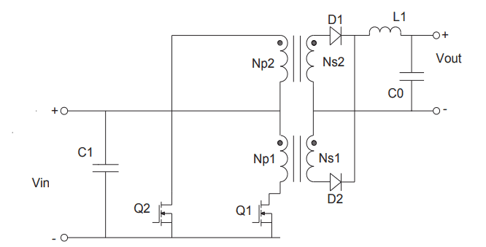

Fig. x Push-pull Converter Topology

Advantages

Depending on the design and operating circumstances, push-pull converters can reach high levels of efficiency.

Push-pull converters offer strong output voltage control, even in the presence of input voltage or load current changes.

A push-pull converter is excellent for applications that call for low noise levels since it uses a center-tapped transformer to aid lower output ripple.

Push-pull converters function in a balanced way, which helps to cut down on noise and electromagnetic interference.

Push-pull converters are capable of handling high power levels, making them appropriate for applications requiring high power densities.

Disadvantages

Push-pull converters have a complicated architecture, which can make them more challenging to design and debug than certain other types of DC-DC converters.

Push-pull converters are often created for certain input and output voltage ranges, which might restrict their versatility in some applications.

A push-pull converter that uses a center-tapped transformer must include a magnetic component, which can increase the design's weight and cost.

Selection of components for the push-pull converter must be done carefully to ensure that the circuit functions properly and effectively. Reduced efficiency, higher EMI, and other issues can be brought on by improper component selection.

Choosing D = 0.4 is useful for most of the available controllers.

Choosing turns ratio N2/N1= 7 is quite good for the operation.

Rload is computed:

Capacitance is computed by using 3% output voltage ripple limit:

We can use a 4.7 μF capacitor to satisfy the inequality above.

To find magnetizing inductance, we use the formula:

should be satisfied to be on the CCM.