**APPENDIX**

**Printed Circuit Board Drawings**

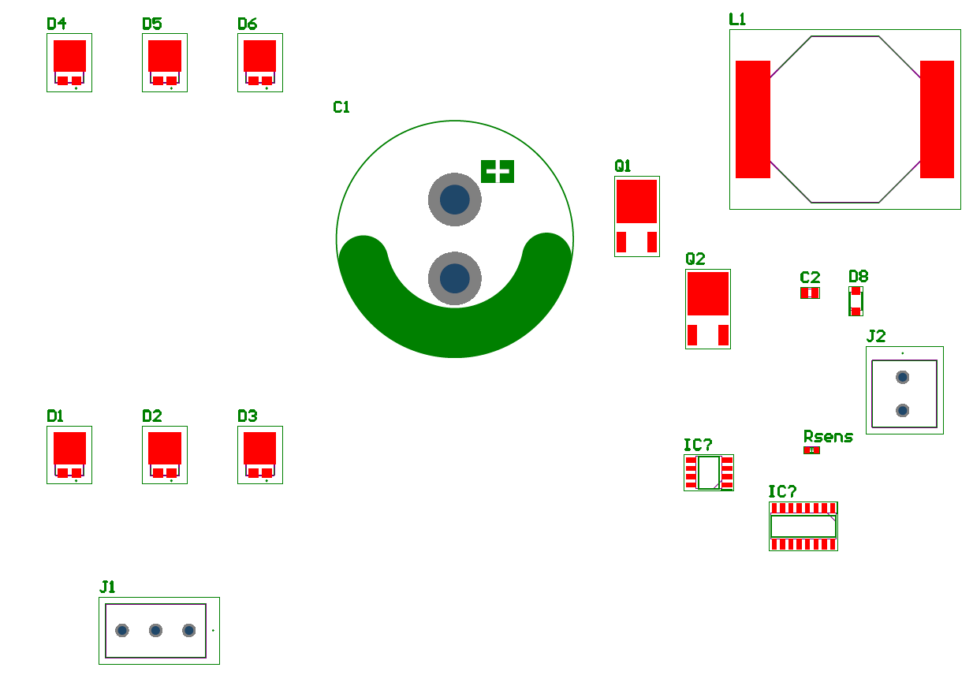

Figure 1. Approximate distribution of Components on PCB (The PCB limits are not shown for demonstration)

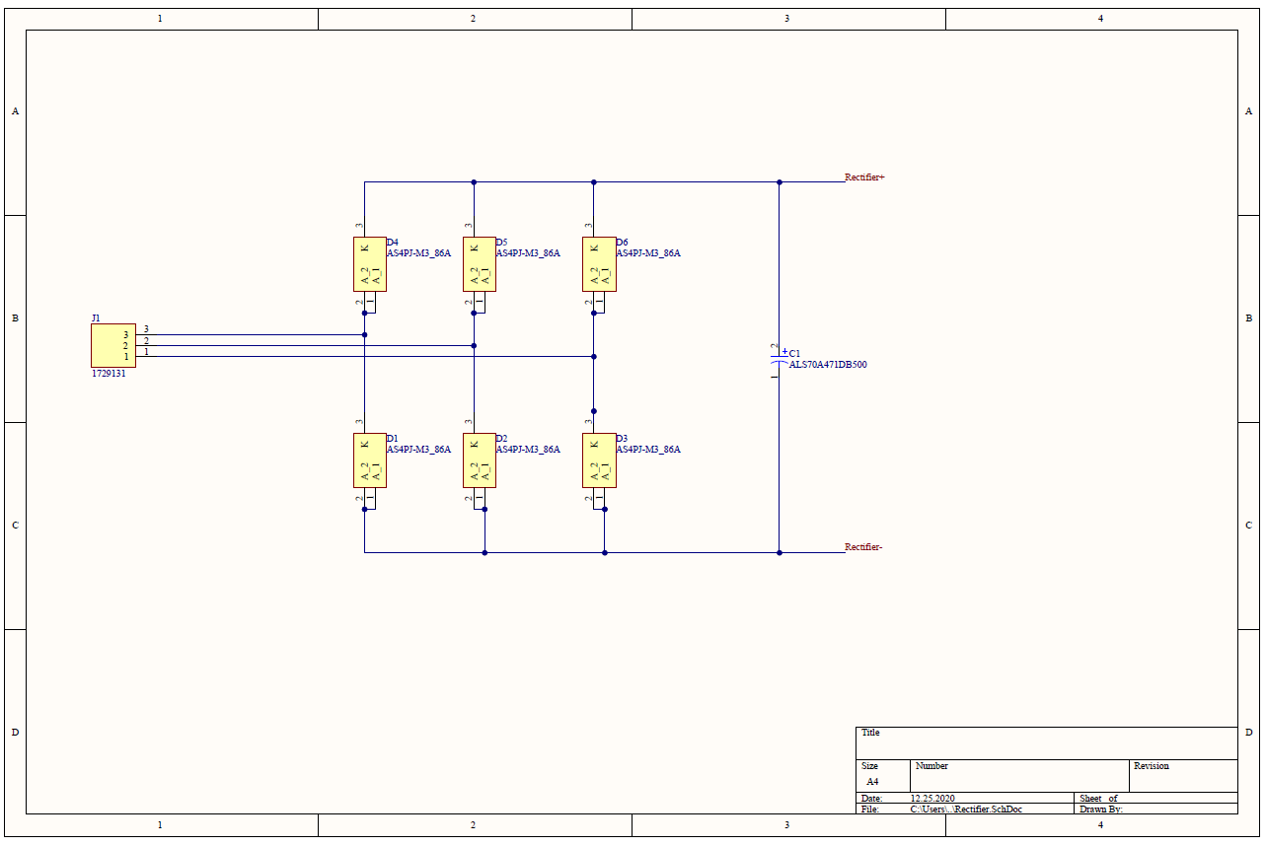

Figure 2. Completed Schematic of rectifier circuit

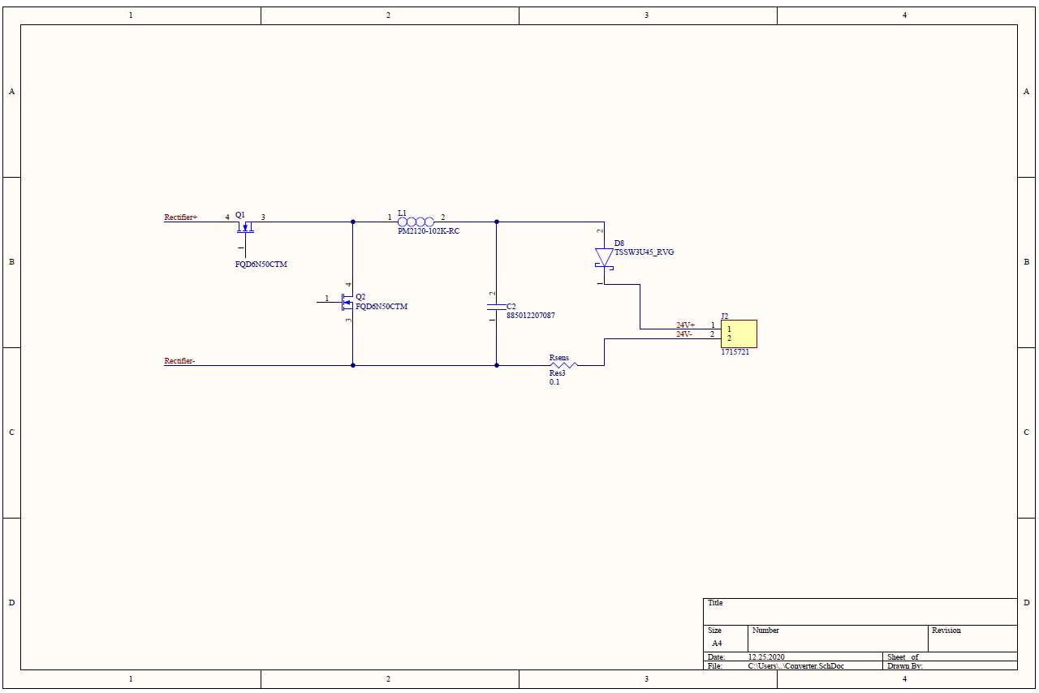

Figure 3. Schematic of Buck Converter circuit (Current sense is missing)

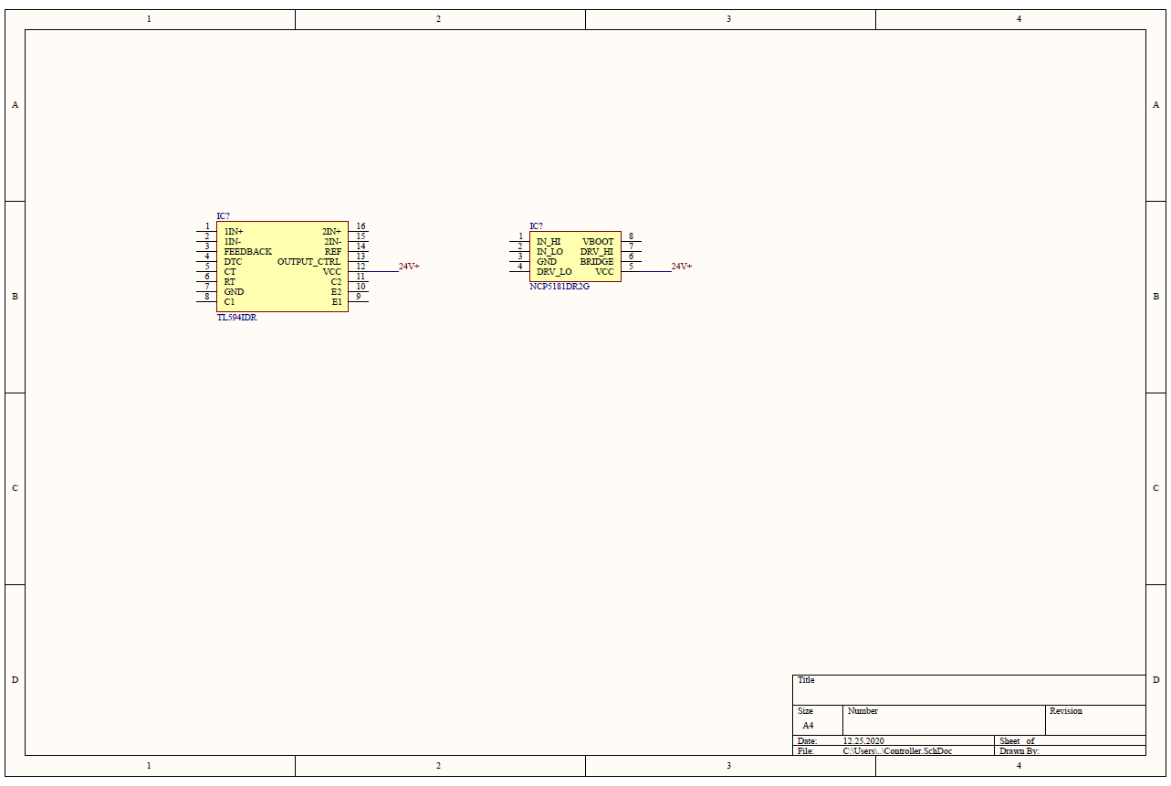

Figure 4. Schematic of Controller with only Integrated Circuits