**EE 498 – Term Project**

**Modeling and Linearization of the Inverted Pendulum on a Cart System**

**Mehmet KILIÇ – 2232262**

In this report, inverted pendulum on a cart system is modeled. First, free body diagram of the system is given below.

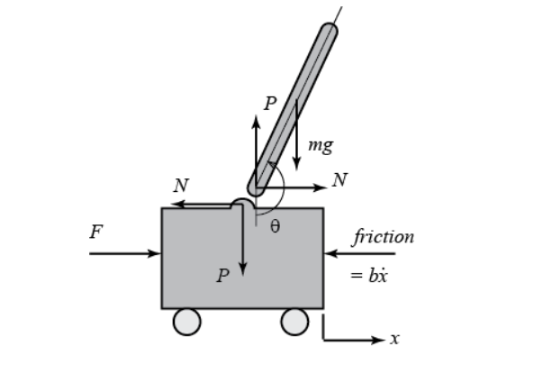

**Figure 1: Free Body Diagram**

M: Mass of the cart

m: mass of the pendulum

b: friction coefficient

L: length of pendulum

I: Mass moment of inertia of the pendulum

F: Force applied to the cart by the actuator

X: Position of the cart

Theta: Pendulum angle

Forces in the direction of x-axis are summed up vectorially. Then, derivations are completed by manipulating the equations.



$$ N= m\ddot{x}+ml\ddot{\theta}\cos\theta-ml\dot{\theta}^2\sin\theta $$

$$(M+m)\ddot{x}+b\dot{x}+ml\ddot{\theta}\cos\theta-ml\dot{\theta}^2\sin\theta=F $$

Forces in the direction of the vertical axis are summed up. Torque equality is used to get rid of variables P and N. Finally, third equation is obtained.

$$P\sin\theta+N\cos\theta-mg\sin\theta=ml\ddot{\theta}+m\ddot{x}\cos\theta$$

$$-Pl\sin\theta-Nl\cos\theta=I\ddot{\theta}$$

$$(I+ml^2)\ddot{\theta}+mgl\sin\theta=-ml\ddot{x}\cos\theta $$

This was the mathematical modeling part for the system. However, resulting equations include trigonometric terms and nonlinear. In addition to the basic mathematical manipulations, we need to linearize these final equations around the point that we want to work around. We want to keep the pendulum at the ϴ = π level. Therefore, ϴ can be approximated to the ϴ = π±φ where φ represents the deviation from the equilibrium point during the transients and its magnitude is negligibly smaller than π. This means that, we are linearizing the equations around ϴ = π point. This is the equilibrium point. Therefore;

$$ \cos \theta = \cos(\pi + \phi) \approx -1 $$

$$ \sin \theta = \sin(\pi + \phi) \approx -\phi $$

$$ \dot{\theta}^2 =  \dot{\phi}^2 \approx 0 $$

Bu putting these relations to the system dynamic equations, we can obtain linearized equations of motion.

$$ (I+ml^2)\ddot{\phi}-mgl\phi=ml\ddot{x} $$

$$ (M+m)\ddot{x}+b\dot{x}-ml\ddot{\phi}=u $$

Where u represents the input F, force action on the cart. After rearranging final ODE’s, we can get the state-space representation for the system.

$$
\left[{\begin{array}{c}
  \dot{x}\\ \ddot{x}\\ \dot{\phi}\\ \ddot{\phi}
\end{array}}\right] =
\left[{\begin{array}{cccc}
  0&1&0&0\\
  0&\frac{-(I+ml^2)b}{I(M+m)+Mml^2}&\frac{m^2gl^2}{I(M+m)+Mml^2}&0\\
  0&0&0&1\\
  0&\frac{-mlb}{I(M+m)+Mml^2}&\frac{mgl(M+m)}{I(M+m)+Mml^2}&0
\end{array}}\right]
\left[{\begin{array}{c}
  x\\ \dot{x}\\ \phi\\ \dot{\phi}
\end{array}}\right]+
\left[{\begin{array}{c}0\\
  \frac{I+ml^2}{I(M+m)+Mml^2}\\
  0 \\
  \frac{ml}{I(M+m)+Mml^2}
\end{array}}\right]u$$

$${\bf y} =
\left[{\begin{array}{cccc}
  1&0&0&0\\0&0&1&0
\end{array}}\right]
\left[{\begin{array}{c}
  x\\ \dot{x}\\ \phi\\ \dot{\phi}
\end{array}}\right]+
\left[{\begin{array}{c}
  0\\0
\end{array}}\right]u$$

In this report, derivations are provided intuitively. For more details, reader may refer to the reference given below.

[1] Inverted Pendulum: System Modeling. Retrieved from:

https://ctms.engin.umich.edu/CTMS/index.php?example=InvertedPendulum&section=SystemModeling