URBAN SOUND CLASSIFICATION

USING DEEP NETS

FINAL REPORT

Mehmet Pekmezci

Gebze Technical University

14.12.2017

Table of Contents
1. Description of Data 3
2. Program Flow 3
3. Preprocessing 7
4. Architectures 8
4.1 LeNET 10
4.2 AlexNET 12
4.3 VGG 13
4.4 Experimental (Twin, Siamese) 14
5. Architecture Construction 15
6. Hyper Parameters 15
7. Summary Results 16
8. Conclusion 16
9. References 16
10. Appendix : Code URL 16

1. Description of Data
The data is already per-processed to a certain point. But we need of course some further preprocessing.
Dataset properties are :
- 8732 WAV files, each containing 4 seconds of urban sounds.
- All the data is labeled. The labels are in their file names.
- The WAV files are labeled in 10 categories (air_conditioner, car_horn, children_playing, dog_bark, drilling,engine_idling, gun_shot, jackhammer, siren , street_music) and each category has approximately the same amount of sample WAV files.
- The dataset is already split into 10 folds containing the WAV files for each category. (being ready for 10 fold cross validation).
- Each fold contains 50 – 100 samples for each class.
- Last fold (fold10) is used as testing data set, which is never used for training.

2. Program Flow
The flow of the program is as follows :
- Convert WAV files to 1 line of data (1x88200)
- Normalize the data
- Write the data and its label to the CSV file ( 1 x 88201)
- Load the files back to memory and select randomly a data line
- Extract X and Y value from CSV data row.
- One Hot Encode Y data
- Train the network with ( X , Y)
- Test the network with a separate data fold, and calculate the accuracy.
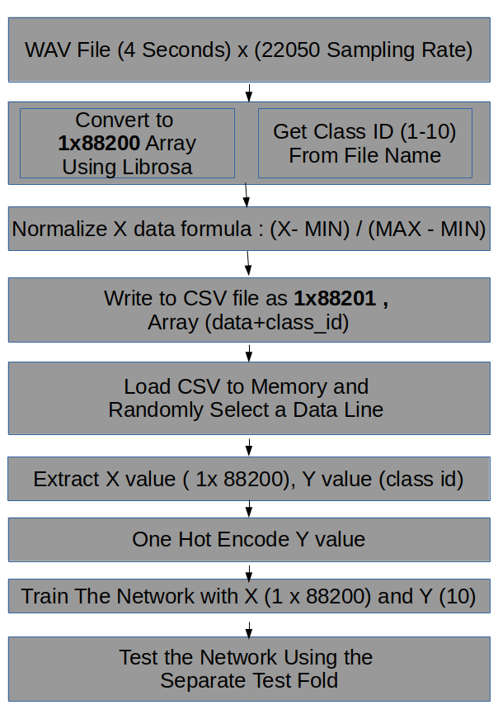Illustration 1: Program Flow

3. Preprocessing
Sound data is not preprocessed with any Fourier or Wavelet based methods. Sound data is directly fed , after shuffling and normalization , into the network.
Three different data processing techniques are used for different types of networks :
- Every 4 second records are split into 1 second records, every fold data is shuffled and normalized with the formula ( X - MIN ) / (MAX – MIN) .
- 4 second data is augmented using translation/stretching , shuffled and normalized with the formula ( X - MIN ) / (MAX – MIN) .
- Sound data is directly converted to array of float numbers, and normalized. Shuffling occurs just before feeding the data to network.

4. Architectures
Convolutional neural networks are used to classify the Urban Sounds.
- In each convolution layer, 1xN dimensional kernels are used for one dimensional sound data.
- 4 types of networks are used ( LeNet, AlexNet, VGG, Experimental)
- All types of networks used in this work have 4 seconds ( 4 x 22050 = 88200) input data and 10 outputs representing the class probabilities.

General structure of the networks is as follows :
Drawing 1: General Network Structure
INPUT LAYER ( 1x 88200 )
CONVOLUTION LAYERS
2 FULLY CONNECTED LAYERS
OUTPUT LAYER (10)

4.1 LeNET
A variation of the original LeNET architecture is used. The graph of the architecture is as follows :
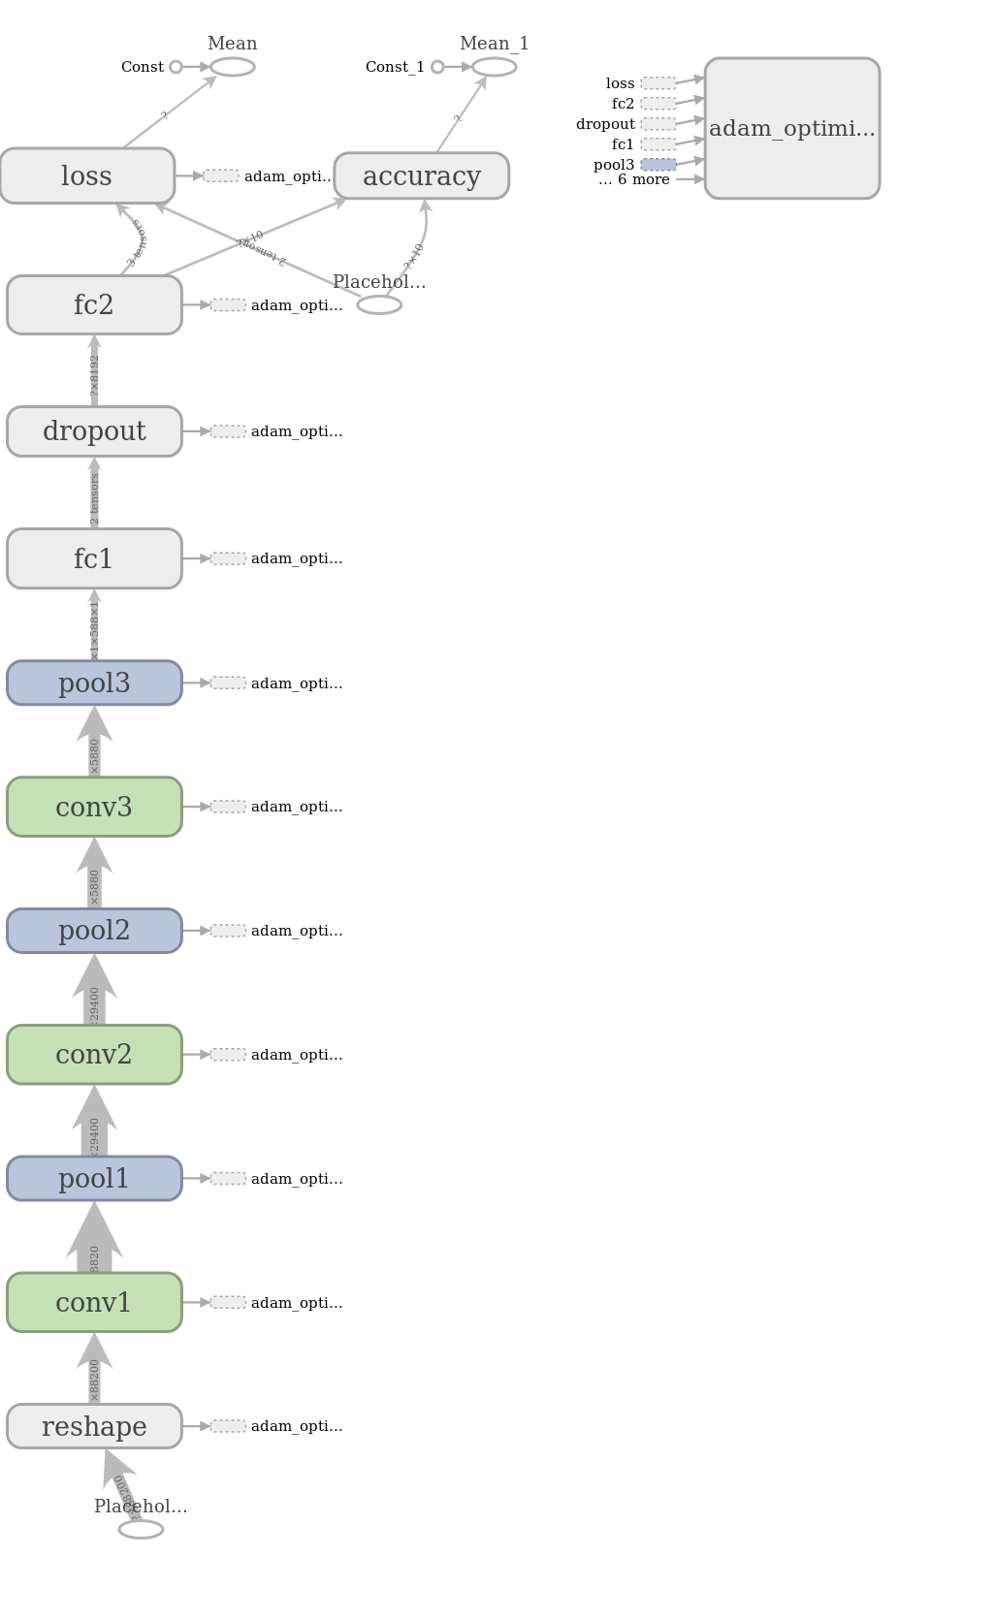Illustration 2: LeNET Arcihtecture

4.2 AlexNET
A variation of the original AlexNET is used. The graph of the architecture is as follows :
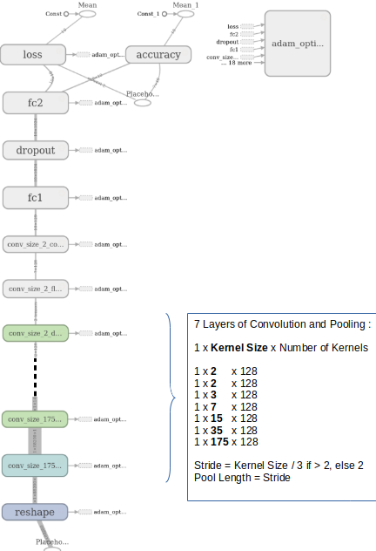Illustration 3: AlexNET Architecture

4.3 VGG
A variation of the original VGG is used. The graph of the architecture is as follows :
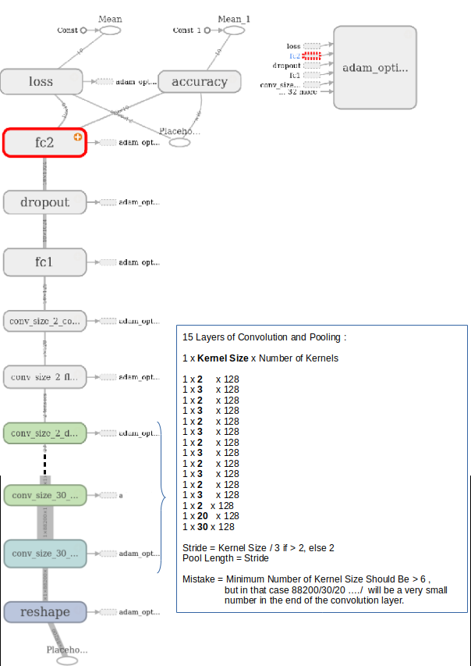Illustration 4: VGG Architecture

4.4 Experimental (Twin, Siamese)
A variation of the original VGG is used. Twin vgg architecture is used , the graph of the architecture is shown below :
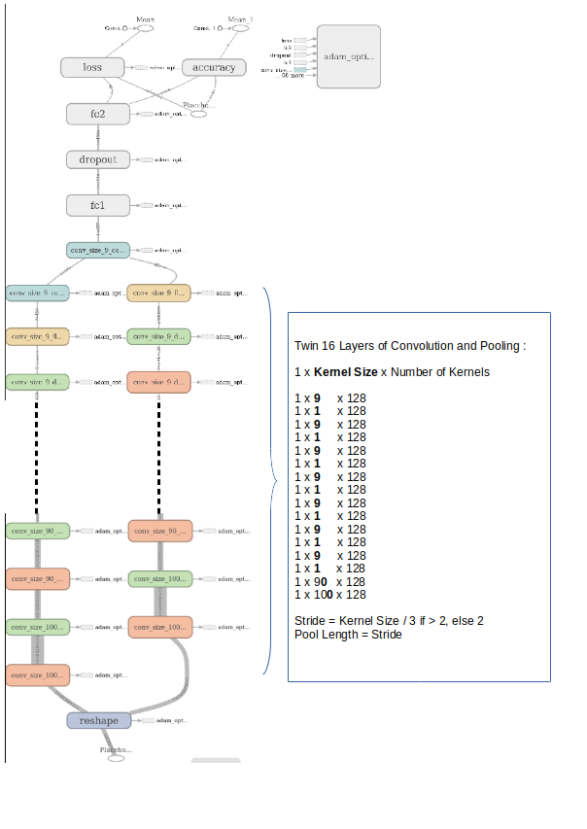Illustration 5: Experimental Twin/Siamese Achitecture

5. Architecture Construction
The architecture is constructed automatically by looping over the “PARALLEL_CONVOLUTION_KERNELS_SIZES” matrix. Each row of this matrix is an array of “kernel size”.

The alexnet architecture is constructed using the matrix
PARALLEL_CONVOLUTION_KERNELS_SIZES=np.array([ [7*5*5,7*5,5*3,7,5,3,2,2] ])

TheVGG architecture is constructed using the matrix
PARALLEL_CONVOLUTION_KERNELS_SIZES=np.array([ [100,90,1,9,1,9,1,9,1,9,1,9,1,9,1,9] ])

The Twin VGG architecture is constructed using the matrix
PARALLEL_CONVOLUTION_KERNELS_SIZES=np.array([ [100,90,1,9,1,9,1,9,1,9,1,9,1,9,1,9]
, [100,90,1,9,1,9,1,9,1,9,1,9,1,9,1,9] ])

6. Hyper Parameters
Hyper parameters are as follows :
- “Learning rate” used in adam optimizer
- “Training Epochs” .
- “Number of Fully Connected Neurons”
- “Mini Batch Size”
- Architecture
  - Number of convolution layers
  - Kernel sizes in each layer.
- “Dropout percentage”

7. Summary Results

Architectures | Learning Rate | Epochs | Fully  Connected  Neurons | Batch  Size | No. of Kernels | Dropout  Probability | Best  Accuracy
LeNET | 1e-5 | 50 | 8192 | 5 | 128 | 0.5 | 0.40
AlexNET | 1e-5 | 35 | 1024 | 5 | 128 | 0.5 | 0.67
VGG | 1e-5 | 60 | 1024 | 1 | 128 | 0.5 | 0.62
Twin VGG | 1e-5 | 60 | 1024 | 1 | 128 | 0.5 | 0.60

Table of Summary Results

8. Conclusion
4 different architectures are experimented using several different hyper parameters. Only the best resulting hyper parameters are given in the “Table of Summary Results”. Normally it is expected to have better results for deeper networks (VGG). But , by using kernel sizes smaller than stride/pooling , (e.g kernel size =1) we missed some features. That should be the reason that we made worse results with VGG than AlexNET. Data augmentation were used in the early experiments but we did not see any increase in the accuracy , so we did not use augmented data any more. Also in the paper [9] , they say that sound data augmentation techniques (stretching, pitch change , …) did not enhance the accuracy for all classes.

The best result we get is 67% accuracy with 7 layer AlexNET. In the paper referenced as [5], they achieved %73 accuracy with CNN by using long kernel sizes (in 2015). So the key point may be using long kernel sizes.Also in the paper refenrenced as [4], they achieved %68 accuracy with 11 layer CNN.

9. Future Work

Following experiments will be made to see if the accuracy will increase :
- Normalizing the data using MAX and MIN of all the data. (We used only within the same sound record)
- MFCC image will be fed to the CNN.
- Implementing an LSTM model to predict class.
- Using RBM as the fully connected layer of the CNN networks.

10. References

[1]https://serv.cusp.nyu.edu/projects/urbansounddataset/urbansound8k.html
[2]https://aqibsaeed.github.io/2016-09-03-urban-sound-classification-part-1/
[3]https://www.tensorflow.org/
[4] https://arxiv.org/pdf/1610.00087.pdf Very Deep Convolutional Neural Networks for Raw Waveforms
[5] http://karol.piczak.com/papers/Piczak2015-ESC-ConvNet.pdf ENVIRONMENTAL SOUND CLASSIFICATION WITH CONVOLUTIONAL NEURAL NETWORKS
[6] https://arxiv.org/pdf/1702.06286.pdf Convolutional Recurrent Neural Networks for Polyphonic Sound Event Detection
[7] http://cs231n.stanford.edu/slides/2017/cs231n_2017_lecture9.pdf
[8] http://datascienceassn.org/sites/default/files/Do%20Deep%20Nets%20Really%20Need%20to%20be%20Deep.pdf
[9[ https://arxiv.org/pdf/1608.04363.pdf

11. Appendix : Code URL
https://github.com/mehmetpekmezci/urban_sound_classification_using_raw_cnn

