URBAN SOUND CLASSIFICATION

WITH

ENSEMBLE OF SVMs

Mehmet Pekmezci

Gebze Technical University

02.04.2017

1. Problem Description
Classification of urban sound according to it's source type ( car, dog, human, …) will be studied in this project.
A 8KHz sampled dataset will be used as the training data. This data can be found at https://serv.cusp.nyu.edu/projects/urbansounddataset/.

Dataset properties are :
- 8732 WAV files, each containing 4 seconds of urban sounds.
- All the data is labeled. The labels are in their file names.
- The WAV files are labeled in 10 categories (air_conditioner, car_horn, children_playing, dog_bark, drilling,engine_idling, gun_shot, jackhammer, siren , street_music) and each category has approximately the same amount of sample WAV files.
- The dataset is already split into 10 folds containing the WAV files for each category. (being ready for 10 fold cross validation).

Steps of sound classification process :
- Analog to digital conversion (WAV files are digital already and contains “PCM data” which is “amplitudes of sound at constant time intervals” )
- Feature Extraction (MFCC)
- Training machine learning algorithm using extracted features and data.
- Cross validating machine learning algorithm.

As performance report , ROC curves , Confusion Matrices and Execution Times will be given.

Before starting classification process, some physical insight of the sound wave is given to understand the nature of the problem.

2. Physical Properties Of Sound
Sound waves are longitudinal mechanical waves (molecules vibrate parallel to the direction of the wave).

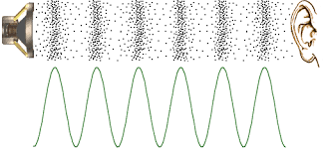Illustration 1: Sound Waves[1]

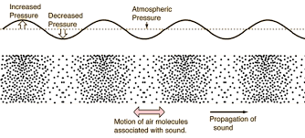Illustration 2: Sound Waves [2]

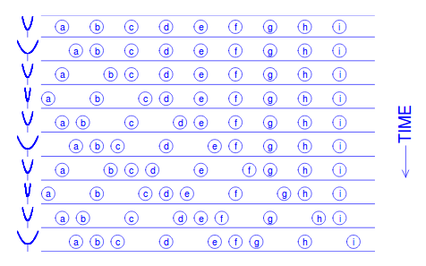Illustration 3: Sound Wave Molecule Movements In Time [4]

The equation of the sound wave is derived from the pressure propagation equation.

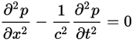Equation 1: Pressure Propagation [16]

The pressure propagation equation is derived using :

- P.V = n.R.T
- F = Mass . Acceleration
- F = Pressure . Area

Solution of the pressure propagation equation gives us sound wave equation.

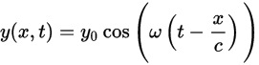Equation 2: Sound Wave [15]

- y is the displacement of the point on the traveling sound wave;
- x is the distance the point has traveled from the wave's source;
- t is the time elapsed;
- y₀ is the amplitude of the oscillations,
- c is the speed of the wave; and
- ω is the angular frequency of the wave.

Ordinary frequency is given by :

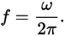Equation 3: Frequency

So sound wave is characterized by its amplitude ( y₀ ) and frequency ( f ).

3. Analog to Digital Conversion
Analog to digital converter (ADC) converts analog signals to digital signals by applying sampling techniques.

Sampling techniques receives the analog sound data and applies the following steps :
- Determine a time interval T to take a snapshot from analog data.
- Take the sample in each interval T

Frequency of Sampling = Sampling Rate =

Determining sampling interval ( frequency or sampling rate) is made according to Nyquist–Shannon sampling theorem. This theorem says that sampling rate should be twice the highest frequency contained in the signal [26].

The dataset used in this project contains 8KHz sampling rate with 16 bits per sample ( 8000 samples per second).

Analog to digital conversion process is realized by the electronic circuits :
- Analog sound data is generated by any sound source
- Microphone captures analog sound data
- Electronic circuit for ADC in the sound card converts analog data to digitized data (PCM). Data that is captured is amplitude values for each sample.
- Sound card driver delivers the digitized data to recording program
- Recording program encodes digitized data into WAV file.
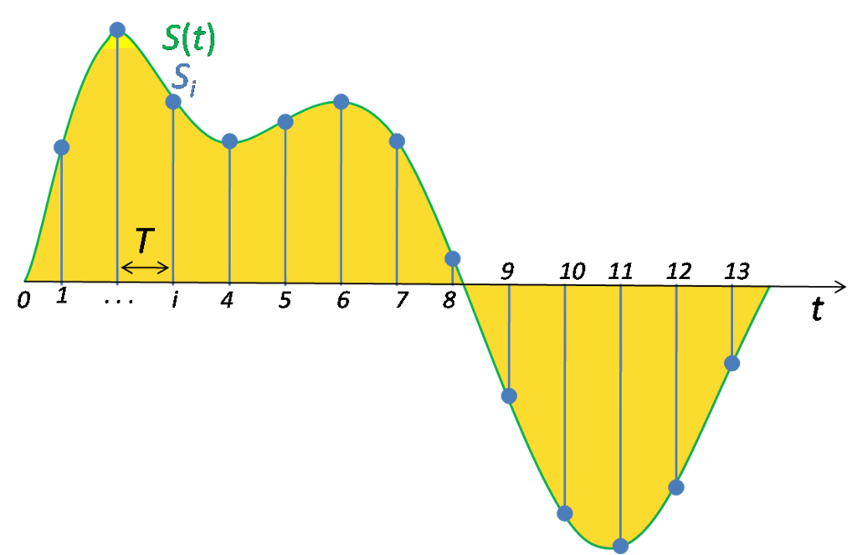Illustration 4: Sampling [25]

Pulse-code modulation (PCM) is a method used to digitally represent sampled analog signals. It is the standard form of digital audio in computers, compact discs, digital telephony and other digital audio applications. In a PCM stream, the amplitude of the analog signal is sampled regularly at uniform intervals, and each sample is quantized to the nearest value within a range of digital steps. [28]

Linear pulse-code modulation (LPCM) is a specific type of PCM where the quantization levels are linearly uniform.

A PCM stream has two basic properties that determine the stream's fidelity to the original analog signal: the sampling rate, which is the number of times per second that samples are taken; and the bit depth, which determines the number of possible digital values that can be used to represent each sample.

The most common WAV audio format is uncompressed audio in the linear pulse code modulation (LPCM) format. The PCM data in the WAV is used by feature extraction algorithms to obtain main features, which is next step.

4. Feature Extraction
Analog to digital converters provides us PCM data that can be represented as discrete data points.
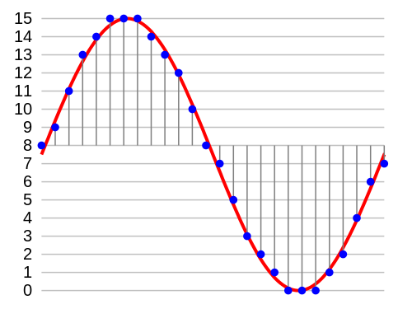Illustration 5: PCM Data Points [32]
After obtaining sound data, meaningful features should be extracted to be able to reach high accuracy rates of classification.
There are several methods for feature extraction from the PCM data :
- Fourier Based Methods ( FFT is used within the algorithm) :
  - Relative Spectra Filtering of log domain coefficients (Rasta-PLP)
  - Predictive Cepstral Coefficients (LPCC)
  - Mel-Frequency Cepstral Coefficients (MFCC)
- Wavelet Based Methods ( Wavelet Transformation is used within the algorithm) :
  - Haar Wavelets
  - Discrete Wavelet Transform (DWT)
  - Scattering Transform [22]
Today mostly MFCC , DWT and Scattering Transform methods are used. We will study MFCC method in this project.

4.1 Fundamental Concepts
Before starting to explain “Mel-Frequency Cepstral Coefficients” method , it will be useful to explain fundamental concepts :
- Mel-Scale
- Fourier Series
- Fourier Transform
- Discrete Fourier Transform
- Fast Fourier Transform
- Discrete Cosine Transform
- Power Spectrum
- Cepstrum
- Relation between Data (amplitude-time) , Spectrum (amplitude-frequency) and Spectrogram (amplitude-frequency-time)
- Building Mel Filter Bank

4.1.1 Mel-Scale
The name Mel comes from the word melody to indicate that the scale is based on pitch (frequency of sound) comparisons. The mel scale, named by Stevens, Volkmann, and Newman in 1937 , is a perceptual scale of pitches judged by listeners to be equal in distance from one another. The reference point between this scale and normal frequency measurement is defined by assigning a perceptual pitch of 1000 mels to a 1000 Hz tone, 40 dB above the listener's threshold. Above about 500 Hz, increasingly large intervals are judged by listeners to produce equal pitch increments. As a result, four octaves on the hertz scale above 500 Hz are judged to comprise about two octaves on the mel scale. [37]
Formula to convert f hertz into m mels is:
[37]
Equation 4: Mel Scale - Frequency
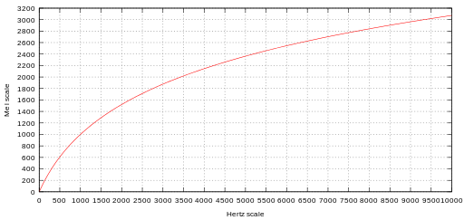Illustration 6: Plots of pitch mel scale versus Hertz scale [37]

4.1.2 Fourier Series
In mathematics, a Fourier series is a way to represent a function as the sum of simple sine waves. More formally, it decomposes any periodic function or periodic signal into the sum of a (possibly infinite) set of simple oscillating functions, namely sines and cosines (or, equivalently, complex exponentials) [38]

Fourier Series of a function f(x) is given by :

[39]

where
[39]
[39]
[39]

Complex Fourier series are obtained by replacing cos and sin with their Euler complex representations .

Euler formula :
[39]
[39]
[39]

Complex Fourier Series :
[39]
[39]

For a function periodic in [ -L/2,L/2] , these become
[39]
[39]

4.1.3 Fourier Transform
The Fourier transform is a generalization of the complex Fourier series in the limit
Replace the discrete with continuous F(k) dk while letting . Then change the sum to an integral, and the equations become :
(Inverse Fourier Transform, +i) [40]
(Fourier Transform, -i) [40]
Fourier Transform of function f to F may be visualized as follows : [41]

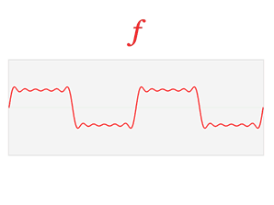Illustration 7: Function f [41]

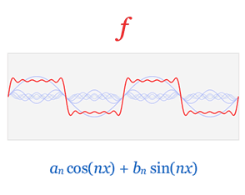Illustration 8: Representation of f as Fourier series [41]

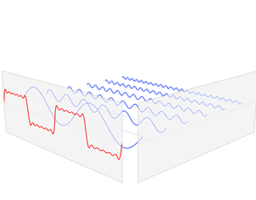Illustration 9: Decomposition of f [41]

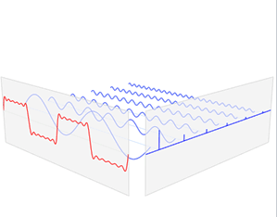Illustration 10: Finding Maximum Amplitudes In Each Frequency [41]

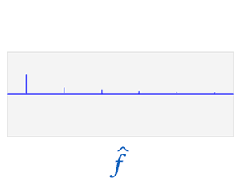Illustration 11: Frequency Domain Representation (Spectrum) of f [41]

4.1.4 Discrete Fourier Transform
The Discrete Fourier Transform (DFT) is the equivalent of the continuous Fourier Transform for signals known only at N instants separated by sample times T ( finite sequence of data). [42]
Fourier Transform formula was :
(Inverse Fourier Transform, +i) [40]
(Fourier Transform, -i) [40]
If we replace continuous variable t with discrete variable t_{n} (), Discrete Fourier Transform is :
(Inverse Discrete Fourier Transform, +i) [40]
(Discrete Fourier Transform, -i) [40]

For Fourier Transformation relationships please refer to https://web.eecs.umich.edu/~fessler/course/451/l/pdf/c5.pdf

4.1.5 Fast Fourier Transform Algorithm
A fast Fourier transform (FFT) algorithm computes the discrete Fourier transform (DFT) of a sequence, or its inverse. It manages to reduce the complexity of computing the DFT from , which arises if one simply applies the definition of DFT, to where n is the data size. This algorithm is invented in 1965 by Cooley and Tukey. [43]
This is a divide and conquer algorithm that divides the DFT into two pieces of size N/2 at each step. (Even-Odd index number separation)

4.1.6 Discrete Cosine Transform
The DCT is exactly equivalent (up to an overall scale factor of 2), to a DFT of 2N−2 real numbers with even symmetry. For example, a DCT of N=5 real numbers abcde is exactly equivalent to a DFT of eight real numbers abcdedcb (even symmetry), divided by two. Like any Fourier-related transform, discrete cosine transforms (DCTs) express a function or a signal in terms of a sum of sinusoids with different frequencies and amplitudes. Like the discrete Fourier transform (DFT), a DCT operates on a function at a finite number of discrete data points. The obvious distinction between a DCT and a DFT is that the former uses only cosine functions, while the latter uses both cosines and sines (in the form of complex exponentials). However, this visible difference is merely a consequence of a deeper distinction: a DCT implies different boundary conditions from the DFT or other related transforms. [44]
The DCT, is often used in signal and image processing, especially for lossy compression (JPEG)

4.1.7 Power Spectrum
The power spectrum answers the question “How much of the signal is at a frequency "w" ? [45]
For a given signal, the power spectrum gives a plot of the portion of a signal's power (energy per unit time) falling within given frequency bins. The most common way of generating a power spectrum is by using a discrete Fourier transform, but other techniques such as the maximum entropy method can also be used. [46]

4.1.8 Cepstrum
The cepstrum can be seen as information about rate of change in the different spectrum bands. It was originally invented for characterizing the seismic echoes resulting from earthquakes and bomb explosions.
Very loosely speaking the cepstrum is an "FFT of an FFT". [47]

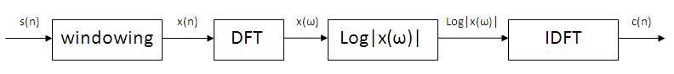Illustration 12: Block Diagram Representing Computaion Of Cepstrum [48]
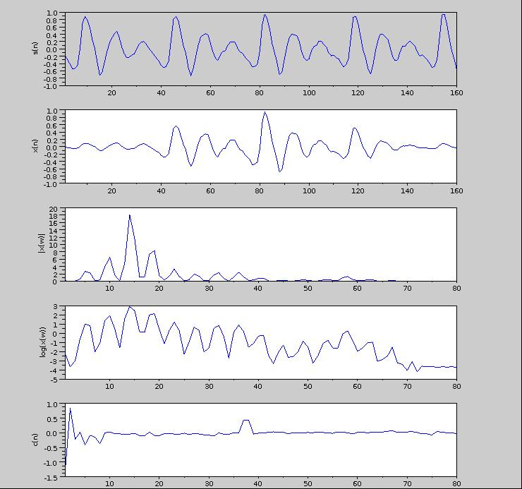Illustration 13: 20 ms voiced speech segment and its cepstrum [48]

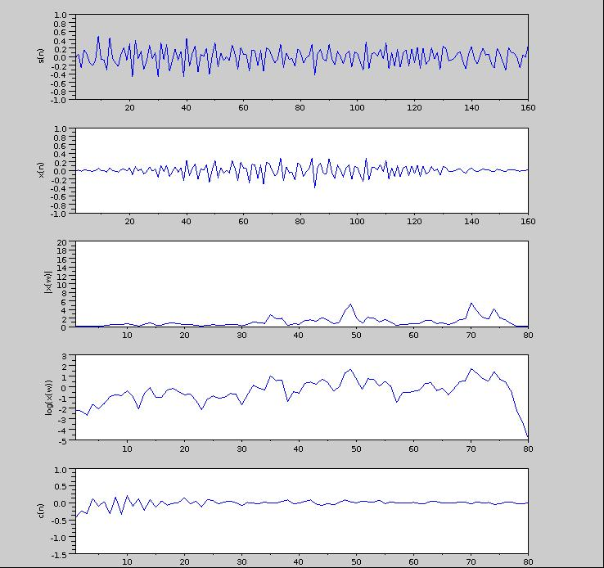Illustration 14: 20 ms unvoiced speech segment and its cepstrum [48]

4.1.9 Relation between Data (amplitude-time) , Spectrum (amplitude-frequency) and Spectrogram (amplitude-frequency-time)
The graph of data it self (discrete time series graph) is a digital representation of the analog data. Spectrum (amplitude-frequency) is obtained by applying FFT.
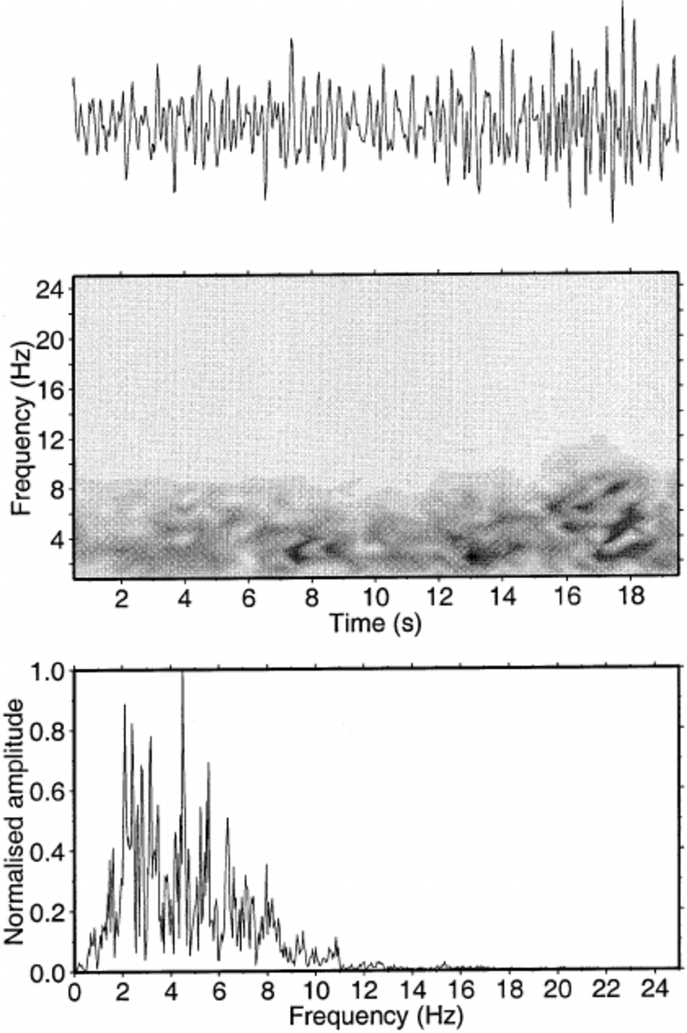Illustration 15: Sound Data - Spectrogram - Spectrum [49]
Steps to obtain Spectrogram [31]:
- Windowing : Cut the sound data into time slices, apply FFT on each slice of data.

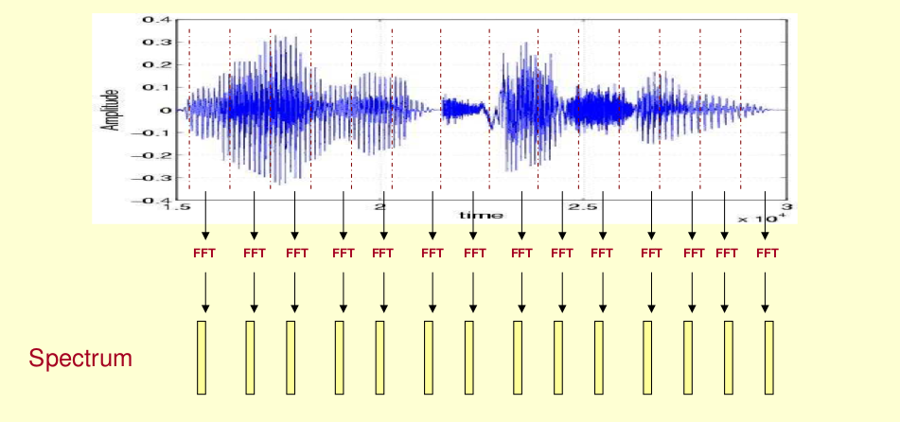Illustration 16: Sound Data Slices [31]

- Apply FFT on each slice (this gives us Amplitude-Frequency graph for each slice)
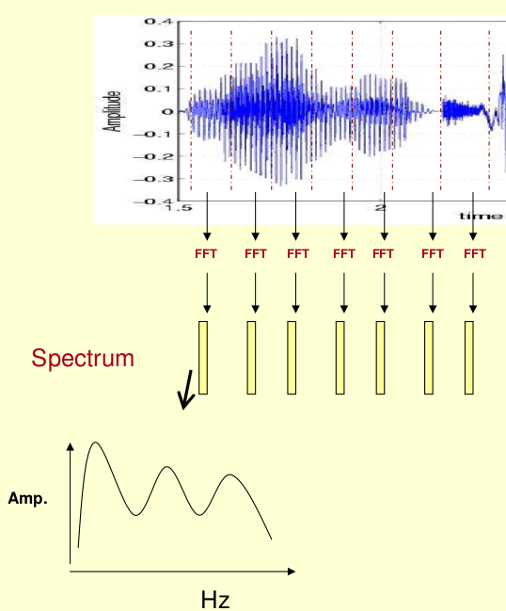Illustration 17: Sound Data Slices FFT [31]
- Rotate the spectrum graph 90 degrees
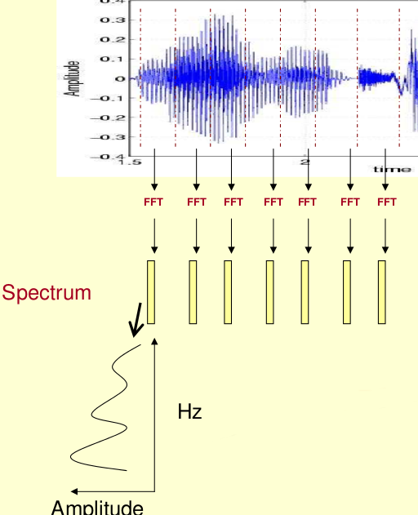Illustration 18: Sound Data Slices FFT Rotate Graph [31]

- Represent each spectrum graphic as gray-scale vector ( maximum point is black (0), minimum point is white(255), and scale the graph accordingly).
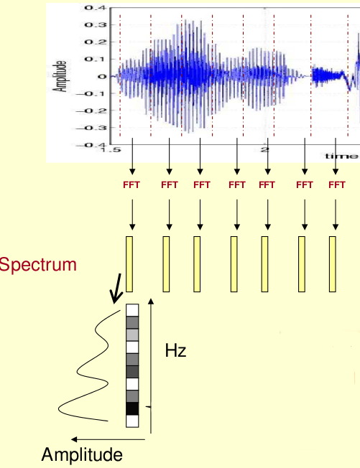Illustration 19: Sound Data Slices FFT Rotated Graph Scale [31]

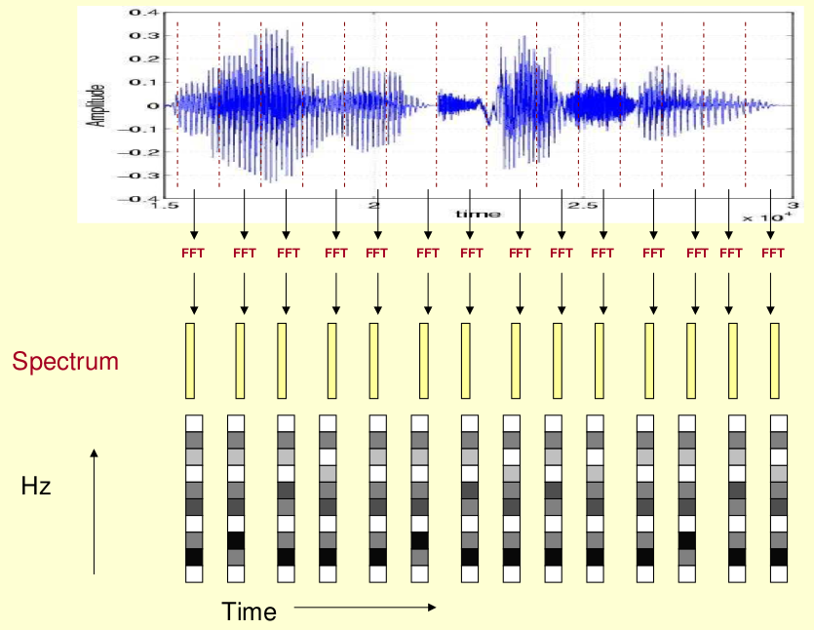Illustration 20: Sound All Data Slices FFT Rotated Graph Scales [31]
This gray-scale representation allows us to see (time – frequency - amlpitude) ( 3 dimensional) at the same time. This representation is called spectrogram. Sound properties are better observed in spectograms.
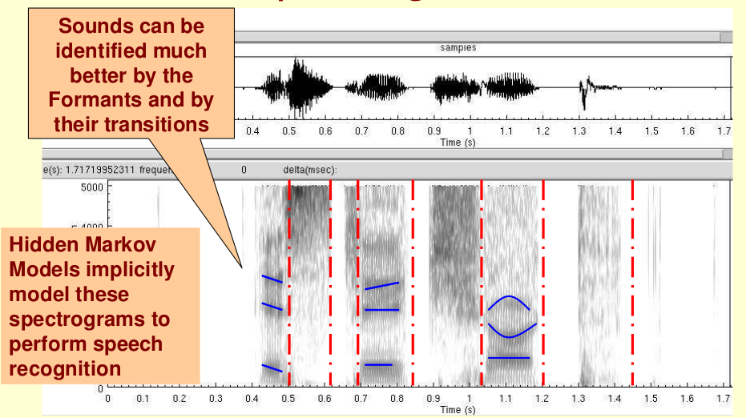Illustration 21: Spectrogram [31]

4.1.10 Building Mel Filter Bank
In this section the example will use 10 filter banks because it is easier to display, in reality you would use 26-40 filter banks.
Mel filter bank building steps are :
- Choose a lower and upper frequency ( generally 300Hz – 8000Hz is chosen for sound data)
- Using equation 4 (section 4.1.1) convert the upper and lower frequencies to Mels. In our case 300Hz is 401.25 Mels and 8000Hz is 2834.99 Mels.
- For this example we will do 10 filterbanks, for which we need 12 points. This means we need 10 additional points spaced linearly between 401.25 and 2834.99. This comes out to:
m(i) = 401.25, 622.50, 843.75, 1065.00, 1286.25, 1507.50, 1728.74,
1949.99, 2171.24, 2392.49, 2613.74, 2834.99

- Now use equation 4's inverse to convert these back to Hertz:

h(i) = 300, 517.33, 781.90, 1103.97, 1496.04, 1973.32, 2554.33,
3261.62, 4122.63, 5170.76, 6446.70, 8000

- We don't have the frequency resolution required to put filters at the exact points calculated above, so we need to round those frequencies to the nearest FFT bin. This process does not affect the accuracy of the features. To convert the frequncies to fft bin numbers we need to know the FFT size and the sample rate,

f(i) = floor((nfft+1)*h(i)/samplerate)

This results in the following sequence:

f(i) = 9, 16, 25, 35, 47, 63, 81, 104, 132, 165, 206, 256

We can see that the final filterbank finishes at bin 256, which corresponds to 8kHz with a 512 point FFT size.

- Now we create our filterbanks. The first filterbank will start at the first point, reach its peak at the second point, then return to zero at the 3rd point. The second filterbank will start at the 2nd point, reach its max at the 3rd, then be zero at the 4th etc. A formula for calculating these is as follows:

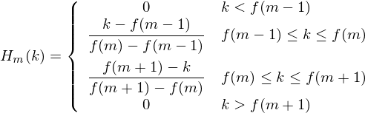Equation 5: Filter Banks[36]
where M is the number of filters we want, and f() is the list of M+2 Mel-spaced frequencies.

The final plot of all 10 filters overlaid on each other is:

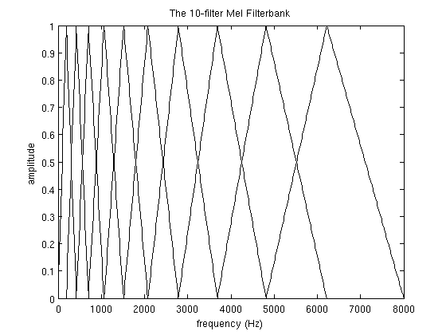Illustration 22: Distribution of Mel Scale Filter Bank [53]

4.2 Mel-Frequency Cepstral Coefficients (MFCC)
The main point to understand about speech is that the sounds generated by a human are filtered by the shape of the vocal tract including tongue, teeth etc. This shape determines what sound comes out. If we can determine the shape accurately, this should give us an accurate representation of the phoneme being produced. The shape of the vocal tract manifests itself in the envelope of the short time power spectrum, and the job of MFCC is to accurately represent this envelope. MFCC was introduced by Davis and Mermelstein in the 1980's . [36]

MFCC steps are as follows :
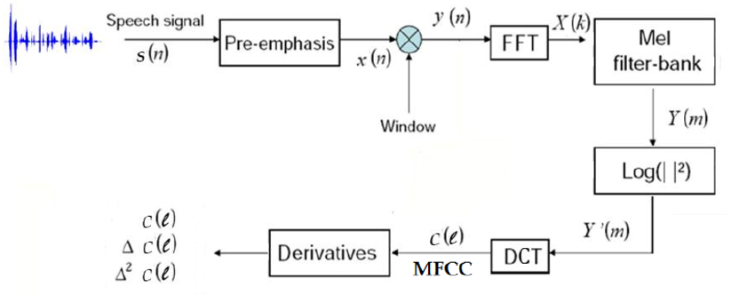Illustration 23: MFCC Diagram [53]
Illustration 24: MFCC Block Diagram [34]

4.2.1 Pre-Emphasis
In order to flatten speech spectrum, a pre-emphasis filter is used before spectral
analysis. It's aim is to compensate the high-frequency part of the speech signal that was
suppressed during the human sound production mechanism. Pre-Emphasis is a first order high-pass filter[51]

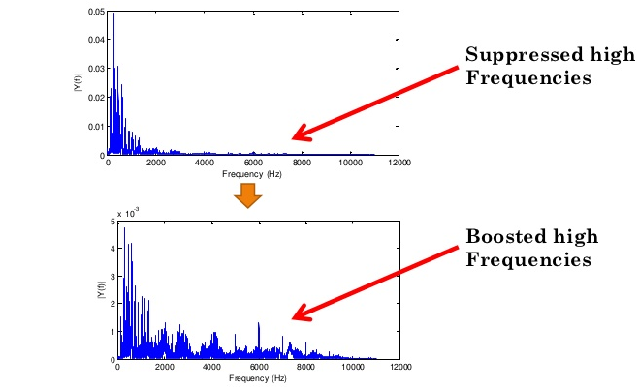Illustration 25: Pre-emphasis [52]

4.2.2 Framing
In a signal identification system, the modulated signal is partitioned into short-time segments called frames. To make the frame parameters vary smoothly, there is normally a 50% overlap between each two adjacent frames. [50]
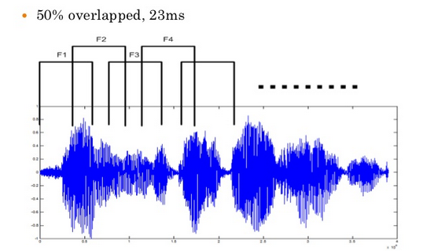Illustration 26: Framing [52]
Selecting the frame length should be done carefully to increase the accuracy of the recognizer. Usually most of the audio algorithms run efficiently with larger analysis frames. In telephony and similar applications the latency is a critical problem. Therefore, there is a natural tendency of using larger analysis frames. On the other hand, after Discrete Fourier Transform (DFT) is performed the pattern of a characteristic may hide in the case of the characteristics of a signal change during the analysis frame. Therefore, two factors should be considered when choosing the most suitable frame length, namely signal stationarity and time-frequency resolution. Speech signals do not remain stationary for a long time. But the theory behind the Fast Fourier Transform (FFT) calculation assumes that the frequency components are unchanged across the analysis frame. Also any deviation from the assumption may lead to an inaccurate determination of the frequency domain components. This shows the importance of ensuring that the signal is stationary across the period of the analysis frame. In this way the analysis frames are necessary to be small enough to capture the rapidly changing details. Accordingly speech signals can be assumed to be stationary over a period of 20-30 ms [53]

4.2.3 Windowing
Windowing is performed on each frame with one of the popular signal processing windows like the Hamming window. Windowing is often applied to increase the continuity between adjacent frames and smooth out the end points such that abrupt changes between ends of successive frames are minimized. [50]

The shape of the Hamming window is similar to that of a cosine wave. The following equation defines the window:

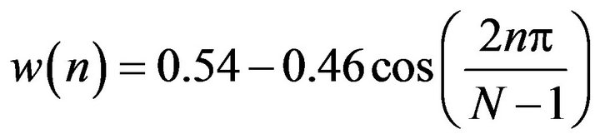

[50]
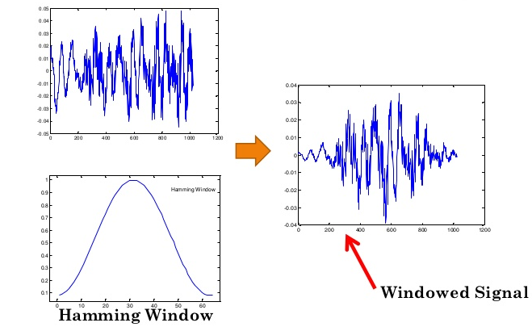Illustration 27: Windowing [52]

4.2.4 Fast Fourier Transformation
Each frame of data is processed with FFT algorithm to obtain frequency-amplitude graphs . Obtaining frequency graph from wave graph is also called “passing from time domain to frequency domain”. Fast Fourier Transformation is a fast implementation of Discrete Fourier Transform which is described in 4.1.2 – 4.1.5 .

DFT may be explained using following equation :
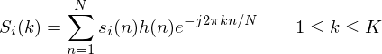Illustration 28: Frequency Series [36]

i | Frame Number
n | Sample Number in frame. For 16kHz data, if the frame length is 25 ms, N=16000x0.025=400
K | Length of the DFT
s_{i}(n) | time domain signal for the frame i
S_{i}(k) | frequency domain signal for the frame i
h(n) | Hamming Window

Illustration 29: FFT Graph [31]

For each S_{i}(k) , mel filter bank process will be applied.

4.2.5 Mel Filter Bank
The frequency range in the FFT spectrum is very wide and so much data to process, thus the magnitude spectrum was passed through a mel filter bank as shown in Illustration 29 and 31 , which is equivalent to multiplying each Fourier transform magnitude coefficient by the corresponding filter value. Building the mel filter bank is explained in section 4.1.10.

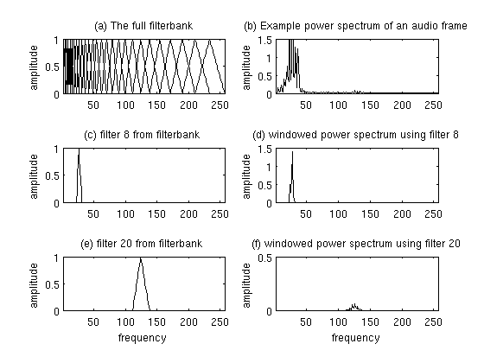Illustration 30: Mel Filter Bank Example [36]
Normally a filter bank is uniform :
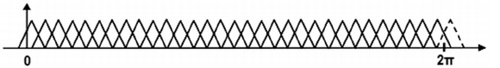Illustration 31: Uniform Filter Bank [54]
But as we are analyzing mel frequencies (section 4.1.1 and 4.1.10) , filter bank becomes :
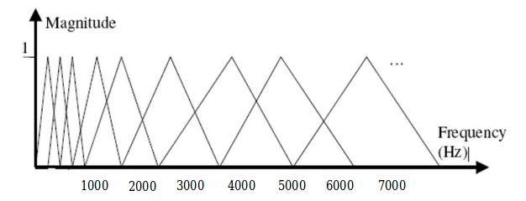Illustration 32: Distribution of Mel Scale Filter Bank [53]
This filter bank is applied to each frame's FFT :

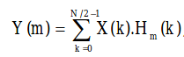Illustration 33: Mel Filter Bank Application [53]

X(k) is FFT(Window(frame)), H_{m}(k) is the m^{th} filter from the filter bank, Y(m) is the sum of X(k)'s filtered spectral components as shown in illustration 34.

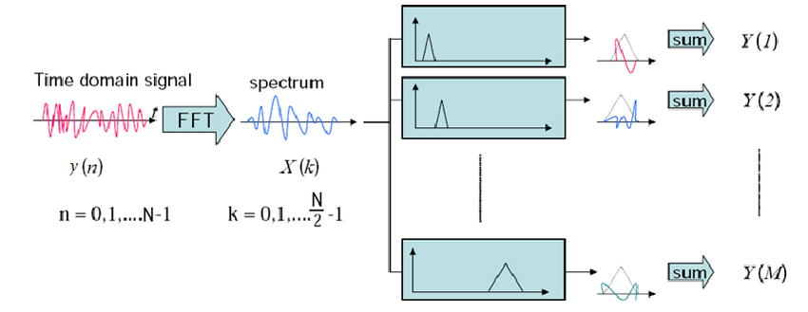Illustration 34: Mel Filter Bank Processing [53]
The logarithm of the square magnitude of the output of Mel-filter bank is then taken with the purpose of compressing dynamic range of values. Square of absolute values of Y(m) is called “Energy” . Y'(m) is called log energy / log power spectrum.

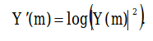Equation 6 : Logarithm of the square magnitude of the output [53]
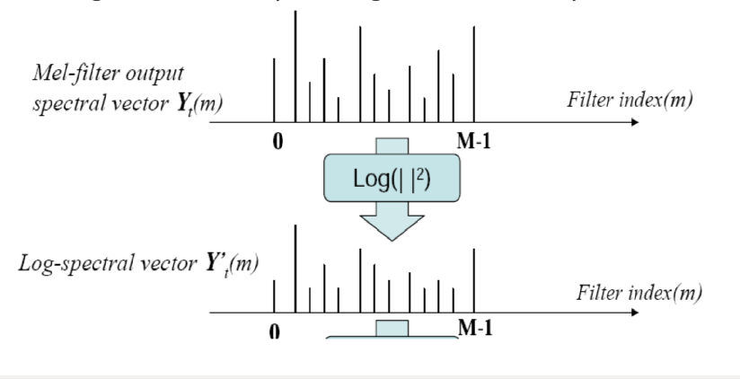Illustration 35: Log Spectral Vector [55]

4.2.6 Discrete Cosine Transformation
Finally, it needs conversion from frequency domain back to time domain. The Inverse DFT converts the frequency domain signal into time domain. Since the log power spectrum is real and symmetric, inverse DFT reduces to a Discrete Cosine Transform (DCT). Therefore, DCT was computed to
convert the log energies to cepstral coefficients. Spectral transitions play an important role in human speech perception.
The cepstrum of a signal x(t) is just:

C(z)=F⁻¹(log(|F(x(t))|²) [55]
F⁻¹ is reverse Fourier Transform, Since the log power spectrum is real and symmetric, inverse DFT reduces to a Discrete Cosine Transform. DCT is computed and MFC Coefficients are obtained as follows :
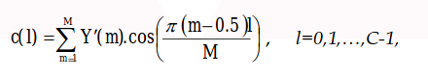Illustration 36: Cepstral Coefficients [53]

Here M is number of filter banks, C number of cepstral coefficients desired. c(l) is the l^{th} MFCC for a specific frame.

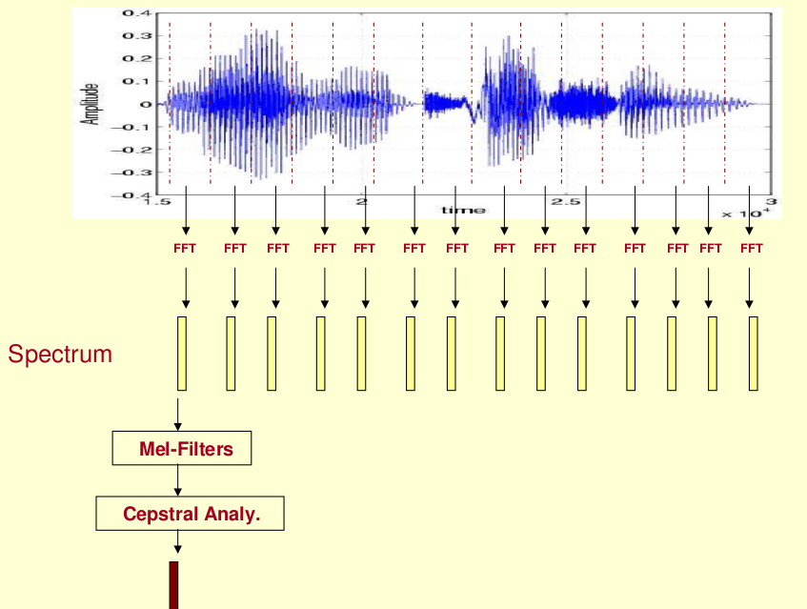Illustration 37: Cepstral Analysis [31]

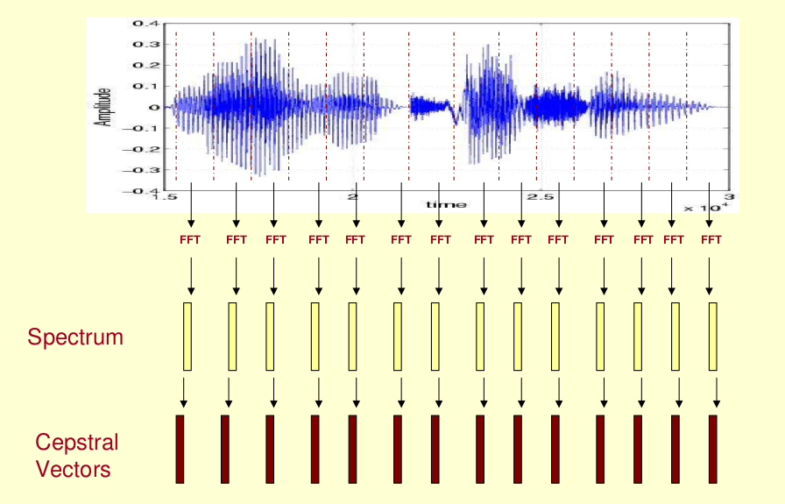Illustration 38: Cepstral Vectors [31]

Illustration 39: Spectrogram (Cepstral Vectors) [31]

4.2.7 Derivatives

During speech production the articulators change their positions continuously and this information might be useful for speech processing. A representation better showing the dynamic behavior of speech can be obtained by extending the analysis to include the temporal derivatives of the parameters among neighbouring frames. This dynamic information was estimated by delta features as follows :

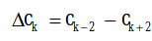Illustration 40: Delta Cepstral Coeficients [53]

where ck is the vector of Cepstral coefficients at frame k. Replacing ck by ∆ck in the above equation the second order derivatives can be obtained, which are called delta-delta or acceleration coefficients.

4.2.8 Output Parameters
Depending on the following parameters for feature extraction (MFCC), we would have different coefficients , which will be used as input feature values in classification algorithm.
These parameters would probably affect classification accuracy.

- Frame length ( generally 25 milliseconds)
- Frame shift ( generally 10 milliseconds)
- FFT size (512, 1024 or 2048)
- Pre-emphasis coefficient ( generally between 0.9 and 1)
- Number of filter banks ( generally 24-30)
- Number of MFC coefficients (generally 12-20) (For each coefficient we will have 1 energy feature, 12 delta MFCC features (first derivative), 12 double-delta MFCC features (second derivative), 1 delta energy feature, 1 double-delta energy feature.

5 Classification
Extracted feature values will be used in the classification algorithm. The data is labeled. We will use Bag of SVMs for classification. Each extracted MFCC feature is trained and validated by single SVM classifier, then the results are joined using majority voting.
For 10 classes of sounds the following results are obtained :

5.1 For 10 MFCC coefficients
Confusion Matrix :

ROC Curve :
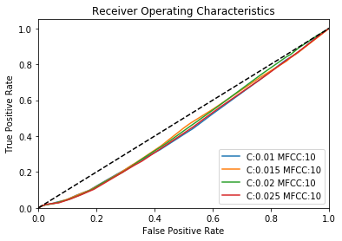

5.2 For 20 MFCC coefficients

Confusion Matrix :

ROC Curve :

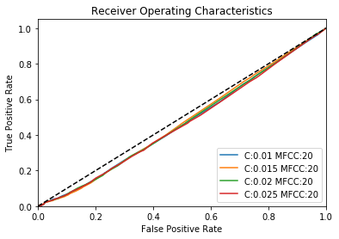
5.3 For 30 MFCC coefficients
Confusion Matrix :

ROC Curve :
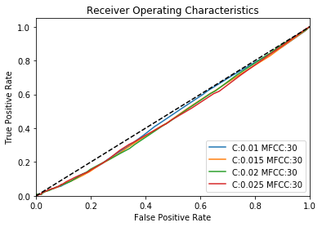

5.4 For 40 MFCC coefficients
Confusion Matrix :

ROC Curve :

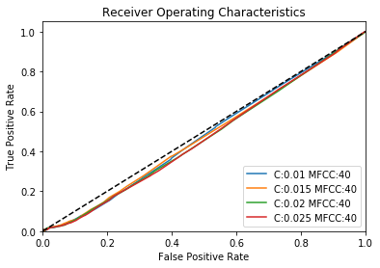

5.5 Execution Times
Execution times (both for training and testing) for each magnitude of coefficients are as follows :

Number of coefficients | Execution time
10 | 691
20 | 1304
30 | 1943
40 | 2552

6 Implementation
The algorithm is implemented using the following libraries of python :
- librosa : Sound processing library to obtain MFCC features. This library calls following sub libraries while processing sound data:
  - aurioread library
  - wave library
- SKLearn SVM library, and OneVsRestClassifies library

7 Alternatives
Features may be extracted also suing discrete wavelet transform (DWT) techniques. The following paper also joins DWT and MFCC features and gives the features as input to SVM classifier :
http://www.irdindia.in/journal_ijacect/pdf/vol2_iss2/11.pdf

A new technique also used for feature extraction , which is a form of discrete wavelet transform , called scattering :
http://www.di.ens.fr/data/scattering/

As classification techniques, SVM, HMM, Neural Networks (mostly DeepNets) are used.

8 References

[1]http://www.mediacollege.com/audio/images/loudspeaker-waveform.gif
[2]http://hyperphysics.phy-astr.gsu.edu/hbase/Sound/imgsou/lwav2.gif
[3]http://eeweb.poly.edu/~yao/EE3414/signal_freq.pdf
[4]https://homepages.wmich.edu/~hillenbr/206/ac.pdf
[5]https://courses.physics.illinois.edu/phys406/Lab_Handouts/Time_Domain_vs_Frequency_Domain_Sound_Field_Measurements.pdf
[6]http://www.theparticle.com/cs/bc/mcs/signalnotes.pdf
[7]http://www.asel.udel.edu/speech/tutorials/acoustics/sound.html
[8]https://aqibsaeed.github.io/2016-09-03-urban-sound-classification-part-1/
[9]https://ccrma.stanford.edu/~jos/mdft/mdft.html
[10]http://www.halitalptekin.com/fourier-serileri.html
[11]https://en.wikipedia.org/wiki/Fourier_transform
[12]http://www.thefouriertransform.com/
[13]https://betterexplained.com/articles/an-interactive-guide-to-the-fourier-transform/
[14]Halliday, Resnick, Walker (2001) , Fundamentals of Physics
[15]https://en.wikipedia.org/wiki/Longitudinal_wave
[16]https://en.wikipedia.org/wiki/Acoustic_wave_equation
[17]http://freecomputerbooks.com/Introduction-to-Sound-Processing.html
[18]http://www.dspguide.com/pdfbook.htm
[19]http://mathworld.wolfram.com/Convolution.html
[20]https://en.wikipedia.org/wiki/Discrete_Fourier_transform
[21]http://kaldi-asr.org/doc/feat.html
[22]http://www.di.ens.fr/data/scattering/
[23]http://www.hardwaresecrets.com/how-analog-to-digital-converter-adc-works/2/
[24]http://whatis.techtarget.com/definition/analog-to-digital-conversion-ADC
[25]https://en.wikipedia.org/wiki/Sampling_(signal_processing)#/media/File:Signal_Sampling.png
[26]http://redwood.berkeley.edu/bruno/npb261/aliasing.pdf
[27]http://www.hardwaresecrets.com/how-analog-to-digital-converter-adc-works/2/
[28]https://en.wikipedia.org/wiki/Pulse-code_modulation
[29]https://en.wikipedia.org/wiki/WAV
[30] https://pdfs.semanticscholar.org/825f/9f5cab0f7e6a61fb0a5e6349c80daecb2cb4.pdf
[31] http://www.speech.cs.cmu.edu/15-492/slides/03_mfcc.pdf
[32] http://www.divilabs.com/2014/12/pulse-code-modulation-pcm-through-matlab.html
[33] http://mirlab.org/jang/books/audioSignalProcessing/speechFeatureMfcc.asp?title=12-2%20MFCC
[34]http://www.iosrjen.org/Papers/vol4_issue8%20(part-1)/D04812125.pdf
[35]http://repository.bilkent.edu.tr/bitstream/handle/11693/32215/gokmencantez.pdf?sequence=1
[36]http://practicalcryptography.com/miscellaneous/machine-learning/guide-mel-frequency-cepstral-coefficients-mfccs/
[37]https://en.wikipedia.org/wiki/Mel_scale
[38]https://en.wikipedia.org/wiki/Fourier_series
[39]http://mathworld.wolfram.com/FourierSeries.html
[40]http://mathworld.wolfram.com/FourierTransform.html
[41]https://en.wikipedia.org/wiki/Fourier_transform
[42]http://www.robots.ox.ac.uk/~sjrob/Teaching/SP/l7.pdf
[43]https://en.wikipedia.org/wiki/Fast_Fourier_transform
[44]https://en.wikipedia.org/wiki/Discrete_cosine_transform
[45]http://www.cmp.caltech.edu/~mcc/Chaos_Course/Lesson6/Power.pdf
[46]http://mathworld.wolfram.com/PowerSpectrum.html
[47]http://doc.sccode.org/Classes/Cepstrum.html
[48]http://iitg.vlab.co.in/?sub=59&brch=164&sim=615&cnt=1
[49]https://www.researchgate.net/figure/222412712_fig5_Fig-5-Velocity-waveform-spectrogram-and-amplitude-spectrum-of-20-s-of-inharmonic
[50]http://file.scirp.org/Html/4-6801198_34183.htm
[51]https://www.google.com.tr/url?sa=t&rct=j&q=&esrc=s&source=web&cd=5&ved=0ahUKEwjIxrqW2e_TAhXD1xoKHeCTB0AQFghJMAQ&url=https%3A%2F%2Fwww.researchgate.net%2Ffile.PostFileLoader.html%3Fid%3D575be5bb5b4952c0f73e5177%26assetKey%3DAS%253A371736848683010%25401465640379360&usg=AFQjCNGpbC7br_n1pfk6wPUGi7IvUjz9nQ&cad=rja
[52]https://www.slideshare.net/gtiwari/text-prompted-remote-speaker-authentication-joint-speech-and-speaker-recognitionverification-system-final-presentation-slide
[53]https://www.researchgate.net/publication/287982381_Speaker_Dependent_Speech_Recognition_on_a_Selected_Set_of_Sinhala_Words
[54]https://www.researchgate.net/publication/275650379_Multicarrier_waveforms_with_IQ_staggering_uniform_and_nonuniform_FBMC_formats
[55]https://www.ce.yildiz.edu.tr/personal/fkarabiber/file/5591/SpeechProc

[56]https://stats.stackexchange.com/questions/18891/bagging-boosting-and-stacking-in-machine-learning

