



Essay / Assignment Title: User Behavior Analysis for Optimizing Engagement on Social Media

Programme title: : Fundamentals of Data Analytics / MSc Data Analytics

Name: Mehmet Hüseyin Somuncu

Year: 2025 hmm

Statement of compliance with academic ethics and the avoidance of plagiarism

I honestly declare that this dissertation is entirely my own work and none of its part has been copied from printed or electronic sources, translated from foreign sources and reproduced from essays of other researchers or students. Wherever I have been based on ideas or other people texts I clearly declare it through the good use of references following academic ethics.
(In the case that is proved that part of the essay does not constitute an original work, but a copy of an already published essay or from another source, the student will be expelled permanently from the postgraduate program).

Name and Surname (Capital letters):Mehmet Hüseyin Somuncu

Date: 04/02/2025

Introduction
CONTENTS 4
INTRODUCTION 5
Data Collection and Preprocessing 6
1. Data Collection 6
2. Data Preprocessing 6
CLUSTERING ALGORITHMS AND MODEL EVALUATION 8
CONCLUDING REMARKS 10
Future Work 10
Final Thoughts 11
BIBLIOGRAPHY 12
APPENDIX (if necessary) 13

CONTENTS

This report, which you will read shortly, includes a study that helps us analyze the behavior of social media users and is carried out to optimize user tags. The report will continue as follows.

1. Introduction: It is an introductory section to analyze the behavior of social media users.
2. Chapter One: Data Collection and Preprocessing: The part where the analysis of user data is collected, this data is cleaned and corrected, excess data is removed and analyzed, that is, it is brought to a usable state is explained in detail.
3. Chapter Two: Clustering Algorithms and Model Evaluation: How clustering algorithms such as KMeans, which are used to group user data, are applied and the results obtained are explained in detail.
4. Concluding Remarks: The results of the study are summarized and the results obtained are discussed. In addition, suggestions are offered for future studies.
5. Bibliography: The sources in the study are according to the Harvard Reference Style.
6. Appendix: Additional information and graphics that are not explained or shown in the report are shown.

INTRODUCTION

Social media platforms, which are present in all of us during the day and even in our entire lives, the most popular of which are applications such as Instagram, Twitter, WhatsApp, and the content consumption and sharing of users using them have become a tool used. Due to this increase, platforms have become the aim of platforms to offer users special content and a personalized opportunity, and the necessary steps are not being taken for this.
This study was carried out to examine the behavior of users on social media platforms and to increase the level of content usage. The study examined how users spend time on the platform, what content they encounter, and how their behaviors can and should be optimized. It grouped users who consume similar content and evaluated whether these groups help the platform to offer customized content. To analyze and understand the behaviors of users and to produce solutions based on behaviors. It examined how users spend their time on the platform and what interactions they have and how these behaviors are optimized. For this purpose, user data has been collected, cleaned, and analyzed.
The primary purpose of the study is to understand user behaviors and increase interaction based on these behaviors. This report covers the steps of data collection, preprocessing, clustering algorithms, and model evaluation.

Data Collection and Preprocessing

Data Collection

Data Source: The dataset includes social media user behaviors from data obtained from Kaggle. This data consists of a dataset reflecting users' activities on the platform (number of likes, sharing frequency, time spent on the platform, etc.).
Data Types: The dataset includes user identification numbers (UserID), names, gender, date of birth, interests, city and country content.
Data Collection Challenges: During the data collection process, difficulties such as user specificity and data quality were encountered. In particular, it was determined that missing data and outliers affected the quality of the dataset.

2. Data Preprocessing

Filling in Missing Data: There were missing values ​​in the dataset. These missing values ​​were filled using the average or mode of the relevant columns. For example, the missing values ​​in the "Monthly_Activity" column were filled with the average of this column.
Data Normalization: The data was normalized so that it could be used more effectively in the analysis process. Normalization is especially important for improving the performance of clustering algorithms.
Age Calculation: Users’ ages were calculated using their birth dates (DOB) and added to the dataset as a new column. This facilitated the analysis of user behaviors by age groups.
Processing of Categorical Data: Categorical data such as gender and interests were converted into numerical values ​​to be used in the analysis process. For example, gender information was coded as “Male” and “Female”.

3. Data Visualization

Line Graphs: Line graphs were used to show the change of user activities over time. For example, the average monthly activity numbers by age groups were shown with a line graph.

Column Graphs: Column graphs were used to show the distribution of categorical data (e.g. gender or city). These graphs helped to understand how user behaviors changed in different categories.
This section explains how the data used to analyze user behaviors was collected and preprocessed. The dataset contains social media user behaviors obtained from the Kaggle platform. The dataset includes user identification numbers (UserID), names, gender, date of birth (DOB), interests (Interests), city and country information.
In the data pre-processing stage, missing data were filled with average values ​​and the data was normalized. In addition, the ages of the users were calculated using their dates of birth (DOB) and added to the dataset as a new column. Categorical data were converted to numerical values ​​to be used in the analysis process.
Line graphs and column graphs were used to visualize the data. For example, the average monthly activity numbers by age groups were shown with a line graph. These graphs helped to understand how user behavior changed in different categories.

CLUSTERING ALGORITHMS AND MODEL EVALUATION

1. Clustering Algorithms

K-Means Clustering: K-Means is a clustering algorithm that divides users into a predetermined number of groups. This algorithm allows users to be grouped according to similar behaviors. For example, they are divided into three main groups as high-interaction users, medium-level users, and low-interaction users. K-Means was preferred because it is simple and fast. It was also an assignment that I practiced a lot on, which we covered in detail in the course.

DBSCAN (Density-Based Spatial Clustering of Applications with Noise): DBSCAN is a density-based clustering algorithm and has the ability to detect outliers. This algorithm allows users to be clustered into natural groups. DBSCAN was used especially to detect noisy data in the data set.

2. Model Application

Determining the Optimal Number of Clusters: The optimal number of clusters for the K-Means algorithm was determined using the Elbow Method. This method shows the error values ​​corresponding to the number of clusters on the graph and the 'elbow' point determines the optimal number of clusters. As a result of the analysis, the optimal number of clusters was determined as 3. This number of clusters formed the groups that best reflected the behavior of the users and were clustered.
Clustering Results: The K-Means algorithm divided users into three main groups:
High Interactive Users: Users who spend more time on the platform and interact with more content.
Medium Users: Users who interact with the platform at a medium level.
Low Interactive Users: Users who spend less time on the platform and interact with less content.

3. Model Evaluation

Accuracy: The accuracy rates of the models were compared. K-Means has a higher accuracy rate than DBSCAN.
Speed: K-Means works faster than DBSCAN.
Interpretability: K-Means made the results easier to interpret.
This section explains the clustering algorithms used to group user behaviors and how these algorithms are implemented. Two clustering algorithms, K-Means and DBSCAN, were used in the study.
The K-Means algorithm is a clustering algorithm that divides users into a predetermined number of groups. The optimal number of clusters for this algorithm was determined using the Elbow Method. As a result of the analysis, the optimal number of clusters was determined as 3. The K-Means algorithm divided the users into three main groups as high-interaction users, medium-level users, and low-interaction users.
DBSCAN is a density-based clustering algorithm and has the ability to detect outliers. This algorithm allowed the users to be clustered into natural groups.
The performance of the models was evaluated in terms of accuracy, speed, and interpretability. K-Means has a higher accuracy rate and faster running time than DBSCAN. In addition, the results of K-Means were easier to interpret.

CONCLUDING REMARKS

This study has demonstrated the effectiveness of using clustering algorithms to analyze user behavior on social media platforms. By applying these algorithms, the platform can categorize users into distinct groups based on their interaction patterns and preferences. The identification of high, medium, and low interactive users allows the platform to offer more personalized content and improve user engagement.
The results indicate that High Interactive Users are those who spend considerable time on the platform and engage with various types of content. These users represent a loyal and active portion of the platform’s community. As such, they can be rewarded with exclusive content or special offers, enhancing their overall experience and encouraging continued interaction.
Medium Interactive Users, on the other hand, interact with the platform at a moderate level. While they are engaged, there is potential to increase their activity through personalized content recommendations tailored to their interests. By using insights gathered from their behavior, the platform can target these users with relevant suggestions, enhancing their overall engagement.
Finally, Low Interactive Users are those who spend less time on the platform or interact with a limited amount of content. To improve their interaction levels, the platform can implement targeted notifications, incentives, or tailored offers that encourage these users to spend more time on the platform and engage with a broader range of content. Engaging these users effectively is essential for increasing the platform’s overall activity and user retention.

Future Work
While this study has demonstrated the potential of clustering algorithms in user behavior analysis, there are several areas where future research can deepen the understanding of user engagement.
Larger Data Sets: One significant limitation of this study is the size of the dataset used for analysis. A more comprehensive dataset would provide a better representation of user behavior and allow for more nuanced insights. Future work should focus on obtaining and analyzing larger datasets to improve the reliability and accuracy of clustering results.
More Advanced Algorithms: Although the basic clustering algorithms used in this study yielded valuable insights, there is potential for even more advanced techniques to refine the analysis. Algorithms such as Hierarchical Clustering or Gaussian Mixture Models could provide more detailed groupings by allowing for overlapping categories and more flexibility in modeling user behavior. These methods could also help in identifying hidden patterns that may not be evident with simpler clustering approaches.
Additional Data Sources: The analysis could also be enhanced by incorporating additional data sources. For example, user demographics (location, and occupation) could offer deeper insights into user behavior and preferences. Similarly, understanding content preferences ( preferred post types, topics, or formats) could help the platform tailor its content delivery even further. By including these additional variables, the platform can create more precise user segments and deliver even more personalized experiences.

Final Thoughts
In conclusion, the use of clustering algorithms for user behavior analysis provides valuable insights that can help social media platforms optimize engagement. The ability to segment users based on their activity patterns allows the platform to deliver tailored content and incentives that drive further interaction. However, future research and the integration of more advanced techniques and data sources will be crucial for improving the accuracy and depth of these analyses. By continuously refining these methods, social media platforms can create more engaging experiences, ultimately leading to higher user satisfaction and increased platform loyalty.

BIBLIOGRAPHY

Scikit-learn. (2023). Clustering. Retrieved from https://scikit-learn.org/stable/modules/clustering.html
Kaggle. (2023). Social Media User Behavior Dataset. Retrieved from https://www.kaggle.com/datasets
Han, J., Kamber, M., & Pei, J. (2011). Data Mining: Concepts and Techniques. Morgan Kaufmann.
McKinney, W. (2017). Python for Data Analysis. O'Reilly Media.
Géron, A. (2019). Hands-On Machine Learning with Scikit-Learn, Keras, and TensorFlow. O'Reilly Media.
Kaplan, A. M., & Haenlein, M. (2010). Users of the world, unite! The challenges and opportunities of Social Media. Business Horizons, 53(1), 59-68.

Gayo-Avello, D. (2013). A survey on opinion mining and sentiment analysis: Tasks, approaches, and applications. ACM Computing Surveys (CSUR), 47(2), 1-30.

Zeng, D., Chen, H., Lusch, R., & Li, S. H. (2010). Social media analytics and intelligence. IEEE Intelligent Systems, 25(6), 13-16.
Dasu, T., & Johnson, T. (2003). Exploratory data mining and data cleaning. John Wiley & Sons.

Han, J., Kamber, M., & Pei, J. (2011). Data mining: Concepts and techniques. Elsevier.

APPENDIX

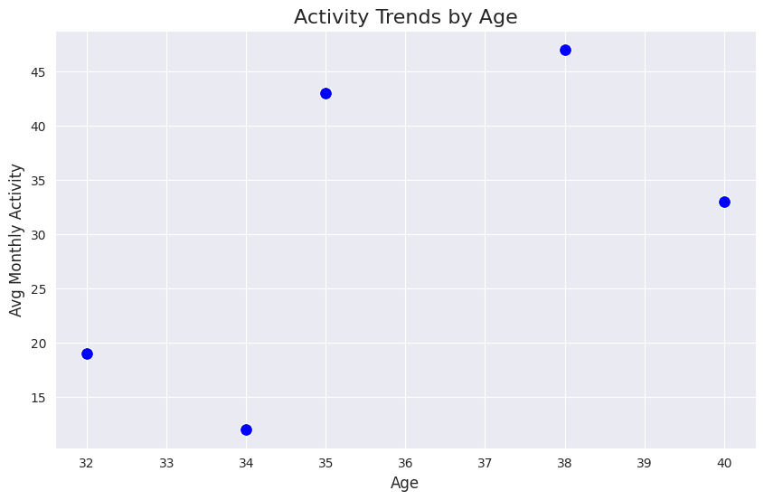

This graph is a scatter plot showing the average monthly activity levels of different age groups.
X-axis (Age): Represents the different age groups.
Y-axis (Avg Monthly Activity): Shows the average activity level in each age group.
Blue dots: Represents the average amount of activity for a particular age group. According to the graph, some age groups have higher activity levels while others have lower levels. The average activity is higher in the 35 and 38 age groups. The activity level is lower in the 34 age group. This graph is used to visualize the effect of age on monthly activity levels.
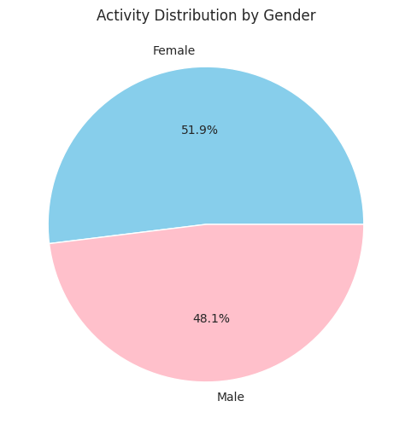

This graph is a pie chart showing activity distribution by gender.
Title: "Activity Distribution by Gender"
Blue slice (Female): 51.9% of activity.
Pink slice (Male): 48.1% of activity.
According to this graph, women perform a slightly larger share of total activity.

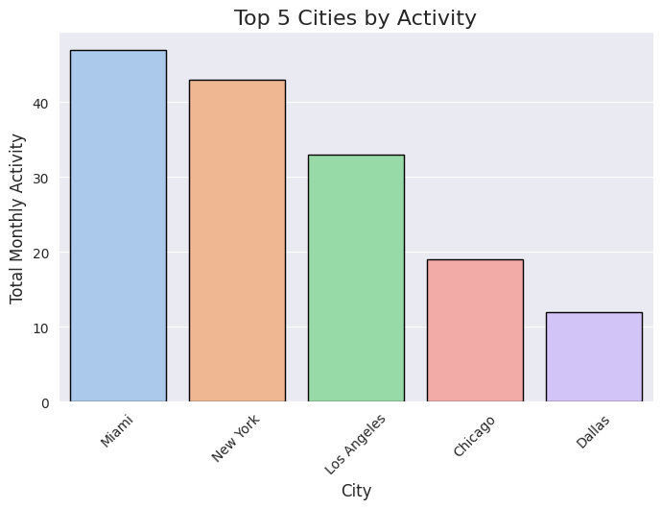

This graph is a bar chart showing the top 5 most active cities by total monthly activity.
Title: "Top 5 Cities by Activity"
X-axis (City): Miami, New York, Los Angeles, Chicago, and Dallas.
Y-axis (Total Monthly Activity): Represents the total amount of monthly activity for each city.
Data Analysis:
Miami has the highest activity level.
New York is the second highest activity city.
Los Angeles has a medium level of activity.
Chicago and Dallas have the lowest activity levels; Dallas, in particular, has the least activity.
This graph is used to compare activity distribution by city.

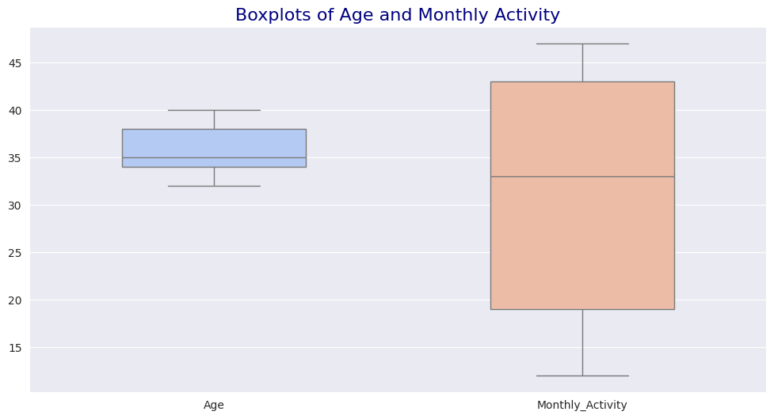

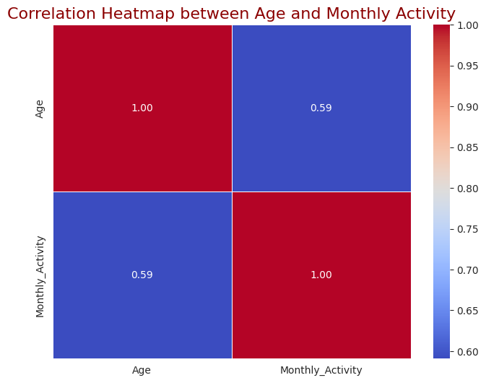

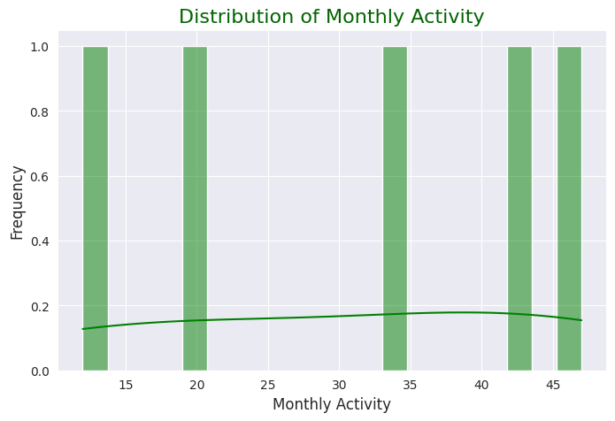

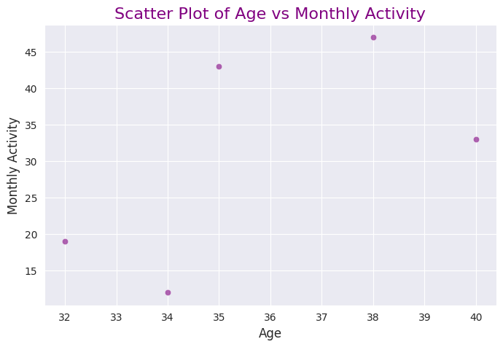

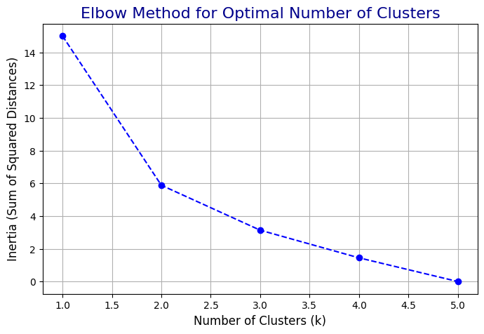

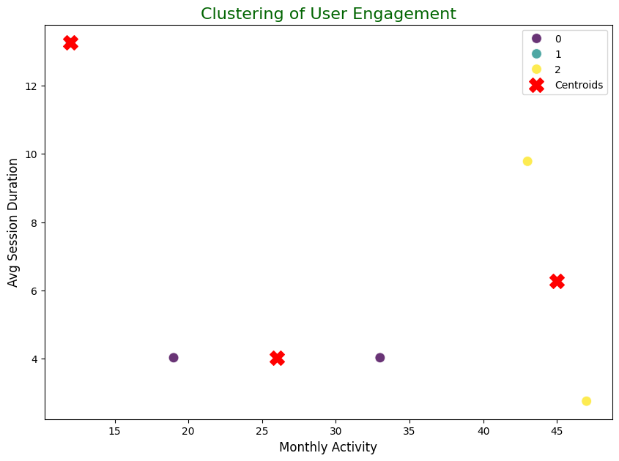

Data preprocessing and feature selection steps were performed to better analyze user interaction data. First, interaction features such as Monthly_Activity, Avg_Session_Duration and Posts_Engaged were randomly simulated. This simulation aims to produce fake data that can be useful for data analysis in cases where real data is missing.

In the data preparation stage, features to be used for clustering were selected. These features include users' monthly activity level, average session duration and the number of posts they interacted with. These selected features were standardized using StandardScaler, so that the data set was transformed so that the mean of each feature was zero and the variance was one.

In order to determine the appropriate number of k for clustering, inertia (total squared difference) for different k values ​​was calculated using the Elbow method. Inertias were visualized with a graph drawn according to different k values ​​and the most appropriate number of clusters was determined. In this step, k = 3 was determined as the optimum number of clusters.

The K-Means clustering algorithm was applied with the optimal k value and a cluster label was assigned to each user. The cluster centers were also visualized, showing where the average feature values ​​of each cluster were concentrated. Clusters were visually separated based on the users’ features such as Monthly_Activity and Avg_Session_Duration. The cluster centers are indicated with red X marks.

Finally, summary statistics were calculated for each cluster and the average values ​​of the features within each cluster were reported. This provides more information about the user interaction profile of each cluster.
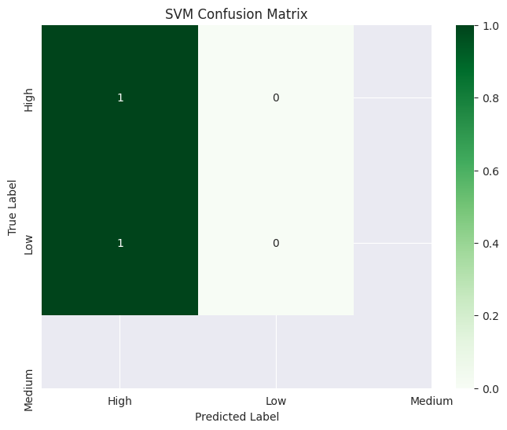

The Support Vector Machine (SVM) model was implemented using a radial basis function kernel. The model was trained on training data (X_train, y_train) and predictions were made on the test data (X_test). The classification performance of the SVM model was evaluated using a classification report that included key metrics such as precision, recall, and F1-score. Furthermore, the accuracy of the model was calculated using the accuracy score, which is the ratio of correct predictions made on the test data.
A heat map was created to visually represent the relationship between the true labels and predicted labels to evaluate the confusion matrix of the model. This visualization was used to better understand the correct and incorrect classifications of the model. The complexity matrix was visualized using a ‘Greens’ diagram, which was drawn together and colored to clearly show the number of predictions made for each category.

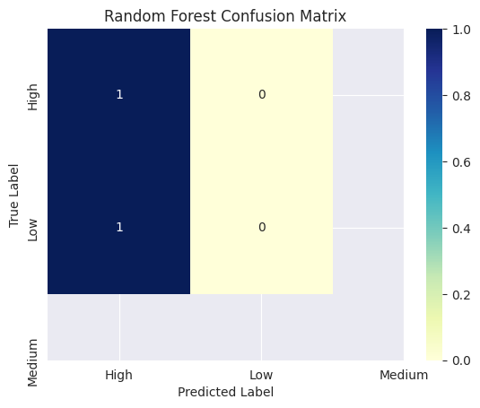

Additional features that were not present in the dataset were simulated. First, a random activity count named Monthly_Activity was generated, with values ​​ranging from 5 to 50. Then, the Avg_Session_Duration feature representing users’ session duration was simulated with random decimals between 2 and 15 minutes. Finally, the Posts_Engaged feature representing the number of posts users engaged with was simulated with random integers between 1 and 20.
As the target variable, an Engagement_Level variable was simulated, which classifies the users’ activity level. This was divided into three categories based on the Monthly_Activity value: low, medium, and high engagement levels. The engagement level was labeled by dividing it into specific intervals, and these labels were converted to numerical data using LabelEncoder.
After selecting the features and the target variable, the features were standardized. Using StandardScaler, the distribution of each feature was transformed to have zero mean and unit variance. The data was split into training and test sets at 70%-30%.
The Random Forest classifier model was trained with training data and predictions were made on test data. The performance of the model was evaluated with accuracy score and classification report, and the confusion matrix was visualized. The complexity matrix is ​​shown using a heat map that visually presents the correct and incorrect classifications of the model.
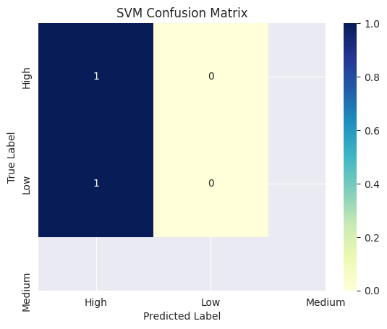
After the model was trained on the training data, predictions were made on the test data and the training time and prediction time were calculated in this process. The accuracy of the model was evaluated as the ratio of correct predictions and the obtained result was indicated with the accuracy score. In addition, the robustness level of the model was calculated with the Stratified K-Fold cross-validation method. Since a small data set was used, 2-fold (split) cross-validation was performed and the general robustness level of the model was evaluated by calculating the average of the obtained scores.
A confusion matrix was created for a detailed examination of the model's performance and this matrix was presented as a heat map to visualize the correct and incorrect classifications of the model. In addition, a classification report was created that included metrics such as precision, recall, and F1-score to evaluate the classification success of the model.
Specific to the Random Forest model, the importance levels of the features used by the model were also calculated and the effect of each feature on the model's predictions was evaluated. In this way, it was determined which features were more effective in the model's decisions.

