**Multı-codec dash player**

Mehmet TEZCAN - 120709001

Burakhan SEVİM - 130709036

Contents

**Summary1**

**1.Project Actions2**

1. Understand Multi-codec Dash Dataset Article2
2. Internet Video Traffic Analysis2
3. Processing Multi-codec Dash Player3

**2. Evalution and Conclusion4**

**Summary**

The number of applications and services that are open to bandwidth is constantly increasing. HTTP adaptive broadcasting with audiovisual content to most of today's internet traffic. Although Internet bandwidth is constantly increasing, audiovisual compression technology is fateful, and we are now faced with the challenge of encountering multiple video codecs.

In our project, we had used a DASH data set consisting of AVC, HEVC, VP9 and AV1 to enable interoperability testing and flow experiments for the efficient use of these codecs under various conditions. Therefore we had created a multi-codec player. With this player, a person can change the codec of video or choose which codec he or she want to run with the player.

1. **Project Actions**
   1. **Understand Multi-Codec DASH Dataset Article**

We had read “Multi-Codec DASH Dataset” article for understanding DASH, codecs and multicodec.

* 1. **Internet Video Traffic Analysis**

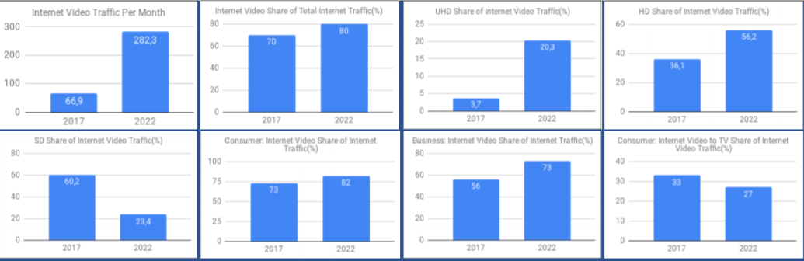

Graph: Internet Video Traffic

As it is seen from the data obtained from Cisco, people have been using the internet more and more for watching videos in recent years. The graph also shows us that people's video quality needs are increasing day by day. Internet video traffic will grow 4-fold from 2017 to 2022, a compound annual growth rate of 33%.

* 1. **Processing of Multi-codec Dash Player**

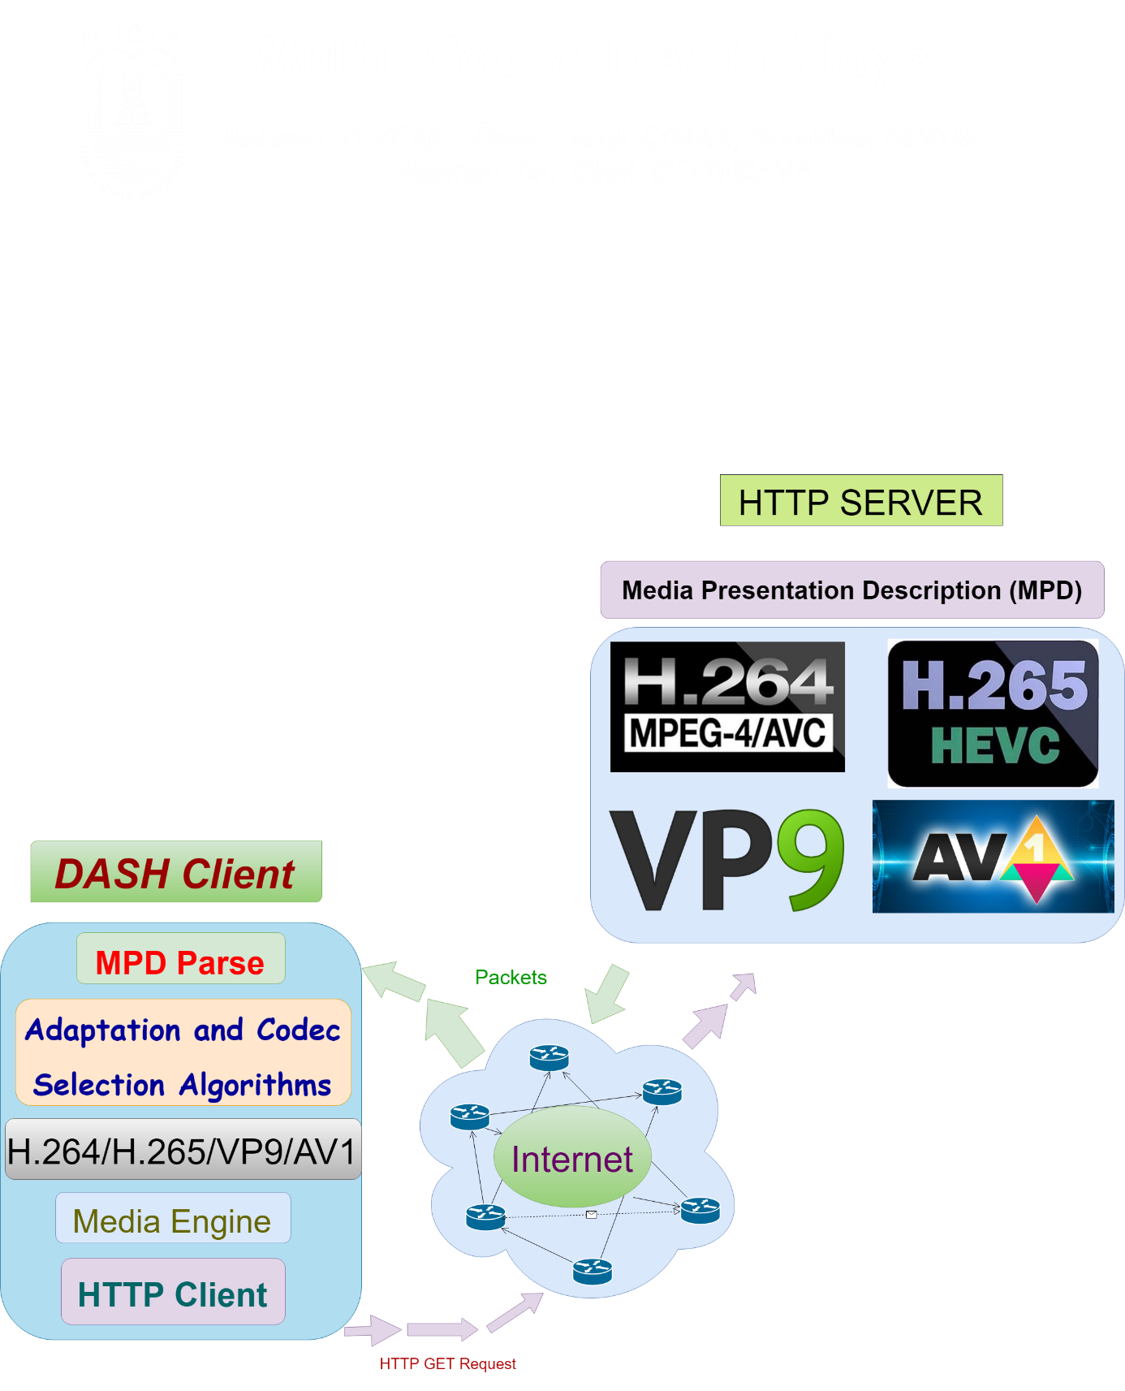

Figure: Processing of Multi-codec Dash Player

In our project that works with server client architecture, the client first sends an http get request. MPD packages from the server are parsed with adaptation and collection algorithms. The user can plays the video by selecting the codec.

**2. Evaluation and Conclusion**

First we have created an interface for the http client. In this interface, the user will be able to watch own video by selecting from 4 different codecs along with his own video link.

With the help of video files created for 4 different codecs on <http://www.itec.aau.at/ftp/datasets/mmsys18> website, we tested our video player and then get some datas. As a result of this process, our video player can run avc codec videos. However, the data we receive from the site due to missing or incorrect data could not run the other 3 codec.

In addition, the codec selection algorithm we designed can parse the mpd file received from the user and make 4 different codecs to the user. However, as mentioned earlier, our video player can run only avc code due to missing and errors in the mpd files.