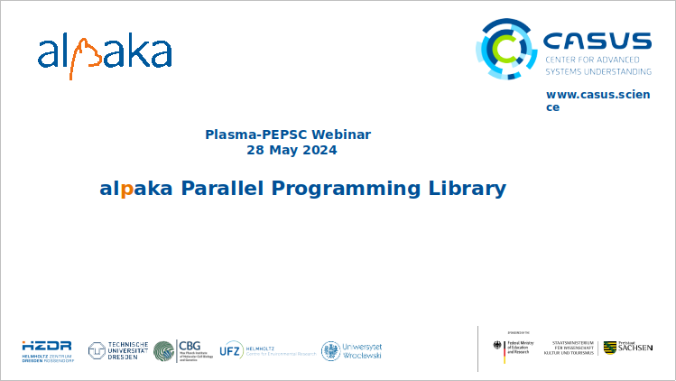
Hello everyone. Thank you for participating. In this presentation I will initially introduce alpaka generally. Then I will go over an alpaka program and explain it step by step. Lastly I will talk about performance and participants of alpaka.

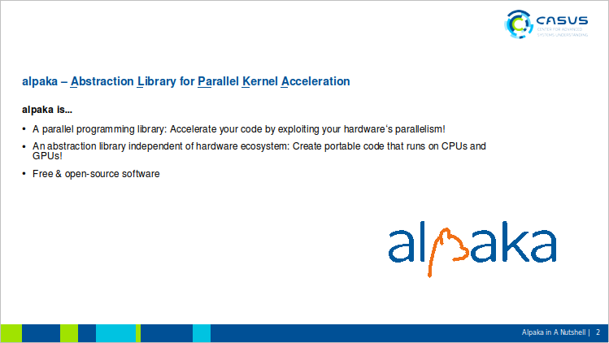
Alpaka is a parallel programming library. You ca accelerate your code by exploiting your hardware’s paralelism. It is an abstraction library independent of hardware ecosystem.

With alpaka you can create create portable code which runs on different GPUs, and on CPUs.

Alpaka is free and open-source.

And lastly it is yet another library using an animal as logo.

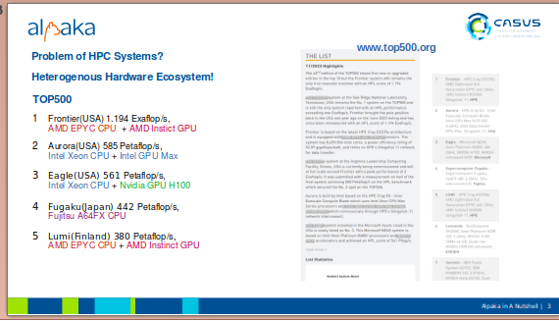
If we just go over the list of top HPC systems, we can see that hardware ecosystem is quite heterogenous.

The first one in the list, Frontier in USA is using AMD GPUs, Aurora is using Intel GPUs, the third one Eagle is using Nvidia GPUs, Fugaku is using CPUs which are actually CPUs with ARM architecture and Lumi in Finland is using AMD GPUs.

And these different vendors propose different programming APIs. Even they are using different colors in their logos and publications.

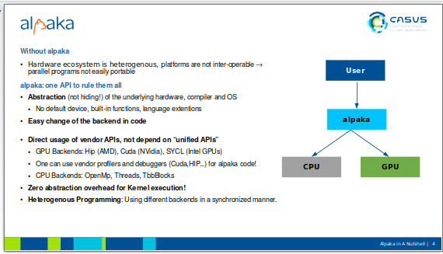

Hence currently HPC Platforms are not interoperable, or in other words programs are not portable.

Alpaka provides one API to support all different GPUs and CPU beckends.

Alpaka provides Abstraction (but not hiding!) of the underlying hardware, compiler and OS
Alpaka does not have default device, built-in functions, language extentions, default stream like in cuda
It is Easy to change the backend in code

Alpaka code directly of vendor APIs, does not depend on “unified APIs”. Produces the same code that a vendor API would generate.
Supported GPU Backends are Hip (AMD), Cuda (NVidia), SYCL (Intel GPUs)
alpaka user can use vendor profilers and debuggers (Cuda,HIP…) for his alpaka code!
CPU Backends: OpenMp, Threads, TbbBlocks
Zero abstraction overhead for Kernel execution!
Heterogenous Programming: Using different backends in a synchronized manner

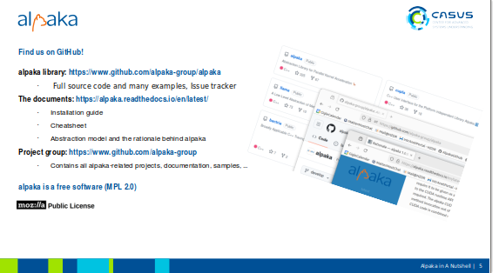

You can Find alpaka on GitHub!

The Git hub includes Full source code and many examples, Issue tracker
The documents pages at readthedocs includes:
Installation guide
Cheatsheet
Abstraction model and the rationale behind alpaka

Alpaka Project group: https://www.github.com/alpaka-group
Contains all alpaka-related projects, documentation, samples, …
text cupla easy porting from cuda, vikunja is for high level algorithms.

alpaka is a free software (MPL 2.0)

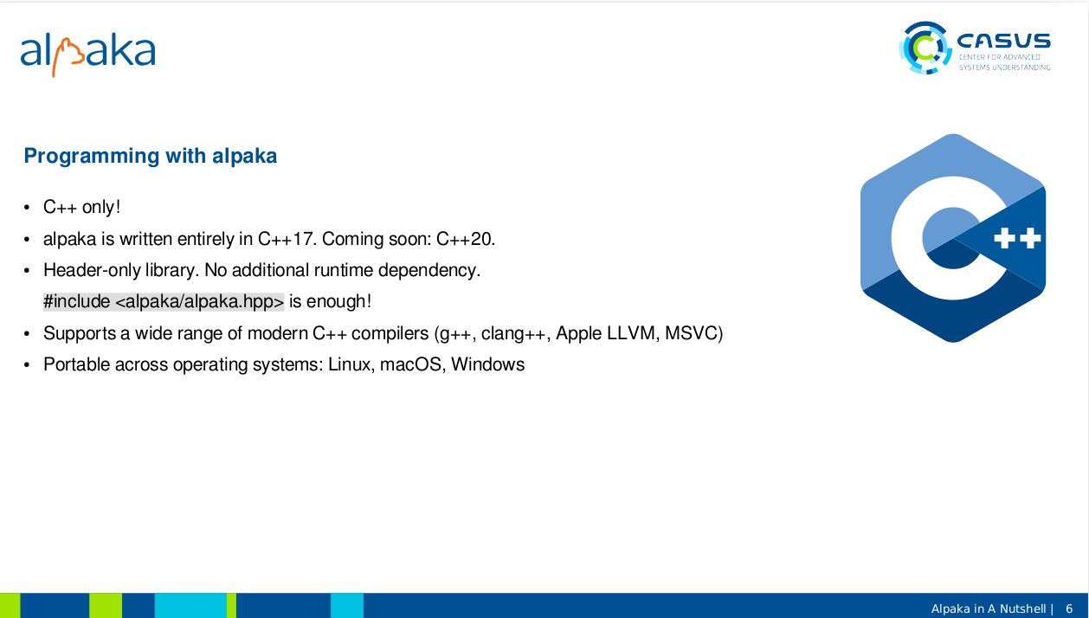

Alpaka is a library for C++. and it is written entirely in C++17. In a short time we will be using C++20 features and compiling on : C++20.
It is a Header-only library. No additional runtime dependency. Compile time dependency is only Boost.
Including alpaka/alpaka.hpp would be enough!
Alpaka Supports a wide range of modern C++ compilers (g++, clang++, Apple LLVM, MSVC)
and it is Portable across operating systems: Linux, macOS, Windows

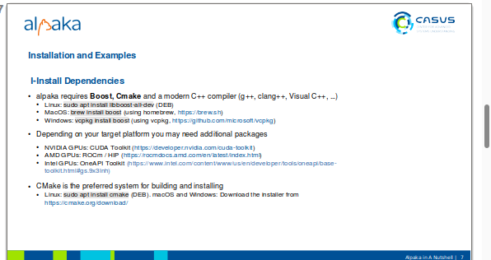

Installation of Alpaka and Building Examples
Initially we need to install dependencies

alpaka requires Boost as a compile time dependency for compilation. For build system configuration Cmake and for compiling a C++ compiler (g++, clang++, Visual C++, …) is needed.

Depending on your target platform you may need additional packages
NVIDIA GPUs: CUDA Toolkit (https://developer.nvidia.com/cuda-toolkit)
AMD GPUs: ROCm / HIP (https://rocmdocs.amd.com/en/latest/index.html)
Intel GPUs OneApiToolkit

CMake is the preferred system for building and installing
Linux: sudo apt install cmake (DEB
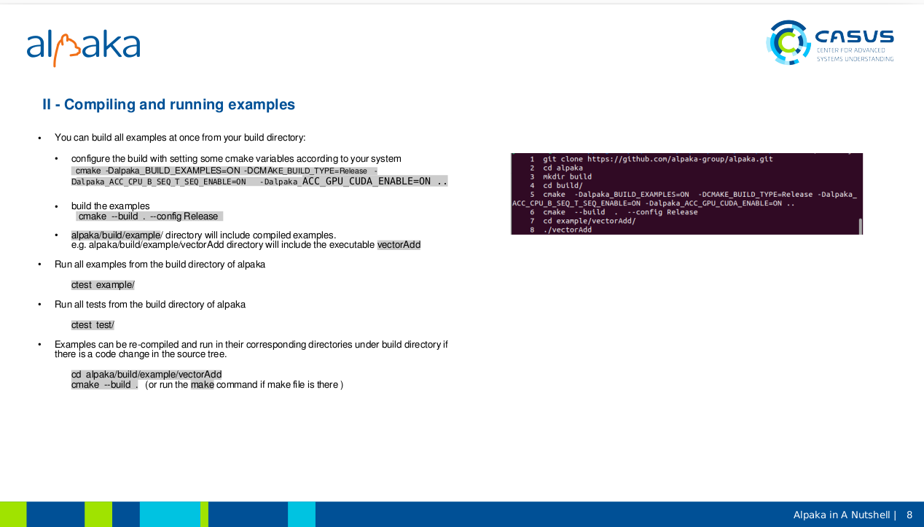

We don’t need to install alpaka files to compile examples. We can just directly compile and run.

Setting cmake variables are important. The user needs to configure the build with setting some cmake variables according to her/his system:

cmake -Dalpaka_BUILD_EXAMPLES=ON -DCMAKE_BUILD_TYPE=Release -
Dalpaka_ACC_CPU_B_SEQ_T_SEQ_ENABLE=ON
-Dalpaka_ ACC_GPU_CUDA_ENABLE=ON

These backend settings doesn’t mean the user has to use these in the code but means they are available and can be used by the user. ( Example selects which one?)

Runnin all examples by ctest example command or all tests by

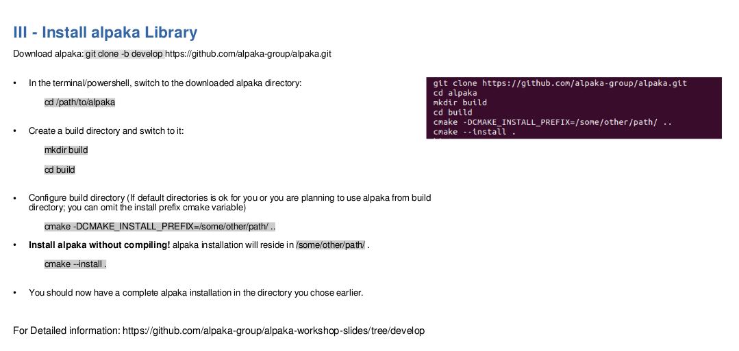

Installation is quite strait forward. Compilation is not needed just configure and install steps are enough instead of configure-compile-install steps. Notice that we don’t need to set cmake variables depending on our system because that will be selected during the compile time of out project.

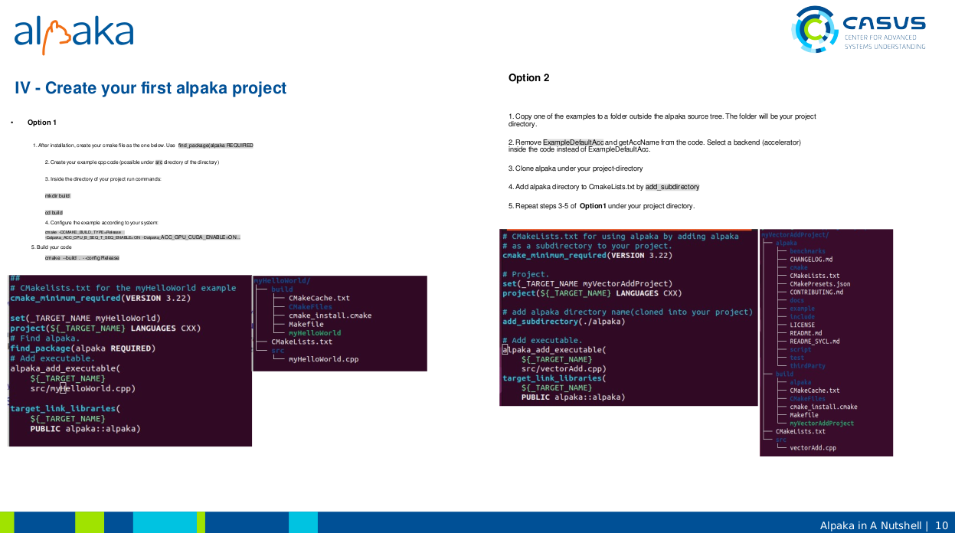

Creating your alpaka project can be achieeved in 2 ways. First creating your cmakelists and your code file in a directory you chose.

Secondly you can just copy one of the examples ( each example is in a different directory in alpaka/example ) change the code a little.

Select all possible systems while configuring the build tree, namely set the corresponding CMAKE variable ON depending on your system.

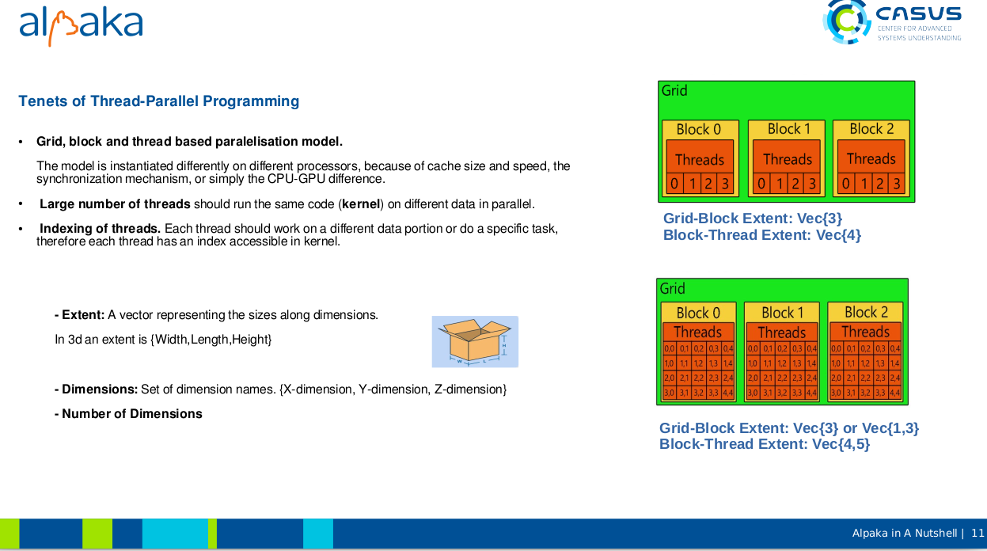

Before moving on the alpaka code I would like to mention on basic concepts of thread-parallel programming.

Alpaka uses Grid-block-thread based paralelisation model. The model is instantiated differently on different processors, because of cache size and the cache speed, the
synchronization mechanism, or simply the CPU-GPU difference. By using this abstraction the execution can be optimally adapted to the available hardware.

Secondly the assumption is that Large number of threads should run the same code (kernel) on different data in a parallel manner.

Lastly; Indexing of threads is needed. Each thread should work on a different data portion or do a specific task,
therefore each thread has an index accessible in kernel.

There are 3 terms I would like to go over. The extent means the sizes along each dimensions. In 3d for example extent is a 3 item vector of {width,length and height}.
Dimensions means set of dimension names although in daily english we use dimensions as the extent.
Lastly number of dimensions is the size of the extent vector.

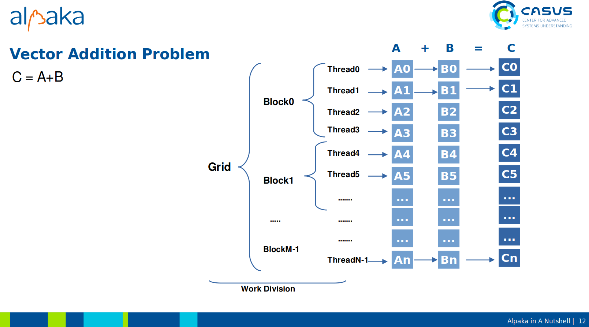

Lets assume that we want to sum to vectors by utilising paralism of the hardware. We have 2 1D vectors A and B and we will calculate their sum C.

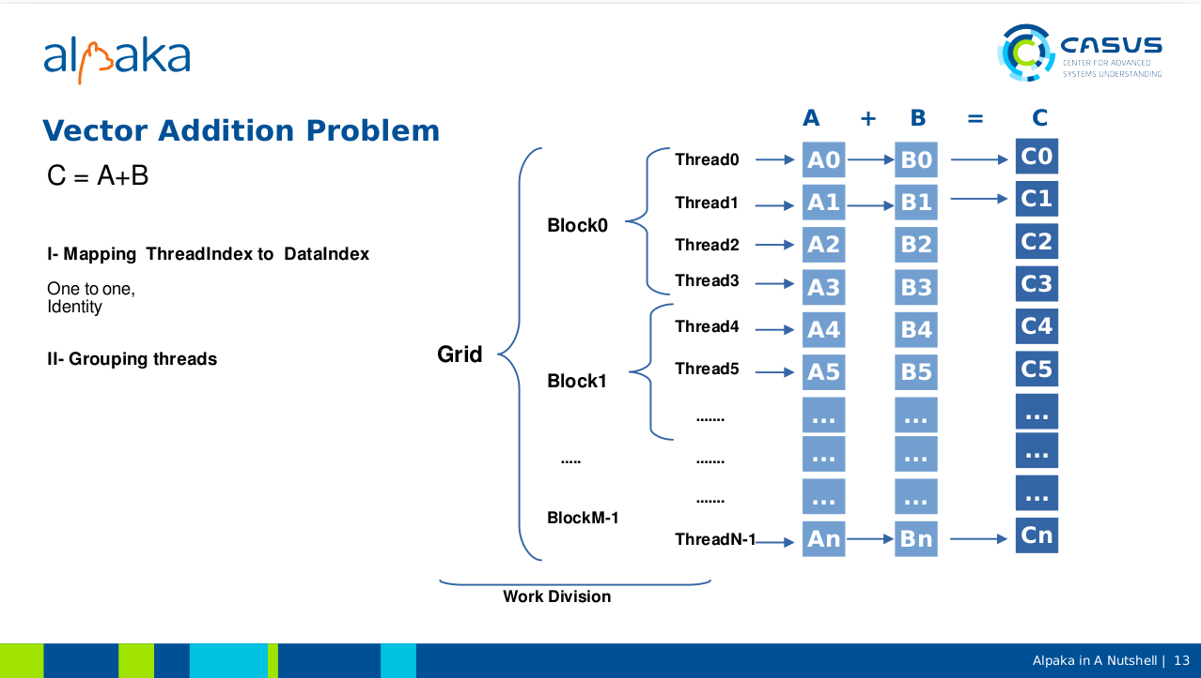

Typically for paralellisation we need to divide the calculation into parallel summations.

In this solution a one-to-one mapping, actually an identity function, between thread indices and data indices is used. Each kernel will get the thread-index it is instantiated by; and sum the data indexed by simply that thread index and set the corresponding item in C.

Thread0 will sum A[0] and B[0], thread1 will sum A[1] and b[1] and so on.

Second issue is how to use the grid-block-thread paralelism. We will come to it later.

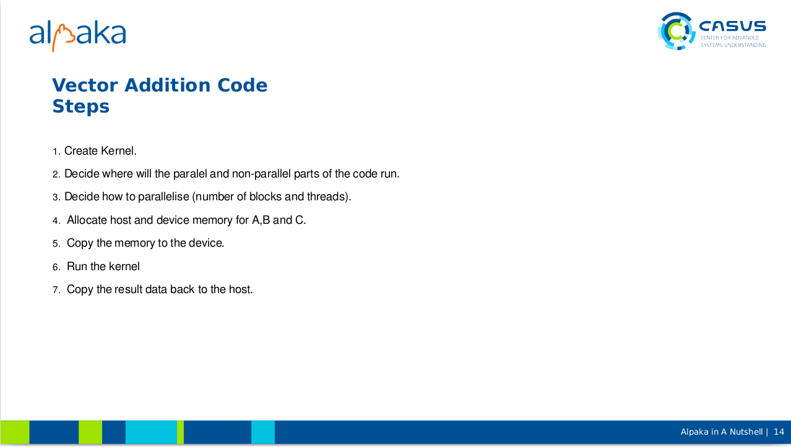

From the coding perspective; the vector addition code should have these steps: 1. Create Kernel.
2. Decide where will the paralel and non-parallel parts of the code run.
3. Decide how to parallelise (number of blocks and threads).
4. Allocate host and device memory for A,B and C.
5. Copy the memory to the device.
6. Run the kernel
7. Copy the result data back to the host.

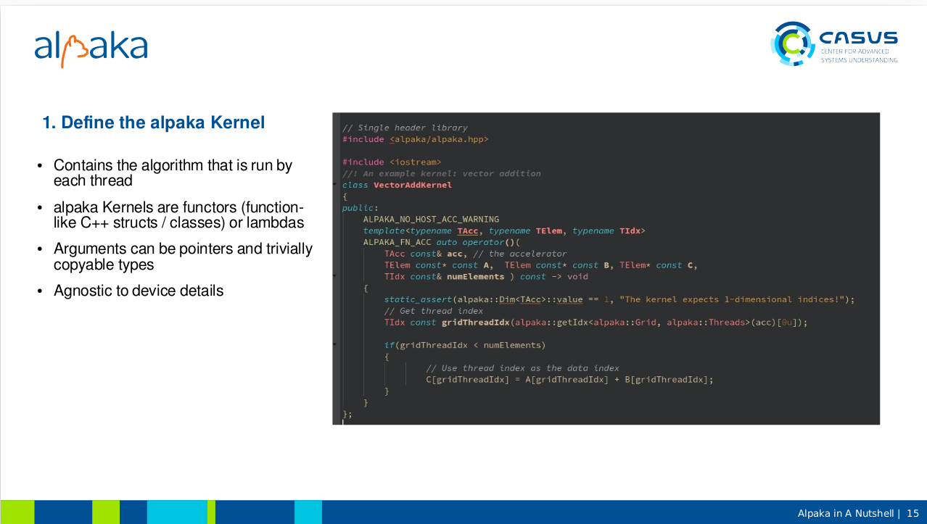

At the first step kernel is defined. Kernel contains code that is run by each thread. Alpaka kernels are functors, namely structs with specificly implemented function operators or lambdas.

Arguments of the function operator can be pointers or trivially copyable types. You can put many pointers and built-in types in a struct and just pass the struct as a value for example.

Alpaka kernel is agnostic to device details.

As you see, Alpaka is low level and transparent. Abstraction usually associated with being high level but alpaka is low level in that sense. One can access to the thread index directly as in Hip or Cuda.

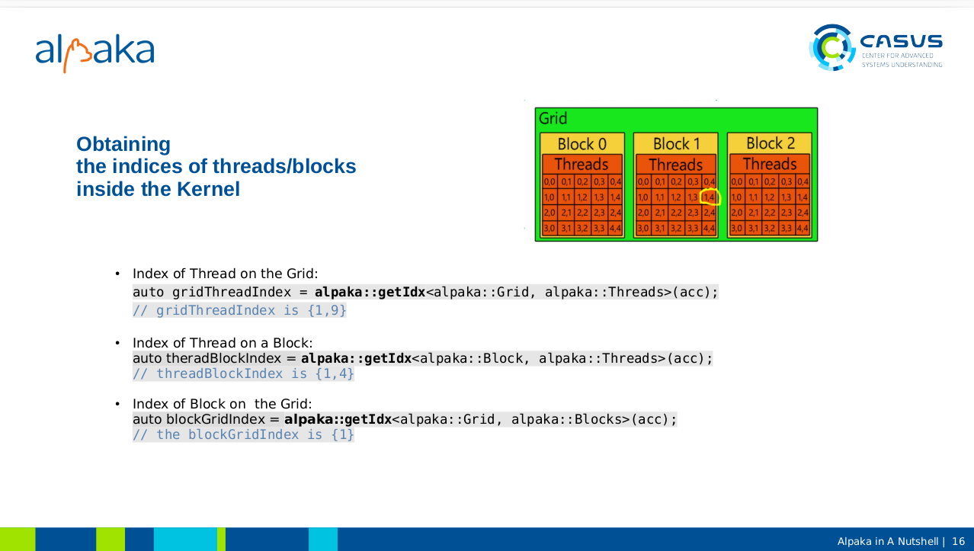

Obtaining the indices of threads or blocks is easy in alpaka kernel thanks to usage of function templates.

Using getIdx function with different predetermined template arguments would be enough get the thread index in grid or in block. Or the index of block in the grid.

For eample the thread [1,4] of the block1 would have a grid index [1,9] because it is on the second row and the 10th column in the grid. Note that alpaka::Grid and alpaka::Threads types are used as template arguments.

Same thread will have a threadBlock index [1,4] which shows its coordinates wrt the block.

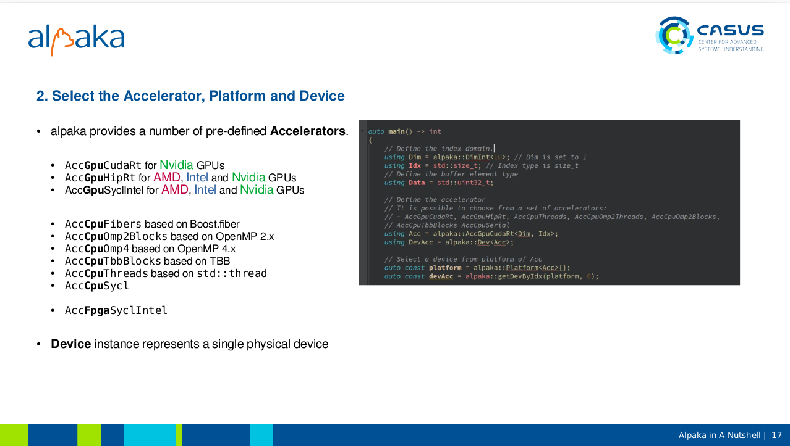

Now we can design the code that will NOT run in parallel, namely the code that will run on the host device which will just trigger the parallel part.

Initialy selecting the one of the predefined accelerator types according to your system is needed. There are 3 accelerator types for as the GPU backend, 6 types for the CPU backend and 1 type for the Fpga backend. The accelerator name actualy has 2 important parts first one is the device type (CPU or GPU) and the second part the specific API.

// text Accelerator is an abstraction that makes the kernel ‘device agnostic’.
// easily change the acceleratp

Accelerator is a type that is only instantiated on Device not on the host.
Easy management of physical devices
Contains device information

