Bukeh Effect Using Deeplab Model

This repository present code for semantic segmentation using DeepLab model.
This read-me file helps people who are interested to do semantic segmentation using deeplab.

DeepLab model
Code automatically downloads the DeepLab model into new directory named “deeplab_ model”. No need to download the model manually. DeepLabModel class automatically loads the model from the directory “deeplab_model”.

Before

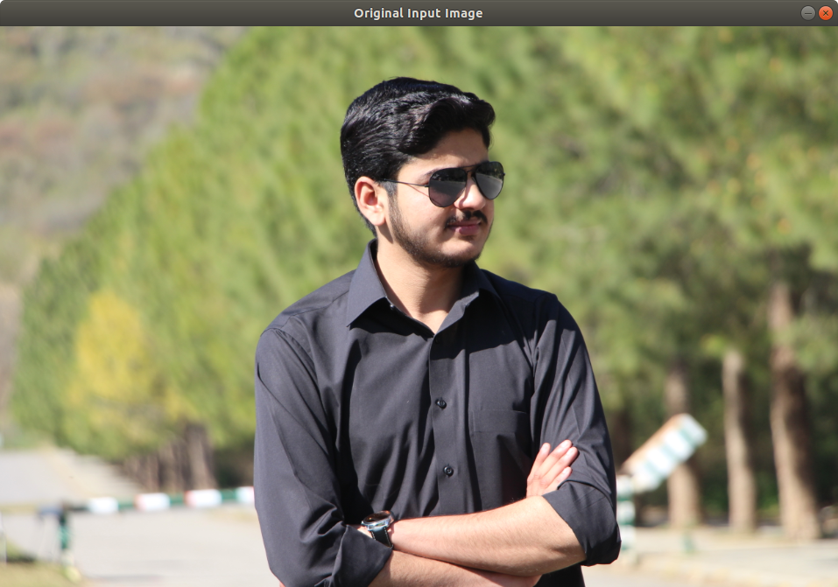

After

