The Bookstore Intelligence Mission
Assignment 2: Web Scraping
Name: Laiba Mehmood
Roll No: 23I-5013
GitHub link:
LinkedIn post link:

1. Dataset Summary
The competitor website https://books.toscrape.com/ was scraped with Python (requests + BeautifulSoup) and the records were stored in a Pandas DataFrame, then saved as competitor_books.csv.
Item | Detail
Books scraped | 600 (30 catalogue pages, scraped in one reusable loop)
Columns | Title, Price, Rating, Availability, Product_URL
Rating conversion | Word ratings (One to Five) converted to numbers 1 to 5
Output file | competitor_books.csv (generated by scraper.py)

2. Mission 1: Reconnaissance
Data Needed | HTML Tag / Class Found | Notes
Book Title | <h3><a title="..."> | Use the title attribute; the visible link text is truncated
Price | <p class="price_color"> | Text such as £51.77; remove £ and convert to float
Rating | <p class="star-rating Three"> | Rating word is stored as a CSS class; map to 1 to 5
Availability | <p class="instock availability"> | Text "In stock"; strip extra whitespace

3. Mission 4: Intelligence Analysis

Q1. Which scraped book is the most expensive?
Title | Price | Rating
The Barefoot Contessa Cookbook | £59.92 | 5

Q2. Which scraped book is the cheapest?
Title | Price | Rating
The Origin of Species | £10.01 | 4

Q3. What is the average book price?
£35.29

Q4. How many books have a 5-star rating?
115 books

Q5. What percentage of the scraped books are in stock?
100.00% (all 600 books are in stock)

Q6. Top 5 highest-rated books
Many books share the 5-star rating, so ties were broken by lowest price.
Title | Price | Rating
Greek Mythic History | £10.23 | 5
The Power Greens Cookbook: 140 Delicious Superfood Recipes | £11.05 | 5
Dear Mr. Knightley | £11.21 | 5
Naturally Lean: 125 Nourishing Gluten-Free, Plant-Based Recipes--All Under 300 Calories | £11.38 | 5
Old School (Diary of a Wimpy Kid #10) | £11.83 | 5

Q7. Among the 5-star books, which one is the cheapest?
Title | Price | Rating
Greek Mythic History | £10.23 | 5

4. Business Recommendation
I would prioritise 5-star, in-stock books with low prices (around £10 to £12), because they give the most customer approval per pound spent. Only 115 of the 600 scraped books (19.2%) are rated 5 stars and all 600 (100%) are in stock, so this small group of top-rated titles is both proven and easy to source. Quality also does not cost extra: 5-star books average £35.06 versus £35.29 for the whole catalogue, and the five highest-rated books cost just £10.23 to £11.83, which is why the CEO's £100 bought 9 books worth 42 stars (about £10.92 per book).

5. Final Challenge: The CEO Has £100
Goal: maximise the total star rating without spending more than £100, buying each book at most once.
Title | Price | Rating
Superman Vol. 1: Before Truth (Superman by Gene Luen Yang #1) | £11.89 | 5
Old School (Diary of a Wimpy Kid #10) | £11.83 | 5
Greek Mythic History | £10.23 | 5
Dear Mr. Knightley | £11.21 | 5
NaNo What Now? Finding your editing process, revising your NaNoWriMo book and building a writing career through publishing and beyond | £10.41 | 4
History of Beauty | £10.29 | 4
The Origin of Species | £10.01 | 4
Naturally Lean: 125 Nourishing Gluten-Free, Plant-Based Recipes--All Under 300 Calories | £11.38 | 5
The Power Greens Cookbook: 140 Delicious Superfood Recipes | £11.05 | 5

Result | Value
Number of books selected | 9
Total cost | £98.30
Total rating score | 42

Method: the problem was solved exactly as a 0/1 knapsack using dynamic programming. This finds the combination with the highest total stars that stays within £100, which is more reliable than simply picking the cheapest books. When two baskets scored the same, the cheaper one was chosen.

6. Bonus 3 and 4: Books per Star Rating
Star Rating | Number of Books
1 star | 126
2 stars | 119
3 stars | 119
4 stars | 121
5 stars | 115

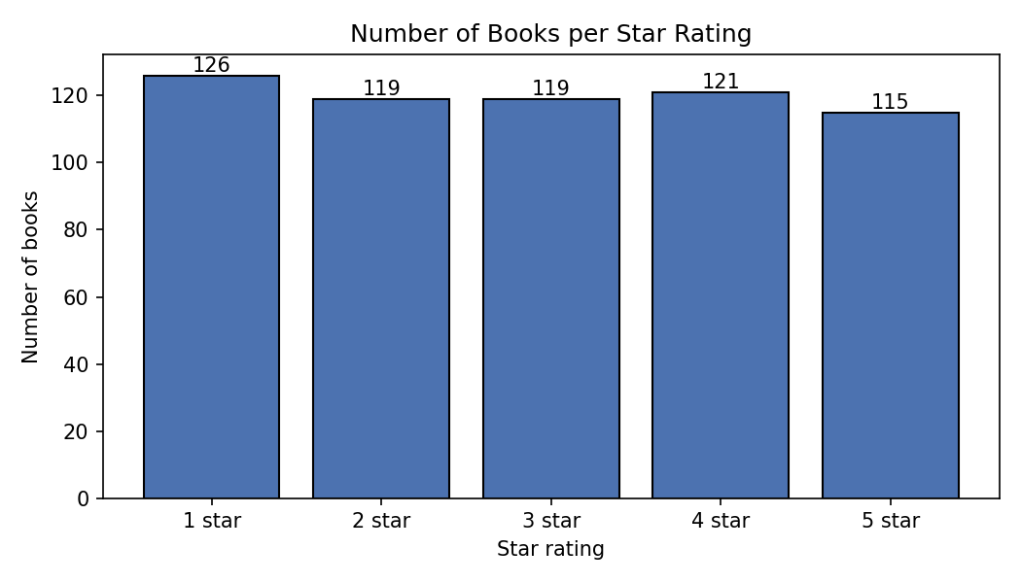
The ratings are spread almost evenly across all five levels, so star rating alone does not separate cheap from expensive books.

