Lab 02
TITLE
“Hands-On Git and Version Control”
Name:
Mehmoona Abid
Registration number:
(2023-BSCS-97)

Section:
A
GitHub username
mehmoonaabid

Lab 2: Hands-On Git and Version Control
Estimated duration: 3 hours
Submission repository: DevOps
Submission directory: Labs/Lab02
Screenshot directory: Labs/Lab02/screenshots

Complete the practical work in the repository required by each task. Submit all evidence to your GitHub repository named exactly DevOps using the directory structure shown below.
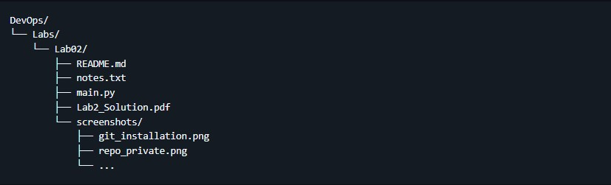
Navigation: Click any task below to jump to its instructions.

Task List
Getting Started
Task 1: Create Private GitHub Repository
Task 2: Connect Repository via SSH
Task 3: Configure Git Username and Email
Task 4: Explore the .git Folder
Task 5: Local Repository Management
Task 6: File Status & Staging
Task 7: Branch Creation Using GitHub GUI
Task 8: Branch Creation and Push Using Git Bash
Task 9: Branching & Merging
Task 10: Pull Request and Branch Review (GitHub GUI)
Task 11: Detailed Branch Strategy (Develop/Staging)
Task 12: Code Review Workflow
Task 13: Branch Cleanup Best Practices
Bonus Task: Simulated Team Collaboration
Exam Evaluation Questions
Mandatory Screenshot and Autograding Rules

Required Automated-Grading Filenames
The current Lab 2 grader checks these 37 files:
git_installation.png
repo_private.png
ssh_keygen.png
github_sshkey.png
ssh_clone.png
git_identity.png
git_config_list.png
git_folder.png
delete_git.png
git_init.png
first_commit.png
first_push.png
status1.png
commit_notes.png
bugfix_branch_gui.png
bugfix_branch_local.png
feature_db_branch.png
branch_create.png
feature_commit.png
merge.png
push_branches.png
pr_creation.png
pr_merge.png
branch_delete.png
branch_strategy.png
branch_merges.png
final_merge.png
pr_create_details.png
pr_assigned_reviewer.png
pr_request_changes.png
pr_rejected.png
pr_updated_with_commits.png
pr_merge_confirm.png
pr_merged.png
pr_branch_deleted.png
remote_branch_deleted.png
remote_branch_delete_cmd.png
Each of these 37 checks has equal weight. Bonus and additional exam-practice screenshots may be reviewed separately and are not included in these 37 automated checks.

Getting Started
1. Install Git on your PC.
- Download Git for Windows, Mac, or Linux
- Save the evidence as Labs/Lab02/screenshots/git_installation.png.

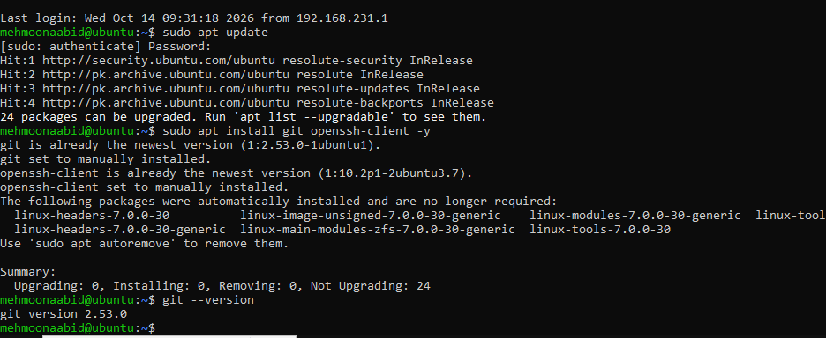
Task 1: Create Private GitHub Repository
- Create a new private repository named exactly DevOps_Lab2_Practice on GitHub.
- Take a split-screen screenshot showing the repository is private and your required terminal prompt. Save it as Labs/Lab02/screenshots/repo_private.png.
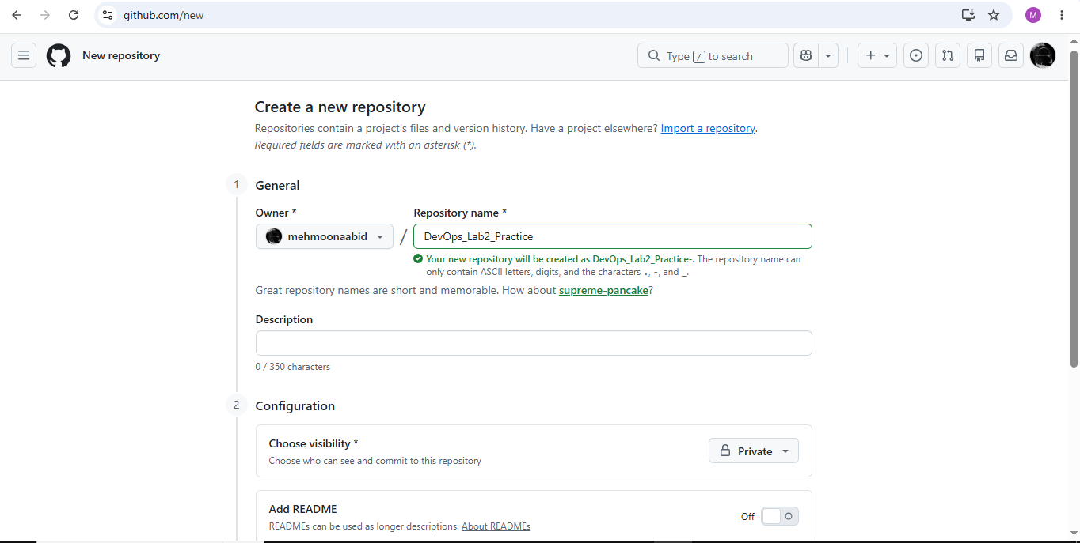

Task 2: Connect Repository via SSH
1. Generate a new SSH key using PowerShell: ssh-keygen -t ed25519 -C "your_email@example.com" cat ~/.ssh/id_ed25519.pub
• Save it as Labs/Lab02/screenshots/ssh_keygen.png. Do not show the private key contents.
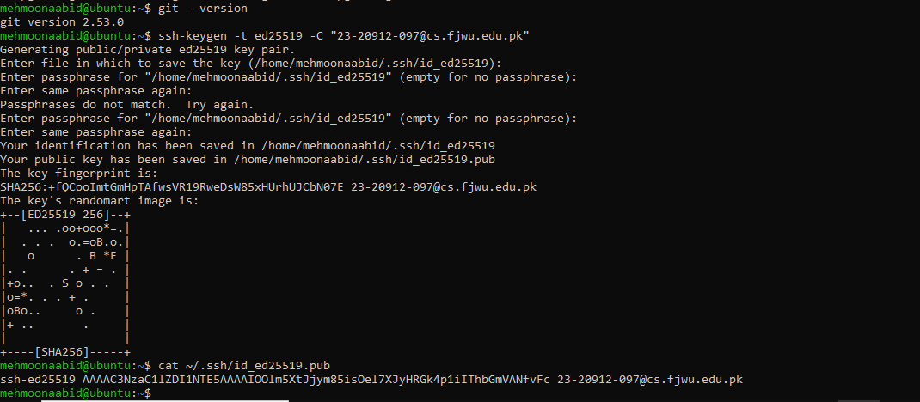

2. Add your SSH public key to GitHub (Settings > SSH and GPG keys).
• Save a split-screen screenshot as Labs/Lab02/screenshots/github_sshkey.png.

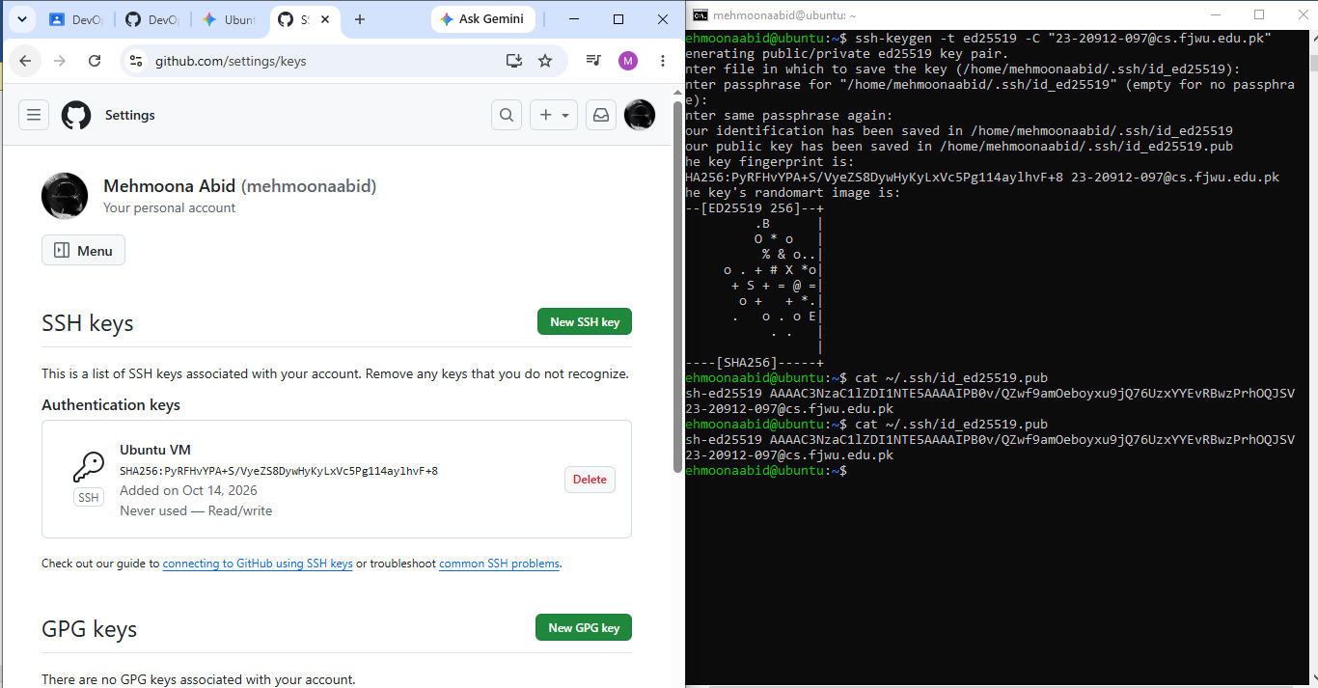

3. Clone your DevOps_Lab2_Practice repository using SSH.
git clone git@github.com:<yourusername>/DevOps_Lab2_Practice.git • Save it as Labs/Lab02/screenshots/ssh_clone.png.
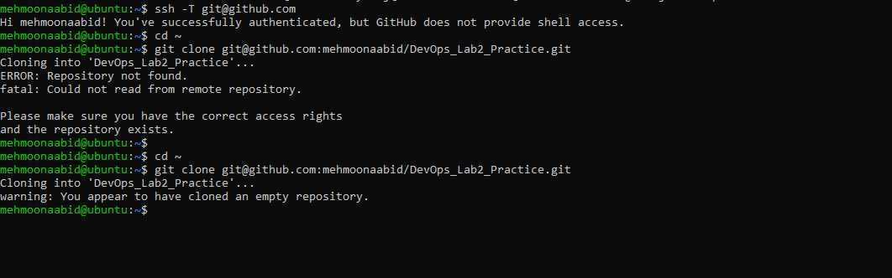

Task 3: Configure Git Username and Email
- Set up your Git identity (this ensures all commits are linked to you):
- git config --global user.name "Your Name"
git config --global user.email "your_email@example.com"
  - Save a screenshot of your terminal as git_identity.png.
2. Verify your configuration:
git config --list
• Screenshot as git_config_list.png.
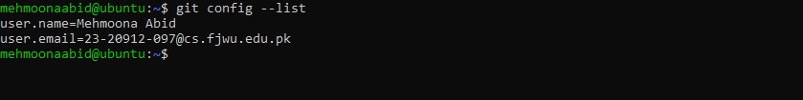

Task 4: Explore the .git Folder
- Navigate into your cloned repository folder.
- Show hidden files and locate the .git directory.
- Explore what’s inside using: ls -a .git
• Take a screenshot as git_folder.png.

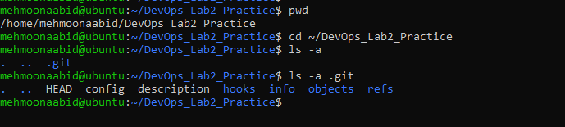
4. Note: This folder contains history, logs, and config for your repository. Do not modify these files manually.

Task 5: Local Repository Management
1. Delete the existing .git folder from your cloned repo using Git Bash:
rm -rf .git git status ==> error why?
• Take a screenshot as delete_git.png.

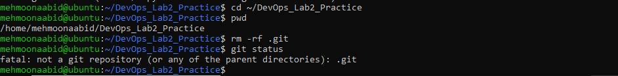
2. Re-initialize the local git repository:
git init
Save a screenshot as git_init.png.
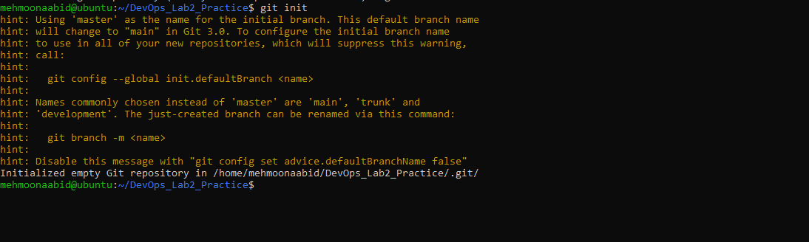
3. Add a file named README.md and commit it:
echo "# Lab02 Git Practice" >> README.md
git add README.md
git commit -m "Initial commit"
Save a screenshot as first_commit.png.
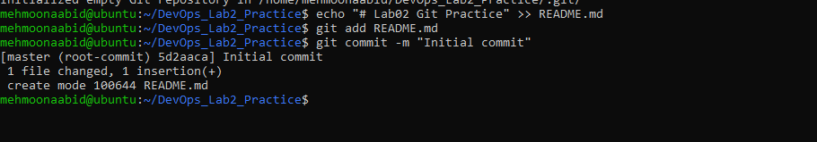
- Connect your local repo to GitHub and push:
git remote add origin git@github.com:<yourusername>/DevOps_Lab2_Practice.git
git branch -M main
git push -u origin main
Save a screenshot as first_push.png.
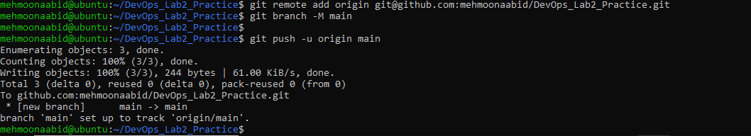

Task 6: File Status & Staging
- Create a new file notes.txt and write a note.
echo "Adding some test notes" >> notes.txt
- Check status:
git status
  - Screenshot as status1.png.
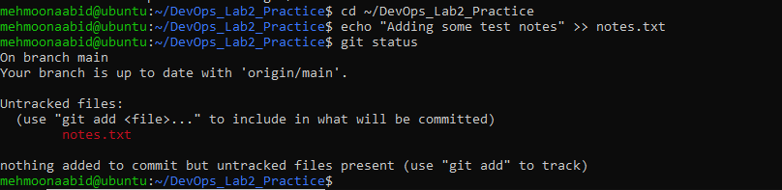
- Stage and commit:
git add notes.txt
git commit -m "Add notes.txt"
  - Screenshot as commit_notes.png.
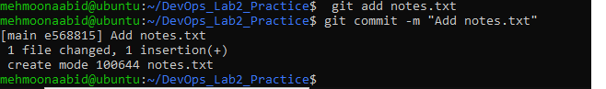
Edit notes.txt and repeat status/commit steps.

Task 7: Branch Creation Using GitHub GUI
- On GitHub (web interface), create a branch named bugfix/user-auth-error.
- Pull the branch to your local repository to sync.
git pull origin bugfix/user-auth-error
- Take a screenshot of branch creation in the GUI as bugfix_branch_gui.png.
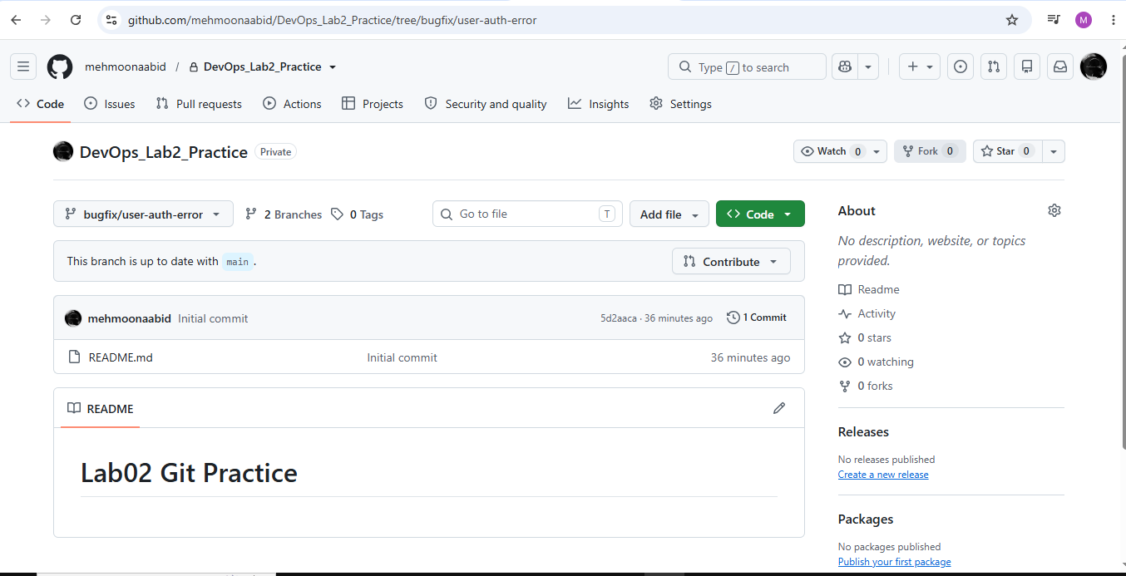

- Take a screenshot of your local git branch list after pulling as bugfix_branch_local.png.
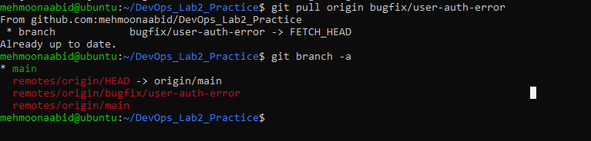

Task 8: Branch Creation and Push Using Git Bash
- Create a branch named feature/db-connection using Git Bash:
git checkout -b feature/db-connection
- Push the branch to the remote repository:
git push origin feature/db-connection
• Take a screenshot of the branch creation and push as feature_db_branch.png. 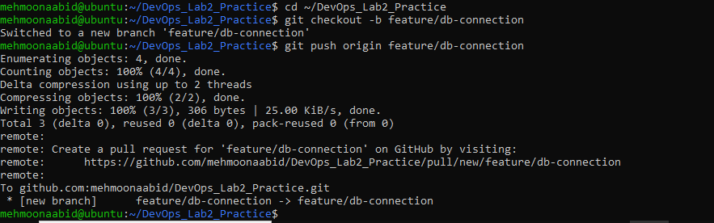

Task 9: Branching & Merging

1. Create and switch to a branch feature-1:
git checkout -b feature-1
• Screenshot as branch_create.png.
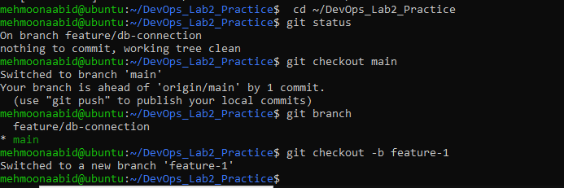

- Modify main.py (add a function) and commit.
git add main.py
git commit -m "Add new function to main.py" • Screenshot as feature_commit.png.

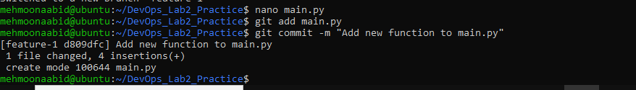

3. Switch back to main and merge:
git checkout main git merge feature-1
• Screenshot as merge.png.
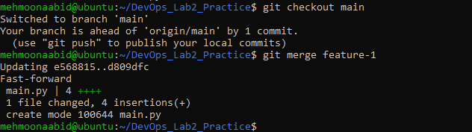
Merging directly into main from your local terminal is widely considered a risky anti-pattern, especially on a team. In professional software development, using a Pull Request (PR) or Merge Request (MR) is the gold standard.
4. Push all branches: git push origin main
git push origin feature-1
• Screenshot as push_branches.png.
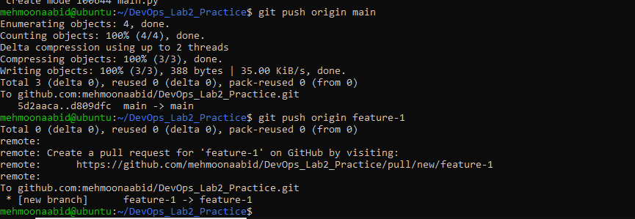

Task 10: Pull Request and Branch Review (GitHub GUI)
On GitHub, create a Pull Request from the branch feature/db-connection to main.
Review the Pull Request and merge it using the GitHub GUI.
After merging, delete the feature/db-connection branch using the GitHub GUI.
Take a screenshot of:
The Pull Request creation (pr_creation.png)
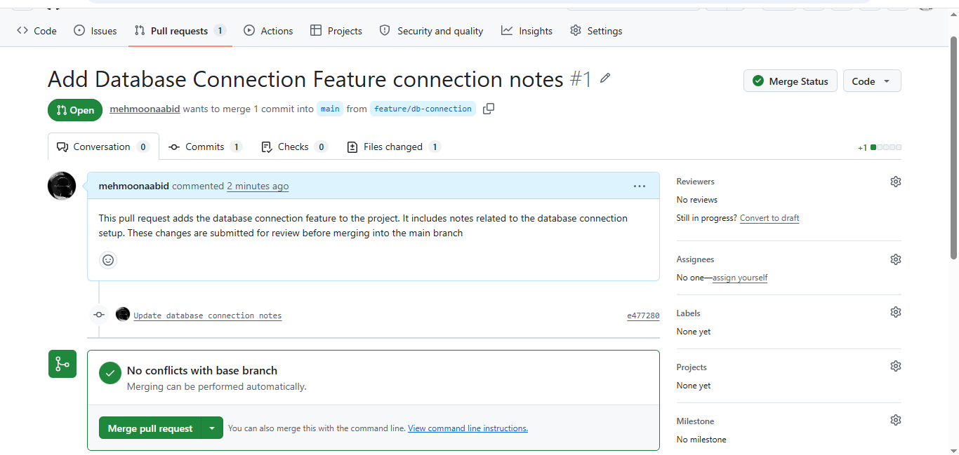
The Pull Request review and merge (pr_merge.png)
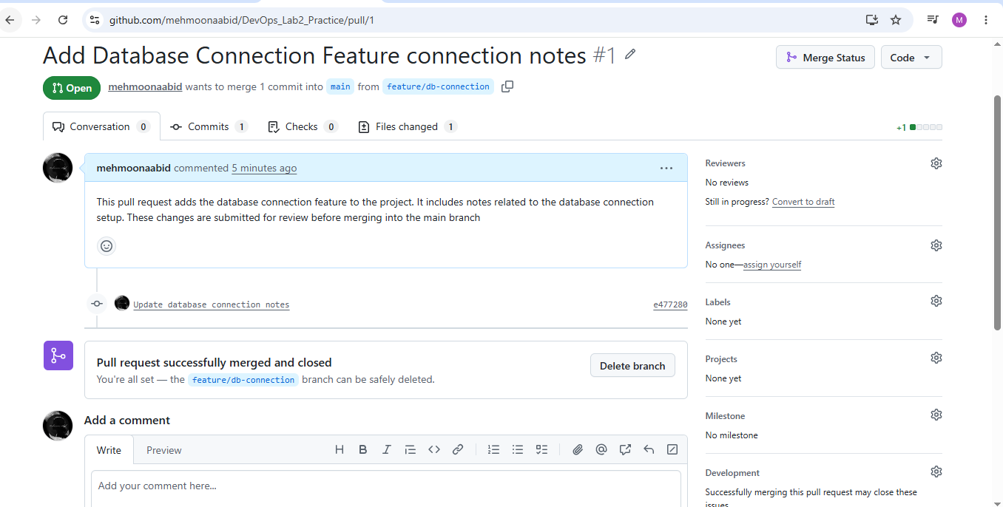
The branch deletion (branch_delete.png)
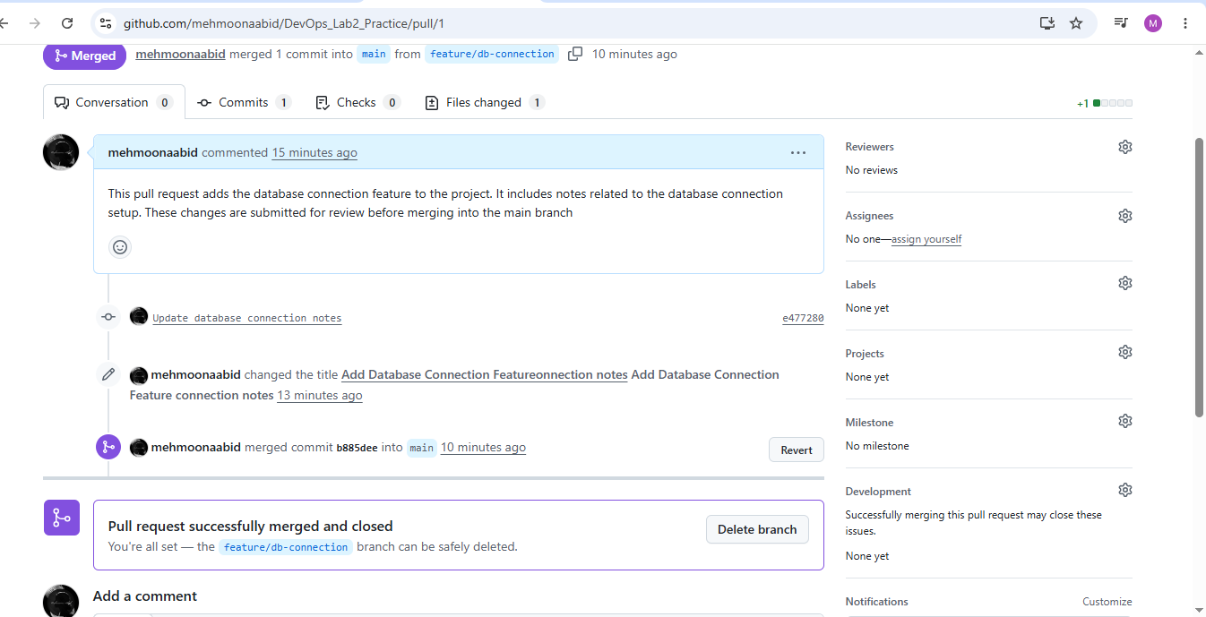

Task 11: Detailed Branch Strategy (Develop/Staging)
1. Create the following branches to simulate a professional branching strategy:
- develop
- staging
- feature/*
- bugfix/*
2. Example workflow:

- Developers work on feature/* and bugfix/* branches.
- Merge into develop after completion.
- develop is merged into staging for testing.
- Finally, staging is merged into main (production).
3. Document the workflow with screenshots:
- Branch list (branch_strategy.png)
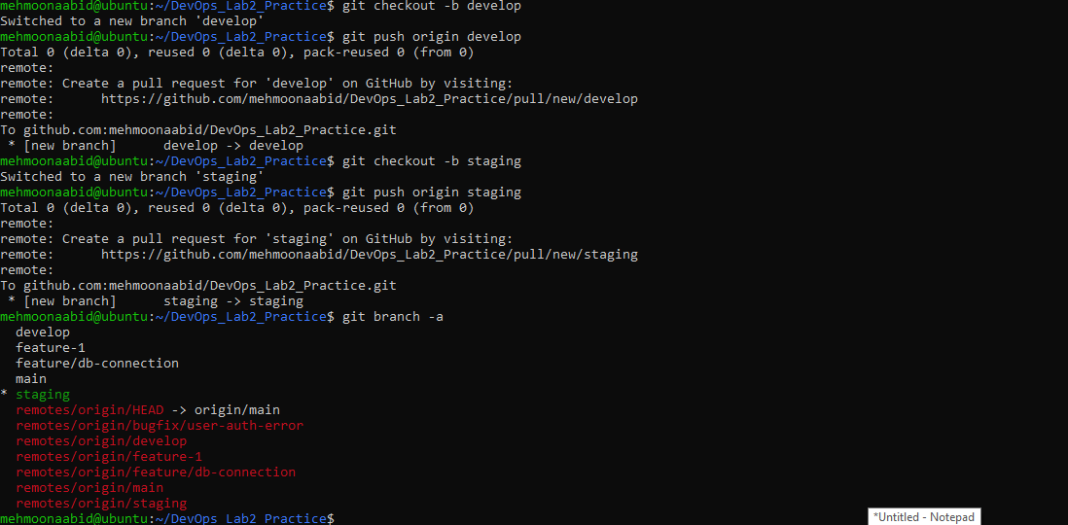

- Merges into develop and staging (branch_merges.png)

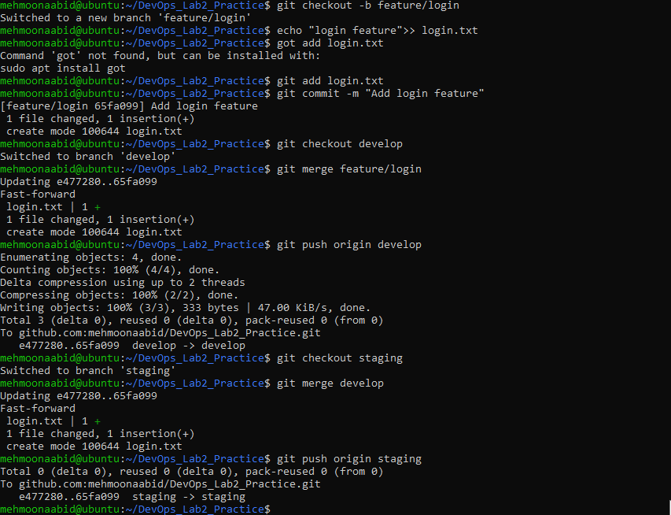

- Final merge into main (final_merge.png)
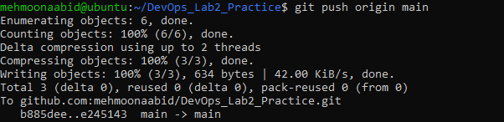

Task 12: Code Review Workflow
1. Create a Pull Request (PR) / Merge Request (MR):
- From a feature branch into main.
- Add a clear title and description summarizing the changes.
- Screenshot as pr_create_details.png.
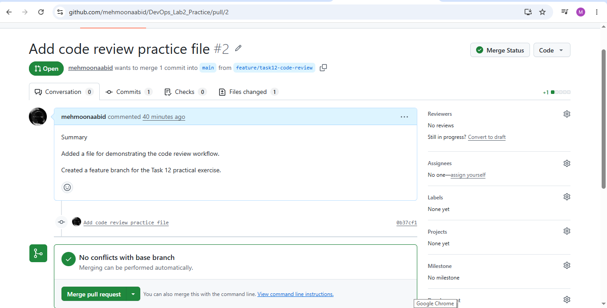
2. Assign a reviewer (teammate or second account).
• Screenshot as pr_assigned_reviewer.png.
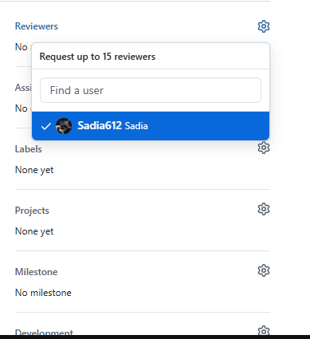

3. Reviewer Actions (capture screenshots for each):
- Request changes and add comments → pr_request_changes.png
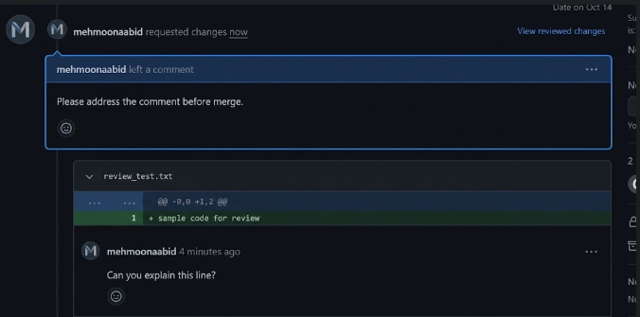
- Reject or close a practice PR → pr_rejected.png. Use a separate practice PR if necessary so all required review states can be demonstrated safely.
4. Author Actions:
- Fix issues in the same branch and push new commits.
- PR updates automatically.
Screenshot updated PR with new commits → pr_updated_with_commits.png
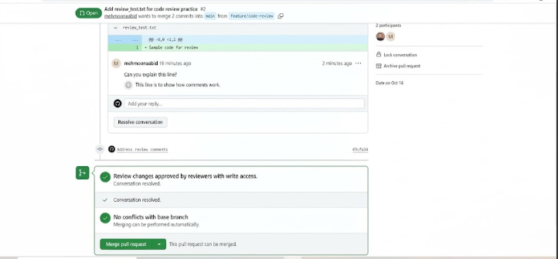
5. Merge the PR:
- Reviewer approves → merge using GitHub/GitLab UI.
- Choose merge style (merge commit, squash, or rebase).
- Screenshot confirmation → pr_merge_confirm.png.
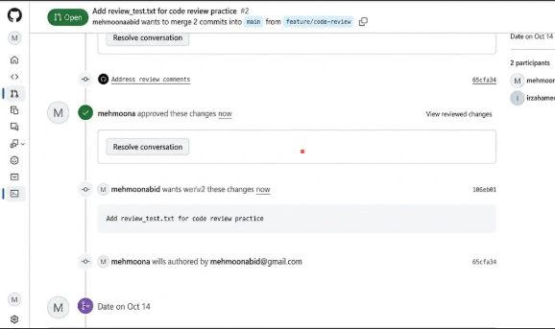
Screenshot result → pr_merged.png
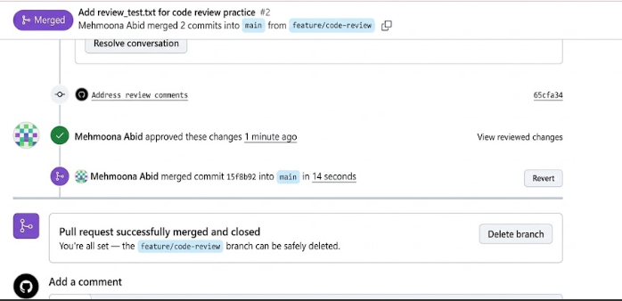

6. Branch Handling After Merge:
• Delete the merged PR branch and save the evidence as pr_branch_deleted.png.
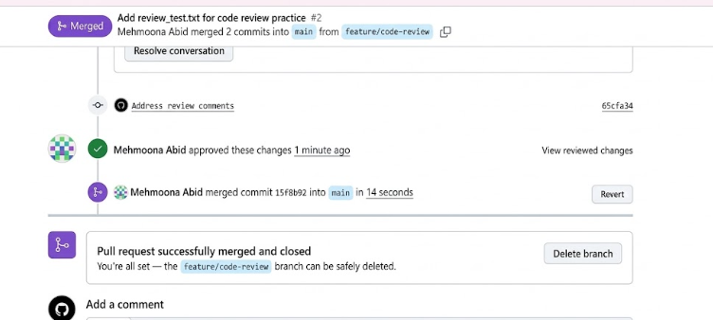

Task 13: Branch Cleanup Best Practices
1. Delete Remote Branch After Merge:
- Delete a merged branch through the GitHub UI and save the evidence as remote_branch_deleted.png.
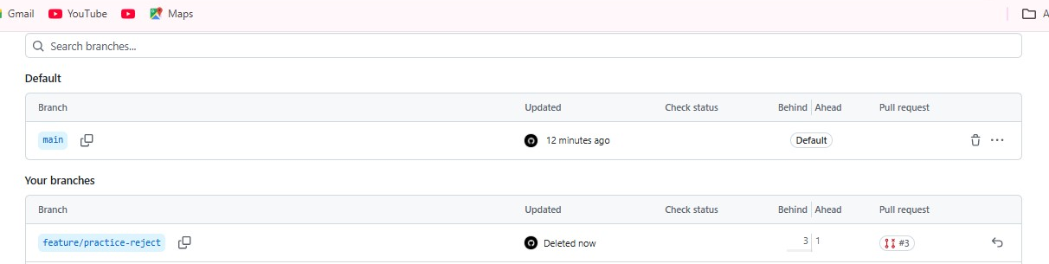
- Delete another completed remote branch from the terminal: git push origin --delete <branch-name>
- Save the terminal evidence as remote_branch_delete_cmd.png.
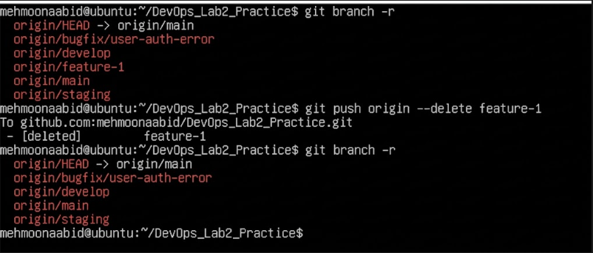
- Update Local Repository:
git checkout main
git pull origin main
git branch -d <branch-name>
git branch

- Save the GitHub branch-deletion evidence as remote_branch_deleted.png.

- Save the terminal command used to delete a remote branch as remote_branch_delete_cmd.png.
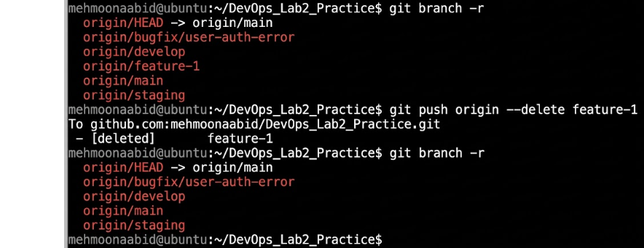

Exam Evaluation Questions
The three Q1_*.png files listed in the mandatory filename section are part of the current automated score. Q1_merge_history.png, Q2, and Q3 evidence are additional exam-practice evidence and may be reviewed separately.

Advanced Branching & Merge Verification Create a new branch in your repository.
Screenshot as Q1_branch_created.png.
Make a small change in a file and commit it.
Screenshot as Q1_commit_done.png.
Merge this branch back into the main branch.
Screenshot as Q1_merge_done.png.
Show the history of commits in a way that verifies the merge.
Screenshot as Q1_merge_history.png.
Multi-Stage Workflow Simulation
Set up a branching workflow with three branches: main, develop, and staging.
Screenshot as Q2_branches_created.png.
Create a feature branch from develop, make changes, and commit them.
Screenshot as Q2_feature_branch_commit.png.
Merge the feature branch into develop.
Screenshot as Q2_merge_into_develop.png.
Merge develop into staging.
Screenshot as Q2_merge_into_staging.png.
Merge staging into main.
Screenshot as Q2_merge_into_main.png.
Provide proof that each stage contains the updated changes before it reaches main.
Screenshot as Q2_stage_verification.png.
Collaboration & Conflict Resolution
Work with a collaborator: both contributors should modify the same file but in separate branches.
Screenshots as Q3_branches_modified1.png, Q3_branches_modified2.png, and Q3_branches_modified3.png.
Attempt to merge the branches and capture the conflict.
Screenshot as Q3_merge_conflict.png.
Resolve the conflict so that both contributions are preserved.
Screenshot as Q3_conflict_resolved.png.
Provide evidence that the final version of the file contains both collaborators’ changes.
Screenshot as Q3_final_file.png.
Submission
Before the deadline, verify the following:

Your repository is named exactly DevOps.
Your work is stored under Labs/Lab02.
Every required screenshot is stored under Labs/Lab02/screenshots.
Screenshot filenames match the required names exactly.
Every required screenshot clearly shows your standardized terminal identity, task evidence, and relevant output.
README.md this file.
No password, private key, token, or secret is visible.
All files are committed and pushed to GitHub.
Use these commands for the final submission check:

git commit -m "Submit Lab 02 evidence" git push origin main
Confirm on GitHub that the files are visible before considering the submission complete.

This lab is designed for hands-on mastery of essential Git concepts as covered in your course materials. All steps reflect real workflows you’ll use in professional software development.

